Our Catchments  
Our Communities

Strengthening the Catchment Stewardship Framework in Victoria

**Acknowledgements**

The Department of Energy, Environment and Climate Action (DEECA) acknowledges West Gippsland Catchment Management Authority (CMA) and RM Consulting for their roles in this collaborative project with DEECA. The remaining CMAs, Melbourne Water, and Taungurung Land and Waters Council are acknowledged for their specific contributions. Professor Ian Rutherfurd (Melbourne University), Katie Warner (North East CMA), Dan Garlick (West Gippsland CMA), Corinne Mays (Melbourne Water), Sarah Holland-Clift (Corangamite CMA), and Adam Hood (Department of Energy, Environment and Climate Action) are acknowledged for their insights on catchment stewardship.

**Author:**

Catchment Stewardship Team, Water and Catchments Group, DEECA.

**Photo credit:**

Powlett River / Kugerungmome – Catchment Stewardship Project Area – Darryl Whitaker / West Gippsland Catchment Management Authority. March 2021.

We acknowledge and respect Victorian Traditional Owners as the original custodians of Victoria’s land and waters, their unique ability to care for Country and deep spiritual connection to it.

We honour Elders past and present whose knowledge and wisdom has ensured the continuation of culture and traditional practices.

DEECA is committed to genuinely partnering with Victorian Traditional Owners and Victoria’s Aboriginal community to progress their aspirations.

© The State of Victoria Department of Energy, Environment and Climate Action February 2024.

**Creative Commons**

This work is licensed under a Creative Commons Attribution 4.0 International licence, visit the [Creative Commons website](http://creativecommons.org/licenses/by/4.0/) (<http://creativecommons.org/licenses/by/4.0/>).

You are free to re-use the work under that licence, on the condition that you credit the State of Victoria as author. The licence does not apply to any images, photographs or branding, including the Victorian Coat of Arms, and the Victorian Government and Department logos.

**ISBN**978-1-76136-715-1 **(pdf/online/MS word)**

**Disclaimer**

This publication may be of assistance to you, but the State of Victoria and its employees do not guarantee that the publication is without flaw of any kind or is wholly appropriate for your particular purposes and therefore disclaims all liability for any error, loss or other consequence which may arise from you relying on any information in this publication.

**Accessibility**

To receive this document in an alternative format, phone the Customer Service Centre on 136 186, email [customer.service@delwp.vic.gov.au](mailto:customer.service@delwp.vic.gov.au), or contact National Relay Service on 133 677. Available at [DEECA website](http://www.deeca.vic.gov.au/) ([www.deeca.vic.gov.au](http://www.deeca.vic.gov.au/)).

Table of Contents

Introduction 4

Building better Catchment Stewardship 6

Delivering Outcomes through People Connecting to Place 8

Traditional Owners Caring for Country 9

Stewardship and Integrated Catchment Management 10

Policy, Regulation and the Role of Government 15

Outcomes of Catchment Stewardship 18

The pathway to current theory and practice of stewardship 19

# Introduction

Catchment stewardship involves both individual and collective efforts in managing catchments to generate intergenerational benefits for the environment, people, and place.

Catchment stewardship builds on a longstanding approach where Catchment Management Authorities coordinate the development and implementation of regional catchment strategies and work closely with partners, including the natural resource management sector, Traditional Owners, and public and private land managers, to promote and directly support the health and resilience of our catchments.

The condition of Victoria’s catchments has declined since European settlement. Most of the indicators used to measure catchment heath show catchments are remaining in moderate to poor condition and neutral or concerning trends over time (Figure 1). This is a direct result of two hundred years of development; land clearing, unsustainable farming practices and increased invasive pests. Many of these threats continue to impact on catchment condition.

Population and demographic shifts influence the capacity of communities to respond to these challenges, and climate change and impacts from extreme events are becoming more evident, placing further pressure on the health of our catchments and the communities that live in them.  
Figure 1: Catchment condition and 5-year trends in Victoria reported by CMAs in 2021-2022 (DEECA 2023)

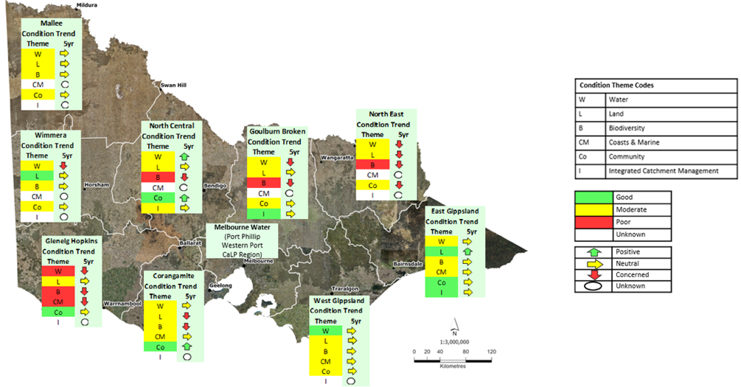

Victoria’s response to the decline of catchment condition is to strengthen the important value of catchment stewardship because it recognises that people and places are connected.

This paper describes contemporary catchment stewardship in Victoria which enriches and sustains relationships between people and the environment in which they live, work, and recreate (Bennett, N. J,. Whitty, T. S., Finkbeiner, E., Pittman, J., Bassett, H., Gelcich, S., and Allison, E. H. (2018). Environmental Stewardship: A conceptual review and analytical framework. Environmental Management, 61(4), 597-614). This work lays the foundation for a stronger more accountable stewardship framework for government and partners going into new cycles of investment and evaluation.

It includes definitions, principles, current case studies and a reflection on a range of tools (structure based, rules based and incentive based) used to support better stewardship of our catchments.

This paper is built on a legacy of knowledge and wherewithal, ranging from international literature to paddock-based practice. It is a current statement of the aspirational approach to better catchment stewardship in Victoria.

# Building better Catchment Stewardship

Catchment stewardship has been defined in the Our Catchments, Our Communities – building on the legacy strategic directions statement 2021. This paper updates and expands it to include contemporary perspectives of what it is, what are the key areas of focus and what are the guiding principles for practice in Victoria.

Catchment stewardship involves both individual and collective efforts in managing catchments to generate intergenerational benefits for the environment, people, and place.

The premise of catchment stewardship is that actions of people connecting to place affect catchment health and resilience; and that the positive impact of this can be better when we plan and act collaboratively, considering a range of perspectives, values and interests. It highlights the long timelines needed for stewardship to have benefits for the environment, people and places of value.

A principles-based approach to stewarding the landscape, rather than a prescribed program of work, is adopted. Three guiding principles shape the way that catchment stewardship is understood and implemented:

* Employment of a collaborative planning and delivery approach guided by a shared vision and agreed place-based objectives.
* Support for Aboriginal self-determination and processes to bridge western and indigenous approaches to governing, planning, and delivery.

Valuing the diversity of perspectives and knowledge, including local, scientific, and traditional ecological knowledge, of landscapes and natural resources.

Current policy settings in Victoria have two key focus areas that drive the way these principles underpin the delivery of better stewardship into places of significant value:

* Active management of natural resources to build resilience or protect or enhance their condition.
* Support for Traditional Owners and Aboriginal people to heal and care for Country.

Figure : Catchment stewardship – a principles-based approach where people connect to place.

**A flow chart diagram describing Catchment Stewardship, with three guiding principles feeding into this definition. Catchment Stewardship is a principles-based approach where people connect to place.**

# Delivering Outcomes through People Connecting to Place

The idea that people and nature are inextricably interconnected is at the core of the stewardship approach (Bieling, C., and Plieninger, T. (2017). Leveraging landscape stewardship: Principles and ways forward. In C. Bieling and T. Plieninger (Eds), The Science and Practice of Landscape Stewardship (pp. 366-377). Cambridge University Press.). Stewardship is often described as an ‘ethic’ or a set of values that engender appreciation of and respect for the environment as the basis for our prosperity and quality of life (Roberts, B. (1992). Land care manual. Sydney: New South Wales University Press.). This ‘ethic’ is held by people, be they First Nations people, private landholders, public land managers, industries, businesses, groups, or individual community members.

While improved ecological outcomes are the main objective of most stewardship projects, catchment stewardship occurs where ‘people’ and ‘place’ intersect. It begins with individual actions on a small scale (i.e. household or property) and improved community and Traditional Owner capacity; and builds to collective action with catchment scale outcomes when there are shared objectives at ‘place’.

Uttwillock Wetlands community event.

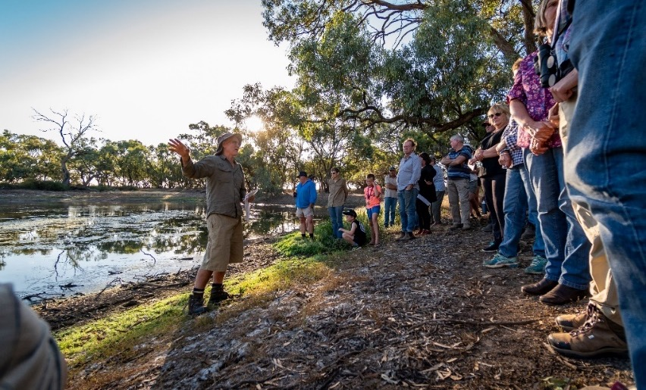

# Traditional Owners Caring for Country

Central to building better stewardship is the acknowledgement of Traditional Owner values and interests as custodians of Country, especially supporting their capacity to care for and heal Country. It is also recognised that there are conceptual differences between Traditional Owner perspectives of custodianship of Country and the western-derived concept of stewardship. Aligning aspirations for Country is key part of building catchment stewardship as a holistic approach connecting nature, people and place.

Taungurung works crew on Country.

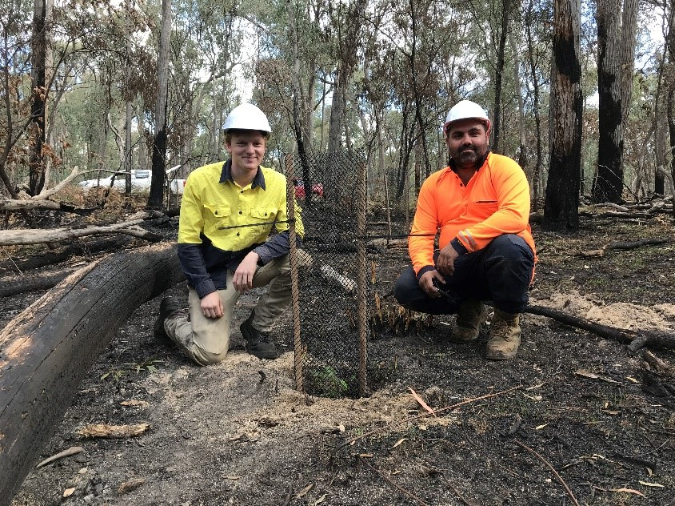

# Stewardship and Integrated Catchment Management

Stewardship is the sum of the individual and collective actions across a catchment that delivers the above outcomes. In Victoria, Catchment Management Authorities (CMAs) work with sector partners, the community and Traditional Owners, coordinating collaborative planning and management across a range of natural resource management themes in Victoria. Those themes are identified in regional catchment strategies as Land, Water, Biodiversity, Marine and Coasts, and Community. In Victoria, this collaboration across themes is referred to as Integrated Catchment Management (ICM). ICM has become the key ‘process’ used by CMAs to support better catchment stewardship.

ICM recognises that elements within a system (i.e. a catchment) are highly connected and that the use and management of one part of a system will impact its other parts. The interconnectedness of water, land, biodiversity, and communities within a catchment, therefore, requires a holistic and integrated management approach. This integrated approach to catchment management provides the foundation to build capacity and contributes to greater system resilience.

### Case Study - It takes a village to care for a catchment

**To highlight the principle ‘A collaborative planning and delivery approach guided by a shared vision and place-based objectives’.**

The Powlett River/Kugerungmome* Catchment ICM Project, delivered by West Gippsland Catchment Management Authority, takes a ‘whole of catchment’ approach to improve the strategic and collaborative management of this beautiful and important catchment. The collaborative approach has built the capacity, connection and cultural competency of the partners and the strategic management of land, water and biodiversity across the catchment.

The 50,800 hectare area is largely used for dairy and beef production and supplies water for urban (three townships) and domestic consumption and agriculture. It is also part of the Bunurong Land Council Aboriginal Corporation (BLCAC) Registered Area and is an important landscape for the Bunurong people.

Underpinned by a collaborative approach, 15 community, industry and government partners were engaged in the development of a Discussion Paper and the associated Strategic Directions Statement (that describes a 20-year vision for the Powlett River Catchment), and a three-year Powlett ICM implementation plan.

The partnership approach has opened up and created new ways to work. It has allowed partners to work out how best to share delivery of the on-ground activities – based on their capacity and skills at the time. An important part of this process has been the sharing of knowledge and on-country cultural learning with the BLCAC.

*Bunurong Land Council Aboriginal Corporation granted permission to use the dual name for this project, with Kugerungmome the Bunurong people’s traditional name for the Powlett River catchment.

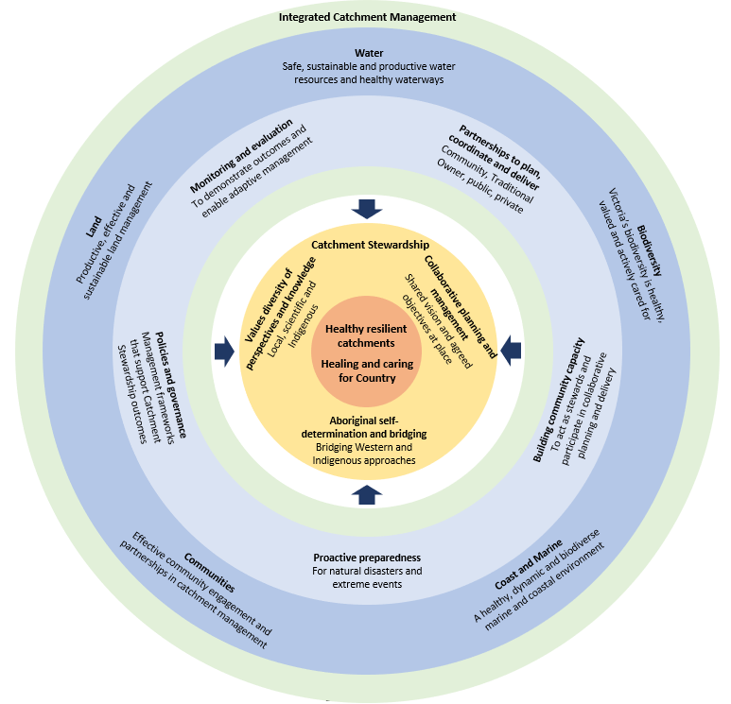

Figure 3: Catchment Stewardship and Integrated Catchment Management concept diagram.

The strong interaction between good ICM and stewardship is represented in the circular logic in Figure 5 (The definition of ICM has been drawn from the Strengthening Catchment Stewardship in Victoria Discussion Paper and strategic directions statement ‘Our Catchments Our Communities: Building on the Legacy for Better Stewardship’.).The circular logic highlights the value of understanding the holistic, interconnectedness of natural resource systems to be able to properly connect people and place and Traditional Owners and Country. It has a range of thematic outcomes from current policy: land, water, biodiversity, marine and coasts and community (the dark blue ring). These are the bases for the regional catchment strategy outcomes framework across Victoria. The next level focuses on the range of tools that are used more broadly to deliver Integrated Catchment Management and Stewardship (the light blue ring). The inner circle points to the crucial importance to improving stewardship through direct collaboration in a place, and the role of bridging western and indigenous approaches; and the value of diverse perspectives and knowledge. This leads to healing and caring for Country and more healthy and resilient catchments.

### Case Study – Management of Natural Resources

**To highlight the definition of catchment stewardship ‘Catchment stewardship involves both individual and collective efforts in managing catchments to generate intergenerational benefits for the environment, people, and place. Catchment stewardship focuses on:**

* **Active management of natural resources to build resilience or protect and enhance their condition**
* **Supporting Traditional Owners and Aboriginal people to heal and care for Country.’**

The Glenelg Hopkins catchment is home to more than 7,600 wetlands which provide habitat to a wide variety of plants, birds, and other threatened species. Wetland loss, through drainage for agriculture, has long been an issue across the area, and declining rainfall due to climate change is placing additional pressure on these important wetland systems.

Through the project titled ‘Looking after Country – valuing wetlands in the productive Greater Grampians (Gariwerd) landscape’, funded by the Victorian Government’s Our Catchments Our Communities program, the Glenelg Hopkins Catchment Management Authority (CMA) has collaborated with individuals, groups, and partners. Together, through their individual and collective efforts they are undertaking wetland restoration and protection activities to generate intergenerational benefits for the environment, people, and place.

By collaborating with Traditional Owners (Eastern Maar, Wadawurrung and Gunditj Mirring peoples) the project has sought to improve local community cultural awareness through events such as the Lake Bolac Eel Festival and supported the incorporation of Traditional knowledge and language into wetland management.

Nine landholders who manage twenty-one wetlands across 174 hectares have also partnered with the CMA to improve wetland management through protection, changed land management, flora and fauna assessments or capacity building activities. Four additional land managers are trialling precision agriculture tools to reduce the impacts of cropping on wetlands.

Landcare groups across the region have also partnered with the CMA and landholders to drive improved wetland stewardship through the project, with twelve Landcare groups and their members involved in activities such as rabbit control around wetlands and planning for landscape climate resilience.

# Policy, Regulation and the Role of Government

Stewardship as described, also requires a role for government to ensure that there is clear support for the public benefit that it delivers. In Victoria this includes supportive legislative structures and regulatory tools, the provision of funding that can leverage buy-in and provide direct grants; and the provision of planning coordination, capacity building, advice and support (the light blue ring in Figure 3).

## Victoria’s catchment management framework – A solid foundation

The *Catchment and Land Protection Act 1994* (CaLP Act) established the catchment management framework, which for more than 25 years has supported the coordinated and integrated planning and management of water, land, biodiversity, and marine and coasts as parts of connected systems.

The CMAs (and Melbourne Water since 2022) through partnerships and collaboration with agencies, Traditional Owners, and local communities across the ten catchment and land protection regions, coordinate this integrated approach.

Regional catchment strategies identify and describe government and community values and priorities for the natural resource management themes, and set strategic directions to deliver integrated environmental, cultural, social, and economic outcomes in local areas. They are the primary instruments for integrated natural resource management planning in Victoria operating at the regional scale (Figure 4).

Figure 4: Catchment and Land Protection Regions and the Regional Catchment Strategies.

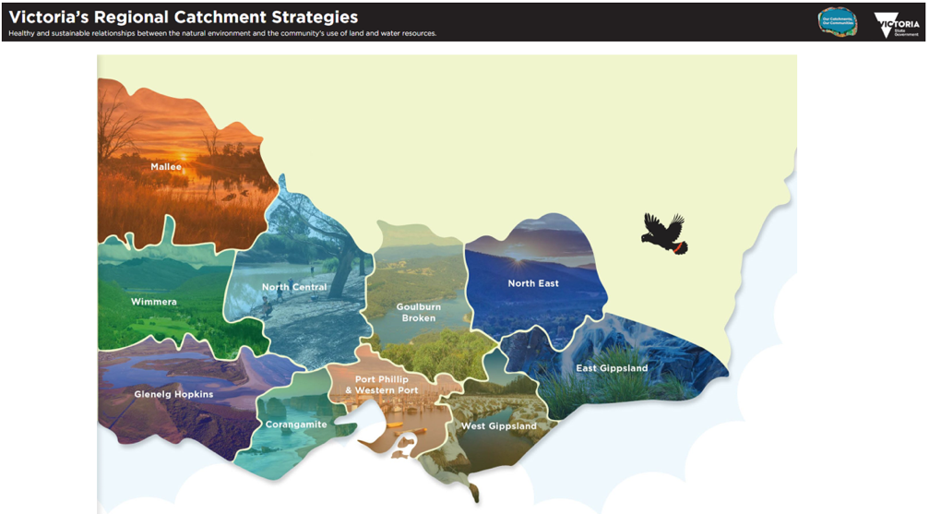

The ten regional catchment strategies are accessible at <http://www.rcs.vic.gov.au/>.

This legislative setting has provided the basis for ICM as a valuable tool to build a stewardship approach for actively protecting or enhancing the condition of our natural resources now and for the future.

The CaLP Act contains additional regulatory provisions that underpin the stewardship “role of Government”, particularly where there are failures to address risks to catchment values. Provisions in use are those to declare noxious weeds and pest animals; and to establish the rules, and the roles and responsibilities for their control and management as threats to environmental, agricultural, cultural, economic, and social values.

here are also special areas that can be declared to protect the quality and condition of land; water quality; aquatic habitats; aquifer recharge and discharge areas. Victoria has 123 special areas (Figure 5) classified as special water supply catchment areas specifically to protect the supply

and quality of water from land use risks in our catchments. These are enacted through referral provisions under state and local controls in the Victorian Planning Provisions, and codes of practice for timber harvesting and management and intensive agricultural industries.

Figure 5: Special water supply catchment areas.

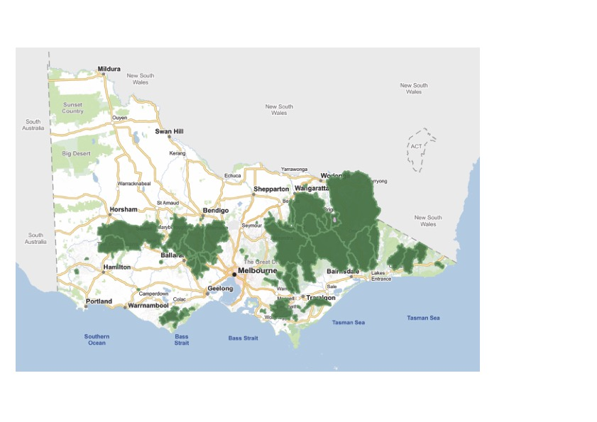

## Policy, program and funding support for catchment stewardship

The basis for driving strengthened catchment stewardship is recognised in a range of policy and programs in particular, [***Water for Victoria (2016)***](https://www.water.vic.gov.au/about-us/water-for-victoria), where the value of holistic management of catchments is recognised and supported through investing in integrated catchment management.

*Water for Victoria (2016)* points to the [***Our Catchments, Our Communities***](https://www.water.vic.gov.au/catchments/our-catchments-our-communities)policy and program settings which in 2016-2019, re-introduced the need for greater community stewardship of natural resources. This has been enhanced from 2021 by building on the legacy, where active catchment stewardship is a long-term outcome to improve catchment health and resilience.

The Victorian Government invested $43.75 million between 2016 and 2024, delivering on-ground projects, more effective community engagement and delivery, better connection between state and regional planning, support for implementing regional catchment strategies, clearer roles and accountability, and improved monitoring and reporting.

### Case Study – Diversity of Perspectives and Knowledge

*To highlight the principle ‘Values a diversity of perspectives and knowledge including local, scientific and indigenous knowledge of landscapes and natural resources.’*

North Central Catchment Management Authority (CMA), Coliban Water and Dja Dja Wurrung Clans Aboriginal Corporation have joined forces to deliver ‘A Healthy Coliban Catchment’. The project aims to ensure a safe and secure water supply, improved waterway, and biodiversity health and to protect the cultural history of the Upper Coliban catchment.

Guided by the vision and actions documented in the collaboratively developed 2018 Upper Coliban Integrated Catchment Management Plan, the project is working with local councils, community groups, Traditional Owners, landholders, and communities on individual and collective catchment management actions to achieve intergenerational benefits for environment, people and place.

A Technical Working Group with representatives from North Central CMA, Coliban Water and Dja Dja Wurrung guide the project providing technical and cultural information, whilst a Community Reference Group contributes a diversity of perspectives and local knowledge.

Meetings, joint field days, Board tours, Landcare and local government collaborations, Aboriginal waterway assessments, On-Country ‘Wartaka’ (meaning ‘meeting with purpose’) and the employment of Djaara staff to support the project have also helped to foster shared learning and knowledge exchange about the landscape and enable the successful delivery of on-ground achievements.

The Victorian Government’s Our Catchments Our Communities program has partnered in the delivery of the project.

# Outcomes of Catchment Stewardship

A range of outcomes define the success of catchment stewardship. On-ground catchment stewardship programs directly contribute to one or more of these outcomes.

They are not intended to all be measured for every catchment but a selection of them could be used to evaluate the success of relevant stewardship approaches. These outcomes are aspirational and together describe the vision for catchment stewardship in Victoria:

* **Empowered Aboriginal custodianship** – Improved Aboriginal self-determination embedding their voices in planning and on-ground actions.
* **Community empowerment** – Communities are connected, capable, empowered, and self-directed to act independently as leaders in catchment stewardship.
* **Multiple benefits for the environment, people, and place** – Including environmental, cultural, and social benefits.
* **Intergenerational equity** – Catchment stewardship protects natural values for future generations.
* **Protected achievements** – Catchment stewardship extends and protects the legacy of past projects and investments through a commitment to ongoing maintenance and enhancement.
* **Raised standards** – Stewardship raises expectations over time and equips the community to support progress (and not slip backwards).
* **Resilient communities and landscapes** – Catchment stewardship improves community and landscape resilience to climate change, natural disasters and/or extreme event

# The pathway to current theory and practice of stewardship

Revisiting the essence of stewardship theory and practice in Victoria began with the 2020 Victorian Integrated Catchment Management Winter Sessions. Representatives from the Victorian Catchment Management Council; CMAs; NRM Regions Australia; Traditional Owners; the Productivity Commission; Tertiary Institutions; Greening Australia; Landcare; the Victorian Farmers Federation; the Wentworth Group of Concerned Scientists; Vic Water; and Victorian Government Departments provided their insights on catchment stewardship answering four questions:

* What is it?
* Who are the stewards?
* What value can it bring in the face of climate change and extreme events?

How do we know when it is successful?

The dialogue coming out of those winter sessions was enlightening and encouraging. It has guided policy, investment, and practice over recent years in Victoria.

Three sector-based engagement sessions with CMAs and Melbourne Water in early 2022 focused on the published definitions of catchment stewardship. The participants felt that the definitions were too rigid and set too strongly in outdated public economics language. They questioned the notion of “public benefits” and “duty of care” as concepts that individual resource managers understood, or had control over. They questioned the capacity of stewards to be able to always leave resources in better condition than their current state, especially in the face of climate change. The work that followed on has sought to better define catchment stewardship in current practice.

In 2022 and 2023 two Peer Learning Workshops and a series of specific interviews further developed a shared perspective of stewardship and what Traditional Owner self-determination and caring for and healing Country means in relation to catchment stewardship. These workshops involved CMAs (including Melbourne Water), Traditional Owners (including Taungurung, Dja Dja Wurrung and Gunditjmara representatives), academics, emerging community leaders and DEECA policy and program specialists.

These workshops led and promoted the development of a shared approach to catchment stewardship and the need for bridging and support for Traditional Owner self-determination and custodianship of Country. They highlighted the value of community and sector partnerships when delivering valuable on-ground projects in a place. They stressed the importance of listening to and learning Traditional Owner perspectives and knowledge about cultural landscapes and Country. They reiterated the importance of systems thinking and coordination that supports integrated catchment management across land, water, biodiversity, marine and coasts.

### Case Study – Bridging Western and Indigenous Approaches

**To highlight the principle ‘Supports Aboriginal self-determination and processes to bridge western and indigenous approaches to governance, planning, and delivery.’**

Supporting self-determination sits at the heart of the ‘Taking Care of Country’ project that has been facilitated by the Goulburn Broken Catchment Management Authority (CMA) and supported by the Victorian Government’s Our Catchments Our Communities program. From the outset, the CMA sought to work with Yorta Yorta Nation Aboriginal Corporation (YYNAC) and Taungurung Land and Waters Council (TLaWC) to co-design the project and support the delivery of Traditional Owner priorities identified in their Elder endorsed Country Plans.

Through multiple CMA and Traditional Owner discussions, three priority areas for action were identified: Reedy Lake Wildlife Reserve for the Taungurung people, and the sand hills at Gemmill’s Swamp Nature Conservation Reserve and the Goulburn River for the Yorta Yorta people.

Together the CMA and the Traditional Owner groups have sought to bridge differences in their respective approaches to planning and delivery. Slowing planning processes to a pace that enables trust and working relationships to be built, prioritising Traditional Owner interests in the works program, providing resources to support Traditional Owner works crew delivery and seeking Traditional Owner guidance for on-ground activities and preferred monitoring approaches.

Progress is being made to support the Traditional Owner groups to heal and care for Country at the sites they have determined to be a priority, generating intergenerational benefits for the environment, people, and place.

Taungurung have made significant progress at Reedy Lake Wildlife Reserve including cultural heritage surveys, weed control, revegetation, fauna surveys and flood level monitoring, which have all contributed to cultural learning in the field for the works teams. Progress has also been achieved between Yorta Yorta and Shepparton City Council on a shared works program currently being implemented at the Gemmill’s Swamp Nature Conservation Reserve sand hills.

### Case Study – Collaborative Planning and Delivery

*To highlight the principle ‘Employs a collaborative planning and delivery approach guided by a shared vision and agreed objectives at place.’*

The Lower Kiewa River in North East Victoria sits at the nexus of an area of significant urban growth, high-value agricultural land and important natural environments. The area hosts a vibrant community of Landcare and agricultural groups, land managers and government agencies who are committed to actively managing the landscape and Traditional Owners devoted to healing and caring for Country. Despite the alignment of their mission, these groups often operated independently, which presented an opportunity for collaborative planning and delivery.

In 2022, funded by the Victorian Government’s Our Catchment Our Communities program, the North East Catchment Management Authority commenced a project to build strategic partnerships at place and empower the Lower Kiewa community to care for the catchment together. Using a Project Steering Group of community and agency representatives, Traditional Owner meetings and engagement with the broader community (through an online survey, drop-in sessions, and interactive maps), an understanding of community aspirations, places of importance and priorities for stewardship action in the Lower Kiewa were identified.

A shared vision of *‘A healthier and more resilient Lower Kiewa catchment achieved through active cultural, land, water and biodiversity stewardship and effective partnerships working across public and private land’* and agreed delivery priorities were documented through a Lower Kiewa Stewardship Action Plan. Leveraging this shared plan and improved partnerships, the community, agencies, and Traditional Owners are now working together to benefit the environment, place and people of the Lower Kiewa and build the resilience of the landscape for future generations.