Planning our Basin future together

A prospectus to safeguard Victoria’s environments and communities in the Murray-Darling Basin
We acknowledge and respect Victorian Traditional Owners as the original custodians of Victoria’s land and waters, their unique ability to care for Country and deep spiritual connection to it. We honour Elders past and present whose knowledge and wisdom has ensured the continuation of culture and traditional practices. We are committed to genuinely partnering with Victorian Traditional Owners and Victoria’s Aboriginal community to progress their aspirations.
© The State of Victoria Department of Energy, Environment and Climate Action, May 2024
Creative Commons
This work is licensed under a Creative Commons Attribution 4.0 International licence, visit the Creative Commons website.
You are free to re-use the work under that licence, on the condition that you credit the State of Victoria as author. The licence does not apply to any images, photographs or branding, including the Victorian Coat of Arms, and the Victorian Government and Department logos.
ISBN 978-1-76136-645-1 (Print)
ISBN 978-1-76136-646-8 (pdf/online/MS word)
Disclaimer
This publication may be of assistance to you but the State of Victoria and its employees do not guarantee that the publication is without flaw of any kind or is wholly appropriate for your particular purposes and therefore disclaims all liability for any error, loss or other consequence which may arise from you relying on any information in this publication.
Accessibility
To receive this document in an alternative format, phone the Customer Service Centre on 136 186, email customer.service@deeca.vic.gov.au, or contact National Relay Service on 133 677. Available at DEECA website.
Contents
Foreword 3
The Basin Plan in 2024 5
Rehabilitating the rivers and floodplains of northern Victoria 5
Basin Plan outcomes 5
Recent Commonwealth announcements 7
What is at stake for Victoria 8
Victoria’s approach to catchment management 10
Managing for community values in Victorian catchments 10
Victoria’s approach to the Basin Plan 11
Working with Victorians to implement the Basin Plan 17
Victoria’s Basin catchments 20
The Victorian Murray downstream of Nyah 21
The Victorian Murray upstream of Nyah 24
The Loddon 28
The Campaspe 33
The Goulburn 37
The Broken 42
The Lower Broken Creek 46
The rivers of north east Victoria 50
The Wimmera-Mallee 54
Adapting Victorian irrigation districts for the future 58
Previous water recovery in irrigation districts 58
The Goulburn Murray Irrigation District (GMID) 60
The Sunraysia pumped districts 61
Planning the future of irrigation districts together 62
Next steps 66
Working with Victorian communities 66
Delivering the 2,750 GL as the agreed Basin Plan target 66
Preventing the negative impacts of blunt water purchase programs 67
Endnotes 68

Foreword
Victoria has worked with a sense of urgency and purpose to improve water management and environmental outcomes in the Basin for decades, and particularly since the establishment of water extraction caps in 1992. The Basin Plan presents our biggest opportunity in generations to make a significant and enduring difference in our river rehabilitation work across the southern connected Basin. As the second step to the Living Murray Program, the Basin Plan allows us to accelerate our own local catchment improvement work with communities in ways that support them to thrive into the future.
That is why, despite the challenges of such a major reform program, Victoria has delivered on all our key milestones and obligations to date, with a focus on real-world outcomes.
All Victorian Water Resource Plans were accredited on time. All of our bridging-the-gap water recovery targets in Victorian catchments were met on time. The largest water infrastructure upgrade program in Australia’s history was delivered across the Goulburn-Murray Irrigation District and 17.7 GL of additional water recovery has already been contracted that complies with the agreed socio-economic criteria.
We have seen the benefits to the environment that are already being realised from previous river and floodplain restoration programs through the Living Murray initiative – which celebrated its twentieth anniversary this year. The Living Murray represented a new approach to river management – bringing together water for the environment with changes to rules and infrastructure to get ecological benefits in a highly regulated water system. We are continuing to deliver these benefits through environmental works and measures under the Basin Plan, as a proponent or co-proponent in 22 of the 36 Sustainable Diversion Limits Adjustment Mechanism (SDLAM) projects, which allow environmental water to be used to its greatest potential.
Victoria is a vocal advocate for the water interests and aspirations of First Nations communities and the release of the Water is Life: Traditional Owner Access to Water Roadmap in 2022 provides an important pathway to create and maintain a careful and considered balance between Traditional Owner self-determination in water access and management and the rights and entitlements of irrigators and landholders, environmental groups, and the community.
We are demonstrably committed to the objectives of the Basin Plan, and our actions show the value we place on a healthy basin and sustainable communities in the context of population growth and climate change. These challenges must be faced with the communities where they are taking place.
With limited protections for the community from the socio-economic impacts of additional water recovery, the Commonwealth Government’s long-awaited agreement to fund critical Victorian environmental works will reduce the volume of water that is removed from the consumptive pool.
However, our collective success is not just ‘what’ we implement, but ‘how’ we implement the various components of this ambitious Basin Plan. Our communities and industries well remember the devastating impacts that untargeted open tender water purchases have had on Victorian communities and industries. It has been publicly documented by Commonwealth Government agencies and economic experts that these buyback programs have short-term benefits to willing sellers, but negatively impact the communities remaining and the irrigation systems that they rely on. All Basin jurisdictions know about these impacts and are looking for a range of ways to remove or reduce negative socio-economic impacts of these changes for their stakeholders and communities.
Bringing our collective knowledge, expertise and views together, including our growing partnerships with Victorian Traditional Owners, we have found ways to deliver significant and lasting benefits that rehabilitate landscapes. We have done this by taking conscious steps towards resizing irrigation infrastructure to make sure that the industries that rely on it are sustainable, and have access to reliable, affordable water.
This prospectus sets out the ways that further water recovery in Victoria could be done in a better way than the blunt open tender water purchases of the past. This plan is intended to guide the work we do to influence the processes and negotiations of any significant volume of water to be purchased in Victoria. We want to talk with you about how to use what we know, build on our experiences, and identify and maximise the opportunities that benefit local environments without risking the viability of our communities.
"Our actions show the value we place on a healthy basin and sustainable communities in the context of population growth and climate change"

This prospectus builds on the achievements of the past and proposes alternative ways to get environmental benefits, without stopping essential projects and running open tender buyback programs. This approach will not completely eliminate the negative socio-economic impacts that further water recovery from the consumptive pool will have on our communities. But it will enable us to identify and mitigate these negative impacts.

The Basin Plan in 2024

Rehabilitating the rivers and floodplains of northern Victoria
Since 2013, Victoria has led the delivery of the Basin Plan.
Working with communities with a focus on environmental outcomes, Victoria has secured 826.5 GL of our target. That's 77% despite floods and the pandemic.
1075.3 GL Bridging the Gap target
Victoria has 22 notified SDLAM projects and we are on track to deliver:
- 88% of our target through operational projects
- 93% with addition of VMFRP
98% with addition of Constraints Management Program
We also have further projects under investigation.
Plus additional water recovery with neutral or positive socio-economic outcomes
- 7 GL Delivered
10.7 GL additional contracted water recovery

Basin Plan outcomes

Environment
- Our investment in these environments is approaching $1 billion statewide since 2004, with a focus on works like fishways, snags, in-stream vegetation and controlling pest plants and animals.
- Environmental water has been delivered to 120+ Victorian sites to benefit local plants, animals and ecosystems, reviving and transforming our Living Murray icon sites like the Hattah Lakes and Barmah-Millewa Forest.
- Meeting our environmental watering goals has improved habitats and breeding opportunities for waterbirds.
Environmental water has improved the abundance and distribution of small and large-bodied native fish, maintaining species richness.

Compliance and enforcement
- Victoria has a transparent, robust and nation-leading compliance framework complemented by extensive metering coverage.
Victoria has the largest fleet of modern meters in Australia with 98% of water take in the Murray-Darling Basin metered and 61% of meters telemetered, providing real-time data to water authorities.

SDLAM
- We are delivering our Sustainable Diversion Limit Adjustment Mechanism (SDLAM) projects which will continue to increase positive and long-term environmental outcomes.
This includes significant progress on the Victorian Murray Floodplain Restoration Project to restore the heath and increase climate resilience for 14,000 hectares of environmentally critical and culturally significant floodplain landscapes.

Rules and regulation
- All of Victoria’s Water Resource Plans are accredited and in place, clearly demonstrating how our water management frameworks meet the requirements of the Basin Plan, and Victoria continues to comply with Sustainable Diversion Limits in all valleys.
Victoria is compliant with Basin Plan trading rules and has reviewed and improved the rules around intervalley trade to make sure delivery of traded water doesn’t cause ongoing damage to the Goulburn and Campaspe Rivers.

Community wellbeing and food and fibre production
- Victoria led the development of the socio-economic criteria to apply to all additional water recovery, ensuring that up to 450 GL of water could be recovered with neutral or positive outcomes for the community.
- Australia's food bowl is in northern Victoria, and includes the largest irrigation area in the country, producing more than $3 billion worth of farm-gate produce every year, which along with flow-on industries, employs over 35,000 people.
- In Sunraysia, irrigated production represents 25% of Victoria’s agricultural value, including 99.9% of table grapes, 99.6% of almonds, 86% of citrus and 75% of our wine grapes.
In the Goulburn Murray Irrigation District, we produce 21% of Australia’s milk, 75% of Australia’s pears, 50% of Australia’s stone fruit.

Recent Commonwealth announcements
In August 2023, the Commonwealth Government announced that it had made an 'Agreement' with New South Wales, South Australia, Queensland and the Australian Capital Territory governments to make changes to the Basin Plan.
This announcement by the Commonwealth Government made the commitment of more time to deliver on Basin Plan targets – including water recovery, environmental projects, and constraints relaxation – and the ability for the Commonwealth Government to use water purchases to deliver the additional 450 GL of water above the Basin Plan target of 2,750 GL.
The Commonwealth Government 'Agreement' was not developed or made at the Murray-Darling Basin Ministerial Council table. This was the first time a major change has been made to Murray-Darling Basin water management without the agreement of all jurisdictions. The Victorian Government was not satisfied that there was enough evidence to warrant a departure from the original Basin Plan, beyond more time to deliver critical floodplain restoration projects including those impacted by the Victorian floods and the impacts of the pandemic, which had been consistently advocated for since 2018, including by the Productivity Commission.
The Victorian Government has always maintained its commitment to the Basin Plan as originally agreed, which included a legislated requirement for any recovery towards the 450 GL to have neutral or positive socio-economic outcomes. This requirement also explicitly prevented any water purchases towards the 450 GL.
The Victorian Government did not agree with the changes by the Commonwealth Government because those common-sense changes to allow more time for projects were tied to accepting water purchases for an additional 450 GL and the negative impacts that flow from that. There was no certainty or detail on how much water might be recovered out of our catchments, or how this recovery might be done.
In December 2023, the Commonwealth Water Act 2007 was amended, including removing the cap on water purchases, providing the Commonwealth Government with the ability to purchase up to 300 GL of additional water under the Basin Plan to meet existing ‘bridging the gap’ targets (the outcome required to reach the Basin Plan target of 2,750 GL of outcomes for the environment), as well as being able to purchase water towards the additional 450 GL, with no requirements to protect socio-economic outcomes.
The amended legislation provides more time for projects that make up the Sustainable Diversion Limit Adjustment Mechanism, like the critical Victorian Murray Floodplain Restoration Program and Constraints Projects, as well as allowing new efficiency or offset projects to be brought forward that can contribute to water recovery under the Basin Plan.
The legislation also makes it clear that not all of the 450 GL needs to be recovered from the southern connected basin, with water recovery in northern catchments being clearly eligible under the 450 GL. This is significant to the health of the Darling River and interconnected systems, and the Commonwealth’s position that environmental water is needed across the entire Basin.

What is at stake for Victoria
These Commonwealth changes mean that northern Victorian communities are exposed to greater risks from potentially large-scale, untargeted open tender water purchase programs. With a clear indication from the Commonwealth Government that it intends to begin recovering water in 2024 towards the 450 GL, it is likely that more water will be recovered in Victoria in the years to come.
To implement the agreed Basin Plan of 2012, nearly 1,000 GL of consumptive water has already been recovered from the southern Basin with water purchases. More than 50% of this has come from Victorian high reliability water shares. In this context, the Victorian Government has been closely monitoring the socio-economic impacts of the Basin Plan and has continued to build an evidence-based understanding of the nature and extent of how the Basin Plan has affected communities.
Our consistent position on the Basin Plan is rooted in this understanding of what is at stake. Northern Victorian catchments, from the alpine rivers of the north-east through to Sunraysia, are home to large populations in thriving and connected towns which are underpinned by water. Water which supports values for Traditional Owners, values for agriculture, towns, industry and is fundamental to riverine ecosystems and floodplain landscapes.
Northern Victoria is Victoria’s largest and highest value irrigation region accounting for more than 60% of Victoria’s irrigated agricultural production valued at more than $3 billion annually. Major sectors include dairying, horticulture (nuts, fruit, and vegetables), viticulture, cropping and livestock production, each of which support flow-on industries including processing, distribution, and tourism. Northern Victoria accounts for 90% of Victoria’s grapes, fruit, and nuts, and around 30% of the State’s dairy and vegetable production.
The Goulburn-Murray Irrigation District (GMID) is the largest irrigation district in Australia, and is home to thousands of farm businesses, as well as secondary and tertiary industries that flow from primary production, providing employment and services for people in the region. Beyond the GMID, private diverters along the Murray River, and the pumped irrigation districts of the mid-Murray and Sunraysia service high-value horticultural plantings and the flow-on industries they support.
Agricultural production is an important economic driver in northern Victoria with around 21,000 people directly employed in agriculture and a further 16,500 employed in related industries including processing and manufacturing. Dairy and horticulture make up a large portion of this accounting for over 10,000 direct jobs and a further 3,500 in manufacturing and processing.
Victorian irrigation districts are publicly owned and supported by the thousands of landholders that benefit from water delivery to their farms and properties. The Victorian and Commonwealth Governments have spent more than 2 billion dollars modernising and rationalising irrigation districts to reduce losses, improve water delivery, set the system up for the future and recover significant volumes of water for the environment.
Across northern Victoria, ecologically significant waterways and floodplains intersect with irrigation districts, cities, and towns, and in many cases are facing the challenges of ongoing river regulation, as well as climate change. These riverine and floodplain landscapes need active and adaptive management to continue to survive and improve into the future.
Victorian Traditional Owners have managed land and water in what we call the Murray-Darling Basin for tens of thousands of years. Victorian Traditional Owners have been all but entirely excluded from water management decisions for over 200 years, and the Victorian Government is continuing a stronger partnership approach to water management with Traditional Owners, recognising the importance of Traditional Owner knowledge and expertise.

Water plays an essential role in the health, prosperity and identity of our Basin communities. It is in this context that the Victorian Government takes a strong position on the Basin Plan and continues to work proactively to find and advocate for environmental outcomes and the reduction of negative impacts of changes to the Plan, to provide the best possible future for Victoria.

Victoria’s approach to catchment management

Managing for community values in Victorian catchments
Victoria’s catchment management framework helps us to achieve improvements in rivers, floodplains and catchment landscapes despite the modifications and impacts that have occurred because of the development of major towns, infrastructure, and agricultural industries.
We act to target change from individual river reaches to entire river basins, focusing on key indicators of waterway health in all tributaries to our mighty rivers. We have learnt that success is achieved by localised, consistent effort across physical landscapes, social landscapes, public and private land and over long periods of time.
Together with our communities, we have developed regionally focused, holistic, landscape-based strategies that co-ordinate efforts of local land, water and biodiversity managers. This includes Sustainable Water Strategies, Regional Catchment Strategies, Regional Waterway Strategies and Land and Water Management Plans in irrigation areas.
As statutory bodies, Victoria’s Catchment Management Authorities (CMA) are central to integrated catchment management outcomes – strategically investing in activities such as pest plant and animal control around important places, working with landowners to reduce water quality impacts and by planting native vegetation to support connectivity between areas of high biodiversity.
Victoria’s CMAs also have a strong track record of planning for and working with water corporations and land managers to deliver water for the environment and targeting threatened species through dry and wet times. This has supported the objectives of both the EPBC Act (Cth) and the FFG Act (Vic). For example, delivering water for Murray Hardyhead at Lake Elizabeth, Kunat Kunat (Round Lake), Brickworks Billabong and Koorlong Lake where reduced flow and increasing salinity are key threats that need to be addressed for their recovery.
Well before the Basin Plan was in place, CMAs were completing environmental flow studies to identify how best to get positive ecological responses in water dependent ecosystems. This included working with their partners and local communities to set realistic management objectives, considering the gaps between current and ‘ideal’ watering regimes and what was possible in highly modified systems.
"Victoria has been supporting Aboriginal Water Assessments that Traditional Owners can use to assert their cultural water needs"

This work led to policy and projects to identify what changes would lead to the best environmental improvements, from changing infrastructure and operations or recovering water for the environment to restore key elements of the natural hydrograph.
As a partner in The Living Murray program, Victoria has long understood that effective catchment management in northern Victoria requires water to be delivered for the environment, infrastructure works and complementary management activities to increase the environmental benefits gained from using this water, active use of environmental water, and the involvement of Traditional Owners in how significant landscapes are managed.
Building on this approach, Victoria has been supporting Aboriginal Water Assessments and similar approaches that Traditional Owners can use to assert their cultural water needs and continues to be more ambitious in commitments to work with Traditional Owners in a partnership approach in water management.

Victoria’s approach to the Basin Plan
Victoria’s approach to delivering the outcomes of the Basin Plan remains the same.
The Victorian Government's approach has always been to achieve environmental outcomes in a way that minimises socio-economic impacts by:
- investing in water recovery methods that have the least impact on the consumptive pool available to water users, and
maximising environmental outcomes from the water available to environmental water holders.
The Victorian Government's priority has always been to develop and deliver projects to achieve the 2,750 GL target we signed up to (Figure 1).

Existing environmental works and measures
Victoria is maximising environmental outcomes by delivering floodplain projects that get the most out of environmental water in a drying climate, like the Victorian Murray Floodplain Restoration Project. These projects impact landscapes that are significant for communities and Traditional Owners requiring genuine consultation every step of the way.
Victoria continues to be committed to these floodplain projects, which are the only way to provide water consistently to these landscapes due to the impacts of river regulation and the ongoing effect of climate change. Without floodplain projects, these landscapes will never be able to be watered in a way that suits local plants and animals, except in historically rare flooding events. One example is the proposed works at Wallpolla Island described in Figure 2.
As a partner in 22 out of 36 existing measures under the Sustainable Diversion Limits Adjustment Mechanism, we are delivering on diverse ways to get the most of environmental water, including through projects to improve river operations like Enhanced Environmental Water Delivery, which aims to coordinate environmental water releases across all Murray River tributaries to maximise downstream and system-wide connectivity outcomes.

Potential for new environmental works and measures
The changes to Commonwealth legislation mean that new environmental works and measures can be proposed which deliver environmental outcomes through enhancing the benefits of environmental watering and increasing flexibility for river operators (e.g. works to maximise environmental benefits from available water like the proposed project at Wallpolla Island (Figure 2).
These new measures can contribute towards the Sustainable Diversion Limit Adjustment Mechanism (SDLAM), providing improved environmental outcomes which contribute towards achievement of the ‘bridging the gap’ Basin Plan target of 2,750 GL.
The Victorian Government is considering what new ideas could contribute to meeting Basin Plan obligations, including re-establishing a project to recognise and enhance the environmental gains achieved by modern river operations (Improved Regulation of the River Murray (IRORM) Project).
Victoria is delivering improved environmental outcomes for our waterways and wetlands by delivering water for consumptive purposes in creative ways through irrigation channels and rivers. We will work with Commonwealth agencies to investigate how these benefits can be recognised.
All opportunities to enhance how water delivery can benefit our waterways will be further explored, for example:
- By looking at ways to build new infrastructure that can deliver more water for the environment, minimising the negative impacts of river regulation (e.g. increasing the size of the outlet at Lake Eppalock to increase Campaspe River flows).
Investigating the benefits that could be achieved by delivering water through the Lindsay River and onto the floodplain in a flexible way in that vital waterway of the Mallee.
Figure 1: Victoria’s focus when delivering the outcomes of the Basin Plan
Victorian Government focus
The Victorian Government’s focus remains on achieving the shared outcomes of the Basin Plan agreed by all governments in 2012.
Water recovery
Over 2,100 GL of water entitlements have been recovered already through Commonwealth water purchases and state water savings projects
Environmental projects
650 GL of shared environmental outcomes.
Half of the agreed 605 GL of projects to deliver environmental works and improved river operating rules has already been delivered. New projects which provide environmental outcomes can be submitted to the Commonwealth for consideration
Focus of recent Commonwealth legislation
New powers to purchase water for the additional 450 GL. Existing environmental projects have had time extensions for delivery and new projects can be considered.
Additional water recovery
Up to 450 GL additional recovery.
27 GL has already been achieved or contracted to deliver additional water recovery with neutral or positive socio‑economic impacts.
Figure 2: Outline of the benefits of the proposed works at Wallpolla Island, enabling water to be delivered to the floodplain in a way that replicates the frequency, duration and extent of flood events with significantly less water (figure adapted from Victorian Murray Floodplain Restoration Project)
Murray River | Semi-permanent and Temporary Wetland | Red Gum Forest and Lignum Shrubland | Black Box Woodland | Alluvial Plain
River flows (ML/d) | 60,000 | 80,000 | 100,000 | 120,000+
Pre-regulation flows
Frequency of flow events (years) | 64 in 100 | 39 in 100 | 26 in 100 | 16 in 100
Longest interval between events (years) | 3 | 5.5 | 10.6 | 12.6
Current flows (with environmental water entitlements)
Frequency of  flow events (years) | 33 in 100 | 14 in 100 | 6 in 100 | 6 in 100
Longest interval between events (years) | 8 | 18.7 | 20.2 | 30.7
Flows with Victorian Murray Floodplain Restoration Project (VMFRP) works*
Frequency of flow events (years) | 60 in 100 | 35 in 100 | 25 in 100 | 15 in 100
Longest interval between events (years) | 3 | 5.5 | 10.6 | 12.6
* The VMFRP sites can reduce the longest interval between floods to less than or equal to the maximum pre-regulation interval, depending on ecological thresholds and site condition.

Water recovery for environmental outcomes
Victoria has been successful at finding ways to recover water for the environment that result in positive on-ground outcomes for ecosystems and species and doing it in a way that minimises negative impacts on communities and industries.
This work has been driven by close to three decades of efforts by individuals, water corporations and governments to improve water use efficiency in Victoria to support water recovery for the environment and adapt to a changing climate. Forty-six major projects spread across the state have delivered more than 1,600 GL of water savings, the majority of which have gone to the environment (over 1,400 GL). The Goulburn-Murray Irrigation District has played a significant part of this water recovery.
In 1993, the Goulburn regulated water supply system was the first to have both consumptive and environmental rights clearly articulated followed by the Victorian Murray system. Over the next 30 years a wide variety of water recovery mechanisms have been used to recover water for the environment.
This has included
- water purchases,
- entitlement conversions (e.g. the ‘sales water’ deal as part of the Living Murray Initiative),
- decommissioning of head works water storages (e.g. Lake Mokoan, Greens Lake),
- shutting down delivery networks (e.g. Campaspe and Wimmera Irrigation Districts),
- irrigation district upgrades and rationalisation (e.g. Connections), and
on-farm efficiency upgrades including entitlement transfer from landholders.
Through implementation of the Basin Plan we have learned that different water recovery methods have both positive and negative impacts, and some have unintended consequences that were not envisioned when first proposed. It is critical these learnings are incorporated into any future water recovery.
"Victoria is focused on continuing to use the best possible ways to get that water and get the best outcomes for communities and the environment"

We know from work completed by ABARES that water purchases and on-farm water recovery programs have increased water market prices in the past, and that further water purchases will exacerbate this impact. We also know from the CEWH’s environmental water portfolio that Victorian high reliability water shares have been disproportionately purchased in previous water recovery programs.
As water markets have matured over the past 15 years, it has become clear that Victorian high reliability water shares are a critical part of functioning of water markets in the southern-connected Basin that can support diverse irrigation industries and support towns and industries to meet their water needs in dry years. Victorian high reliability water shares provide a major source of seasonal allocations in drier years due to our conservative allocation approach, and flexible carryover rules provide entitlement holders options to manage their risks between seasons.
In the current setting, more water may be recovered in Victoria to meet the Basin Plan target of 2,750 GL for the environment, to recover water towards the additional 450 GL for enhanced environmental outcomes, or to meet other Commonwealth Government policy objectives.
In responding to the implementation of Commonwealth policy, our work will be informed by a range of factors, including:
- Continuing to find ways to deliver water recovery through approaches that minimise the volume of water taken from the consumptive pool, including through water infrastructure upgrades like the GMW Water Efficiency Project.
- Where any water is recovered from the consumptive pool, looking for complementary water savings through a targeted approach, finding system savings to boost environmental outcomes without unnecessarily reducing the water available for productive use.
- Recovering water through projects that result in a direct environmental outcome and can be delivered to where it is needed for targeted ecological requirements.
- Recovering water in a way that has community support, including by working in partnership with Traditional Owners to deliver projects that can benefit cultural outcomes in specific regions.
- Looking at ways to reduce the impacts of river regulation by thinking about how water recovery could open up opportunities to restore a large proportion of natural flow regimes (e.g. by creating entitlements to restore unregulated flows or removing barriers to flow and fish passage).
Finding water recovery approaches that actively reduce the long-term costs of water infrastructure for the community in Victoria, like rationalising irrigation delivery infrastructure or changing system operations to be more efficient.
If and when targeted strategic buyback programs do occur, it is essential that the socio-economic impacts are meaningfully identified and addressed at the outset.
In this context, a strategic approach is needed to minimise the socio-economic impacts of any water recovery from the consumptive pool.
This could include programs which align to system-scale outcomes and:
- Seek to concentrate water purchases in regions where entitlement holders are keen to transition away from irrigated agriculture and the purchase of entitlements can be matched with rationalisation of infrastructure to reduce ongoing costs into the future.
- Focus on water products that are both useful for environmental water holders and reduce socio-economic impacts by minimising the impact on the connected water market – for example, low reliability water shares, or water entitlements that are not integrated into the southern-connected water market such as take and use licences in unregulated rivers.
Assess water purchase applications against Victoria's principles for water recovery (Table 3) to minimise risks of stranded assets or water market arbitrage.

Working with Victorians to implement the Basin Plan
The recent changes to Commonwealth legislation have changed the way the Basin Plan will be implemented and increased the risk that water could be recovered in ways that will not improve the health of Victorian rivers and wetlands.
The Victorian Government has continued to seek confirmation from the Commonwealth Government about how much it intends to purchase from Victoria and there has not been a clear response. In the absence of this critical information, we cannot wait any longer to start the conversation with our communities about the next steps for Victoria. These conversations are critical to allow for communities to plan for the future and to provide advice on the types of actions that the Commonwealth Government should undertake to minimise impacts of water purchase, in particular preventing blunt untargeted water purchases.
The Victorian Government wants to work with its communities and the Commonwealth Government to ensure Basin Plan water recovery happens in a way and through a process that can get the best outcomes for Victorian environments and communities.
The approach set out in this prospectus provides a pathway to achieve environmental benefits that would not be possible under a non-targeted water purchase program. Through a strategic approach in each catchment, it is possible to both increase environmental benefits and reduce socio-economic impacts on our communities.
We will learn from the past and look at options in all catchments, considering the scale of future irrigation infrastructure, current and future utilisation, operating costs, and system loss requirements.
Where current infrastructure like weirs, regulators and channels are not providing value to the community or existing system operations are no longer supporting productive outcomes, we will look at potential changes to deal with the damage caused to waterways by river regulation, not just adding to environmental water held in storages.
The first step is to start the conversation with communities about the opportunities, and what we need to consider in any further water recovery (Figure 3).
Figure 3: Proposed approach to community consultation on the next steps of Basin Plan implementation in Victoria
- Establish our principles for water recovery with the community and seek community feedback on approach
Work with local stakeholders and Traditional Owners to establish principles, approach and potential water recovery projects
- Identify recovery areas that will have the biggest benefits and least harm
Work with local stakeholders and Traditional Owners in each river basin and irrigation districts in Victoria to discuss options and build in local knowledge
- Assess and analyse
Address socioeconomic impacts and identify actions to mitigate or minimise them
- Negotiate with the Commonwealth Government on package for delivery
Negotiate on projects that deliver the best outcomes for communities, Traditional Owners and the environment
- Deliver projects
Understand dependencies and deliver projects based on agreed prioritisation and timeframe

Principles
In this new context, we have developed a set of principles based on Victorian Government policies and our work with communities over many years for how we consider options for further water recovery for any purpose in northern Victoria – including towards the agreed 2,750 GL Basin Plan target, or the additional 450 GL (Table 1). These principles are not new, they are built on the lessons learned from past programs and our ongoing engagement and consultation with the community, Traditional Owners and stakeholders.
We are seeking feedback on how well these principles reflect community values and cover what we need to consider as we work together on identifying opportunities.
Table 1: Principles for further water recovery in Victoria
Principle | Why it matters
Demonstrated environmental benefits in and for Victoria | Victorian landscapes should benefit from water recovery. While progress has been made on rehabilitating our riverine landscapes, there is more to do.  Our rivers are heavily regulated, and we need a strategic approach, including complementary works like fishways and removing unnecessary infrastructure. Without this, further water recovery will have little benefit for our rivers, and in some instances will pose risks for rivers, wetlands, and floodplains.
Minimised impact on water availability for towns, industries and agricultural production | Water availability for things like agriculture, industries, sports grounds and parks and urban drinking supplies is the foundation of northern Victorian communities.  A strategic approach to water recovery that recognises these important values will give us the best chance of supporting strong, resilient, and thriving industries, towns and the communities they support.
Proactive structural change to support a sustainable future for irrigators and communities | As water availability and ownership changes across northern Victoria, it is more important than ever to have upfront transparency and understanding of the costs, benefits, and long-term viability of irrigated systems.  This will mean that water users will have the infrastructure they need and can remain an important part of their regional economies for a long time to come.  Regional development goals will be incorporated, so that the long-term benefit of any change lines up with where our regions are heading in the future.
Supports progress towards Traditional Owner self-determination in water access and management | Victoria has a commitment to supporting Traditional Owner self-determination to access water and influence water management.  We need to work in partnership with Traditional Owners to ensure that when major projects or changes are considered, we incorporate Traditional Owner knowledge and outcomes up front, making the most of all opportunities.

Victoria’s Basin catchments
Values and opportunities for change
This section outlines a summary of each of Victoria’s Murray-Darling Basin catchments, describing the water which flows through them, the water-dependent values in each region and what the scope of change associated with water recovery could be and what this might mean for local outcomes.
The Victorian Government does not support untargeted open tender water purchases, but recognises that with the change in legislation the Commonwealth Government intends to enter the market. To minimise the impacts of Commonwealth Government water purchases, the Victorian Government supports alternatives to untargeted open tender water purchases that promote positive socio-economic and environmental outcomes.
These ‘opportunities’ do not represent specific projects or proposals at this stage, but rather show where a certain volume of water recovery for the environment may start to open up opportunities to make more fundamental changes to how water is managed at a catchment scale. They provide the setting for an alternative to untargeted open tender water purchases based on regionally based strategic projects.
These summaries give a high-level outline of how water is managed, held and used in each river basin of northern Victoria. They include the volume of water entitlements held privately for productive uses in different parts of each region (referred to as 'water shares' for major regulated systems).
The history of water reform in Victoria over the past 100 years has shown that how water is managed, used, and valued continues to evolve. This evolution is driven by policy reform, climate change, community values, industry trends and the increasing recognition of Traditional Owner knowledge and government responsibilities for Traditional Owner engagement and agency in water management.
Our water recovery legacy means that the large-scale projects to increase water use efficiency and modernise infrastructure have largely been done. That means that integrated projects including multiple ways to recover water are required to avoid the worst-case socio-economic outcomes and to creatively achieve better on-ground outcomes for the environment.
A fundamental part of what water recovery options there are in northern Victoria is considering the risks and opportunities in major irrigation areas like the Goulburn-Murray Irrigation District and Sunraysia. More specific information about irrigation districts is in Adapting Victorian irrigation districts for the future.
These summaries are how we start discussing the Victorian Government's preferred alternative to open-tender water purchases and look at the bold changes that could be made to set northern Victorian regions up for the future.

The Victorian Murray downstream of Nyah
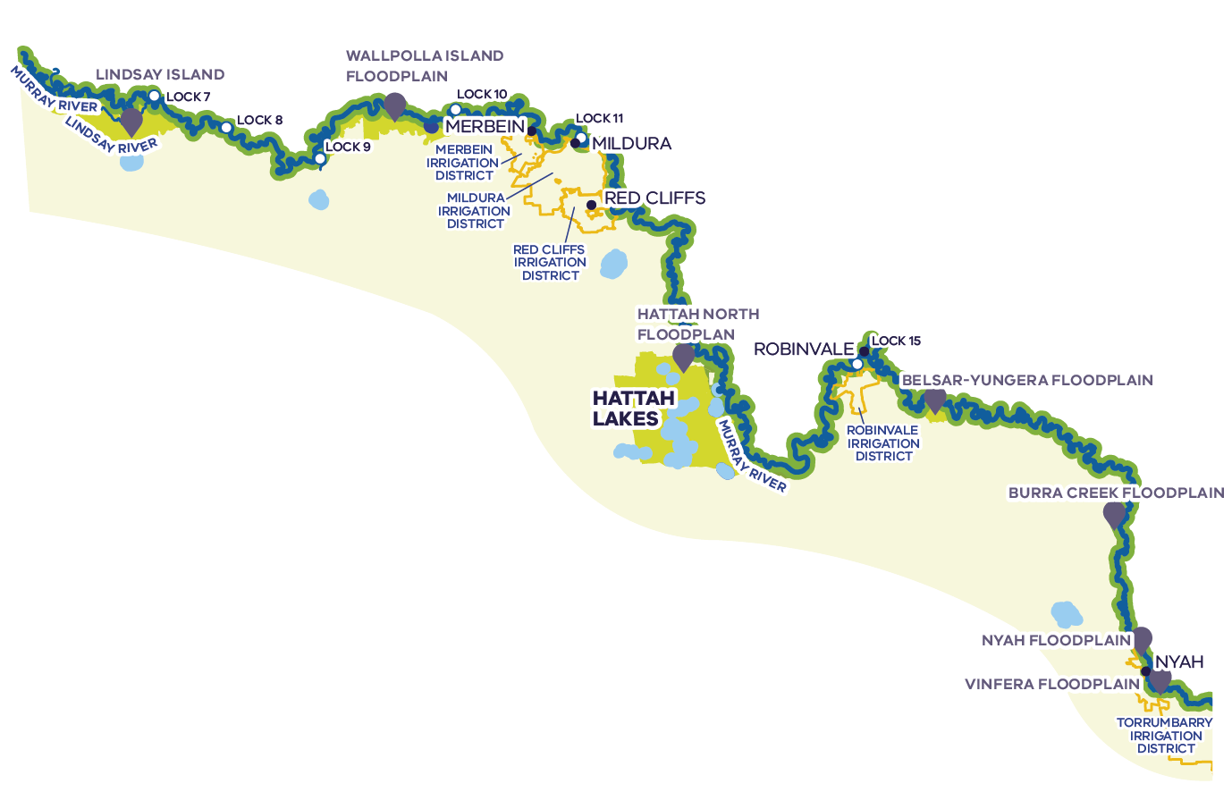
The Victorian Murray downstream of Nyah is characterised by iconic river red gums along watercourses and wetlands, with black box woodlands at higher elevations and a mosaic of widely distributed lignum and nitre-goosefoot shrublands, floodplain lakes, wetlands and grassy swamps. The river and its floodplain and wetlands also contain important cultural heritage sites.
Hume Dam – 3,005 GL
Dartmouth Dam – 3,856 GL
Hume Dam is jointly managed by GMW and NSW authorities on behalf of the MDBA, while Dartmouth Dam is managed by GMW on behalf of the MDBA.
Total system entitlements (GL)^{1,3}
- Private: 1,189
- Enviro: 777
- Urban: 69
Loss/Operations: 168
Private water shares – zone 7 (GL)⁴
- LRWS: 161
HRWS: 672
Annual private water use – downstream of Nyah (GL)⁵
- 404: Low
- 491: Average
572: High
Agricultural production
- The main irrigated land uses in the Victorian Murray downstream of Nyah are perennial and annual horticulture
- Grapes are the main crop in the Sunraysia irrigation districts, almond plantings dominate outside these areas
Irrigated agriculture in the lower Murray and Sunraysia contributes to approximately $1,860 million of gross annual total agricultural production value²

Environmental condition and objectives
Flow seasonality in the Murray downstream of Nyah is more natural than the mid-Murray, with flows peaking in spring/summer, however the river channel becomes much larger and floodplain inundation requires much higher flows. Floodplain vegetation has declined in condition and extent due to the reduction in flood frequency/duration caused by river regulation, as well as land clearing that has left only fragmented remnants of wetland and floodplain habitat.
Operational constraints currently limit the ability to deliver large river flows for sufficient durations to inundate floodplain wetlands to meet native vegetation and waterbird breeding requirements. Environmental watering aims to support native fish, birds and vegetation through a range of measures, including flow pulses to trigger spawning of native fish and using infrastructure to direct water onto the floodplain to target high value areas. This protects these areas during dry times and, when natural flooding occurs, enables the duration and extent to be maintained or increased to support large colonial waterbird breeding events.

Potential change scenarios
Water recovery range | Potential recovery method | Potential socio-economic outcomes | Potential environmental outcomes
Low  1-10 GL | - Voluntary, targeted water purchases in small local areas  - Investigate opportunities to recover additional water through efficiency upgrades to modernise remaining open channels in the region | - Any reduction in potential for irrigated production must be matched with sensible transition support  - Opportunity to improve level of service for any users that benefit from supply channel upgrades | - Change in irrigation supply to specific reaches, particularly in anabranches, may support more natural local flow regime and could be complemented by restoration of local waterways and floodplains
Medium  10-20 GL | - Voluntary, targeted water purchases in specific parts of irrigation districts or supply systems  - Investigate opportunities to recover additional water through efficiency upgrades, feasible alternative water supply options and rationalisation of irrigation infrastructure | - Any reduction in potential for irrigated production must be matched with sensible transition support  - Opportunities to rationalise infrastructure alongside any water purchases will be prioritised to reduce the long-term costs of infrastructure | - Potential for removal or reconfiguration of floodplain obstructions (e.g. private channels, roads) to promote floodplain connectivity and support more natural local flow regime
High  20+ GL | - Voluntary, targeted water purchases at a regional scale  - Investigate opportunities to recover additional water through changes to weir infrastructure and river operations | - Any reduction in potential for irrigated production would require regional transition support  - Significant opportunity for complementary savings to reduce scale of water purchase required to achieve the same outcome | - Opportunity to reconsider weir infrastructure and river operations practices to support ecological outcomes that depend on variable water levels, and restore a more natural flow regime to parts of the Murray River

These scenarios are outlined as a conversation starter with regional communities. Importantly we will partner with Traditional Owners on the opportunities to progress self-determination in water access and management through water recovery proposals. This will include consideration of how changes to water management can protect or enhance cultural values or contribute to Traditional Owner aspirations on their Country.

The Victorian Murray upstream of Nyah
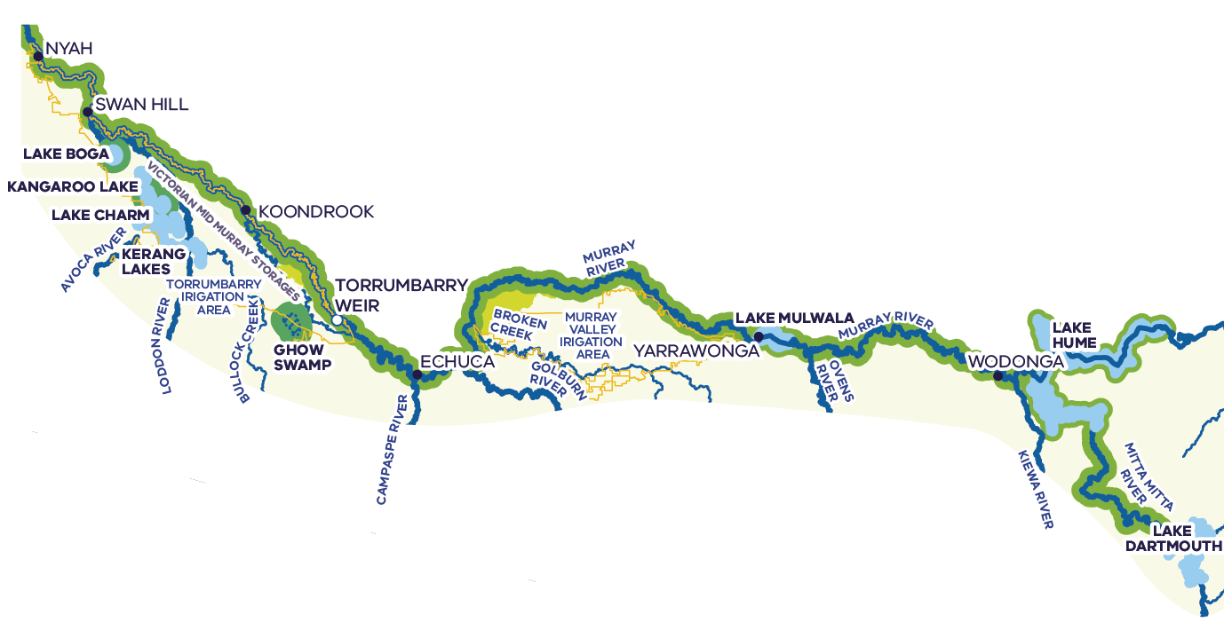
The Victorian Murray upstream of Nyah supports significant ecological values, including varied native vegetation communities, a range of fish, birds, frogs, turtles, platypus and macroinvertebrates, including many vulnerable and endangered species, as well as important ecosystem functions. The river and its floodplain and wetlands also contain important cultural heritage sites.
Private water shares – zones 6 and 7 (GL)⁴
- LRWS: 278
HRWS: 881
Annual private water use – upstream of Nyah (GL)⁵
- 206: Low
- 444: Average
614: High
Hume Dam – 3,005 GL
Dartmouth Dam – 3,856 GL
Hume Dam is jointly managed by GMW and NSW authorities on behalf of the MDBA, while Dartmouth Dam is managed by GMW on behalf of the MDBA.
Total system entitlements (GL)^{1,3}
- Private: 1,189
- Enviro: 777
- Urban: 69
Loss/Operations: 168
Agricultural production
- The main irrigated land uses in the Victorian Murray upstream of Nyah outside irrigation districts are cropping and livestock grazing (non-dairy)
- In the Torrumbarry and Murray Valley Irrigation Areas the main land uses are cropping and dairy
Irrigated agriculture in the Victorian Murray upstream of Nyah contributes to approximately $892 million of gross annual total agricultural production value²

Environmental condition and objectives
The Murray River begins high in the Australian Alps and then flows unregulated around 300 km to the Hume Dam. Downstream of Hume Dam, flows are highly regulated by multiple low-level weirs to supply water for irrigation. This has reversed flow seasonality, with higher flows in summer and autumn.
Operational constraints currently limit the ability to inundate floodplain wetlands to meet the needs of native vegetation and waterbird breeding. In the unregulated upper reaches, flow for the environment is managed by cease-to-pump rules on licence conditions and monitoring for changes in demand.
use to maintain minimum flows and water level in in-river pools to support native species and ecosystems during critical periods.
In the mid-Murray, environmental water management focuses on providing habitat, connectivity, spawning cues and dispersal for native fish species, enhancing in-channel and fringing native vegetation, floodplain forests and wetlands (e.g. Barmah-Millewa and Gunbower-Koondrook-Perricoota), and waterbird habitat and breeding. Ecosystem functions are also targeted including drought refuges, maintaining water quality, transporting nutrients and sediment.

Potential change scenarios
Water recovery range | Potential recovery method | Potential socio-economic outcomes | Potential environmental outcomes
Low  1-10 GL | - Voluntary, targeted water purchases in small local areas  - Investigate opportunities to recover additional water through rationalisation of irrigation infrastructure | - Any reduction in potential for irrigated production must be matched with sensible transition support  - Opportunities to rationalise infrastructure alongside any water purchases will be prioritised to reduce the long-term costs of infrastructure | - Change in irrigation supply to specific reaches or sections of the river system (e.g. Gunbower Creek or other anabranches) may support more natural local flow regime and/or complementary environmental works
Medium  10-20 GL | - Voluntary, targeted water purchases in specific parts of irrigation districts or supply systems  - Investigate opportunities to recover additional water through rationalisation of irrigation infrastructure and changes to system operations (e.g. providing greater flexibility in management of mid-Murray storages) | - Any reduction in potential for irrigated production must be matched with sensible transition support  - Opportunities to rationalise infrastructure alongside any water purchases will be prioritised to reduce the long-term costs of infrastructure | - Change in irrigation supply to specific reaches or sections of the river system (e.g. Gunbower Creek or other anabranches) may support more natural local flow regime and/or complementary environmental works
High  20+ GL | - Voluntary, targeted water purchases at a regional scale  - Investigate opportunities to recover additional water through rationalisation of irrigation infrastructure and changes to system operations (e.g. providing greater flexibility in management of mid-Murray storages) | - Any reduction in potential for irrigated production would require regional transition support  - Opportunities to rationalise infrastructure alongside any water purchases will be prioritised to reduce the long-term costs of infrastructure  - Significant opportunity to achieve complementary savings to reduce scale of water purchase required to achieve the same outcome | - Opportunity to reconsider system operations in local areas and how this supports multiple outcomes for the environment, including opportunities to restore natural flow regimes and deliver complementary measures

These scenarios are outlined as a conversation starter with regional communities. Importantly we will partner with Traditional Owners on the opportunities to progress self-determination in water access and management through water recovery proposals. This will include consideration of how changes to water management can protect or enhance cultural values or contribute to Traditional Owner aspirations on their Country.

The Loddon
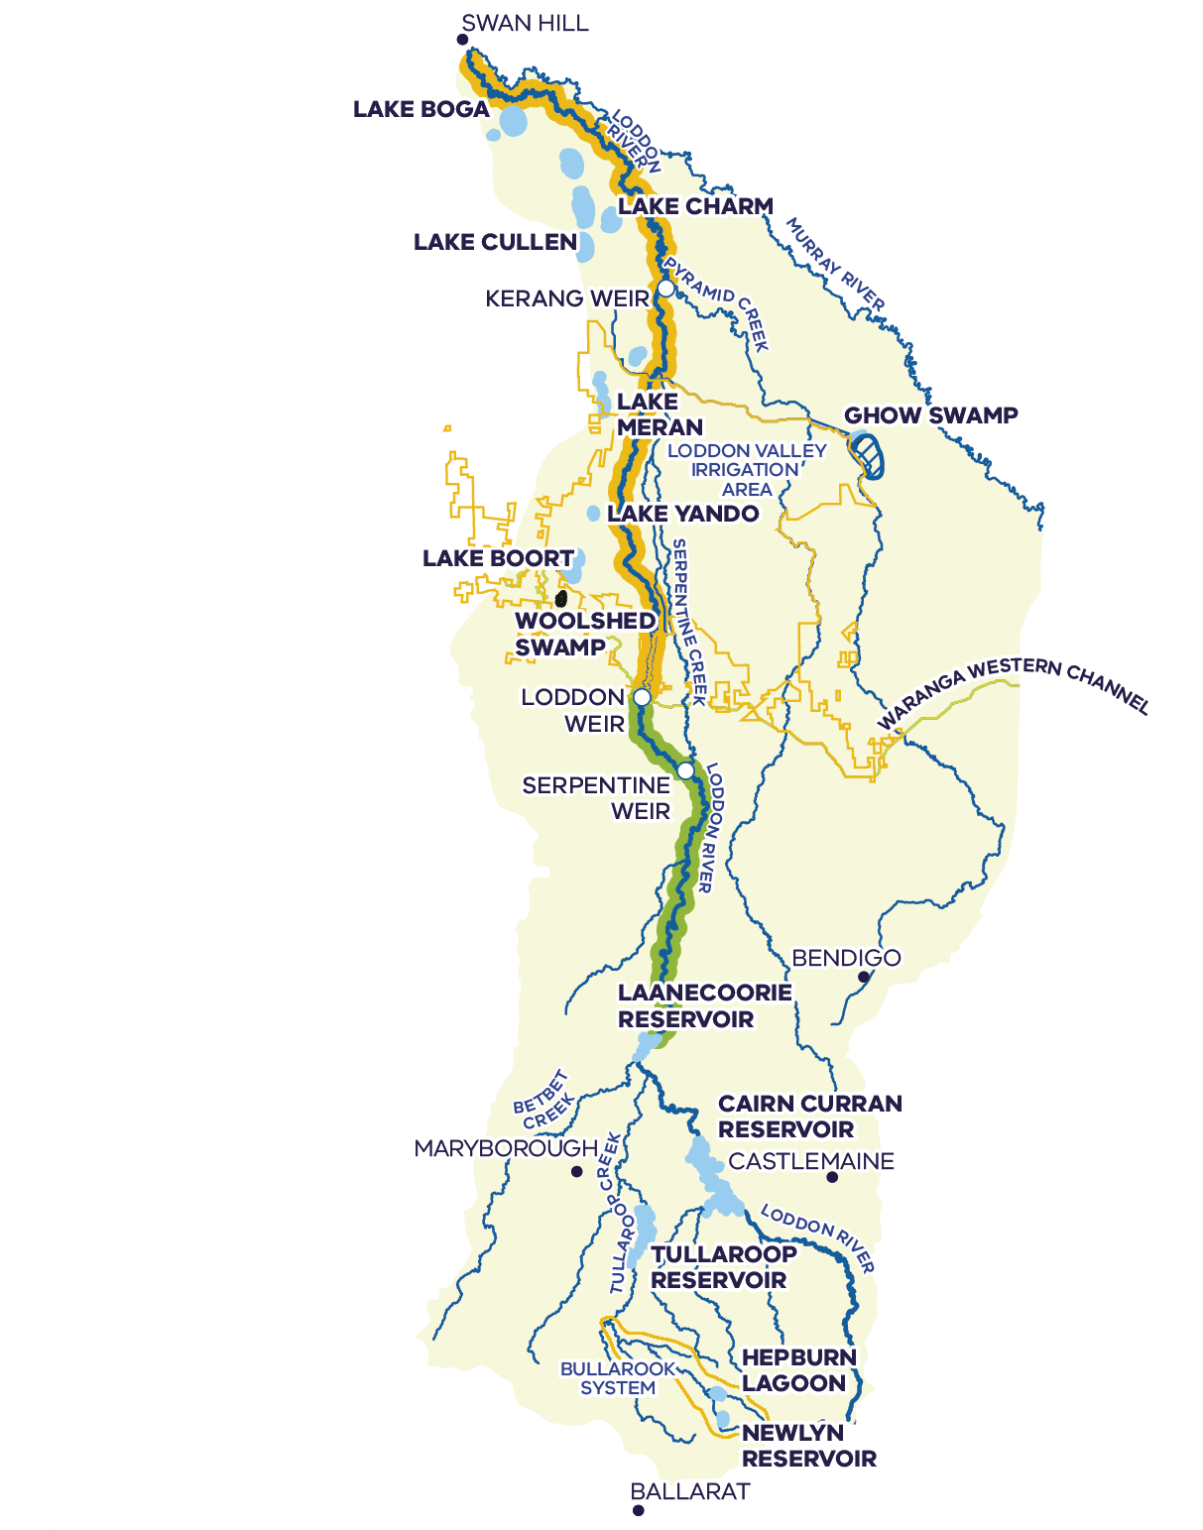
The Loddon River system supports platypus, rakali and several species of native fish, including Murray cod, golden perch, silver perch, river blackfish and Murray-Darling rainbowfish. It includes internationally recognised wetlands that provide a range of important habitats in an otherwise heavily modified environment. The river and its floodplain and wetlands also contain important cultural heritage sites.
Unregulated entitlements downstream of Loddon Weir: 8,534 ML
Annual water use (ML)⁵
- 935: Low
- 2,253: Average
3,395: High
Private water shares (ML)
- LRWS: 7,545
HRWS: 17,527
Annual private water use (ML)⁵
- 4,398: Low
- 6,743: Average
10,093: High
Annual private trade out (ML)⁶
- 3,783: Low
- 6,345: Average
7,382: High
Tullaroop Reservoir – 73 GL
Cairn Curran Reservoir – 147 GL
Laanecoorie Reservoir – 8 GL
Up to ~71 GL set aside at start of year to cover storage and river losses associated with running the river as a fully regulated system to deliver irrigation entitlements during summer and autumn of that year.
The Loddon system provides a supplement that supports allocations to Goulburn system entitlements in average and wet years. In recent years, the maximum amount available in any year has been ~61.1 GL.
Water from the Loddon system supplies Goulburn system entitlements in the Loddon Valley Irrigation Area.
Total system entitlements (GL)¹
- Private: 58
- Enviro: 17
- Urban: 7
Loss/Operations: 0
Bullarook system
Total system entitlements (ML)¹
- Private: 1,139
- Enviro: 100
- Urban: 500
Loss/Operations: 0
Private water shares (ML)
- LRWS: 381
HRWS: 758
Annual private water use (ML)⁵
- 284: Low
- 653: Average
909: High
Agricultural production
- The main irrigated land uses in the Loddon, including the Loddon Valley Irrigation Area, are cropping and livestock grazing (non-dairy)
Irrigated agriculture in the Loddon contributes to approximately $925 million of gross annual total agricultural value²

Environmental condition and objectives
Achieving environmental objectives in the Loddon system is limited by the availability of water for the environment, particularly in drought years, with the reaches downstream of the Loddon Weir most impacted. The lower reaches of the Loddon River are critical vegetation corridors in a landscape where only 13% of original vegetation remains. Environmental water is critical to maintain water quality, connect pools, provide habitat for re-establishing native fish populations, and improve the condition of streamside vegetation.
Although fish populations in the Loddon system are affected by the many barriers caused by weirs and reservoirs, a large range of species are still found through the catchment. Pyramid Creek and the lower Loddon River support large-bodied fish such as golden perch, Murray cod and silver perch, and are important corridors for fish migration between the Loddon and Murray systems.

Potential change scenarios
Water recovery range | Potential recovery method | Potential socio-economic outcomes | Potential environmental outcomes
Low  1-5 GL | - Voluntary, targeted water purchases in small local areas  - Investigate opportunities to recover additional water through rationalisation of irrigation infrastructure | - Any reduction in potential for irrigated production must be matched with sensible transition support  - Opportunities to rationalise infrastructure alongside any water purchases will be prioritised to reduce the long-term costs of infrastructure | - Deliver summer low flows and freshes in dry years to maintain water quality and drought refuges  - Deliver higher low flows during winter and spring to increase productivity and support fringing vegetation and platypus movement  - Enable wetland outcomes to be targeted, filling or topping up wetlands (e.g. to support turtle populations)
Medium  5-10 GL | - Voluntary, targeted water purchases in specific river reaches or parts of irrigation districts supplemented by the Loddon system  - Investigate opportunities to recover additional water through reduced system losses (e.g. through changes to operations at Laanecoorie Reservoir) | - Any reduction in potential for irrigated production must be matched with sensible transition support  - Opportunities to rationalise infrastructure alongside any water purchases will be prioritised to reduce the long-term costs of infrastructure | - More frequent freshes to improve fish, platypus and productivity outcomes  - Change in irrigation supply to specific reaches may support more natural local flow regime
High  10+ GL | - Voluntary, targeted water purchases in specific river reaches or parts of irrigation districts supplemented by the Loddon system  - Investigate opportunities to recover additional water through rationalisation of irrigation infrastructure, reduced system losses and review of operations and allocation of water resources | - Any reduction in potential for irrigated production would require regional transition support  - Opportunities to rationalise infrastructure alongside any water purchases will be prioritised to reduce the long-term costs of infrastructure  - Significant opportunity to achieve complementary savings to reduce scale of water purchase required to achieve the same outcome | - Opportunity to reconsider system operations and how this supports multiple outcomes for the environment, including opportunities to restore natural flow regimes and deliver complementary measures

These scenarios are outlined as a conversation starter with regional communities. Importantly we will partner with Traditional Owners on the opportunities to progress self-determination in water access and management through water recovery proposals. This will include consideration of how changes to water management can protect or enhance cultural values or contribute to Traditional Owner aspirations on their Country.

The Campaspe
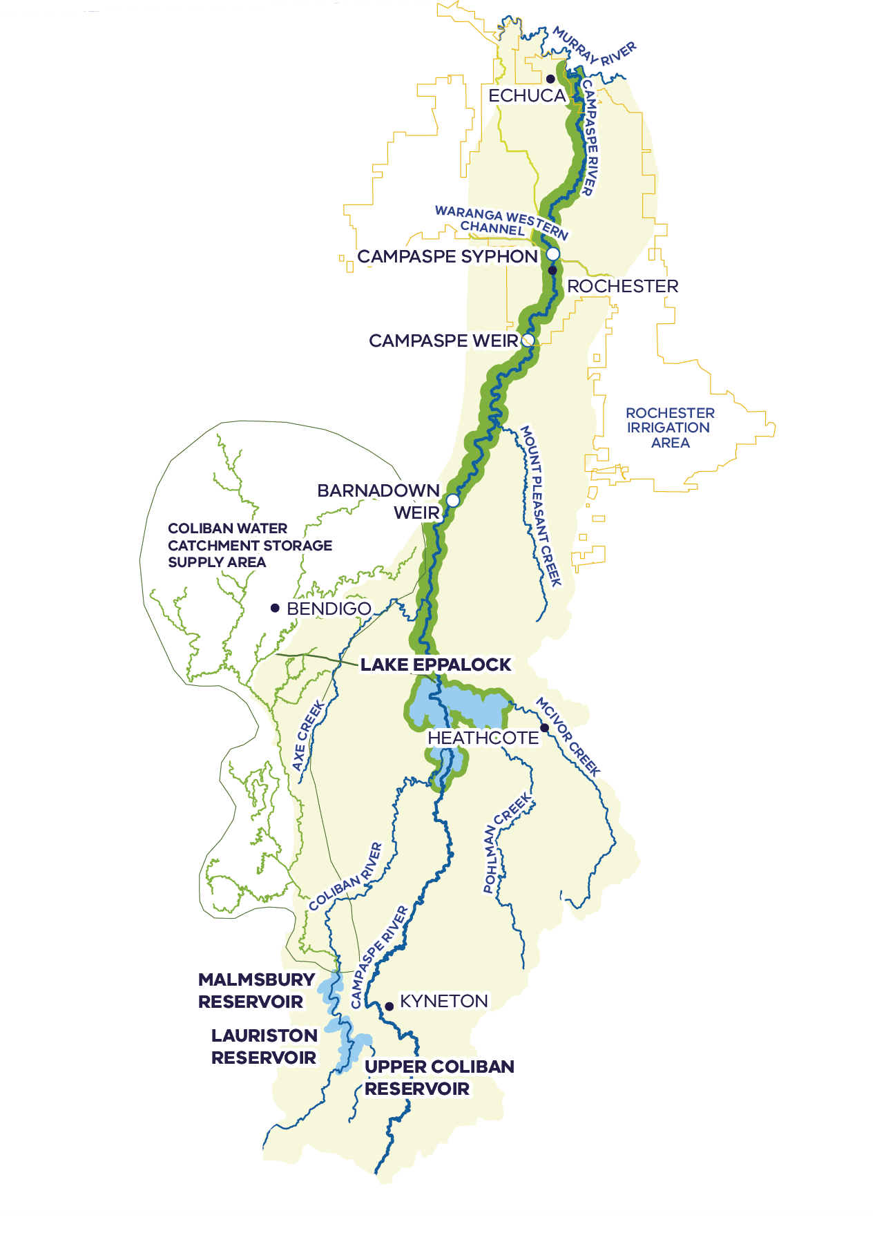
The Campaspe River provides important habitat for several native fish species, including Murray cod, silver perch, golden perch, Murray-Darling rainbowfish and flat-headed gudgeon. Platypus, rakali (water rats), turtles and frogs are also present along the length of the Campaspe River. The river and its floodplain and wetlands also contain important cultural heritage sites.
Private water shares (ML)
- LRWS: 6,691
HRWS: 14,179
Annual private water use (ML)⁵
- 4,011: Low
- 7,811: Average
10,094: High
Annual private trade out (ML)⁶
- -322: Low
- 4,274: Average
9,535: High
Lake Eppalock – 305 GL
Up to ~47 GL set aside at start of year to cover storage and river losses associated with running the river as a fully regulated system to deliver irrigation entitlements during summer and autumn of that year.
The Campaspe system provides a supplement that supports allocations to Goulburn system entitlements in wet years. In recent years, the maximum amount available in any year has been ~24.7 GL.
Coliban Water is entitled to 18% of the storage capacity and inflows to Lake Eppalock to support urban supply to Bendigo and surrounding towns.
Total system entitlements (GL)¹
- Private: 28
- Enviro: 36
- Urban: 66
Loss/Operations: 12
Agricultural production
- The main irrigated land uses in the Campaspe outside irrigation districts are cropping and livestock grazing (non-dairy)
- In the Rochester Irrigation Area cropping and dairy are the main land uses
In the Rochester Irrigation Area cropping and dairy are the main land uses²

Environmental condition and objectives
Achieving environmental objectives in the Campaspe system is limited by current operational constraints. The Campaspe River and its main tributary the Coliban River are highly regulated and natural flows have been heavily disrupted. Around 40% of entitlement in the Campaspe system is held by environmental water holders. With current infrastructure – in particular the 1,600 ML/day outlet capacity at Lake Eppalock – it is a significant challenge to deliver environmental water in the volumes and timing required to achieve ecological objectives.
With a larger outlet and potential for greater environmental water deliveries, restoration of more of the natural flow regime could help native fish migrate and disperse throughout the Campaspe system, better support platypus, bank vegetation and condition as well as reducing blackwater risks.

Potential change scenarios
Water recovery range | Potential recovery method | Potential socio-economic outcomes | Potential environmental outcomes
Low  1-5 GL | - Voluntary, targeted water purchases in small local areas  - Investigate opportunities to recover additional water through reduced local delivery losses | - Any reduction in potential for irrigated production must be matched with sensible transition support | - Investigation of any local opportunities to restore fish passage associated with system changes  - Change in irrigation supply to specific reaches may support more natural local flow regime
Medium  5-10 GL | - Voluntary, targeted water purchases in specific river reaches or parts of irrigation districts supplemented by the Campaspe system  - Investigate opportunities to recover additional water through rationalisation of irrigation infrastructure (e.g. opportunities through the Coliban Regional Rural Modernisation Project) | - Any reduction in potential for irrigated production must be matched with sensible transition support  - Investigate opportunities to provide additional flood mitigation benefits through greater storage operations flexibility (e.g. larger outlet at Lake Eppalock) | - Coordinate potential restoration of fish passage with a more natural flow regime  - Opportunity to reconsider system operations and how this supports multiple outcomes for the environment, including opportunities to restore natural flow regimes and deliver complementary measures
High  10+ GL | - Voluntary, targeted water purchases at a regional scale  - Investigate opportunities to recover additional water through rationalisation of irrigation infrastructure, reduced system losses and review of operations and allocation of water resources | - Any reduction in potential for irrigated production would require regional transition support  - Investigate opportunities to provide additional flood mitigation benefits through greater storage operations flexibility (e.g. larger outlet at Lake Eppalock)  - Significant opportunity for complementary savings to reduce scale of water purchase required to achieve the same outcome | - Significant opportunity to reconsider system operations and how this supports multiple outcomes for the environment, including opportunities to restore natural flow regimes and deliver complementary measures

These scenarios are outlined as a conversation starter with regional communities. Importantly we will partner with Traditional Owners on the opportunities to progress self-determination in water access and management through water recovery proposals. This will include consideration of how changes to water management can protect or enhance cultural values or contribute to Traditional Owner aspirations on their Country.

The Goulburn
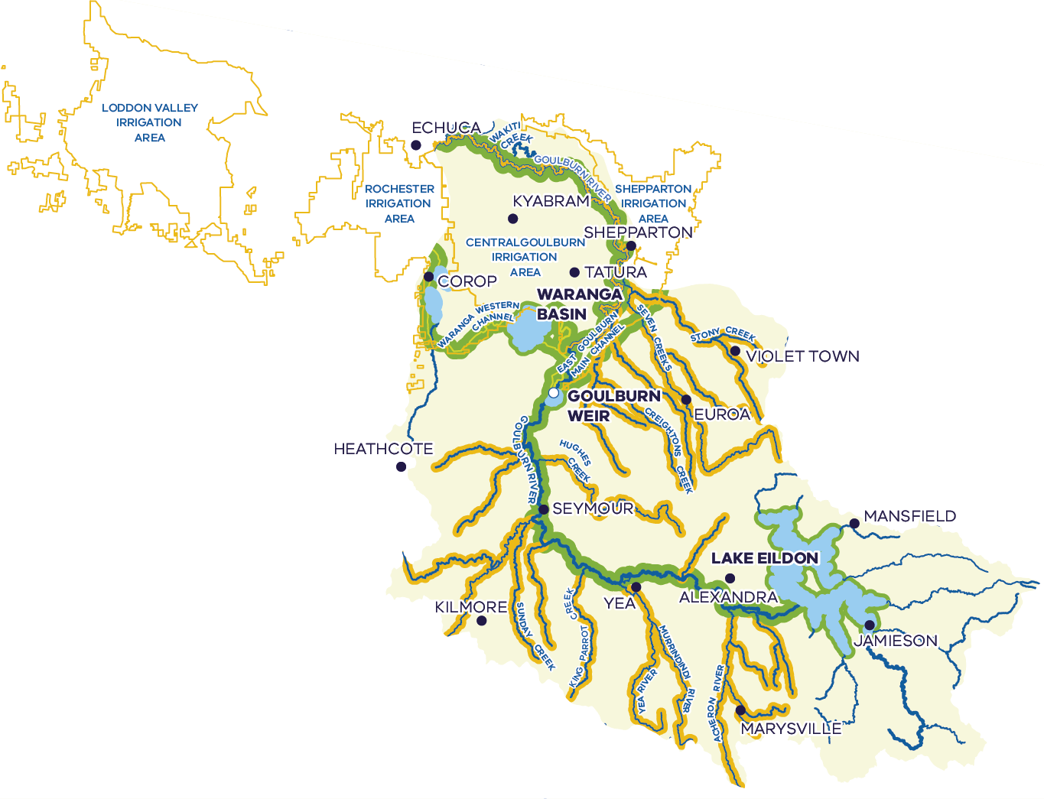
The Goulburn River is identified as a priority waterway in the Goulburn Broken Waterway Strategy. It supports a variety of threatened species including the iconic Murray cod, the endemic barred galaxias, one of only two self-sustaining populations of trout cod in Australia and the critically endangered alpine tree frog. The river and its floodplain and wetlands also contain important cultural heritage sites.
Lake Eildon – 3,334 GL
Waranga Basin – 432 GL
Goulburn Weir – 26 GL
The Goulburn system supplies regulated Goulburn River entitlements and four irrigation areas of the Goulburn-Murray Irrigation District, including the Loddon Valley and Rochester Irrigation Areas to the west which are supplemented by the Loddon and Campaspe Rivers, respectively.
Regulated entitlements are supplied from water harvested in Lake Eildon and tributary flows regulated at Goulburn Weir. On average, tributary inflows downstream of Lake Eildon can supply ~50% of water used in the Goulburn system each year.
In addition to meeting regulated Goulburn system entitlements, the Goulburn system also supplies ~95 GL/year to the Murray system that underpins legacy entitlement trade between the systems, up to 40 GL/year to support entitlements and losses in the Lower Broken Creek, and a 30 GL water quality reserve for the Goulburn and Lower Broken Creek.
Total system entitlements (GL)¹
- Private: 1,205
- Enviro: 660
- Urban: 114
Loss/Operations: 387
Private water shares (GL)
- LRWS: 422
HRWS: 745
Annual private water use (GL)⁵
- 348: Low
- 645: Average
875: High
Unregulated tributary entitlements
Between Lake Eildon and Goulburn Weir: 9,180 ML
Annual water use (ML)⁵
- 2,385: Low
- 2,598: Average
2,824: High
Downstream of Goulburn Weir: 3655 ML
Annual water use (ML)⁵
- 671: Low
- 927: Average
1,106: High
Agricultural production
- The main irrigated land uses in the Goulburn outside irrigation districts are cropping and livestock grazing (non-dairy)
- In the Central Goulburn Irrigation Area dairy and cropping are the main land uses
Irrigated agriculture in the Goulburn contributes to approximately $1.2 billion of gross annual total agricultural production value²

Environmental condition and objectives
The Goulburn catchment is Victoria’s largest river basin, covering 7.1% of the state. The Goulburn River has several significant tributaries, including the Acheron, Yea and Broken rivers. The natural flow pattern of both the Goulburn River and local waterways and wetlands within the wider catchment have been significantly altered due to river regulation, land use changes, small dams and drainage schemes. Flows in the upper Goulburn River are now typically low in winter/spring and high in summer/autumn, which is the reverse of the natural seasonal flow pattern. New trade and operating rules for the lower Goulburn River aim to prevent unacceptable impacts to the environment due to unseasonal high flows in summer and autumn.
Achieving environmental objectives in the Goulburn system is limited by current operational constraints, which mean that flows to restore the natural flow pattern and connect the river and its floodplains during winter/spring cannot be delivered from storages. However, opportunities to restore and protect unregulated tributary flows through the Goulburn system could help promote more natural flow patterns in the Goulburn River as well as providing benefits to the Murray River further downstream.

Potential change scenarios
Water recovery range | Potential recovery method | Potential socio-economic outcomes | Potential environmental outcomes
Low  1-10 GL | - Voluntary, targeted water purchases in small local areas  - Investigate opportunities to recover additional water through rationalisation of irrigation infrastructure and reduced local delivery losses (e.g. in small supply systems) | - Any reduction in potential for irrigated production must be matched with sensible transition support  - Opportunities to rationalise infrastructure alongside any water purchases will be prioritised to reduce the long-term costs of infrastructure | - Change in irrigation supply to specific reaches may support more natural local flow regime
Medium  10-20 GL | - Voluntary, targeted water purchases in specific river reaches or parts of irrigation districts  - Investigate opportunities to recover additional water through rationalisation of irrigation infrastructure and reduced local delivery losses (e.g. in small supply systems) | - Any reduction in potential for irrigated production must be matched with sensible transition support  - Opportunities to rationalise infrastructure alongside any water purchases will be prioritised to reduce the long-term costs of infrastructure | - Change in irrigation supply to specific reaches may support more natural local flow regime  - Investigate opportunities to help mitigate challenges delivering environmental water through targeted purchases focused on specific areas to restore more natural local flow regimes
High  20+ GL | - Voluntary, targeted water purchases at a regional scale  - Investigate opportunities to recover additional water through fundamental changes to system operations | - Any reduction in potential for irrigated production would require regional transition support  - Opportunities to rationalise infrastructure alongside any water purchases will be prioritised to reduce the long-term costs of infrastructure  - Investigate links between water recovery in the Goulburn and supporting system reform in priority areas like the Loddon and Campaspe where local water resources currently supplement Goulburn entitlements  - Significant opportunity for complementary savings to reduce scale of water purchase required to achieve the same outcome | - Opportunity to support environmental outcomes across multiple systems through reconsidering supplements from the Loddon and Campaspe systems  - Opportunity to reconsider system operations and how this supports multiple outcomes for the environment, including opportunities to restore natural flow regimes and deliver complementary measures

These scenarios are outlined as a conversation starter with regional communities. Importantly we will partner with Traditional Owners on the opportunities to progress self-determination in water access and management through water recovery proposals. This will include consideration of how changes to water management can protect or enhance cultural values or contribute to Traditional Owner aspirations on their Country.

The Broken
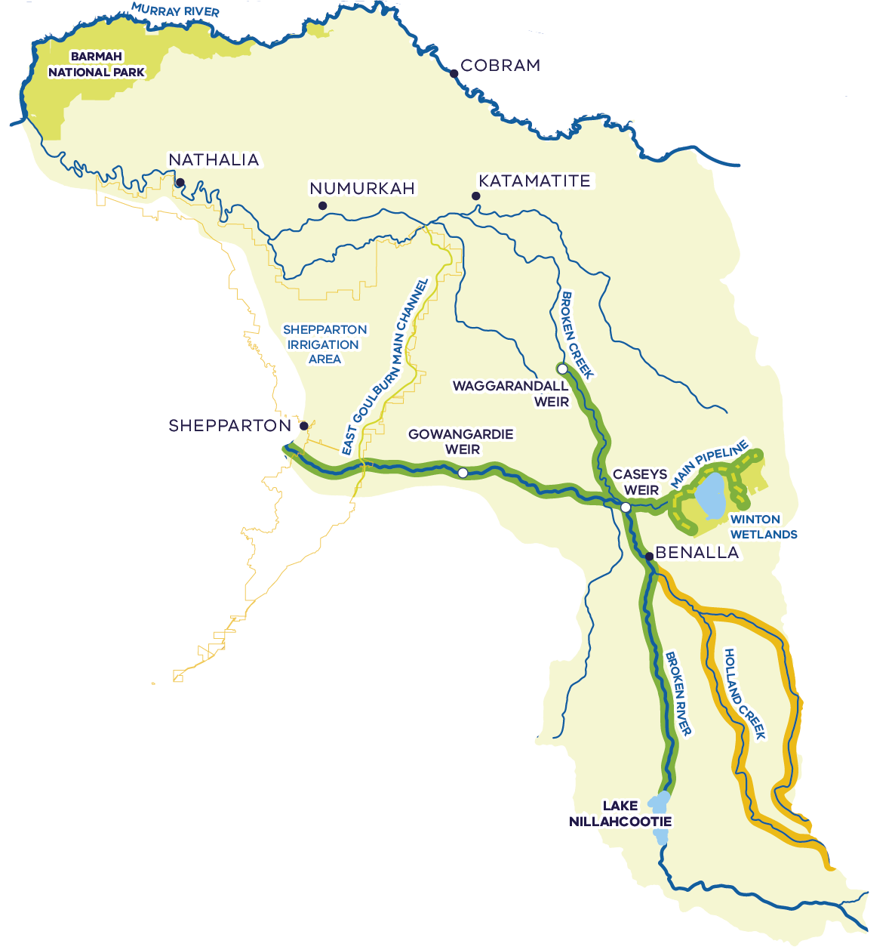
The Broken River is identified as priority waterway in the Goulburn Broken Waterway Strategy. It retains one of the best examples of healthy in-stream vegetation in a lowland river in the region. These waterways support a diverse and abundant native fish community and are thought to support a large platypus population. The river and its floodplain and wetlands also contain important cultural heritage sites.
Private water shares (ML)
- LRWS: 3,277
HRWS: 16,151
Annual private water use (ML)⁵
- 1,440: Low
- 3,733: Average
5,883: High
Annual private trade out (ML)⁶
- -10: Low
- 3,707: Average
6,618: High
Lake Nillahcootie – 40 GL
Up to ~28 GL set aside at start of year to cover storage and river losses associated with running the river as a fully regulated system to deliver irrigation entitlements during summer and autumn of that year.
Total system entitlements (ML)¹
- Private: 2,956
- Enviro: 647
- Urban: 3,360
Loss/Operations: 1,850
Unregulated entitlements – Holland and Ryans Creeks: 1,553 ML
Annual water use (ML)⁵
- 543: Low
- 690: Average
861: High
Agricultural production
- The main irrigated land uses in the Broken are livestock grazing (non-dairy) and cropping
Irrigated agriculture in the Broken contributes to approximately $366 million of gross annual total agricultural production value²

Environmental condition and objectives
Achieving environmental objectives in the Broken system is limited by the availability of water for the environment. Environmental water management focuses on providing and maintaining habitat and water quality for native fish, macroinvertebrates and aquatic vegetation, and for platypus in the Upper Broken Creek. A significant component of the natural winter/spring flow regime in the lower Broken River was restored when Lake Mokoan was decommissioned, which has supported improved seasonal flows downstream in the lower Goulburn and Murray Rivers.
The small volume of environmental water currently held in the Broken system itself is used to maintain low flow recommendations at critical times of the year and opportunistically deliver small freshes. Meeting these recommendations currently requires the VEWH to trade water into the Broken system and at times watering actions have not been delivered due to the limited volume of environmental water available.

Potential change scenarios
Water recovery range | Potential recovery method | Potential socio-economic outcomes | Potential environmental outcomes
Low  1-5 GL | - Voluntary, targeted water purchases in local river reaches  - Investigate opportunities to recover additional water through reduced local delivery losses | - Any reduction in potential for irrigated production must be matched with sensible transition support | - Ability to meet low flow requirements, year-round and in all years  - Investigation of any local opportunities to restore fish passage associated with system changes  - Change in irrigation supply to specific reaches may support more natural local flow regime
Medium  5-10 GL | - Voluntary, targeted water purchases in local river reaches  - Investigate opportunities to recover additional water through reduced local delivery losses | - Any reduction in potential for irrigated production must be matched with sensible transition support | - Deliver summer and autumn freshes to different parts of the river system to improve river health  - Coordinate potential restoration of fish passage with a more natural flow regime
High  10+ GL | - Voluntary, targeted water purchases at a regional scale  - Investigate opportunities to recover additional water through fundamental changes to system operations | - Any reduction in potential for irrigated production would require regional transition support  - Investigate opportunities to transition irrigation supply to neighbouring channel systems  - Significant opportunity for complementary savings to reduce scale of water purchase required to achieve the same outcome | - Opportunity to reconsider system operations and how this supports multiple outcomes for the environment, including opportunities to restore natural flow regimes and deliver complementary measures

These scenarios are outlined as a conversation starter with regional communities. Importantly we will partner with Traditional Owners on the opportunities to progress self-determination in water access and management through water recovery proposals. This will include consideration of how changes to water management can protect or enhance cultural values or contribute to Traditional Owner aspirations on their Country.

The Lower Broken Creek
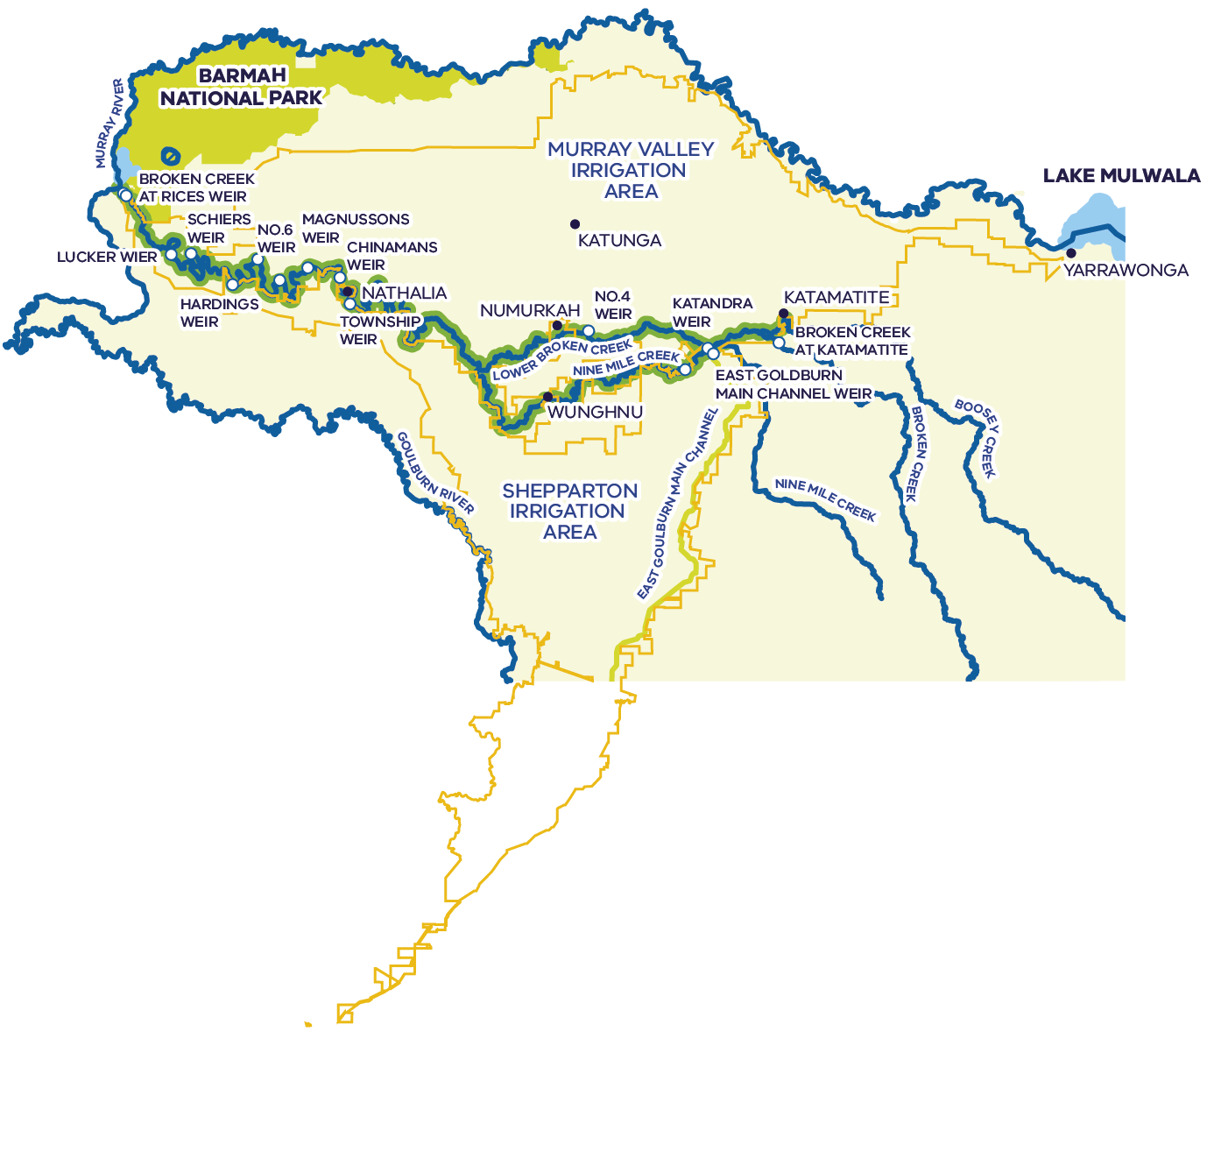
The Lower Broken Creek is identified in the Goulburn Broken Regional Waterway Strategy as a priority waterway, and recognised locally and regionally for Victorian native flora and fauna dependent on the aquatic ecosystem. The creek and its floodplain and wetlands also contain important cultural heritage sites.
Many private water users that divert water from the Lower Broken and Nine Mile Creeks can also be supplied from channels in the Murray Valley or Shepparton Irrigation Areas.
Water to support entitlements in the Lower Broken Creek is largely supplied from the Goulburn system via the East Goulburn Main Channel. The volume supplied has declined in recent years, with an average of ~15.8 GL supplied in each of the past five years to support private entitlements – a 40% drop compared to the preceding five years.
The Murray system supplements supplies when seasonal determinations in the Murray system are higher than in the Goulburn.
Total system entitlements (ML)¹
- Private: 32,057
- Enviro: 7,458
- Urban: 2,013
Loss/Operations: 0
Private water shares (ML)
- LRWS: 11,735
HRWS: 20,345
Annual private water use (ML)⁵
- 5,999: Low
- 12,853: Average
18,176: High
Annual private trade out (ML)⁶
- 696: Low
- 4,456: Average
6,974: High
Agricultural production
- The main irrigated land uses in the Lower Broken Creek, Murray Valley and Shepparton Irrigation Areas are cropping, dairy and livestock grazing (non-dairy)
Irrigated agriculture in the Lower Broken Creek contributes to approximately $641 million of gross annual total agricultural production value²

Environmental condition and objectives
The Lower Broken Creek and anabranches are highly modified natural waterways with irrigation development for more than 100 years. Prolonged static water level provided by weirs is the primary driver of erosion and bank degradation. The natural flow regime has been seasonally reversed, with dominant high flows in summer and autumn to supply water for irrigation. Despite this, the creek and associated wetlands provide important habitat for large and small native fish such as the nationally vulnerable Murray cod, particularly in dry years.
Environmental water management focuses on supporting habitat for fish, platypus, rakali and turtles, particularly in non-irrigation season when flow can stop, providing flows to trigger fish reproduction and movement and support fish passage, encourage germination and growth of native plants, promote in-stream productivity, control water quality and flush the water fern azolla as necessary.

Potential change scenarios
Water recovery range | Potential recovery method | Potential socio-economic outcomes | Potential environmental outcomes
Low  1-5 GL | - Voluntary, targeted water purchases in small local areas  - Investigate whether further environmental benefits could be recognised in reduced local delivery losses | - Any reduction in potential for irrigated production must be matched with sensible transition support  - Opportunities to rationalise infrastructure alongside any water purchases will be prioritised to reduce the long-term costs of infrastructure | - Change in irrigation supply to specific reaches may support more natural local flow regime  - Investigation of any local opportunities to restore fish passage associated with system changes
Medium  5-10 GL | - Voluntary, targeted water purchases in specific creek reaches  - Investigate opportunities for recover water through targeted removal of weirs not required for town supply | - Any reduction in potential for irrigated production must be matched with sensible transition support  - Opportunities to rationalise infrastructure alongside any water purchases will be prioritised to reduce the long-term costs of infrastructure | - Coordinate potential restoration of fish passage with a more natural flow regime  - Increased opportunity to reverse negative environmental impacts of prolonged static water levels (e.g. erosion, poor water quality)
High  10+ GL | - Voluntary, targeted water purchases at a regional scale  - Investigate opportunities to recover additional water through fundamental changes to system operations | - Any reduction in potential for irrigated production would require regional transition support  - Investigate opportunities to transition irrigation supply to neighbouring channel systems  - Significant opportunity for complementary savings to reduce scale of water purchase required to achieve the same outcome | - Opportunity to fundamentally change system operations to enable restoration of natural flow regime and promote multiple positive environmental outcomes

These scenarios are outlined as a conversation starter with regional communities. Importantly we will partner with Traditional Owners on the opportunities to progress self-determination in water access and management through water recovery proposals. This will include consideration of how changes to water management can protect or enhance cultural values or contribute to Traditional Owner aspirations on their Country.

The rivers of north east Victoria
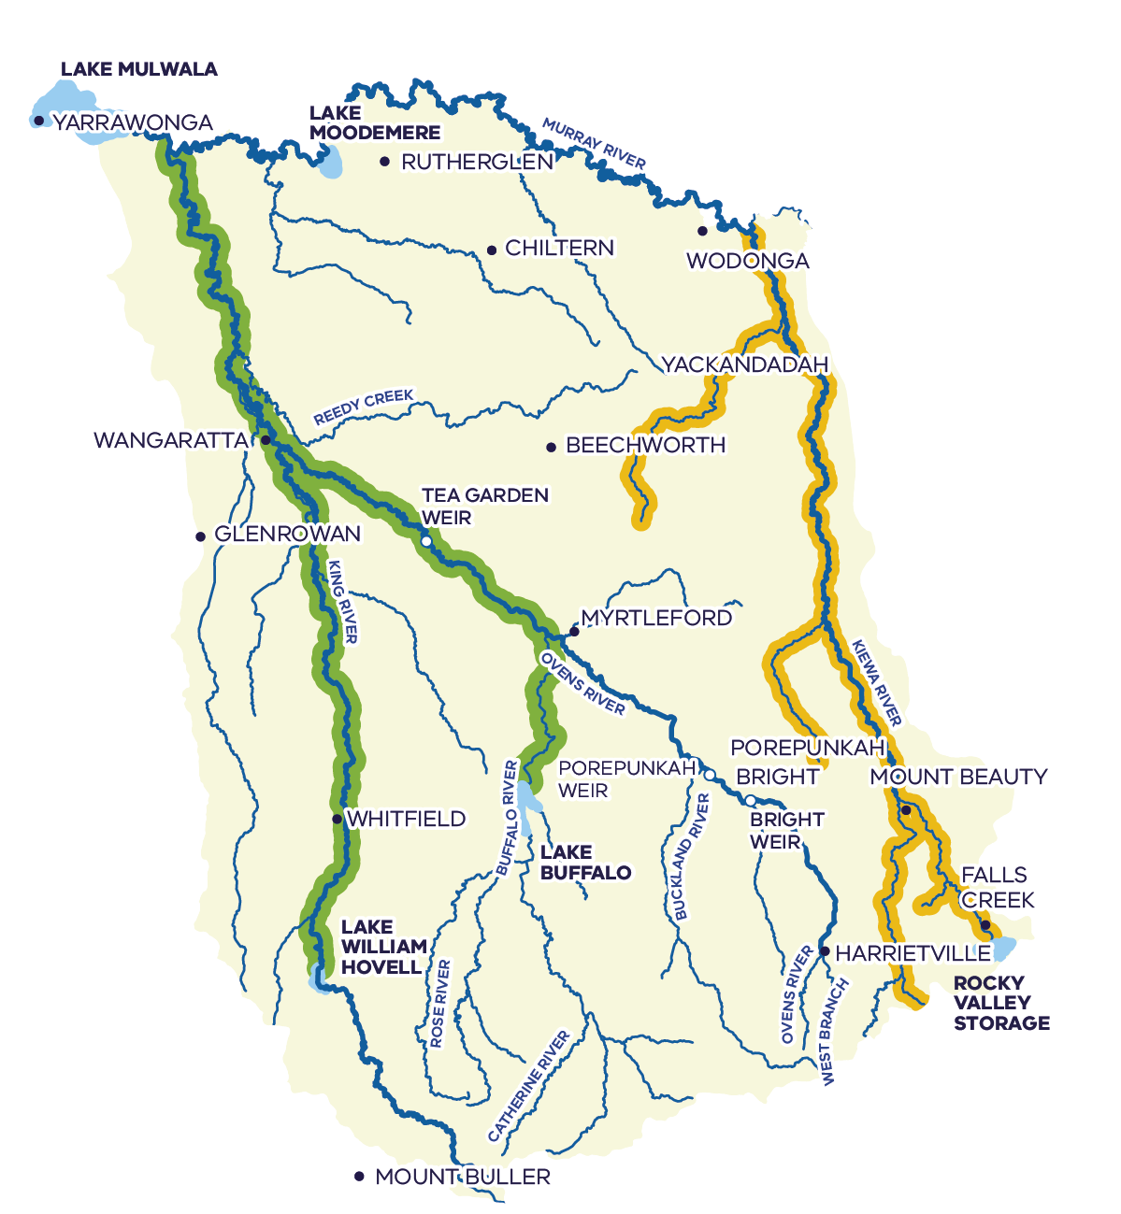
The rivers of north east Victoria are particularly valuable to the ecology of the Murray River given their limited regulation, which provide natural inflows into the Murray River. The Ovens River is the only lowland river listed under the Victorian Heritage Rivers Act for its unique environmental values, while the Kiewa River supports a variety of native and bird species, including the threatened azure kingfisher. The rivers and their floodplain and wetlands also contain important cultural heritage sites.
Private water shares (ML)
- LRWS: 12,495
HRWS: 25,978
Annual private water use (ML)⁵
- 5,832: Low
- 7,663: Average
11,115: High
Lake Buffalo – 24 GL
Lake William Hovell – 14 GL
The small storages of the Ovens-King system spill regularly, making a large contribution to flows in the Murray relative to the size of the basin.
Ovens-King system entitlements (ML)¹
- Private: 70,912
- Enviro: 123
- Urban: 2,912
Loss/Operations: 0
Kiewa system entitlements (ML)¹
- Private: 18,162
- Enviro: 0
- Urban: 2,206
Loss/Operations: 0
Annual private water use (ML)⁵
- 3,196: Low
- 4,442: Average
5,195: High
Agricultural production
- The main irrigated land uses in the Ovens-King are livestock grazing (non-dairy) and perennial horticulture (mostly wine grapes along the King River)
- The main irrigated land uses in the Kiewa are dairy (agistment and fodder) and cropping
Irrigated agriculture in the Ovens-King and Kiewa contributes to approximately $374 million of gross annual total agricultural production value²

Environmental condition and objectives
The Ovens-King system is semi-regulated and has regular spills (most years) from the King and Buffalo River storages, so the rivers and floodplains receive more of a natural flow regime compared to other northern Victorian catchments. The small volume of held environmental water can be used to maintain habitat and water quality for native fish and aquatic vegetation for short periods in dry times.
The Kiewa River retains a largely natural flow regime as consumptive use is relatively low – almost all basin inflows reach the Murray River. The largest diversions are associated with the Kiewa Hydroelectric Scheme, which enables water to be harvested from various locations and funnelled through three hydropower stations, before being returned to the river. Historically, this has increased the size of some flow events in summer. However, hydroelectricity production in summer is becoming less profitable due to the growth in rooftop solar and release patterns are changing, which will change the impact on flows. There is no held environmental water in the Kiewa basin, and flow is managed with passing flow conditions on bulk entitlements and licensed diversions and by 17 local management plans that have restriction triggers or flow sharing arrangements.

Potential change scenarios
Water recovery range | Potential recovery method | Potential socio-economic outcomes | Potential environmental outcomes
Low  1-5 GL | - Voluntary, targeted water purchases in local river reaches | - Any reduction in potential for irrigated production must be matched with sensible transition support | - Enable summer and autumn baseflows to be maintained and freshes to be delivered in the Ovens River during dry periods  - Contribute to meeting downstream environmental objectives in the Murray River
Medium  5-10 GL | - Voluntary, targeted water purchases in local river reaches | - Any reduction in potential for irrigated production must be matched with sensible transition support | - Enable summer and autumn baseflows to be maintained in the Ovens and King Rivers, and freshes to be delivered in the Ovens River during dry periods  - Contribute to meeting downstream environmental objectives in the Murray River
High  10+ GL | - Voluntary, targeted water purchases in local river reaches | - Any reduction in potential for irrigated production would require regional transition support | - Enable summer and autumn baseflows to be maintained and freshes to be delivered in both the Ovens and King Rivers, during dry periods  - Contribute to meeting downstream environmental objectives in the Murray River

These scenarios are outlined as a conversation starter with regional communities. Importantly we will partner with Traditional Owners on the opportunities to progress self-determination in water access and management through water recovery proposals. This will include consideration of how changes to water management can protect or enhance cultural values or contribute to Traditional Owner aspirations on their Country.

The Wimmera-Mallee
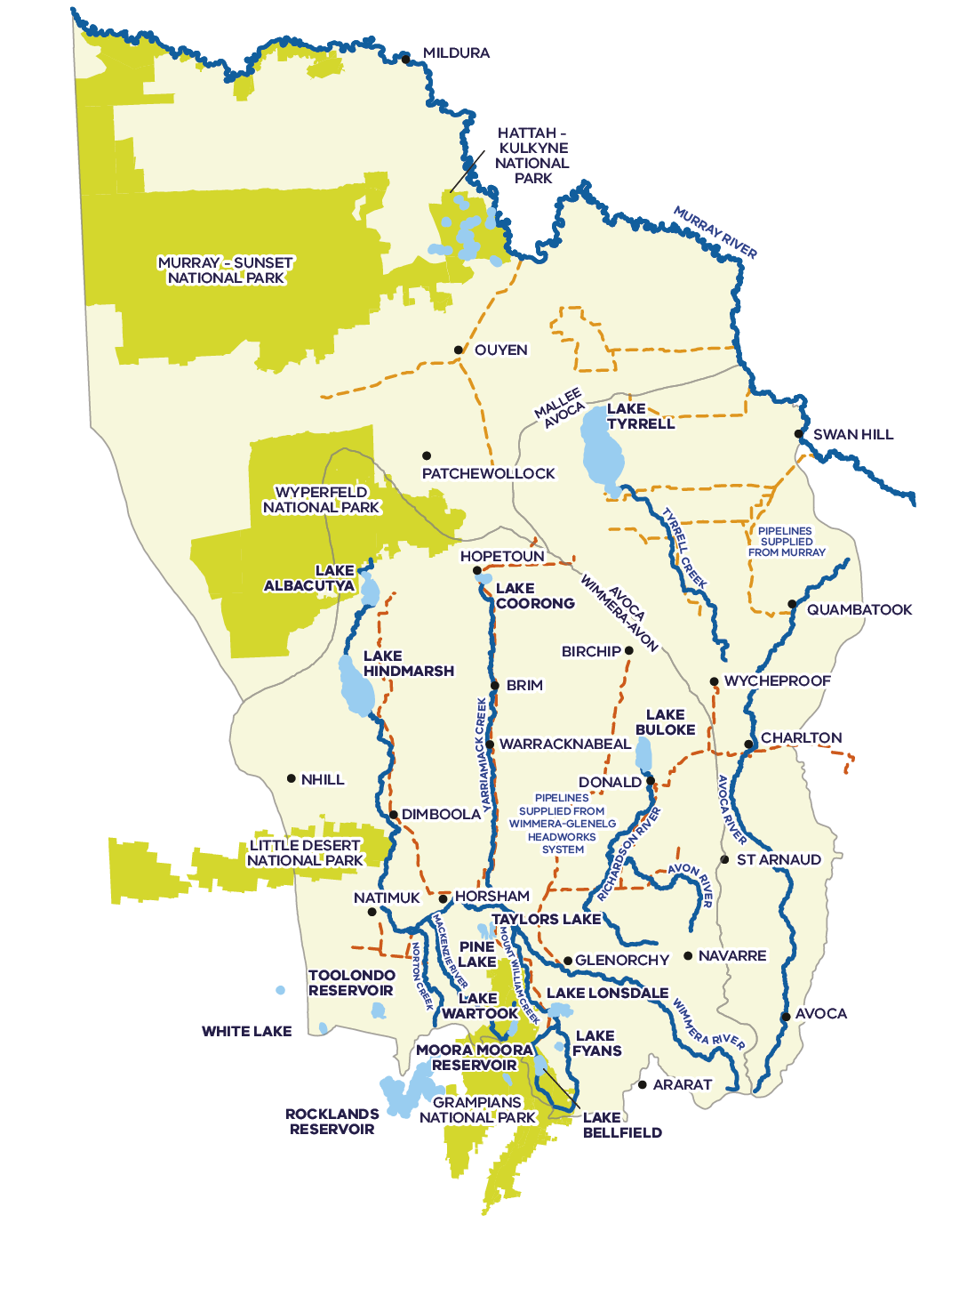
The Wimmera-Mallee has several priority waterways identified in the Wimmera and North Central Waterway Strategies, including the Wimmera and Avoca Rivers, and the Ramsar-listed Lake Albacutya. There are also over 50 highly diverse wetlands, supplied with water from pipelines. Wimmera-Mallee waterways support large populations of waterbirds, unique populations of river red gums, many significant native fish populations (including one of Victoria’s few self-sustaining populations of freshwater catfish), platypus, turtles and frogs. The waterways of the Wimmera-Mallee also contain important cultural heritage sites.
Rocklands Reservoir – 348 GL
Lake Toolondo – 92 GL
Lake Bellfield – 79 GL
Lake Lonsdale – 66 GL
Lake Wartook – 29 GL
Taylors Lake – 27 GL
Lake Fyans – 19 GL
Moora Moora Reservoir – 6 GL
Water to support entitlements in the Wimmera-Mallee is primarily supplied from the Wimmera-Glenelg headworks system. Multiple smaller systems provide additional surface and groundwater for urban, industrial, domestic and stock use, and limited irrigation from groundwater.
Water from the Murray system supplies the Northern Mallee pipeline and part of the Wimmera-Mallee pipeline, while the Goulburn system supplies a small volume of water for domestic and stock use in the east of the region.
Entitlements include ~45 GL pipeline product held by Grampians Wimmera Mallee Water for urban, industrial, domestic and stock use, plus ~3 GL to deliver water to prioritised recreational lakes.
Wimmera system entitlements (ML)¹
- Private: 9,513
- Enviro: 69,560
- Urban: 50,756
Loss/Operations: 6,260
Annual urban, industrial, domestic and stock use supplied from the Wimmera-Glenelg headworks pipeline system (ML)⁵
- 11,858: Low
- 14,324: Average
16,370: High
Avoca system entitlements (ML)¹
- Private: 7,459
- Enviro: 0
- Urban: 278
Loss/Operations: 6,260
Annual private water use (ML)⁵
- 31: Low
- 65: Average
206: High
Agricultural production
- The main agricultural land uses in the Wimmera-Mallee are cropping and dryland grazing
- A small amount of irrigation from groundwater occurs in the Wimmera-Mallee, with annual and perennial horticulture, and hay production the main irrigated land uses
Water use by agriculture in the Wimmera-Avon and Avoca basins – predominantly for livestock – contributes to approximately $2,350 million of gross annual total agricultural production value

Environmental condition and objectives
Within the Murray-Darling Basin, the main rivers of the Wimmera-Mallee flow into terminal lakes before reaching the Murray River. They are characterised by extreme fluctuations in flow from season to season and year to year. Over summer and autumn waterways typically don’t flow for long periods of time, if at all. There are limited opportunities to deliver additional water for the environment for rivers in the Wimmera-Mallee, in part due to limited infrastructure and watercourse capacity.
There has been significant investment in modernisation of water supply systems and recovery of water for the environment in the Wimmera-Mallee. The environment holds 48% of all entitlements as a result of the Wimmera-Mallee Pipeline project and the closure of the Wimmera Irrigation District. Pipelines supply water to over 50 Wimmera-Mallee wetlands, mostly located on reserved Crown land. Some are localised hotspots for highly diverse communities of native flora and fauna, including several threatened species, in an otherwise agricultural landscape.
Environmental water management is focused on maintaining critical habitats for native fish, waterbirds, platypus, rakali, turtles, frogs and crayfish, improving connectivity for native fish movement, supporting breeding opportunities for waterbirds, plus enhancing vegetation within and along waterways. Ecosystem functions are also targeted including supporting drought refuges, and maintaining appropriate surface water salinity and geomorphic habitat.
Achieving environmental objectives in the Wimmera-Mallee is limited by the reliability of existing water for the environment, particularly in drought years when water storages can become critically low.

Potential change scenarios
Because most water entitlements in the region are held for urban, industrial, domestic and stock use, and this water is already delivered via an efficient piped supply, there are limited new opportunities to recover additional water for the environment.
Water recovery range | Potential recovery method | Potential socio-economic outcomes | Potential environmental outcomes
Unknown | No known options | To be assessed based on any specific opportunities | Additional environmental water could help support environmental outcomes in dry times

These scenarios are outlined as a conversation starter with regional communities. Importantly we will partner with Traditional Owners on the opportunities to progress self-determination in water access and management through water recovery proposals. This will include consideration of how changes to water management can protect or enhance cultural values or contribute to Traditional Owner aspirations on their Country.

Adapting Victorian irrigation districts for the future
Irrigation districts form a critical part of Victoria’s agricultural production. By providing a controlled water supply, irrigation districts allow consistent access to water for food and fibre producers, reducing dependence on rainfall and mitigating drought risks. This stability promotes higher productivity, a diverse range of industries and sustainable agriculture. Irrigation districts must adapt over time as farm businesses respond to a changing climate, competition for water and market demands. Irrigation communities across northern Victoria are adjusting to changes in water availability driven by factors such as: climate variability and change, commodity prices, water market trends, and environmental water recovery under the Murray-Darling Basin Plan.

Previous water recovery in irrigation districts
Past water recovery efforts have had both positive and negative outcomes for the viability of irrigation districts and local irrigators. Through projects like the Connections Project, irrigation districts have been upgraded and modernised, providing higher levels of service for customers and setting farm businesses up to deal with variable water availability. Through water purchases and on-farm programs, some irrigators have benefited through Commonwealth Government funding, while negative flow-on impacts have increased the challenges for the long-term viability of irrigation districts.

Open tender water purchases
Water purchases benefit individuals who sell their entitlements to government, as the prices paid under water purchase programs typically exceed water market prices at the time. However, analysis from the Australian Bureau of Agricultural and Resource Economics and Sciences (ABARES) makes it clear that there is an impact on the market when there isn’t a proportional reduction in the demand for irrigation water. This is more likely to be the case where irrigators sell their water entitlements without the irrigation infrastructure that supplies them being decommissioned at the same time. The on-going cost to maintain this underutilised infrastructure in the long-term can also create a challenge for water corporation customers that remain.
Where untargeted water purchase programs have occurred across northern Victoria in the past, they have resulted in a patchwork of reduced irrigation throughout districts. Because reductions in water use were dispersed throughout the system, targeted works to remove infrastructure and reduce costs were not possible. This is often referred to as the ‘Swiss cheese effect’. This means that the infrastructure that supplies people in the district continues to attract the same costs for operations, maintenance and replacement of channels, pipes, and outlets, but are used less by landholders to support economic activity.

On-farm water use efficiency programs
On-farm projects, which allow participants to exchange water entitlements for farm infrastructure upgrades were once thought to be an effective water recovery mechanism that limited negative socio-economic impacts by off-setting reduced entitlements with greater water-use efficiency. These programs have been proven to have the largest effect on allocation prices in the water market, as irrigators that participated tended to increase their water use following on-farm upgrades, increasing the competition for remaining water allocations in the consumptive pool. ABARES estimate that on-farm programs have about double the effect on water market prices as that of water purchases, per unit of water recovered.
"ABARES estimate that on-farm programs have about double the effect on water market prices as that of water purchases, per unit of water recovered"

Off-farm water recovery programs
Off-farm water recovery, which occurs through irrigation upgrades that reduce losses, or rationalising infrastructure required to supply remaining customers, have a negligible effect on water allocation prices and should continue to be considered as part of any water recovery program.

Future water recovery in irrigation districts
The potential scale of Commonwealth Government water purchase means that rationalisation of irrigation areas needs to be considered and discussed with irrigators and the broader community. Undertaking rationalisation alongside water purchases can mitigate water market impacts as individuals that sell their water are no longer supplied for irrigation into the future. This means that the reduction in supply of water is matched with less irrigation customers in the system and less infrastructure that needs to be paid for in the future.
If this is done in a coordinated way, the flow-on impacts of local reduced agricultural production – including to downstream sectors or regional economies – are concentrated in a particular region, making it easier to design effective targeted government assistance to support transition.
We know from experience that irrigation rationalisation is hard and requires complex negotiations with affected landholders, but it can result in better outcomes than the alternatives. At the larger scale, we saw the community-led decision to decommission the Campaspe Irrigation District as part of the Connections Project. At a smaller scale, targeted rationalisation opportunities were taken up during Connections at the individual property or local channel level and was supported by broader district customers as a mechanism of last resort.
In the context of potential untargeted water purchase programs that could see significant volumes of water sold out of Victoria’s irrigation districts, and the large and rapid consequences this will have, the relative benefits and costs of rationalising targeted areas must be carefully considered. This includes the need to proactively consider reducing the extent of irrigation infrastructure in northern Victoria, the costs of which are borne by a large group of users.
"We know from experience that irrigation rationalisation is hard and requires complex negotiations with affected landholders, but it can result in better outcomes than the alternatives."

The Goulburn Murray Irrigation District (GMID)
The Goulburn Murray Irrigation District (GMID) is the largest irrigation system in Australia servicing over 840,000 ha of northern Victoria, stretching from Swan Hill to Yarrawonga, including Shepparton and Echuca. The GMID produces more of Australia’s fruit and dairy produce than any other region, with irrigated agriculture in Goulburn Broken and North Central generating an estimated $1.4 billion of value per year in addition to production from non-irrigated land. The GMID supports a growing population of more than 173,000 people and a range of agricultural industries such as dairy, cropping, horticulture and grazing.
The Victorian and Commonwealth Governments have made significant investments in the GMID over the past 25 years through the Snowy Water Recovery and the nation’s largest water recovery project, the Goulburn Murray Water (GMW) Connections Project which invested over $2 billion in modernising the GMID. Completed in 2020, Connections recovered 429 GL of water to benefit irrigators, urban water users and the environment and improved system efficiency providing greater security and service delivery for irrigators. In 2020, a further $177.5 million in funding from the Commonwealth Government was secured to deliver the GMW Water Efficiency Project, which is improving system efficiency and service delivery to customers while recovering 15.9 GL for the environment.
In addition to water efficiency projects, large volumes of water have been recovered from the GMID through purchases. Between 2001 and 2015, there was a 540 GL reduction of high reliability water entitlements tied to land in the GMID. Changing water availability and other social and economic drivers have seen major land use transitions occur in the GMID over the past decade, most notably a reduction in dairy and dairy associated activity (agistment and fodder). This transition has seen a subsequent increase in cropping and grazing across the district.
The large and consistent effort of water recovery in the GMID over the last 30 years means that lower cost programs with positive outcomes which can recover water have already been completed. To secure the future of irrigated agriculture in the GMID for generations to come any further recovery needs to carefully consider the potential benefits and costs to individuals, regions and the broader customer base of the GMID which supports the ongoing costs of irrigation infrastructure.
Table 2: Summary of irrigation modernisation works in the GMID in the last decade
Project name | Date | Funding amount | Total water recovery | Area covered
Connections Project | 2008–2020 | $2.06 B | 433 GL | GMID (all districts)
GMW Water Efficiency Project | 2021–2023 | $177.5 M | 15.9 GL | GMID (all districts)

The Sunraysia pumped districts
The Sunraysia irrigation region in the Mallee produces the highest value of irrigated production in Victoria at almost $1.3 billion in 2020–21, making up almost 25% of the irrigated agricultural value in the state. The Mallee produces 99.9 per cent of Victoria’s dried and table grapes, 99.6 per cent of Victoria’s almonds, 86.2 per cent of Victoria’s citrus fruit and 75.5 per cent of Victoria’s wine grapes. The Mallee is one of Australia’s major almond growing regions. There is a mix of new crops growing in the area such as pistachios, almonds, olives and avocados. Cereal hay is also a growing opportunity. The Mallee’s economy and agriculture sector supports a growing population of more than 89,500 people and has an established food processing industry in Mildura and Swan Hill.
The $120 million Sunraysia Modernisation Project (SMP) began in early 2014 and improved the efficiency and quality of irrigation water delivery by replacing open irrigation channels with pipelines and automated pumping stations – recovering 7.8 GL for the environment. In 2019 a second stage of the project (SMP2) was completed that targeted the replacement of high loss spur pipelines and open channels to reduce seepage and evaporation losses.
In 2021, building on the successful delivery of the Sunraysia Modernisation Projects, Lower Murray Water (LMW) and the Victorian Government proposed the LMW Water Efficiency Project to upgrade remaining outdated infrastructure within the pumped districts, estimated to recover up to 2.5 GL of water savings. Of this, 1.8 GL will be provided to the Commonwealth Environmental Water Holder, with further savings to be shared equally between delivering water for Traditional Owners and improving urban water security in the region.
Table 3: Summary of irrigation modernisation works in the Sunraysia region in the last decade
Project name | Date | Investment | Total water recovery | Area covered
Sunraysia Modernisation Project 1 | 2014–2016 | $120 M | 7.8 GL | Merbein, Red Cliffs and Mildura
Sunraysia Modernisation Project 2 | 2019 | $7.8 M | Unverified | Merbein and Red Cliffs
LMW Sunraysia Water Efficiency Project | 2022–2025 | $37.9 M | ~2.5 GL | Merbein, Red Cliffs and Mildura

Planning the future of irrigation districts together
The Victorian Government wants to ensure Basin Plan water recovery happens in a way that supports irrigators and their communities to remain productive, resilient, and sustainable.
Commonwealth Government water purchase programs in the past have been voluntary, which means there is uncertainty about how much water entitlement holders in northern Victorian irrigation districts may be willing to sell to the Commonwealth Government, and where that water may come from.
The ‘Swiss cheese effect’ of historic water recovery from irrigation districts has made opportunities to rationalise infrastructure and recover conveyance losses hard to identify and achieve. This means the fixed costs of running the network must be maintained by customers who are producing less food and fibre from irrigation.
To avoid these impacts future water recovery programs must:
- Strategically consider opportunities to rationalise irrigation infrastructure and improve the efficiency and affordability of the system in the long-term,
Avoid the ‘Swiss cheese effect’ of ad hoc purchases that undermine the long-term viability of irrigation districts.
This means taking a strategic approach, learning from the past and considering the scale of future irrigation infrastructure based on current and future utilisation, operating costs, and system loss requirements.
Opportunities to reduce the footprint of irrigation districts will be influenced by factors such as patterns in water use, water trade, infrastructure asset condition, agricultural activity, demographic trends, and land use change.
We need to work with irrigation district customers to identify where opportunities may exist to strategically align water purchase with reconfiguration or rationalisation of irrigation infrastructure to maintain the efficiency and affordability of irrigation systems.

Considering the outcomes of Commonwealth water purchase open tenders
The Commonwealth Government may choose to undertake a water purchase tender in Victoria to seek to understand irrigator interest in water purchase. This has recently been done in specific catchments of New South Wales and Queensland to work towards completing remaining water recovery under the ‘Bridging the Gap’ 2,750 GL target in areas where shortfalls remain.
While the previous requirement that water recovery towards the 450 GL must not have any negative impact on Basin communities has been removed, the new legislation requires that socio-economic impacts of any water purchase must be considered before the program is approved.
The Victorian Government is seeking assurances that if the Commonwealth Government undertakes any water purchase tenders, that opportunities for reducing socio-economic impacts, enhancing environmental outcomes, and securing the long-term viability of our irrigation districts are discussed with the Victorian Government before any contracts are signed.
This will enable opportunities to reduce socio- economic impacts by identifying potential additional water recovery through system savings, and targeting infrastructure works which reduce ongoing costs for remaining customers.

A planned, community-led approach
In-line with existing state policy, the Victorian Government will support community-led proposals to reconfigure or rationalise irrigation infrastructure that are identified as part of community consultation on this prospectus. Previous experiences in water recovery have shown that these types of proposals can work at a small scale (channels and pods), or a larger scale (whole irrigation networks or sub-systems).
To align with the principles for water recovery in the context of irrigation districts, we need to consider:
- alignment with strategic asset management planning
- opportunities to reduce whole-of-life costs for the network and bring down ongoing costs for remaining customers
- maximising opportunities to recover additional storage and delivery losses
- opportunities to maintain or improve customer access to supply infrastructure and channel capacity
future water supply needs for affected customers (e.g. stock and domestic supply)
Estimates in Table 4 give an indication of the potential water recovery that could be achieved in the GMID through targeted programs of rationalisation/reconfiguration and voluntary water purchase.
Table 4: Initial estimates of water recovery ranges in the Goulburn-Murray Irrigation District from targeted water purchase and rationalisation/reconfiguration
Water recovery scenario | Percentage of district affected | Number of customers affected | Potential water recovery*
Low | 15% | 1,903 | 51 GL
Medium | 20% | 2,347 | 62 GL
High | 25% | 3,553 | 108 GL
*Note: These initial water recovery estimates assume the voluntary sale of 50% of the entitlements held in the affected area and recovery of 50% of existing channel losses due to infrastructure rationalisation.
If these volumes were recovered from the GMID through untargeted open tender water purchases, leaving no opportunity to rationalise or reconfigure the network, this would negatively impact customers in the district by exacerbating the ‘Swiss cheese effect’. This could increase prices for remaining customers if those who sell their water also terminate their delivery share.
For instance, if the “high” scenario in Table 4 (108 GL) was recovered from the GMID through untargeted water purchases, and 50% of associated delivery shares were terminated, customer prices could be expected to increase by 9%. If 100% of associated delivery shares were terminated, customer price increases of 15% could be expected.

Case Study – The Campaspe Irrigation District
Irrigation distribution systems must adapt over time as farm businesses respond to a changing climate, competition for water and market demands.
In 2010, the Campaspe community led the decision to close their irrigation district after five years of very low or zero allocations. The community considered future prices to maintain the irrigation system under a climate of low water availability and compared that with the cost of a reticulated domestic and stock pipeline. A few existing Campaspe district irrigators moved to alternative irrigation supply arrangements sourced from the Goulburn system to maintain their production. This decision to rationalise part of the system brought down ongoing costs for other GMID customers.

Next steps

Working with Victorian communities
Putting communities at the centre is critical to achieving the best possible outcomes for the long-term. Engaging with our communities will help to identify what options there are to deliver improved outcomes for Victorian waterways and floodplain landscapes that could not be delivered just by buying water, and the support needed to achieve that change.
After thirty years of recovering water for the environment, there are no ‘easy options’ left. However, by working with the community, options can be identified which align with regional plans and set up towns, industries, and water-dependent landscapes for a future with less water in the context of climate change.
In the context of new legislation and the Commonwealth Government’s position on open tender water purchases, the Victorian Government will work with communities on the principles for water recovery, and the process to develop and deliver projects that align with those principles. It is also crucial that the Commonwealth’s implementation of its legislation does not disadvantage Victoria and that the Commonwealth remains committed to realising the benefits of the Plan across all Basin jurisdictions, including in the northern Basin.
This work will require extensive community engagement and planning and the Victorian Government will be working with the Commonwealth Government to seek funding to support this.

Delivering the 2,750 GL as the agreed Basin Plan target
The Victorian Government's priority is to develop and deliver projects to achieve the 2,750 GL target we signed up to in 2012. That includes, with the confirmation of funding from the Commonwealth Government, recommencing work on the Victorian Murray Floodplain Restoration Project.
The Victorian Government is also working with the Commonwealth Government to deliver other notified projects and to develop new projects that can maximise the environmental outcomes under the 2,750 GL and minimise any future shortfalls in Victoria achieving compliance with our Sustainable Diversion Limits.
Developing new environmental projects and working on recognition of environmental outcomes being achieved through the delivery of water through Victorian rivers will be a part of our ongoing conversations with the Commonwealth Government.
The Victorian Government has strongly advocated for all water recovery undertaken for the Basin Plan being counted first towards the primary, agreed target of 2,750 GL which delivers the objectives of the Basin Plan. Any further recovery above that target can then flow to the additional 450 GL.
We will always make this expectation clear.

Preventing the negative impacts of blunt water purchase programs
Building on our input to consultation so far, the Victorian Government will work with the Commonwealth Government on meeting the legislated requirement for water purchase programs to meaningfully consider socio-economic impacts.
This will aim to:
- avoid unnecessary socio-economic impacts,
- maximise the environmental benefits of any investment in Basin Plan water recovery through a strategic approach, and
ensure meaningful and real opportunities to partner with Victorian Traditional Owners are not overlooked.

Endnotes
1. System entitlement volumes represent a maximum volume that can be taken in a one-year period. The volume available in a particular year is dependent on the rules for allocating water set out in the entitlement and the seasonal conditions in that year, which varies. The rules for allocating water under an entitlement can differ between entitlements and systems. This affects the ability and likelihood of water being taken in a particular year. Some entitlements, often held by the environment and water authorities, do not have a specified annual volume. Those entitlements still provide for a share of the resource, however there is no volume reported here for them.
2. Australian Bureau of Statistics (2020-21), 'Value of Agricultural Commodities Produced, Australia, 2020-21 – Gross and local value estimates by Australian Statistical Geography Standard (ASGS) Edition 3 regions', Agricultural Commodities, Australia, accessed 5 February 2023.
3. System entitlements for the Victorian Murray upstream and downstream of Nyah, excluding the Lower Broken Creek.
4. Includes private water share volumes for all of zone 7 (Victorian Murray – Barmah to South Australia), including areas not represented on the corresponding map, because entitlements may or may not be linked to land.
5. Based on annual water use volumes for the past 10 years.
6. Based on annual net trade volumes between this zone and other zones for the past 10 years. Positive numbers represent net trade out of the zone, while negative numbers represent net trade into the zone.

