

**RECONFIGURATION FEASIBILITY STUDY**

**FEASIBILITY REPORT**

**CONTENTS**

Executive Summary 7

1 INTRODUCTION 10

1.1 Overview 10

1.2 THE BROKEN SYSTEM REVIEW 11

1.3 the challenge 12

1.4 THE CASE FOR CHANGE 13

2 Study Processes 20

2.1 FEASIBILITY STUDY SCOPE 20

2.2 Governance structure 21

2.3 Consultative committee 21

2.4 project principles and success Criteria 23

3 UNDERSTANDING THE ISSUES 26

3.1 Stakeholder and community engagement 26

4 Traditional Owner engagement 32

4.1 Overview 32

4.2 Engagement strategy 32

5 IDENTIFYING THE Options 33

5.1 Overview 33

5.2 Broken River Zones 33

5.3 Identification of reconfiguration options 35

5.4 preliminary options assessment 35

5.5 Reconfiguration Scenarios 39

6 Reconfiguration scenario analysis 40

6.1 base case model development 40

6.2 scenario 1 – Do nothing 41

6.3 scenario 2 – Transition out of irrigation (whole SYSTEM) 42

6.4 scenario 3 – Remove or Reconnect all Services in Zone 5 47

6.5 scenario 4 – Remove or Reconnect all Services in Zone 3 52

6.6 scenario 5 - Mokoan Pipeline Supply Channel Upgrades 58

6.7 scenario 6 – SYSTEMWIDE INITIATIVES 63

6.8 scenario 7 – SECURE ACCESS TO D&S WATER 68

6.9 scenario 8: Combination option 72

6.10 scenario 9: Extended combination option 78

6.11 Multi-criteria analysis 83

6.12 Multi-criteria analysis assessment and results 83

6.13 mca analysis results 87

7 ASSESSING THE OPTIONS (Value for Money) 92

7.1 Cost Benefit Analysis overview 92

7.2 Interpretation of results 93

7.3 Initial Cost Estimations 93

7.4 Assumptions 93

7.5 LIMITATIONS 105

8 Cost-Benefit Analysis results 107

8.1 overview 107

8.2 Impacts and assumptions 107

8.3 Capital costs 108

8.4 Operating and maintenance costs 110

8.5 Agricultural productivity 111

8.6 Environmental impacts 114

8.7 Results 114

9 Risk Framework 117

9.1 Risk Framework execution 117

9.2 Risk Development 118

9.3 Assessment criteria 121

10 BRINGING IT TOGETHER – STUDY OUTCOMES AND NEXT STEPS 123

10.1 Study outcomes 123

10.2 Alignment with Resilient Rivers Water Infrastructure Program objectives 124

10.3 Considerations for future implementation 125

10.4 Resilience to changing climate. 125

10.5 Detailed Business case - Governance, and resources to deliver program outcomes. 128

11 Conclusion 134

Acknowledgement

Sequana acknowledges the Traditional Owners of Country   
throughout Australia and pays respect to and recognises   
the contribution from their Elders past and present.

Hon Harriet Shing MP

Minister for Water

Level 17

8 Nicholson Street

East Melbourne

Victoria, 3002

Dear Minister Shing,

We, the members of the Broken Reconfiguration Feasibility Study Consultative Committee, wrote to you last year to extend our heartfelt gratitude for your support and dedication to the improvement of our water supply system.

As you know, our system has become highly reliant on annual conditions, with increasing challenges imminent as we face a future with reduced water availability. With your support, we have been able to make progress in our commitment to finding a workable solution that draws on both community and specialist insights to arrive at a system reconfiguration that can support the region’s long-term needs.

Throughout the development and now finalisation of the feasibility study, we have worked closely with the Department of Energy, Environment and Climate Action, Goulburn-Murray Water and its specialist advisors to explore system reconfiguration options to support the community to plan for a responsible, prosperous and more certain future.

We can confirm our contributions have been provided in good faith and our diverse views reflected in the work of the study team. We have had robust, yet respectful discussions, holding the study team and each other to a high standard of scrutiny, as the importance of the task demands.

The Broken Reconfiguration Feasibility Study undertook extensive consultation with the community, allowing it to methodically assess and present a series of feasible reconfiguration option packages using a combination of engagement insights, modelling and data analysis. We believe the feasibility study reflects the community’s want for change, outcomes of which include/s: improved stock and domestic reliability, opportunity for continued irrigation, improved water quality, environmental outcomes and the opportunity for irrigators to transition away from irrigation.

From the consultation undertaken, the consultative committee unanimously agree there is enough community support to seek funding to develop a detailed business case. We believe this project aligns with the principles of Victoria’s Planning Our Basin Future Together prospectus and would be suitable to be considered for funding by the Commonwealth under the Basin Plan.

Subject to your consideration of the feasibility study and release publicly we would be pleased to support you in finding funding opportunities to progress this important work.

We thank you again, Minister Shing, for your support and commitment to our community. We look forward to future opportunities to build on the good work achieved through the Broken Reconfiguration feasibility Study so that our community-led adjustment can be successfully realised for the benefit of our future generations.

Warm regards,

Broken Reconfiguration Feasibility Study Consultative Committee

RECONFIGURATION FEASIBILITY STUDY

REVISION CONTROL

|  |  |  |  |  |
| --- | --- | --- | --- | --- |
| Issue | Author | Reviewed | Approved | Signature |
| Draft | M. Thek, R. Ross, J. Davison & H. Clarke | M. Thek | D. Irwin |  |
| Final Draft | J. Davison, R. Ross | R. Ross | D. Irwin |  |

DISCLAIMER

This report is not intended to be used by anyone other than the Department of Energy, Environment and Climate Action (DEECA) Other parties can only rely on the report if Sequana is notified and agrees.

We prepared this report solely for DEECA’s use and benefit in accordance with and for the purpose set out in our contract and agreed scope of work with DEECA. In doing so, we acted exclusively for DEECA and considered no-one else’s interests.

We accept no responsibility, duty, or liability:

* to anyone other than DEECA in connection with this report
* to DEECA for the consequences of using or relying on it for a purpose other than that referred to above.
* We make no representation concerning the appropriateness of this report for anyone other than DEECA. If anyone other than DEECA chooses to use or rely on it they do so at their own risk.

This disclaimer applies:

* to the maximum extent permitted by law and, without limitation, to liability arising in negligence or under statute; and even if we consent to anyone other than DEECA receiving or using this report. The information, statements, statistics and commentary (together the ‘Information’) contained in this Report have been prepared by Sequana from publicly available material and from discussions held with stakeholders.

Sequana does not express an opinion as to the accuracy or completeness of the information provided, the assumptions made by the parties that provided the information or any conclusions reached by those parties.

Sequana have based this Report on information received or obtained, on the basis that such information is accurate and, where it is represented to Sequana as such, complete. The information contained in this Report has not been subject to an audit.

Executive Summary

The Broken Reconfiguration Feasibility Study is a community-led initiative to explore system reconfiguration options to support the community in planning for the challenges of an annual system with reduced water availability in the future.

In 2019, community members and irrigators called for a review of the sustainability of the Broken System, given the low or zero opening allocations to entitlements and changes that had occurred since the decommissioning of Lake Mokoan in 2008.

The Broken System Review was completed between 2020 and 2022. In its recommendations to the Victorian Minister for Water, the review’s Project Steering Group was clear that due to ongoing challenges for entitlement holders in the region and the impacts of climate change, a study into system reconfiguration options – including fundamental changes to the irrigation footprint – must be done first to support the community to plan for reduced water availability in the future.

Commencing in early 2023, the Broken Reconfiguration Feasibility Study was overseen by a consultative committee appointed through an EOI process. The consultative committee included seven community members and observers from DEECA, Goulburn-Murray Water, Goulburn-Broken Catchment Management Authority, local government and the Victorian Environmental Water Holder. The function of the committee was to consider and discuss local perspectives on opportunities to reconfigure the Broken River System in line with the project’s objectives and principles.

The study's primary goal was to identify and assess feasible options for reconfiguring the Broken system. Reconfiguration options were then tested with the community and evaluated based on success criteria developed in conjunction with the Consultative Committee at the beginning of the study.

These included:

**Achieve Multiple Benefits** –The reconfiguration options will seek to achieve:

⦁ A sustainable future for productive agriculture in the region

⦁ Secure, year-round access to water for D&S and urban needs

⦁ Protection or enhancement of the environmental values of the Broken River

⦁ Supporting recreational values that the community values including fishing and passive enjoyment of the river, and

⦁ Supports Traditional Owner cultural values and self-determination.

**Create Change** – The recommended proposals provide effective assistance where needed to support farm business change away from irrigated agriculture.

**Future Ready** – The proposed measures will be robust, adaptable and capable of delivering benefits under potential future climate change scenarios and increased variability.

**Community Acceptance** – The recommended proposals receive wide acceptance from the community following an appropriate engagement program and clear communications that provide the key/pertinent factors for each option.

**Value for Money** – The recommended proposals are affordable and represent value for money to project funders and water users.

Of the nine reconfiguration option scenarios considered, Scenario 9 was found to provide the best overall value for money at an investment of $129 million dollars. This Scenario achieves all identified success criteria and provides the largest potential to enhance the environmental sustainability of the system, provide transitional support for irrigators wanting to exit irrigation, and provide secure access to domestic and stock water supply.

The Feasibility Study identified several areas of further investigation which would need to be addressed as part of the development of a detailed business case:

* Further assessment of the opportunity to remove demand from Zone 4 (Caseys Weir to Gowangardie Weir) through the use of pipelines.
* Detailed review of the Broken System flow study (incorporating the Broken River and Upper Broken Creek) to identify the optimal use of increased environmental water availability and ensure no un-intended consequences result from a change in irrigation demands.
* Updating the multi-criteria assessment to incorporate the environmental benefits of removing Gowangardie Weir once. the extent of this benefit is quantified.
* The feasibility study has made assumptions about voluntary acceptance of reconfiguration options. Discussions with landholders about re-connection options and support for transition out of irrigation will take place as part of the next phase of the project. The need for controlled reconfiguration powers will also be considered as part of the next phase.

Based on the assumptions developed to assess each of the scenarios Scenario 9 has   
the potential to recover an estimated 7,793ML (Long-Term Diversion Limit   
Equivalent) for the environment. An additional 3,064ML (Long-Term Diversion Limit   
Equivalent) is assumed to be retained in the system to improve reliability*. The cost per ML is estimated to be $16,603 for the estimated recovery of 7,793ML (Long-Term   
Diversion Limit Equivalent).

*\*The cultural water requirements have not yet been confirmed and would be part of  
the business case process - this would be incorporated into the share assumed to be retained in the system.*

The Benefit Cost Ratio (BCR) for Scenario 9 is 0.64, which provides substantial benefits compared to the bookend scenarios of do-nothing (Scenario 1) and transitioning the whole system away from irrigation (Scenario 2). Under Scenario 2, Domestic and Stock (D&S) supply would be maintained and significant environmental benefits could be achieved through the transfer of recovered water. However, the impact on the regional economy through the estimated loss of agricultural productivity results in a BCR of -2.47 for Scenario 2 as this scenario does not offer the opportunity to re-connect those who want to continue in irrigation to other irrigation supplies. Scenario 9 also offers broader benefits than transitioning the whole system away from irrigation, this includes:

* Improving the supply infrastructure to the Mokoan pumping station to curtail significant water quality and weed control issues. Important supply infrastructure downstream will require less frequent maintenance caused by the current poor water quality.
* Removal of a significant fish migration barrier at Gowangardie Weir. This outcome would help to improve aquatic biodiversity in the river and contribute to a heathier river ecosystem. Restoring natural river pathways will enhance the connectivity between different habitats, promoting genetic diversity and resilience among aquatic species.

The Scenario 9 BCR could be assumed to be on the lower-end estimate. The full extent of environmental benefits that could be realised from this reconfiguration will be better understood once an updated flow study is undertaken during business case.

The results of the multi-criteria analysis provide further support for Scenario 9, as it received the highest overall net score of all scenarios assessed.

The BRFS provides a strong case for progressing this community-led initiative into the next phase of Business Case development, marking a significant step towards realising a more resilient and sustainable Broken System.

The outcomes of this feasibility study along with the endorsement of the Consultative Committee will be provided to the Victorian Minister for Water for decision on the State’s support for the proposed key next steps and timing.

# INTRODUCTION

## Overview

The Broken River System in north-eastern Victoria sustains a vital agricultural sector and local community. Over the past few decades, average annual water inflows to the Broken System have significantly decreased and become more variable. The decline in System reliability poses significant challenges to the sustainability of irrigation in the system in its current configuration.

The scope of the Broken Reconfiguration Feasibility Study (BRFS) covers the regulated part of the Broken Basin. The Broken Basin is made up of the Broken River, which is a tributary of the Goulburn River, and the Broken Creek, which is an effluent stream that diverges from the Broken River at Caseys Weir and flows in a north-westerly direction to the Murray River. The basin covers an area of approximately 7,724 km2.  The BRFS project area comprises the section of the Broken River from Lake Nillahcootie to its confluence with the Goulburn River at Shepparton, and the Upper Broken Creek, from the Broken River offtake at Caseys Weir to Waggarandall Weir (Figure 1).

A map showing the whole Broken Basin Including rivers, towns Shepparton, Benalla, waterbodies, wetlands and irrigation channels


Figure 1: Map of the Broken Basin (Source: Broken System Review 2020-2022 – Final Report (2022))

## THE BROKEN SYSTEM REVIEW

In 2019, the then Minister for Water, Lisa Neville, received a letter from Broken System Entitlement Holders (both irrigation and domestic and stock users), with support from the Victorian Farmers Federation (VFF), raising concerns about the performance and sustainability of the Broken River Irrigation System (BRIS). In December of that same year, Minister Neville announced a Review of the regulated Broken River System, recognising a need to consider how best to manage the System, with its declining inflows in an increasingly drying climate.

A Project Steering Group (PSG) comprising seven local Entitlement Holders, together with representatives from the Goulburn Broken Catchment Management Authority (GBCMA), North East Water (NEW), and the Victorian Environmental Water Holder (VEWH) was formed to lead the review, and to make recommendations to the Minister about the System’s future management. The PSG was supported in its work by the Department of Energy, Environment and Climate Action (DEECA) (formally the Department of Environment, Land, Water and Planning (DELWP), and Goulburn-Murray Water (GMW).

The Review undertook an extensive investigation into various aspects of the System, including historical and recent inflows, operational and management rules, different water products, as well as the System’s functionality and sustainability. At the conclusion of the Review, the PSG issued a statement on the two key issues that posed fundamental challenges to the sustainability of the system in its current configuration:

* Firstly, the Broken had become an annual System after the closure of Lake Mokoan in 2008, leaving Lake Nillahcootie as a small storage with up to 60% of its volume committed to covering system operating losses. With a catchment of only 5% of the Broken Basin and highly variable inflows, the System relied on contributions from unregulated flows downstream of the storage to help meet demands.
* Secondly, climate change is intensifying in its impacts to this System, increasing variability between years, and decreasing volumes of inflows to the catchment.

It was identified that users of the System would be challenged to be sustainable without decisive action to address low- or zero-opening allocations to entitlements, the variability of allocations between years, and sourcing reliable allocations to support domestic and stock access.

The Review ultimately resulted in seven recommendations to the Minister, which included:

* **Recommendation 1** – Clear information should be made available that describes the current reliability of water entitlements in the Broken System, including variability between seasons and potential climate change impacts over the long term.
* **Recommendation 2** – Information about operational actions that GMW takes to maximise the efficiency of the regulated Broken System should be made available.
* **Recommendation 3** – Individual Broken River diverters should be supported to opportunistically upgrade their water supply arrangements or to connect to other water systems (e.g., the Goulburn or Murray systems) if opportunities arise to improve the resilience of supply.
* **Recommendation 4** – A System reserve that supports access to water by diverters for critical domestic and stock needs in dry conditions should be investigated to support river diverters in managing through years with very low allocations.
* **Recommendation 5** – Sustainable irrigation practices should be promoted in the Broken System to support diverters to make the most of available water and understand their options for managing through dry conditions.
* **Recommendation 6** – Effective support should be introduced for water trade in the Broken System to make sure people can make the most of available water within the catchment.
* **Recommendation 7** – A feasibility study of how the Broken System could be reconfigured should be done – including the potential for a reduced irrigation footprint – so that the local community can understand long-term options for the future of the Valley with reduced water availability.

In submitting the final Review report, the PSG noted:

*‘While each of these recommendations could have positive outcomes for various entitlement holders in the region, they do not fundamentally improve water reliability for entitlement holders generally. We believe that the* ***principal priority is for an investigation into options for reconfiguration of the system, as identified in Recommendation 7’.***

The Minister for Water accepted the PSG’s recommendations in full, including the request to prioritise the completion of the Reconfiguration Feasibility Study which forms the origin of this report.

The Broken System reconfiguration feasibility study commenced in early 2023 and was overseen by a consultative committee who were selected via an EOI process. Though funded by the Victorian Government and supported by specialists, the BRFS is truly a community-led initiative. Since its inception, the BRFS has actively engaged with the community to gather valuable insights on the Broken System, enhancing the study's recommendations. The function of Committee – which was made up of representatives from the community, industry representatives, local government representatives, and key government agencies including DEECA, Goulburn-Murray Water, Goulburn Broken CMA, and Victorian Environmental Water holders – was to consider and discuss local perspectives on opportunities to reconfigure the Broken River System in line with the project’s objectives and principles.

|  |
| --- |
| **Recommendation 7**  A feasibility study of how the Broken System could be reconfigured should be done- including the potential for a reduced irrigation footprint – so that the local community can understand long-term options for the future of the valley with reduced water availability. |

Figure 2: Recommendation 7 – Broken System Review 2020-22

## the challenge

The Feasibility Study sought to address additional issues facing water users in the Broken System that were identified both during the Broken System Review and through early engagement activities associated with the Feasibility Study. These include:

* Overall declining water reliability,
* High variability of water availability between years,
* Low early season allocations,
* Security of access to critical Domestic and Stock needs,
* Transitioning away from a reliance on irrigation,
* Limited trade activity between users within the system – including in dry years.

Providing Broken System users with a clear forecast of the future reliability of the system was a key focus to ensure users are making decisions based on the future capability of the Broken System. Climate change has already impacted water availability across northern Victoria and projections indicate that this will continue.

In recent years, the effect of climate variability has been evident in the Broken Basin. In the 10 years prior to the study, three seasons had allocations below 40% of High-Reliability Water Shares (HRWS), with only 2% of HRWS allocation issued in the 2019-20 season. Two years prior to 2019-20, system users had access to 100% of both HRWS and Low Reliability Water Shares (LRWS), highlighting how quickly conditions can change from ideal to critically low.

Over the same ten-year period, multiple significant flood events caused extensive damage to the region. Climate predictions suggest that diverters will need to manage through variability in the future, with more years experiencing extremely high and low inflows. These challenges mean that the system cannot continue to operate in the future as it has in the past.

## THE CASE FOR CHANGE

As found by the Broken System Review 2020-2022, the Broken operates as an annual system heavily reliant on unregulated inflows downstream of Lake Nillahcootie to help meet demands. Water availability and inflows in the Broken System continue to be impacted by a changing climate. This trend is not unique to the Broken System and is comparable with what is being observed across other river systems in northern Victoria, however the impact for systems such as the Broken is pronounced. The change in inflows and subsequent variability in annual allocation has had a strong influence on farming practices and water use in the region. System users reported low confidence in investing in irrigation infrastructure due to annual variability, uncertainty, and timing of allocations. This and other factors contribute to actual in-system use typically being far less than allocations would allow in all but the driest seasons.

Modelling undertaken as part of the Feasibility Study, as described in this section forecasts a continued decline in system reliability under its current configuration.

### Inflows to storage (Lake Nillahcootie)

Since 2004-05, inflows to Lake Nillahcootie have declined by 42% from the historic average (Figure 3). These reductions have significantly impacted water availability to entitlement holders, as well as the amount of flow through the catchment.

Figure 3: Annual inflows to Lake Nillahcootie 1956-57 to 2022-23

### Unregulated flows

Unregulated flows from tributaries can also support water availability for Broken Entitlement Holders. If they have an allocation – through carryover or seasonal determinations – Entitlement Holders can take water when there is unregulated flow in the river system, with its use accounted for against their entitlements. This reduces demand on the water in Lake Nillahcootie, thereby increasing water availability in storage.

Like in other river systems, climate change has seen flows from the unregulated tributaries of the Broken System decline, with a reduction of 46% in flows from the Moonee Creek and Holland Creek since 2004/05 (Figure 4).

Figure 4: Combined annual flows in the Moonee Creek and Hollands Creek 1957 to 2022-23

The timing of tributary flows is also important. Of the annual tributary inflows from Moonee Creek and Holland Creek, 64% have occurred from June to September, on the fringes of the irrigation season.

This means that the timing of tributary flows typically has not provided a significant benefit to water availability for Broken Entitlement Holders, who have irrigation demands primarily between October and May when tributary flows are typically lower.

### Projected future water availability.

Seasonal determinations each year are dictated by available water resources, mainly the inflows to Lake Nillahcootie. However, estimates of the reliability of entitlements can be used to represent the security of the system in terms of water availability. These estimates are defined as ‘*the percentage of years when 100% allocations are expected to be reached*’.

Through the course of the study an update to the model of the Broken System was undertaken. This update indicated Broken high-reliability water shares (HRWS) would reach 100% allocations by February in **84%** of years, based on a repeat of historical inflows from July 1891 to June 2022.

Future climate conditions were modelled to better understand the potential extent of change faced by system users. The model followed climate change guidelines developed by the former Department of Environment, Land, Water and Planning (DELWP) in 2020, and projections developed by the Commonwealth Scientific and Industrial Research Organisation (CSIRO). Under the High Impact Climate Change (HICC) scenario examined, the model projected reliability could fall to as low as **48%** by 2065. The range of scenarios modelled are detailed in section 5.5.

Reduced inflows to storage mean reduced seasonal determinations of available allocations. With climate change intensifying the impacts experienced, lower inflows in the future will mean fewer years when seasonal determinations reach 100% of HRWS and could mean more variability between seasons including those with 0% of the allocation.

### Seasonal determinations in the Broken system

In the Broken System, a substantial proportion of the 40 GL of storage capacity in Lake Nillahcootie – up to 60% at the start of the season– is required to be reserved to meet System and river losses[1] before any water can be allocated to water user entitlements. This is represented in Figure 5 below.

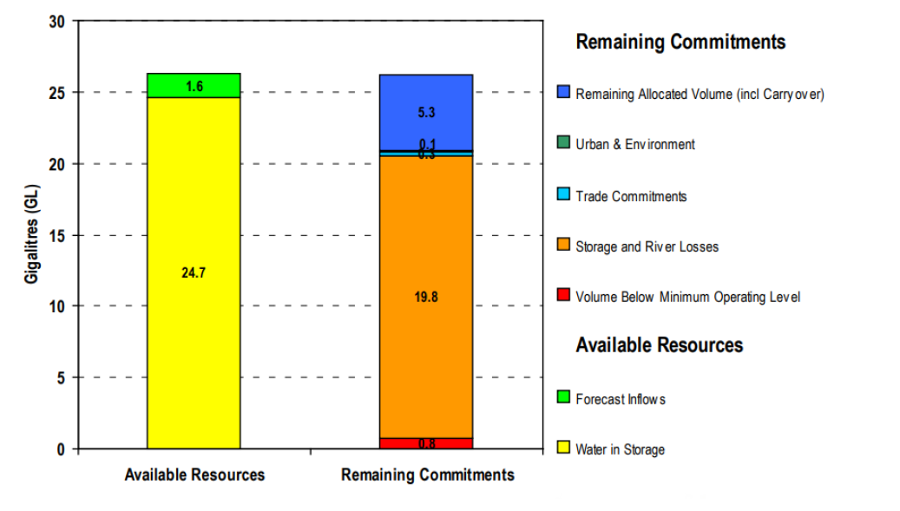

Figure 5: Water balance of available resources In the system as of 3 September 2018

This water needs to be set aside to ensure that carried-over water and new season allocations can be physically delivered to Entitlement Holders. Early in the season, only very small volumes of water are available to be allocated to entitlements even when there is water in storage. This causes particular challenges for domestic and stock users, who generally hold small volumes of water shares to meet their needs.

Improvements to seasonal determinations in average and wet years tend to occur between September and December.

To manage this lack of early season allocation, Entitlement Holders in the Broken System use carryover to manage their water between seasons, taking advantage of this tool to manage their water risks. In recent years, there have been substantial volumes of water carried over between seasons, particularly following wet years. Carryover against private water shares often makes up the majority of water available to irrigators in winter and spring.

### Water availability between years

Figure 6 illustrates the highly variable inflows that the Broken System experiences between years, depending on annual rainfall conditions. In wetter conditions Lake Nillahcootie often fills during the year and water allocation for Broken Entitlement Holders is high. In dry years, allocations can be delayed early in the season and can remain very low throughout the season.

Figure 6 shows that in the last eight years water availability for Entitlement Holders has fluctuated significantly. This has included:

* 5 seasons were average to wet years, resulting in allocations reaching **100% for both HRWS and LRWS[2]**
* 3 Season were dry to very dry years, resulting in HRWS allocations remaining **below 40% with one year as low as 2%**.
* Only one of these seasons has provided a September allocation of greater than 80% HRWS.

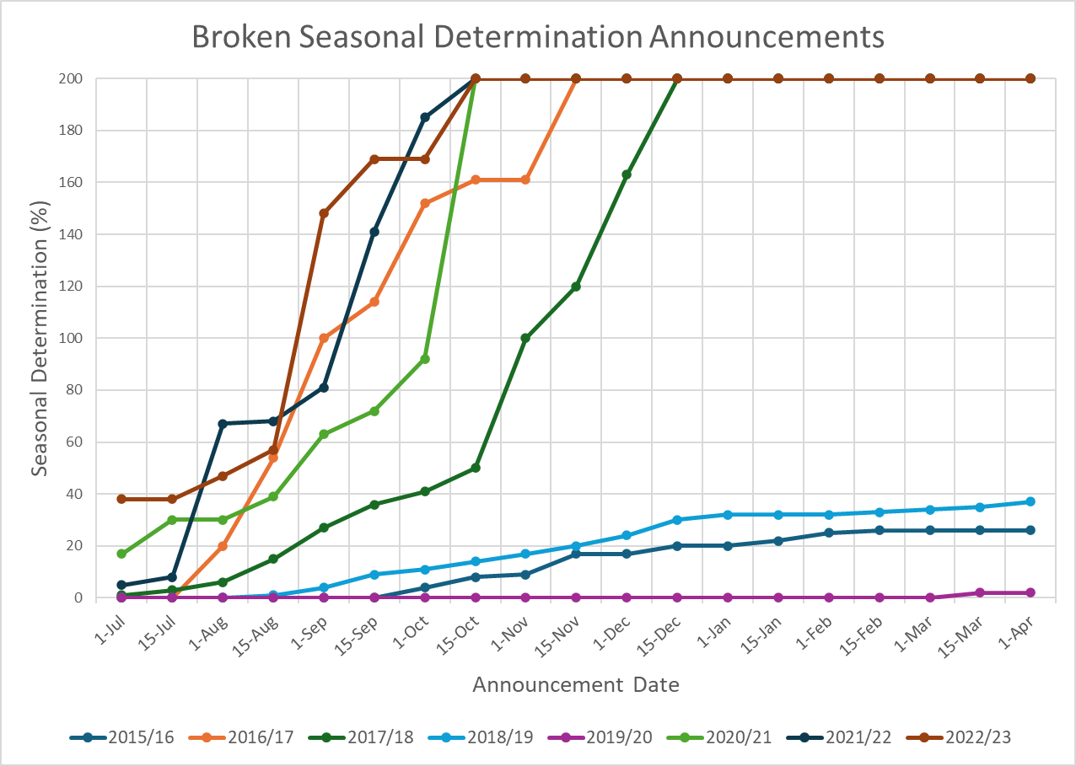

Figure 6: Seasonal determination announcements in the Broken System 2015-16 to 2020-21. Low-reliability determinations are indicated as announcements above 100% on the chart i.e., a determination of 100% HRWS and 100% LRWS is shown as 200%.

### Water user behaviour and trade

There are 299 allocation accounts in the Broken System, of which approximately 140 are primarily for domestic and stock purposes. The decisions that Entitlement Holders make about the use of their water varies according to water availability, timing of allocations and seasonal conditions.

Data from recent years shows that water users in the Broken System have been adapting their use of water from year to year in terms of how much is used for irrigation, how much is traded or carried over between years, and the volumes of water that remain unused, which are written off at the end of the season.

Figure 7shows volumes of less than 5.3 GL being used within the Broken System over the last eight years (including in years where seasonal determination provides 100% of both HRWS and LRWS). During consultation undertaken for the study, community members explained the low usage rate in high allocation years is often the result of on-farm water needs being met by the same above-average rainfall conditions that made the full allocation possible. Conversely, in years with below-average rainfall where they are most in need of a suitable allocation, allocations are lower and may not be available in the early part of the season.

While there has been a relatively large volume of water allocations traded between the Broken and Downstream Systems in recent years (as shown below), there have been much smaller volumes of local allocation trades between water users within the Broken System. 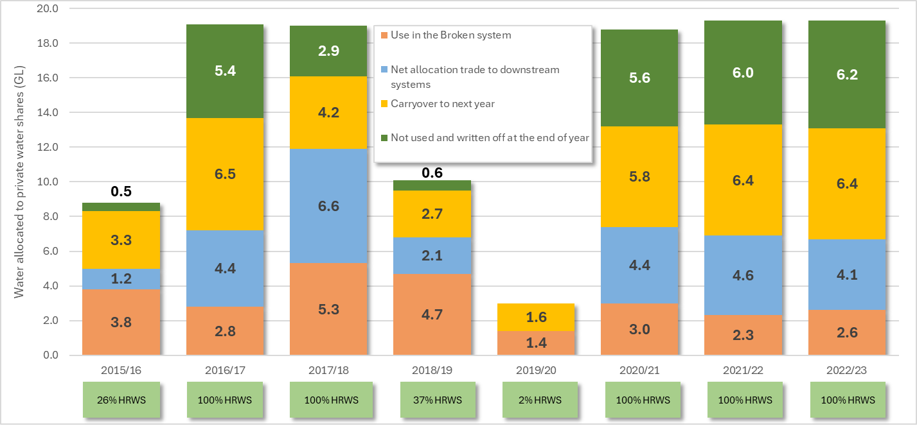

Figure 7: Relative volumes of water allocated to private water shares in the Broken System 2015-16 to 2022-23 in gigalitres (GL) categorised by ‘use’ type. End of year seasonal determinations for each year are below the chart.

### Water use by agricultural practices

A range of agricultural practices occur within the Broken System. Based on information collected to inform Regional Irrigated Land & Water Use Mapping (RILWUM) in 2023, livestock (35%), cropping (20%) and dairy (19%) land use accounted for the majority of water use in recent years. Dairy has the lowest number of Water Use Licences (WULs) associated with all the land use categories (4 WULs), but represents the highest intensity of water use. Horticultural water use fluctuates significantly depending on the seasonal conditions, with up to 13% of system use in dry years, falling to 1% in wet years.

Table 1: Water use by Land use categories

|  |  |  |  |  |  |  |  |
| --- | --- | --- | --- | --- | --- | --- | --- |
| **Season** | | **18/19** | **19/20** | **20/21** | **21/22** | **22/23** | **Average** |
| **Seasonal Allocation (ML)** | | **6,560** | **355** | **21,040** | **21,040** | **21,040** | **14,007** |
| **Land Use Category** | Cropping | 1004 (21%) | 217 (14%) | 571 (18%) | 313 (14%) | 796 (30%) | 526 (20%) |
| Dairy | 580 (12%) | 301 (20%) | 551 (18%) | 539 (23%) | 525 (20%) | 493 (19%) |
| Horticulture | 278 (6%) | 193 (13%) | 320 (10%) | 123 (5%) | 23 (1%) | 229 (7%) |
| Intensive | 227 (5%) | 148 (10%) | 80 (3%) | 72 (3%) | 99 (4%) | 132 (5%) |
| Livestock | 1950 (42%) | 335 (22%) | 1212 (39%) | 930 (40%) | 869 (33%) | 1107 (35%) |
| Other Land Use | 390 (8%) | 159 (11%) | 227 (7%) | 174 (8%) | 182 (7%) | 237 (8%) |
| Rural | 261 (6%) | 155 (10%) | 156 (5%) | 149 (6%) | 129 (5%) | 180 (6%) |
|  | | | | | | | |
| Seasonal Allocation (%) | | 37% HRWS | 2% HRWS | 100% HRWS | 100% HRWS | 100% HRWS | - |
| 0% LRWS | 0% LRWS | 100% LRWS | 100% LRWS | 100% LRWS | - |
| Seasonal Conditions | | Dry | Dry | Wet | Wet | Wet | - |

The case for change in the Broken System is compelling and to a large extent system users have already started to adapt to a changing paradigm evidenced through reduced reliance on irrigation-dominant enterprises and water use.

The step-change in inflows to Lake Nillahcootie and the unregulated tributaries has resulted in significant annual variability in the available water allocation. Customers have expressed the challenge and uncertainty this presents when trying to plan with confidence for the future and invest in irrigation infrastructure which would otherwise be required to support an irrigation dominant enterprise.

The modelling completed for the Broken System forecasts that these impacts will continue to intensify with 100% of HRWS forecast to reduce to 48 years out of 100 under a high climate change scenario by 2065.

This highlights the opportunity for reconfiguration and support for associated community adjustment as a proactive approach to the system challenges as compared to a ‘do-nothing’ approach.

# Study Processes

## FEASIBILITY STUDY SCOPE

The scope of the Broken Reconfiguration Feasibility Study included:

### Oversight and Governance

* Clear and appropriate oversight and governance of the project, including representation from local community leaders and those with strong experience in the design and implementation of major water supply projects.
* Documentation of principles informing how the project is delivered, with a focus on transparency, community engagement and technical rigour.

### Understanding the issues

* Consideration of the detailed analysis completed as part of the Broken Review 2020-2022, including technical information and outcomes of surveys and consultation with the community to understand the challenges facing the system.
* Reflections on previous projects which have led to major changes to water supply and the nature of water-related industries to compile ‘lessons-learned’ and how the unique setting of the Broken System may affect project design.
* Identification of desired outcomes for any reconfiguration options, in-line with the outcomes of the Broken review and in the context of climate change.

### Identifying the options

* A thorough investigation into all feasible options for system reconfiguration in terms of the regulated Broken System, from small-scale local adjustments to water supply for individuals through to decommissioning of areas under irrigation.
* Investigating how risks posed by options could be mitigated or further benefits to the system achieved – including any potential changes to rules (e.g., carryover or passing flow rules).

### Assessing the options

* Analysis of each feasible option to understand the social, economic, and environmental implications and technical complexity of different future scenarios.
* Meaningful community engagement to understand different stakeholders’ perspectives of the benefits and risks of options.
* Clear cost benefit analysis to enable entitlement holders and potential investors to make informed decisions.

### Bringing it together

* Clear and simple documentation of each of the feasible options identified, including positive outcomes and issues.
* Description of how each feasible option stacks up against the identified desired outcomes.
* Enabling a conversation with the Broken Valley community on possible next steps

## Governance structure

The establishment of robust oversight and governance structure was established to ensure the study was successfully implemented.

Utilising the governance structure, shown below, the project was able to develop a series of project principles and success criteria which serve as a mechanism to assess whether the Feasibility Study has achieved its intended objectives.

The project governance structure is illustrated below (Figure 8).

This is an organisation chart showing the project governance structure.  From the top: Victorian Minister for water, DEECA statewide infrastructure, project oversight group (GMW and DEECA).  Side by side are the sequana Project team and the Consultative committee and the next box below is the community and other stakeholders

Figure 8: Project governance structure

## Consultative committee

The Consultative Committee (CC) was established to provide stakeholder input into the direction of the study and feedback on opportunities examined through the process. The CC included representation from the community, industry representatives, local government representatives, and observers from key government agencies including DEECA, Goulburn-Murray Water, Goulburn Broken CMA, and Victorian Environmental Water holder.

Goulburn-Murray Water established the CC as a non-statutory advisory committee. Its functions were to consider and discuss local perspectives on opportunities to reconfigure the Broken River System in line with the project’s objectives and principles.

The CC was essential to facilitate the community-centred and place-based approach using co-design principles.

The CC was involved at key times to provide considered input and advice on the project’s direction and deliverables to ensure that it met its overall objectives. The project was a forward-looking exercise recognising the extensive current knowledge base derived from previous reviews and extensive local expertise.

Areas where advice was sought from the CC include:

* Project principles, risks, and drivers
* New information on system values, attributes, limitations, and opportunities,
* Community and stakeholder views, characteristics, and consultation processes, and
* Appropriateness and validity of high-level project outputs (e.g. technical findings).

It is important to note that feasible options needed to be:

* Consistent with the requirements of Victorian and Commonwealth water legislation and the Victorian water entitlement framework,
* Accord with Victorian water policy and obligations under the *Murray-Darling Basin Plan*,
* Considerate of multiple benefits and impacts, including economic, social, cultural, and environmental, and
* Robust under likely future water availability scenarios.

The roles and responsibilities of the CC were documented as follows:

Consultative Committee Roles & Responsibilities:

* CC members will draw on their local knowledge and experience and contribute to the development of the project consistent with its objectives.
* CC members will be responsible for fairly and accurately reflecting the views of stakeholders with similar interests or, in the case of agency representatives or participants nominated by an organisation, to represent that organisation’s/agency’s views in such a way.
* CC members will review and discuss papers presented to the CC.
* CC members will prepare for and attend CC meetings either virtually or in person where possible and if they cannot attend, send apologies.

CC members will seek to support broader community engagement activities.

The CC supported a collaborative approach through:

* Respect for all individuals, despite differing opinions
* Open and honest discussion
* Encouraging innovative thinking and being open to different ideas
* Acknowledging that difficult discussions may take place
* Contributing to a safe and collaborative environment for concepts, issues, and knowledge to be shared
* Treating sensitive issues discussed within the project with respect and confidentiality.
* Providing input and commentary in alignment with project timelines.

#### Developing advice to the Minister

The outcomes of this Feasibility Study along with the endorsement of the Consultative Committee will be provided to the Victorian Minister for Water for a decision on the State’s support for the proposed key next steps in this community-driven project.

Reflecting the strong relationship with the Minister for Water, following their appointment at the commencement of the Feasibility Study, the CC wrote to the Minister expressing their gratitude for the continued support from the State Government.

A brief section of the letter is shown in Figure 9.

***“We, the members of the Broken Reconfiguration Feasibility Study Consultative Committee, would like to extend our heartfelt gratitude for your support and dedication to the improvement of our water supply system.***

***By supporting the Broken Review through to completion and the subsequent feasibility study, you have helped our community to explore system reconfiguration options to support the community to plan for the challenges of an annual system with reduced water availability in the future.”***

Figure 9: Extract from Consultative Committee letter to the water minister

## project principles and success Criteria

A documented set of guiding project principles and success criteria played a critical role in the completion of the feasibility study, providing a clear framework, direction, and criteria for evaluating the viability and success of the proposed options. Project principles help articulate the fundamental values and objectives guiding the feasibility study.

The development of the project principles and success criteria involved a structured approach to ensure comprehensive input and consensus among Consultative Committee members, agency representatives and the project team. The following summarises the method used:

* The project team commenced by creating an initial set of guiding principles. These principles were shaped by discussions held in the first CC meeting.
* In the second CC meeting, CC members reviewed and provided input into the development of the principles in conjunction with the project success criteria.
* Through these iterative discussions and refinements, the CC collaborated to reach a consensus on the guiding principles and success criteria. The final list of project principles and success criteria was confirmed after incorporating the feedback, suggestions, and considerations from both committee meetings. This ensured that the guiding principles accurately reflected the collective insights, expertise, and perspectives of the stakeholders involved.

### Project principles

The resulting project principles included:

#### Sustainability

The project is committed to promoting sustainable water use and river operations practices. We will prioritise reconfiguration solutions that enhance the long-term health and resilience of the river ecosystem, considering environmental, social, and economic factors.

#### Stakeholder Engagement

We recognise the importance of engaging and involving all relevant stakeholders throughout the feasibility study. We will seek input and feedback from entitlement holders, Traditional Owners, local communities, government agencies, environmental organisations, and other interested parties to ensure a comprehensive and inclusive decision-making process. Our communication methods will be adapted to meet the diverse needs of stakeholders, considering the degree of impact changes may have on different community members.

#### Transparent Communication

We are committed to maintaining transparent and open communication throughout the project. We will provide regular updates, share findings, and engage in meaningful dialogue with stakeholders, ensuring that information is accessible and understandable to all interested parties. So that expectations remain realistic, we will provide honest advice about the likelihood, uncertainties, known constraints, and potential timing of options under examination.

#### Technical Rigour

The feasibility study will be conducted with a strong emphasis on technical rigour. We will incorporate and build on the assessments produced during previous investigations. We will employ reliable data collection methods, accurate analysis techniques, and robust modelling tools to evaluate the potential impacts and benefits of various reconfiguration scenarios.

#### Integrated Approach

We will take an integrated approach, considering the interconnectedness of different aspects related to river use. This will involve examining ecological impacts, recreational opportunities, economic implications, cultural significance, and regulatory requirements to develop a comprehensive understanding of the project’s feasibility.

#### Commitment to Best Practice

We will strive to deliver the study in a manner that sets the standard for future projects of this nature. Lessons from similar projects will be considered to create efficiencies wherever possible.

#### Adaptive Management

Recognising the dynamic nature of river systems and communities, we will embrace an adaptive management approach. This approach allows for ongoing monitoring and evaluation of the reconfiguration strategies and their outcomes, enabling us to make necessary adjustments and improvements as new information becomes available.

#### Diversity and Inclusion

We embrace diversity and inclusion at every stage of our study. Recognising the richness that diverse perspectives bring, we are committed to ensuring that all voices, irrespective of gender, race, ethnicity, age, ability, or any other defining characteristic, are heard and respected.

#### Equity

We are committed to ensuring that the benefits and impacts of the system reconfiguration are distributed fairly among all stakeholders and provide equitable access and benefits for all involved parties.

#### Alignment

We are committed to ensuring that our reconfiguration strategies and recommendations are fully aligned with the water resource management strategies and policies of the Victorian Government, as well as the Commonwealth Water Act and Basin Plan where applicable.

#### Cost-effectiveness

Our study will evaluate the cost-effectiveness of different reconfiguration options. We will strive to identify solutions that provide the greatest benefits in relation to their costs, ensuring efficient allocation of resources and maximising the return on investment.

#### Risk Assessment and Mitigation

We will conduct a thorough risk assessment, identifying potential risks associated with the proposed reconfiguration strategies. Based on this assessment, we will develop appropriate mitigation measures to minimise negative impacts and enhance the overall success and sustainability of the project.

#### Regulatory Compliance

The feasibility study will adhere to all applicable laws and regulations related to water resource management and environmental protection in Victoria. We will work closely with relevant authorities to ensure that our recommendations align with legal requirements and regulatory processes.

#### Privacy Protection and Information Confidentiality

We are firmly committed to safeguarding the privacy of all stakeholders and maintaining the confidentiality of information shared or obtained during the study. All data, insights, and communications will be handled with the utmost discretion, ensuring that sensitive information is not disclosed or misused.

#### Ethical Considerations

We will conduct the feasibility study with the utmost ethical considerations. We will respect the rights and interests of all stakeholders.

### Success Criteria

The resulting success criteria included:

### Criterion 1. Achieving multiple benefits

The reconfiguration options will seek to achieve:

* A sustainable future for productive agriculture in the region,
* Secure, year-round access to water for D&S and urban needs,
* Protection or enhancement of the environmental values of the Broken River,
* Supporting recreational values that the community values including fishing and passive enjoyment of the river,
* Supports Traditional Owner cultural values and self-determination.

### Criterion 2. creating change

The recommended proposals provide effective assistance where needed to support farm business change away from irrigated agriculture.

### Criterion 3. FUTURE READY

The proposed measures will be robust, adaptable and capable of delivering benefits under potential future climate change scenarios and increased variability.

### Criterion 4. Community Acceptance

The recommended proposals receive wide acceptance from the community following an appropriate engagement program and clear communications that provide the key/pertinent factors for each option.

### Criterion 5. VALUE FOR MONEY

The recommended proposals are affordable and represent value for money to project funders and to water users.

# UNDERSTANDING THE ISSUES

## Stakeholder and community engagement

### Strategy

At the outset of the study, the BRFS Communications Plan was developed to ensure a strategic approach to capturing community insights on those listed outcomes would shape the feasibility study.

The Communications Plan identified BRFS engagement objectives, timeframes, customers, stakeholders, risks and activities. The objectives of the plan were to be measured via the successful undertaking of the following actions:

* Inform customers and stakeholders of the upcoming Broken Reconfiguration Feasibility Study (BRFS),
* Establish a BRFS Consultative Committee to provide local insights to the feasibility study,
* Carry out community and stakeholder engagement that builds on the local insights gained from previous consultation and the Consultative Committee,
* Consult with customers and stakeholders on local priorities to inform reconfiguration options, and
* Identify communication risks / contentious issues.

The BRFS team strategically designed engagement that provided opportunities to exchange insights at key junctures throughout the development of the feasibility study. This was intended to help communities manage their available time and attention and ensure the study benefited from community input in a timely manner.

From the outset of the BRFS, advice from the CC was clear – transparency and broad engagement of all communities within the Broken System (not limited to GMW customers) was to underpin all communication and engagement endeavours for the study.

With these guiding principles in place, the team used a variety of engagement tools to build awareness and gather Broken System insights to inform the study.

Figure 10: Phase 4 Engagement – Assessing the options with community in Benalla

### A phased approach to engagement

The plan outlined a staged approach to the communications with five distinct phases aligning to key components of the feasibility study, each requiring specific communication and engagement activities. These phases and their activities are described below.

#### Phase 1 – Project introduction

The early part of the BRFS focussed primarily on the formation of BRFS Consultative Committee (BRFS CC), the completion of BRFS CC Governance Framework and agreeing on the communication and engagement approach between the BRFS team, the BRFS CC and stakeholder entities. Early activities included engaging directly with landowners and attending public events at saleyards and market build awareness of the study and its importance.

#### Phase 2 – Understanding the issues

Phase two of the BRFS was directed to familiarisation of work delivered under the “Broken System Review 2020 – 2022” final report to the Minister. Engagement during this phase focussed on insights received by individual members of the Broken System Review working group, agency representatives and key members of the Goulburn Broken Water Services Committee.

#### Phase 3 – Identifying the options

By the final months of 2023, the BRFS team were undertaking broad public engagement efforts to introduce the project to the broader community including non-entitlement holders. Public events and activities were attended along with a targeted series of project engagement workshops, drop-in sessions and online efforts.

Specific effort in this phase was around the capturing of insights on initial options to ensure the BRFS team had captured all the options the community wanted to see addressed and prioritised under the study. Feedback on initial options was captured via interview, recorded minutes, inviting written contribution to posters, online map-based commenting or other means.

During Phase 3 Engagement, the BRFS team held face-to-face workshops with pipeline customers and D&S syndicates, and hosted public drop-in sessions to gather input from the broader community. The workshops and drop-in sessions were widely advertised. Targeted SMS and customer emails were complemented by newspaper advertisements and paid print and social media placements to ensure that the community was aware of the key engagement opportunities. The workshops and drop-in sessions aimed to inform the community about the study and gather early feedback. The team presented background to the study, problem definition, assessment methods, and success criteria the team would be working to. This round of engagement involved marking up posters, maps, and feedback quadrants to ensure attendees had the opportunity to explicitly tell the BRFS Team “What do you think this study should focus on?”. An example of the posters below (Figure 11) gives a sense of the broad range of views heard including the need to consider more efficient practice, the desire to maintain current lifestyle and practises, requests for more information around trade opportunities and the importance of consideration for dry years, to name a few.

#### Phase 4 – Assessing the options

During the first quarter of 2024, the BRFS team, including an on-farm planning specialist, made a dedicated effort to visit different entitlement holder and water user types across each of the five zones to better understand the landowners current use arrangements, pain points and aspirations for the future in the district. These insights were recorded as part of an active survey period to compare the views of those in the Broken System.

During Phase 4 Engagement, the team hosted more than 50 engagement activities including kitchen table visits and public information sessions. Through these activities, the team heard the views of the Entitlement Holders, cumulatively representing 60 % of water entitlement in the Broken System.

All community members were invited to attend one of five information sessions held over 2 days for an update on the BRFS. A summary of the background to the study and the case for change was provided by the team. At each session, there was general agreement from those attending that “doing nothing” was not a feasible path forward for the Broken System to thrive in the future.

Based on analysis of the water and land use practices, the team presented five profiles that most Broken System entitlement holders broadly fall into. Characteristics of each profile along with potential options to improve outcomes unique to their circumstances were discussed and broadly accepted by attendees without suggestion of the need for additional profiles.

The team also shared data on responses to reconfiguration options gathered from one-on-one engagements held prior to the information sessions. Attendees were able to discuss the insights and share their own views to help shape the future of the Broken System. Attendees were invited to build on the feedback received to-date by completing a BRFS survey or pinning a comment to the system map on the [www.yoursay.gmwater.com.au/BRFS](http://www.yoursay.gmwater.com.au/BRFS) webpage.

#### Phase 5 – Bringing it together

The final phase of the engagement effort on BRFS has been the collation and interpretation of community insights on profiles and options presented. This involved grouping insights into themes, cross-checking against the structure and content of the study and providing feedback to those who had shared their insights as to what was heard and the next steps for the future of the Broken System Reconfiguration effort.

Figure 11: Engagement – Identifying the options with community at the Mokoan Hub

Figure 12: Phase 4 Engagement – Assessing the options with community at Dookie College

### Community Survey

During the first quarter of 2024, the BRFS team developed a survey to provide a consistent approach to the questions asked of stakeholders and the community, in an effort to identify trends, inconsistencies, and other insightful analytics.

The 10-question survey invited a mix of multiple-choice and free-field responses. Respondents were invited to complete the forms digitally, on paper, or verbally in an interview format. All written and verbal responses were entered into the digital system on behalf of respondents to allow for the data set to be complete.

During the survey period, 40 survey responses were received. Survey respondents represented more than 10% of GMW customers and 60% of Entitlement Holders in the Broken System. The outcomes of the survey responses have been incorporated into the stakeholder feedback presented in Section 5 – Identifying the Options.

### Reporting Back

In keeping with the commitments made around transparency, after every CC meeting and each round of community engagement, “What We Heard” summaries were posted to the BRFS webpage on the GMW ‘Your Say’ portal. Between rounds of engagement, project updates, fact sheets and case study materials have also been made available to further assist those wanting to fully understand the work of the study team.

Updates on the next steps for the Broken Reconfiguration will be shared with the community via the BRFS webpage. Possible next steps following the completion of the feasibility study are shown in Figure 13. More information about the process for developing a detailed business case is outlined in Section 9.5.

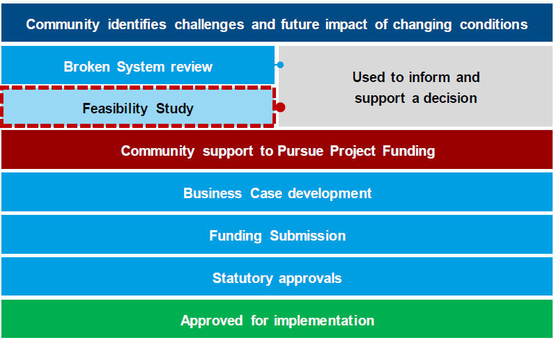

Figure 13: Project stages and possible next steps after completion of the Feasibility Study

### Ongoing connection with Community

The BRFS webpage on the GMW ‘Your Say’ portal will continue to provide a repository of information about the study for self-directed learning and sharing. The map-based ‘social-pinpoint’ commenting tool (Figure 14) remains open for the community to share geographically relevant insights at any time they wish, for the benefit of this, and future progress towards a community-led adjustment in the Broken System.

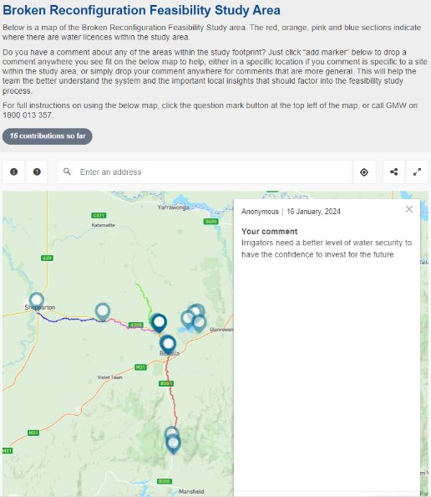

Figure 14: Map based commentary remains available to the community via the yoursay.gmwater.com.au/brfs webpage.

# Traditional Owner engagement

## Overview

​The Taungurung people and Yorta Yorta people are the traditional custodians of the land and waters of the project study area. The Registered Aboriginal Party (RAP) for these lands are:

1. ​Taungurung Land and Waters Council Aboriginal Corporation
2. ​Yorta Yorta National Aboriginal Corporation

​The project team approached both RAPs to self-determine their level of engagement and input to this feasibility project. The process and outcomes are discussed below.

## Engagement strategy

​Alluvium Consulting Australia (Alluvium) approached the Aboriginal Water Officers from Taungurung Land and Waters Council (TLaWC) and Yorta Yorta National Aboriginal Corporation (YYNAC) to introduce the project and offer support for them to provide input into the feasibility assessment. The process for each RAP differed according to the direction we received from them.

### Taungurung Land and Waters Council Aboriginal Corporation

​Alluvium held informal discussions with the Aboriginal Water Officer from TLaWC. These informal discussions led to an in-person meeting at which Alluvium presented the project overview, outlined the scenarios and answered questions. The outcome of this meeting was a request that Traditional Cultural values not be assessed as part of the multi-criteria assessment for this project.

​

​Following this meeting, Alluvium was invited to present to the TLaWC Water Knowledge Group. This presentation provided a further overview of the project and proposed reconfiguration scenarios and responded to questions.

​

​TLaWC advised that they are considering what form their response to the project may take. They requested that the feasibility study not make representations on their behalf. If they see fit, they will supply a Statement of Position on the project to sit alongside the feasibility study.

### Yorta Yorta Nation Aboriginal Corporation

​Alluvium held informal discussions with the Aboriginal Water Officer from YYNAC. Following these conversations, Alluvium was invited to provide a more detailed briefing to the Aboriginal Water Officer. This briefing provided a project overview, high-level details of the potential reconfiguration scenarios, answered questions and offered support to YYNAC to respond to the project in whichever way they wished. The outcome of this meeting was a request that Traditional Cultural values not be assessed as part of the multi-criteria assessment for this project and that the feasibility study not make representations on behalf of YYNAC. YYNAC were invited to provide a statement for inclusion in the final BRFS report, alternatively this could be provided directly to DEECA.

# IDENTIFYING THE Options

## Overview

The development of reconfiguration options utilised a multi-stage approach to ensure effort was not invested in undertaking a detailed assessment of options or scenarios that were not considered to be feasible or did not meet the requirements of the project principles. This approach included a preliminary assessment to filter out options that were deemed infeasible or did not align with the success criteria of the project, as detailed further in section 5.4.1.

The multi-stage approach is shown below in Figure 15.

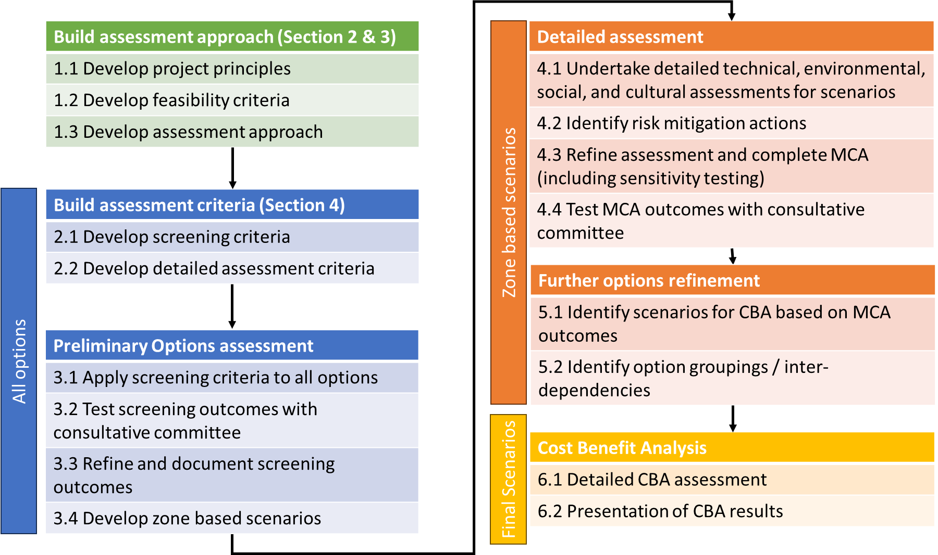

Figure 15: Assessment Framework

## Broken River Zones

In order to properly assess the range of opportunities across the system, the study area is divided into five separate zones, as depicted in Figure 16. A zone-based approach recognises the different geological characteristics, usage pattens, and physical limitations that influence the effectiveness of potential solutions. For instance, the lower reaches of the Broken System run parallel to an irrigation district and piped Domestic & Stock (D&S) supply. In that part of the region, the potential to resupply properties from a more reliable source may prove to be viable. This opportunity is not available in the upper region, as there are no viable resupply sources in proximity.

Further benefits from adopting a zone-based approach include:

* Supports a targeted resource management approach, increasing the efficiency of proposed interventions.
* Focuses any required environmental impact assessment on the specific areas of change, allowing for a more accurate representation of future conditions.
* Localised and relevant community engagement. It enables stakeholders to participate in discussions and provide input into matters that directly impact their zone.
* Provides an opportunity to package a combination of different options tailored to the needs of the zone. The packaging of options may lead to scenarios where benefits are enhanced, and in some cases made viable where they may not have been if delivered as a stand-alone option.

For this study, zones in the Broken System were designated based on common geographical conditions and by the location of river structures. The five zones assigned within the project area, are:

1. Broken River from Lake Nillahcootie to Lake Benalla.
2. Broken River from Lake Benalla to Casey’s Weir, including Entitlement Holders connected to the Mokan Pipeline system.
3. Broken Creek from Casey’s Weir to Waggarandall Weir.
4. Broken River from Casey’s Weir to Gowangardie Weir.
5. Broken River from Gowangardie Weir to the confluence with the Goulburn River.

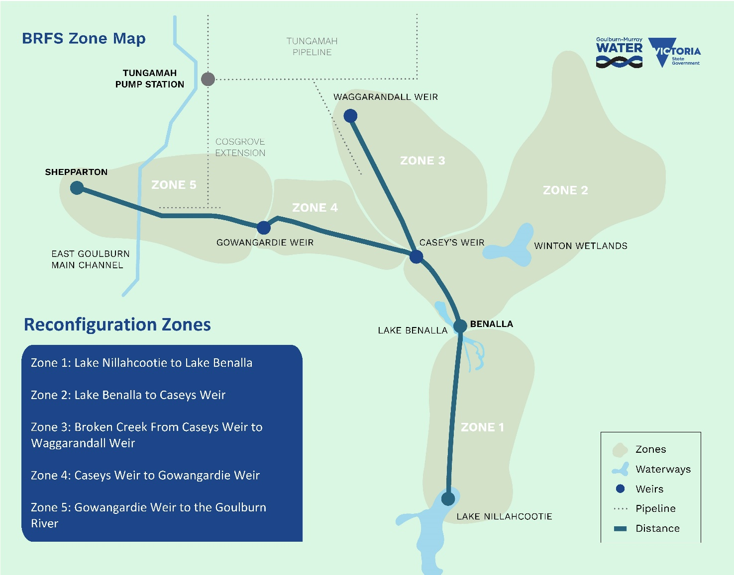

Figure 16: Broken System Reconfiguration Zones

## Identification of reconfiguration options

The process to identify an initial ‘long-list’ of options, which when combined or applied individually to the project area would support the objectives of the BRFS, included:

* A workshop which included key members from DEECA, GMW and the Project Team who were able to utilise their existing industry and regional knowledge and experience to identify an initial suite of options.
* The Consultative Committee (meeting #2) held an open discussion which allowed all members the opportunity to identify potential options utilising their system, local area and industry knowledge.
* A series of community engagement sessions commenced on 21 November 2023, providing the broader community with the opportunity to identify any key options that should be factored into the BRFS. The community engagement aimed to reach as many local community members and Broken System customers as possible. A summary of the involved parties who attended sessions, were contacted via phone or email or attended public events is as follows:
* D&S Syndicates
* Private Pipeline Co-operatives
* Permanent Planting Irrigators
* Traditional Owner
* Ecologist
* GMW customers (contacted via email and SMS)
* BRFS contact list (contacted via email and phone)
* Local newspaper and social media audiences.

A summary of the key messages heard from the community engagement sessions, particularly focussing on the important items for consideration by the project team, is shown below:

* Assess options within the context of modern and efficient farming practices,
* Consider development and changes in land use,
* Evaluate infrastructure feasibility, including storages and pipelines,
* Address system exit issues comprehensively,
* Explore HRWS transfer rules and trade opportunities,
* Seek advice from GMW and maintain strong GMW involvement in the project,
* Prioritise certainty for Domestic & Stock (D&S),
* Emphasise the critical importance of timely allocation and certainty,
* Recognise and differentiate between private and commercial irrigators.

A final ‘long list’ of options resulted which was used as the basis for the preliminary assessment.

## preliminary options assessment

### Evaluation process

In the preliminary assessment, a total of 22 individual options underwent review, with each evaluated against the 11 criteria outlined in the preliminary assessment rubric. The assessment process also included a thoughtful consideration of the ‘level of confidence’ associated with each option.

The preliminary assessment rubric incorporates the following criteria:

* Sustainable irrigation sector future
* D&S Supplies
* Environmental values
* Social
* Cultural
* Robustness
* Risks
* Value for money
* Community acceptance
* Regulatory and Policy Alignment
* Impacts and Benefits.

A qualitative final assessment as to whether the option was likely to offer suitable outcomes across a range of criteria was undertaken. The outcome of the preliminary assessment for each of the 22 options are shown below in Table 2. Detailed assessments for each option are provided in the Technical Report.

Table 2: Preliminary assessment – 22 options

|  |  |  |
| --- | --- | --- |
| **Option** | **Description** | **Shortlisted Y/N** |
| 1 | Secure access to first 2 ML of water use each season for D&S purposes. | Yes |
| 2 | Align D&S use with Section 8 conditions i.e. 24/7 D&S use | No |
| 3 | D&S reserve. Utilising water savings previously generated from the Cosgrove project. | Yes – Linked to Option #1 |
| 4 | Explore options for increasing groundwater access for D&S | Yes |
| 5 | Connection to alternate D&S schemes (e.g. Tungamah/Cosgrove) | Yes |
| 6 | D&S scheme with local off-stream storage. | No |
| 7 | Access to / enhance the Winton wetlands as a storage for Mokoan pipeline supply. | No |
| 8 | Managed Aquifer Recharge | No |
| 9 | East bound Irrigation pipeline from East Goulburn Main | Yes |
| 10 | Pipeline from other regulated systems (e.g. Eildon or Ovens) into the Broken, upstream of Nillahcootie. | No |
| 11 | Transfer Broken demand to the Goulburn System for properties inside the SIA. | Yes – Linked to option #9 |
| 12 | Create ability to access unregulated flows early in the season. | No |
| 13 | On-Farm Storage | Yes |
| 14 | Supported transition to ‘dry-land’ agriculture | Yes |
| 15 | Supported market correction | Yes |
| 16 | Water entitlement purchase and retirement of entitlement solely to improve system reliability. | No – Option #18 preferred |
| 17 | Targeted water entitlement purchase and return to the environment. | No – Option #18 preferred |
| 18 | Water entitlement (HRWS and/or LRWS purchase). % ‘retired’, % environmental, % cultural | Yes |
| 19 | Decommissioning of Infrastructure. E.g. Gowangardie Weir | Yes |
| 20 | Increase capacity of Mokoan pipeline storage lagoon | No* |
| 21 | Provide more opportunities for trading allocation out of the Broken System | Yes |
| 22 | Fund a Whole Farm Plan and business planning program to support irrigation to dry-land transitions. | Yes |

*This option was originally shortlisted however later deemed not to be required.

### Shortlisted options

A summary description of the shortlisted options is provided in Table 3.

Table 3: Shortlisted Options

|  |  |
| --- | --- |
| **Option** | **Summary Description** |
| 1. Secure access to first 2 ML of water use each season for D&S purposes. 2. D&S reserve. Utilising water savings previously generated from the Cosgrove project. | Exploring options to use existing entitlement held by GMW (Cosgrove) or entitlement contributions from water users to underwrite a reserve of water in the system that supports security of access to water for domestic and stock supply in all years. |
| 1. Explore options for increasing groundwater access for D&S | This option is currently available to landowners and several properties currently have access to groundwater. The water quality and reliability of supply differs by location. |
| 1. Connection to alternate D&S schemes (e.g. Tungamah/ Cosgrove) | A review of available connection options to the nearby piped networks of Tungamah and Cosgrove. These schemes are serviced by the Goulburn System offering enhanced reliability compared to the Broken System. |
| 1. East bound Irrigation pipeline from East Goulburn Main 2. Transfer Broken demand to the Goulburn System for properties inside the SIA. | This option will support the connection of existing Broken System customers to the Goulburn System via the design and construction of a pipeline/s from the Shepparton Irrigation Area or from further upstream of the Broken River to supply customers in the lower reaches of the Broken River. |
| 1. On-Farm Storage | This option would support investigation into additional on-farm flexibility by allowing customers to utilise available allocation to store water on-farm as one component of a water management strategy. |
| 1. Supported transition to ‘dry-land’ agriculture | This option would provide advisory assistance to support business transitions planning from current farming practices to be less reliant on irrigation. This assistance could be separated into professional advice, and financial assistance. |
| 1. Supported market correction | This option would allow existing entitlement holders that don’t want to continue in irrigation to transfer out their unused entitlement to other water users within the Broken Valley who want to access additional water and/or improve their security of supply under low allocation conditions. |
| 1. Water entitlement (HRWS and/or LRWS purchase). % ‘retired’, % environmental, % cultural | This option would provide opportunity for entitlement holders to transition away from Broken System water in a systematic way, while considering the sustainability of river operations and resource allocations for the remaining customers. |
| 1. Decommissioning of Infrastructure. E.g. Gowangardie Weir | This option would enable the decommissioning of infrastructure with the river channel to improve long-term river health by supporting native fish migration and other environmental objectives. |
| 1. Provide more opportunities for trading allocation out of the Broken System | This option would enhance the opportunities for allocation trade out of the Broken System, in order to provide improved income generation opportunities for entitlement holders. |
| 1. Fund a Whole Farm Plan and business planning program to support irrigation to dry-land transitions. | Whole Farm Plans and business planning programs will provide landowners with access to professional farm planning services (including design and survey) to support the objectives of their individual property objectives. |

### irrigator profiles Options mapping

In order to demonstrate how these options may be utilised by landowners in practice, the options were assigned to different irrigator profiles that had emerged through community engagement. Table 4 aligns the options to the different irrigator profiles.

Table 4: Options relevant to the differing profiles

|  |  |
| --- | --- |
| **Profile** | **Relevant Option/s** |
| Customers planning to remain in irrigation​ | * Continue with current supply arrangements (for some irrigation properties depending on location) * Reconnect via new Pipeline (including to the Shepparton Irrigation Area). * Whole Farm Plan and business planning incentives * Supported market-based reallocation of water entitlements. * On-Farm Storage. |
| Customers uncertain and seeking additional information | * Whole Farm Plan and business planning program incentives to support irrigation and/or dry-land transitions |
| Customer planning to transition away from irrigation | * Water entitlement (HRWS and/or LRWS purchase). % ‘retired’, % environmental, % cultural​ * Whole Farm Plan and business planning incentives to support irrigation to dry-land transitions * Connection to alternate D&S schemes * Secure access to Domestic & Stock supply * On-Farm Storage * Supported market-based reallocation of water entitlements |
| Customers with a reliance on secure access to D&S supply | * Connection to alternate D&S schemes * Secure access Domestic & Stock supply * On-Farm Storage * Explore options for increasing groundwater access for D&S |
| Customers with own Water Share (non-irrigator: no intent or access to irrigate). | * Provide more opportunities for trading allocation out of the Broken System. * Supported market-based reallocation of water entitlements |

## Reconfiguration Scenarios

Following the endorsement of the suite of preliminary options, the project team held a workshop with DEECA and GMW to develop the reconfiguration scenarios using the shortlisted options​. The options were then assessed to determine how they could be most successfully applied (either in combination or individually), to the five identified zones in the project area. Generally, the scenarios required the combination of multiple options to achieve a potential solution that achieves the desired BRFS outcomes.​ This resulted in the identification of nine individual scenarios which are summarised in Table 5.

Table 5: Reconfiguration scenarios

| Scenario # | Description |
| --- | --- |
| 1 | Do nothing (Baseline to understand opportunity range) |
| 2 | Transition out of irrigation (whole system) (unlikely to be an outcome however required as a basis for comparison) |
| 3 | Re Remove or reconnect all services in Zone 5 |
| 4 | Remove or reconnect all services in Zone 3 |
| 5 | Mokoan Pipeline supply channel efficiency improvements |
| 6 | Systemwide initiatives (Voluntary entitlement purchase plus support for landowners to adapt to a drying climate) |
| 7 | Improved D&S supply security |
| 8 | A combination of Scenarios 3, 4, 6 & 7 |
| 9 | A combination of Scenario 8 with remove or reconnect all services in Zone 4 and Scenario 5 |

# Reconfiguration scenario analysis

## base case model development

Modelling was undertaken to provide a better understanding of potential changes to system losses and system performance under a range of reconfiguration scenarios. Performance was also tested under future climate scenarios and full demand. The GSM REALM model was used for the assessment.

In addition to system reliability, the water resources model was also designed to support comparison against the base case for the following key elements:

* September and February allocation (reliability) - % time exceeded
* Historic climate cases – Reproducing the allocation in any given year based on system parameters and applying historic inflows
* System operating losses by reach
* % of unrestricted demands satisfied.

This information is significant in assessing the potential benefits of system reconfiguration scenarios as it allows quantification of key parameters including:

* Benefits to overall system reliability
* Benefits to early (September) allocations
* Reduction in overall system operating losses
* Environmental flow assumptions.

The model included assumptions on how recovered water would be reapportioned to the environment and system reliability improvements. Changes to system losses and reliability were modelled based on 50% of recovered water provided to the environment, and 50% retired for reliability improvement.

**Note:** This does not preclude the return of water to Traditional Owners for self-determined purposes. DEECA will engage with Traditional Owners on their aspirations for water return and water management in the development of a Business Case, should this study result in one.

The environmental flow demands included in the model are based on the assumed future use of environmental water informed by the existing flow studies and discussions with GBCMA and GMW. An underlying assumption for the existing environmental flow studies is that various reaches (of the Broken River and Broken Creek) are operated to service irrigation demands in the System. If these demands were to change and the river was to be operated without these operational considerations different environmental flow demands may result. A new flow study would be required to investigate how the system could operate without the current operational demands and therefore overall environmental objective and associated flow demands over the year. It is proposed that the flow study review be undertaken as part of the detailed business case.

## scenario 1 – Do nothing

#### Summary

Scenario 1 is the baseline case used to compare current conditions to subsequent reconfiguration scenarios. For Scenario 1, the baseline model is updated to include a range of possible changes to future reliability.

Modelling for Scenario 1 includes assessment of available data to show historical and projected reliability for:

* Historical (utilises historic water usage only)
* Historical, full demand (assumes water use is equal to water entitlement)
* The period Post 1975 (scales historic inflows to match the post-1975 climate using decile scaling)
* The period Post 1997 (scales historic inflows to match the post-1997 climate using decile scaling)
* 2040 high-impact climate change (adjusts future inflows based on climate change forecasts)
* 2065 high-impact climate change​ (adjusts future inflows based on climate change forecasts).

Figure 17 shows the level of system reliability (February allocation - % time exceeded) under the base case scenario representing a reliability of 100% allocation in:

* 84 years out of 100 under ‘historical’ conditions; and
* 48 years out of 100 under the 2065 high climate change.

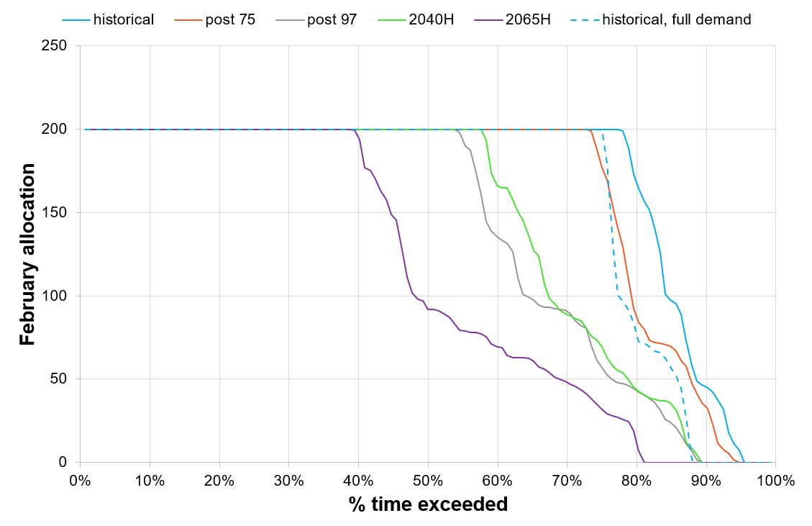

Figure 17: February allocation reliability for scenario 1 (base case) with future climate and full demand scenarios Note that 100 allocation (y-axis) represents 100% allocation of HRWS and 200 represents 100% allocation of both HRWS and LRWS.

#### Assumptions

This Scenario assumes there is no reconfiguration of the Broken System, entitlement holdings are retained by current holders and usage patterns are maintained.

#### Stakeholder Feedback

The general consensus from all stakeholder groups is that keeping the status quo is not an acceptable approach. The evidence of the system decline has been well established and future projections suggest the challenges faced in the system will continue to worsen if no reconfiguration is undertaken.

#### Alignment with Success Criteria

Scenario 1 represents a continuation of the status quo, and it is expected that as system reliability continues to decline there will be a slow, unstructured and unassisted adjustment throughout the Broken System. The community representatives, in originally requesting the Broken System Review in 2019, have signalled that the status quo option is not the solution and as expected it therefore satisfies only one (value for money – given no investment would be required) of the success criteria.

| Achieving multiple benefits​ | Creating change​​ | Future ready​​ | Community  Acceptance​ | Value for Money |
| --- | --- | --- | --- | --- |
| Badge Cross with solid fill | Badge Cross with solid fill | Badge Cross with solid fill | Badge Cross with solid fill | Badge Tick1 with solid fill |

**Note**: Red with cross = Success criteria not met, Orange with horizontal line = Success criteria partially met, Green with tick = Success criteria met

## scenario 2 – Transition out of irrigation (whole SYSTEM)

#### Summary

A total of 21 GL of high and low-security shares are associated with the Broken System. Inclusive of irrigation, D&S and environmental entitlement use, the average annual use across the system ranges between 1.5 GL to 5.5 GL.

Scenario 2 entails a complete transition away from irrigated supply in the Broken System. It was assessed for the purpose of understanding the extent of storage and conveyance water loss reduction possible if all irrigation demand was removed from the system. There is no intention of Scenario 2 being offered as a pathway forward, as it is highly unlikely to receive sufficient community support.

The Scenario includes the transfer of the irrigation component of the 19 GL of privately held high and low-reliability water shares to the environment (i.e. 15 GL HRWS and 3 GL LRWS). D&S supply is retained at the current rate. ​

#### Map

The map below reflects the current irrigation demand across the Broken System (the larger the circle the higher the level of take). Under this scenario, all existing demand converts to Domestic & Stock as represented by the smaller circles.

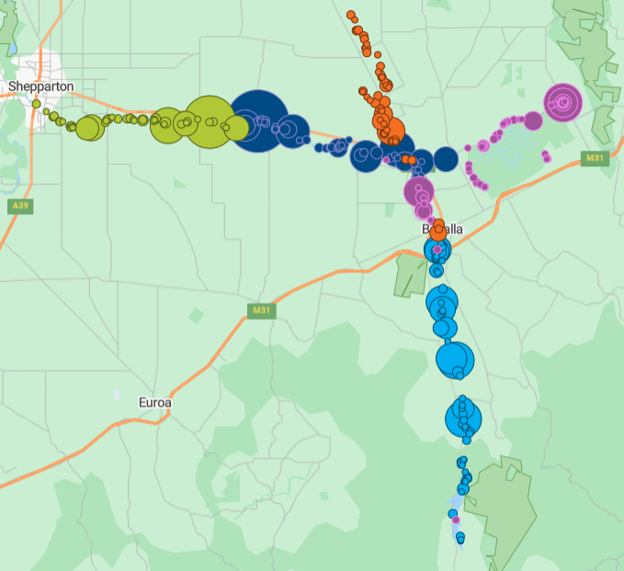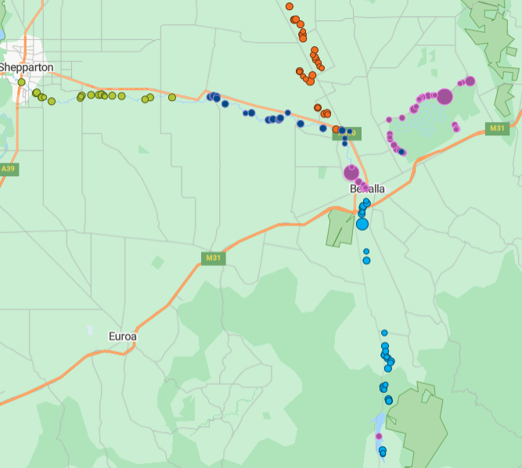

Figure 18: Broken System Water use by property – current use with Irrigation and D&S vs D&S use only

Figure 18 above shows Broken System Water Use 2018/19 – 2022/23 with irrigation and D&S in the top map, D&S only bottom.

#### Options Applied

* Voluntary entitlement relinquishment
* Support to transition to dryland agriculture.

#### Estimated Cost to Complete

Based on an assessment of potential activities and costs to implement scenario 2, the total estimated cost is **$72 million**, comprising of:

Business Case Development: $4.1 million

Implementation: $58.1 million

Project Delivery and Administration: $9.8 million.

Key elements included in the implementation estimate are:

* Entitlement purchases.
* Brokerage and legal fees associated with entitlement purchases.
* Professional farm planning advice to support landowners to transition to non-irrigation practices.

#### Assumptions

* 2 ML of D&S per property is retained.
* 15 GL of HRWS and 3 GL LRWS purchased from entitlement holders for the environment.​

#### Stakeholder Feedback

Through the course of the engagement period, many community members (including 35% of survey respondents) expressed an interest in individually participating in a voluntary sale of entitlement to the government, if an opportunity were to eventuate. Two survey respondents went as far as to suggest a whole-System transition should be seriously considered. However, 45% of respondents indicated that they were not likely to participate in such a program.

For some customers, access to irrigation water is critical to the degree that there would be no practical option to transition to a non-irrigation practice and remain sustainable in their industry. Example property types include an agriculture-based university campus and several permanent plantings. The Broken System supports two vineyards that have been in operation for more than 100 years that have no alternate water supply sources that would meet their needs. The adoption of Scenario 2 would likely result in this type of land use being unsustainable.

#### Comparison to Base Case

Reliability for Scenario 2 was modelled to provide a comparison to other scenarios (Table 6). However, reliability has low relevance to Scenario 2, as in this Scenario there is no longer irrigation demand in the system.

Table 6: Indicative results for scenario 2 (measured against the base case)

| **Metric** | **Baseline (current)** | **Scenario results** |
| --- | --- | --- |
| Full season reliability  (100% HRWS allocation by February) | 84% | 90% |
| Early season reliability  (100% HRWS allocation by September) | 2% | 89% |
| Change in losses compared to base case | 19,584 | -532 |
| Entitlement reallocated to environment (ML)  HRWS  LRWS |  | 13,719  2,929 |
| Entitlement retired for reliability (ML)  HRWS  LRWS |  | 1,496  325 |
| Long-term diversion limit equivalence (LTDLE) (ML) reallocated to environment |  | 8,586 |

Figure 19 –22 show the modelled changes in reliability for September and February compared to the base case.

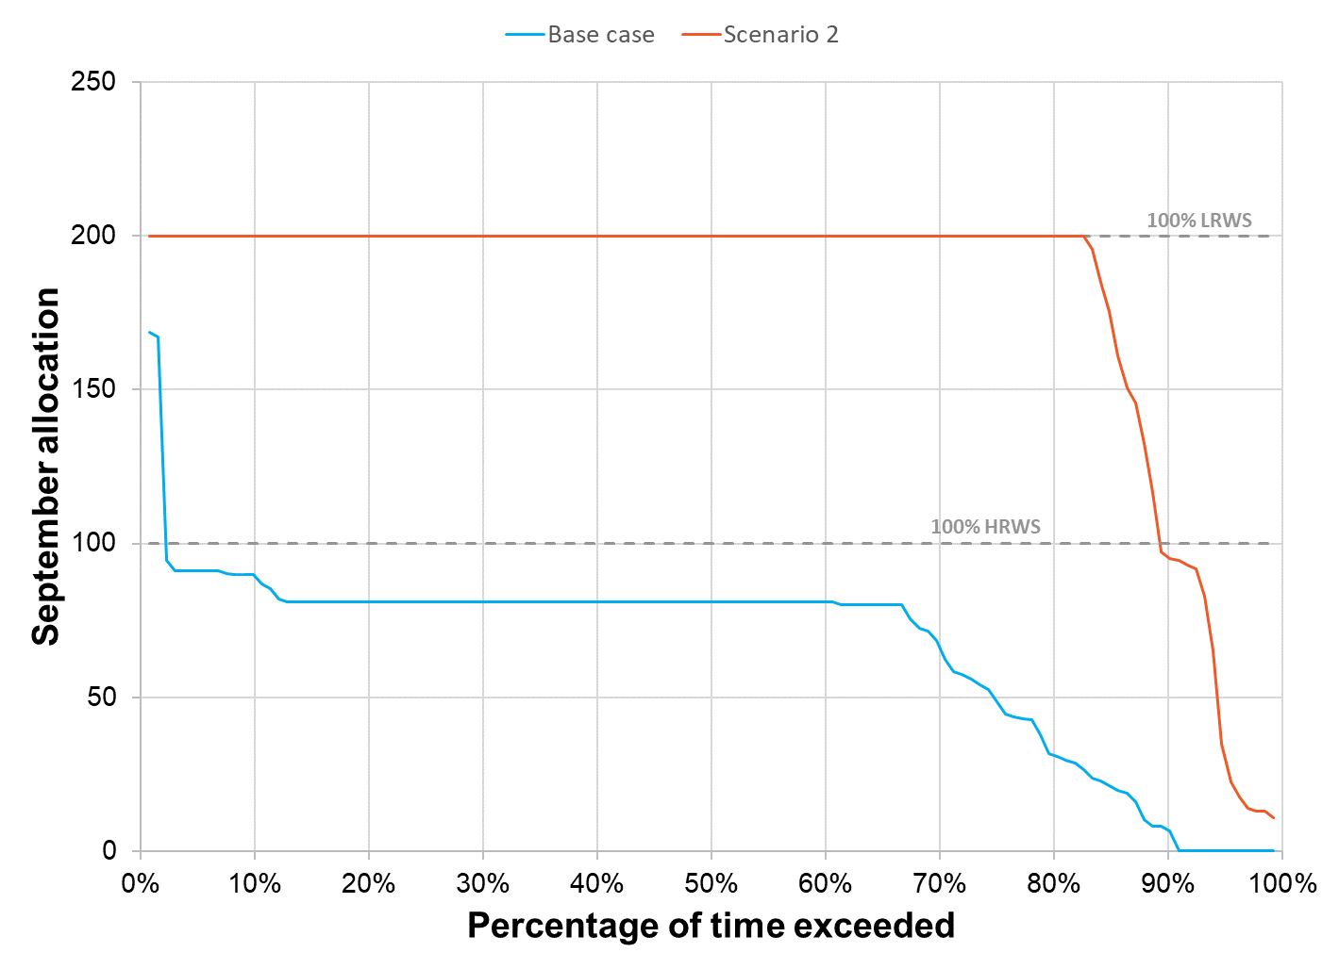

Figure 19: September allocation reliability for scenario 2

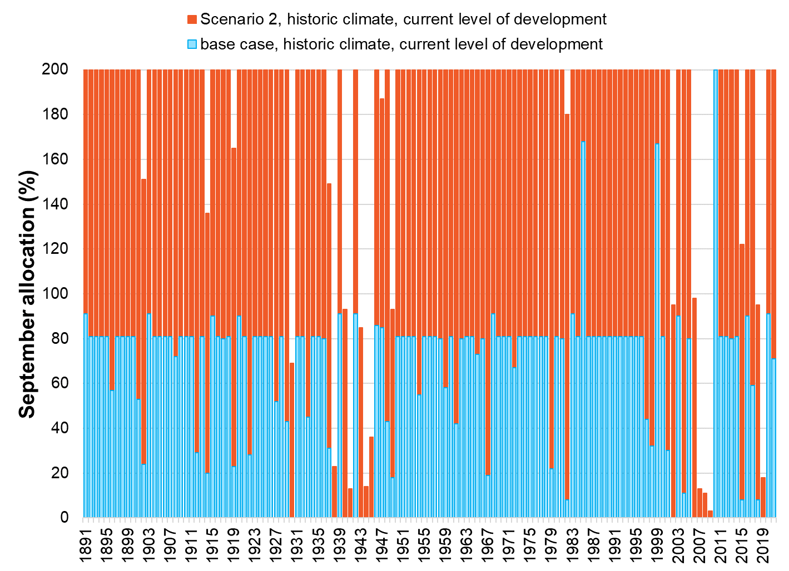

Figure 20: Modelled Historical September allocation under scenario 2

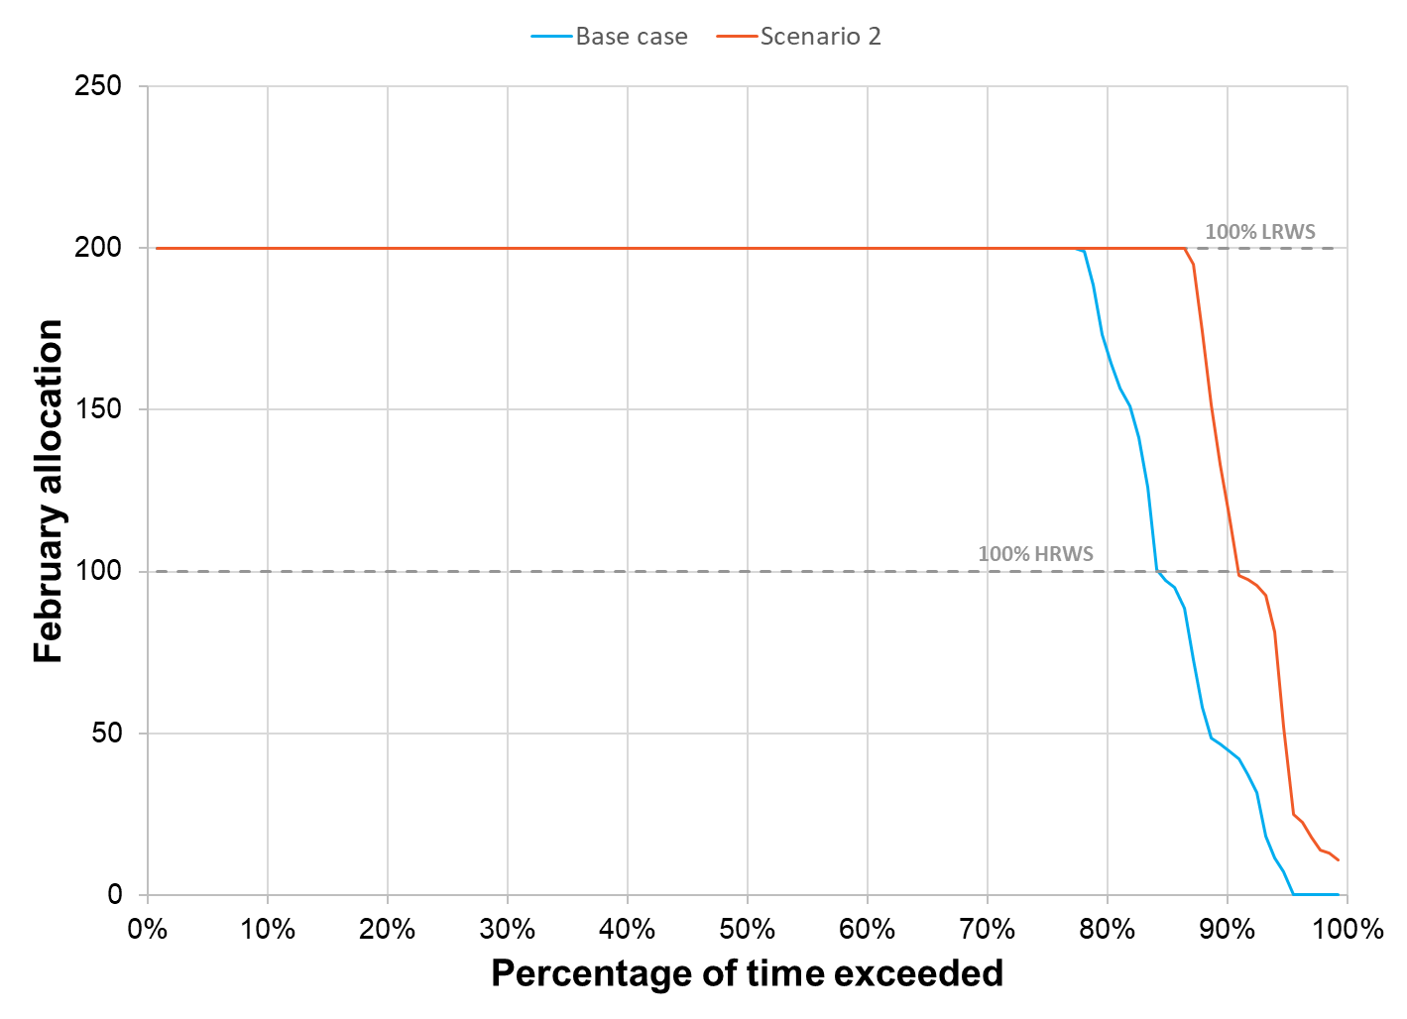

Figure 21: February allocation reliability for scenario 2

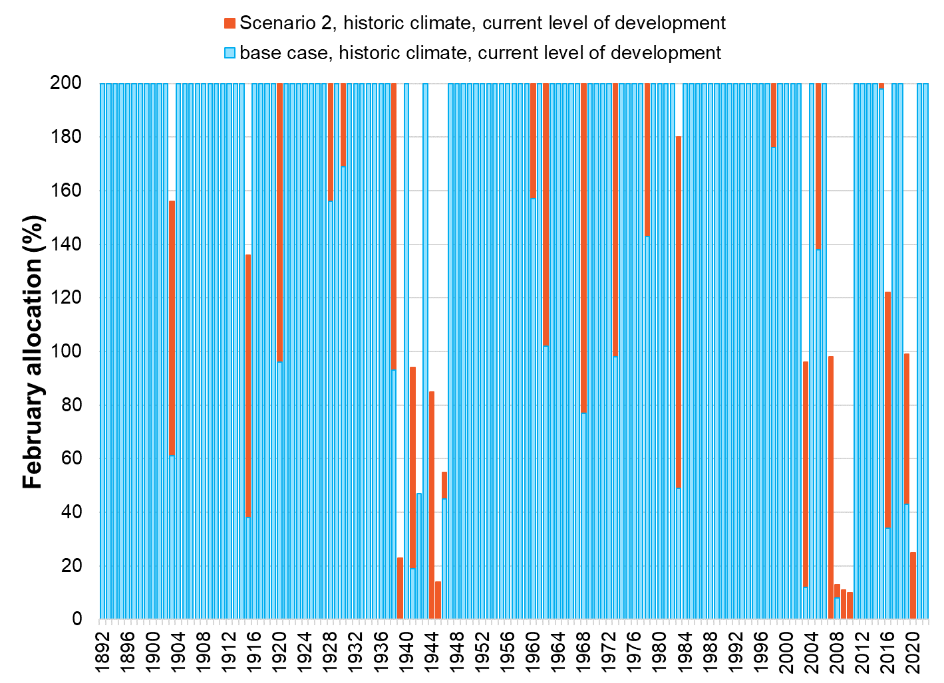

Figure 22: Modelled historical February allocation under scenario 2

#### Alignment with Success Criteria

Scenario 2 represents a complete transformation of the existing Broken System resulting in a transition to a Domestic and Stock only system. The existing entitlements would be recovered and utilised for environmental benefit. System operations would primarily be driven by environmental requirements as opposed to consumptive use demand. The extent of change required under this scenario is unlikely to achieve broad community support.

| Achieving multiple benefits​ | Creating change​​ | Future ready​​ | Community  Acceptance​ | Value for Money |
| --- | --- | --- | --- | --- |
| Badge Cross with solid fill | Badge Tick1 with solid fill | Badge Unfollow with solid fill | Badge Cross with solid fill | Badge Tick1 with solid fill |

## scenario 3 – Remove or Reconnect all Services in Zone 5

#### Summary

* Scenario 3 results in the resupply or removal of all services for Zone 5 to reduce operational losses downstream of Gowangardie Weir.
* ​There are currently 30 existing irrigation service points and 23 D&S service points in Zone 5.
* Resupply under this Scenario involves constructing new irrigation pipelines (primarily from the Shepparton Irrigation Area) and connecting some D&S properties to the Tungamah Pipeline District.​
* This Scenario transfers approximately 450 ML HRWS, 60 ML LRWS from the Broken System to the Goulburn System via connection to the Shepparton Irrigation Area or Tungamah (Cosgrove extension) D&S scheme.​

#### Map

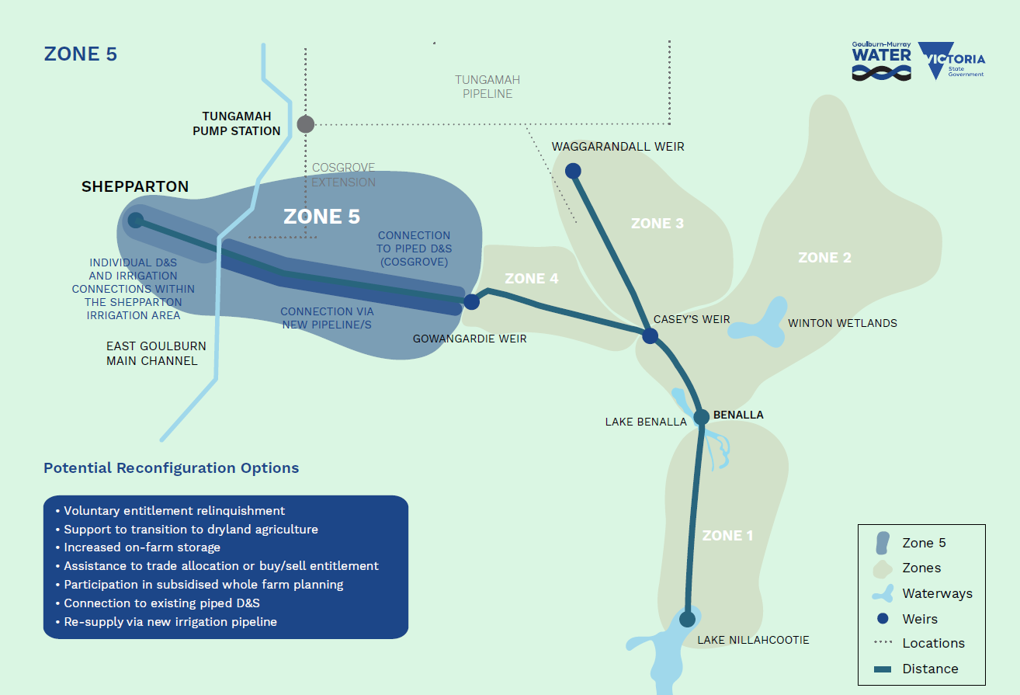

Figure 23: Map showing Zone 5 of the Broken System.

#### Options Applied

* Voluntary entitlement relinquishment
* Support to transition to dryland agriculture
* Increased on-farm storage
* Assistance to trade allocation or buy/sell entitlement
* Participation in subsidised whole farm planning
* Connection to existing piped D&S
* Re-supply via new irrigation pipeline.

#### Estimated Cost to Complete

Based on an assessment of potential activities and costs to implement Scenario 3, the total estimated cost is **$46 million**, comprising of:

Business Case Development: $3.9 million

Implementation: $32.8 million

Project Delivery and Administration: $9.6 million

Key elements included in the implementation estimate are:

* Construction of pipelines to resupply properties
* Entitlement purchases
* Acquisition of Goulburn shares
* Brokerage and legal fees associated with entitlement purchases
* Professional farm planning advice to support landowners to transition to non-irrigation practices.

#### Assumptions

* All Zone 5 properties would be resupplied from outside of Zone 5 (from the Shepparton Irrigation Area, the Tungamah (Cosgrove extension) D&S Pipeline or from Zone 4).
* The concept irrigation pipeline design is based on the current level of water use in the zone.
* For the purpose of modelling, it is assumed that 50% of the unused entitlement (based on 10 years average annual use) would participate in voluntary entitlement purchase. The estimated water recovered through purchase is 2968 ML of HRWS and 709 ML of LRWS.
* The Cosgrove Pipeline has the capacity or can be upgraded to meet the increased demand to resupply Zone 5 D&S users east of the East Goulburn Main on the north side of the Broken River.

#### Stakeholder Feedback

The feedback received in relation to Zone 5 included:

* Two pipeline configurations were discussed, Zone 5 irrigators had a clear preference for connecting to the Goulburn rather than retaining supply from the Broken System.
* Concerns were raised about the potential cost to construct a new pipeline. Previous attempts (under different circumstances) suggested such infrastructure was not a viable option in the Broken.
* Some concerns were raised about recent service issues with the Cosgrove pipeline. Despite concerns, there was still a reasonable level of interest in securing D&S supply via the pipeline.
* Several properties with clearly stated intent to continue in irrigation are privately investing in farm layouts that capitalise on irrigation access.

#### Comparison to Base Case

Compared with the base case, the implementation of Scenario 3 would result in a reasonable improvement in September allocations. However, full-season reliability would only improve by 1%. In this scenario environmental water holdings in the system would increase by 1,484 ML HRWS and 354 ML LRWS increasing the total from 647 ML to approximately 2,485 ML.

Table 7: Indicative results for scenario 3 (measured against the base case)

|  |  |  |
| --- | --- | --- |
| **Metric** | **Baseline (current)** | **Scenario results** |
| Full season reliability  (100% HRWS allocation by February) | 84% | 85% |
| Early season reliability  (100% HRWS allocation by September) | 2% | 69% |
| Change in losses compared to base case (ML) | 19,584 | -137 |
| Entitlement reallocated to environment (ML)  HRWS  LRWS |  | 1,484  354 |
| Entitlement retired for reliability (ML)  HRWS  LRWS |  | 1,484  354 |
| Long-term diversion limit equivalence (LTDLE) (ML) reallocated to environment |  | 1,012 |

Figure 24– Figure 27 shows the modelled changes in reliability for September and February compared to the base case if recovered shares are distributed equally between the environment and improvements to reliability (retired shares).

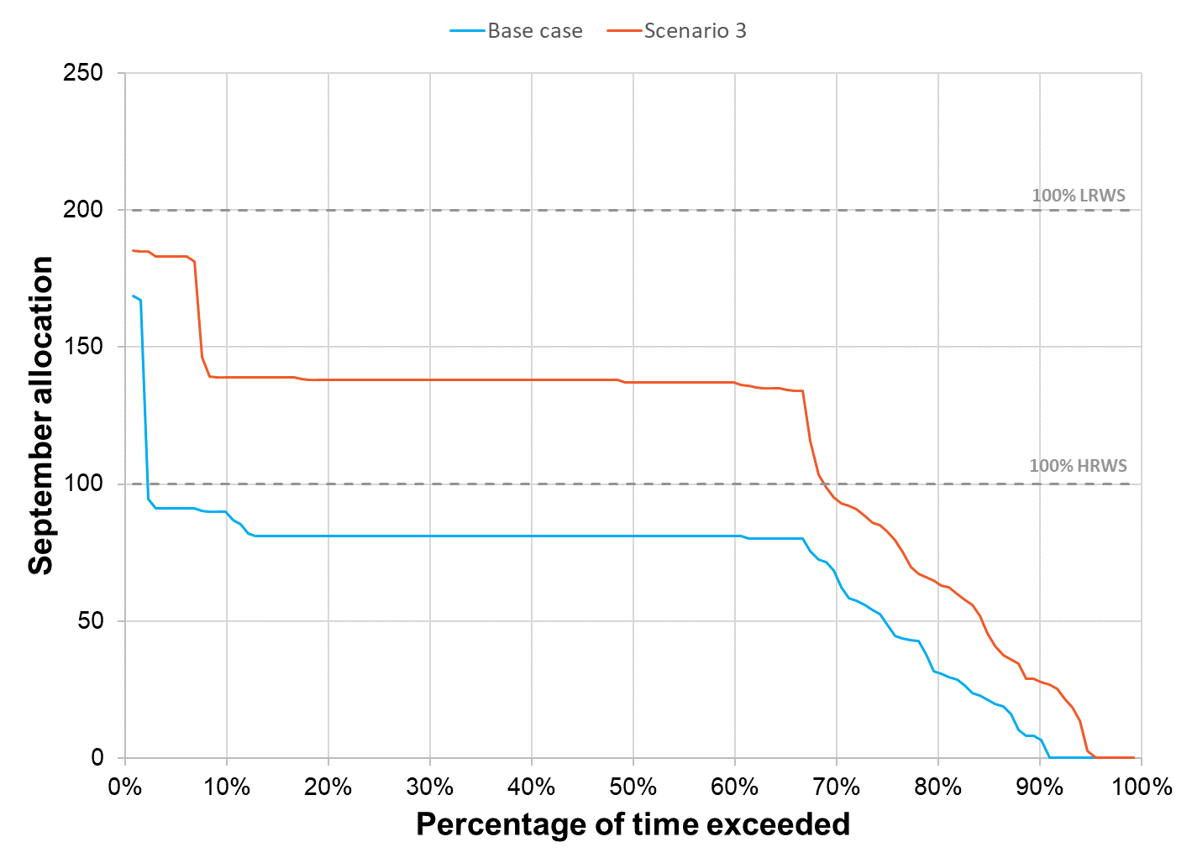

Figure 24: September Allocation Reliability for scenario 3

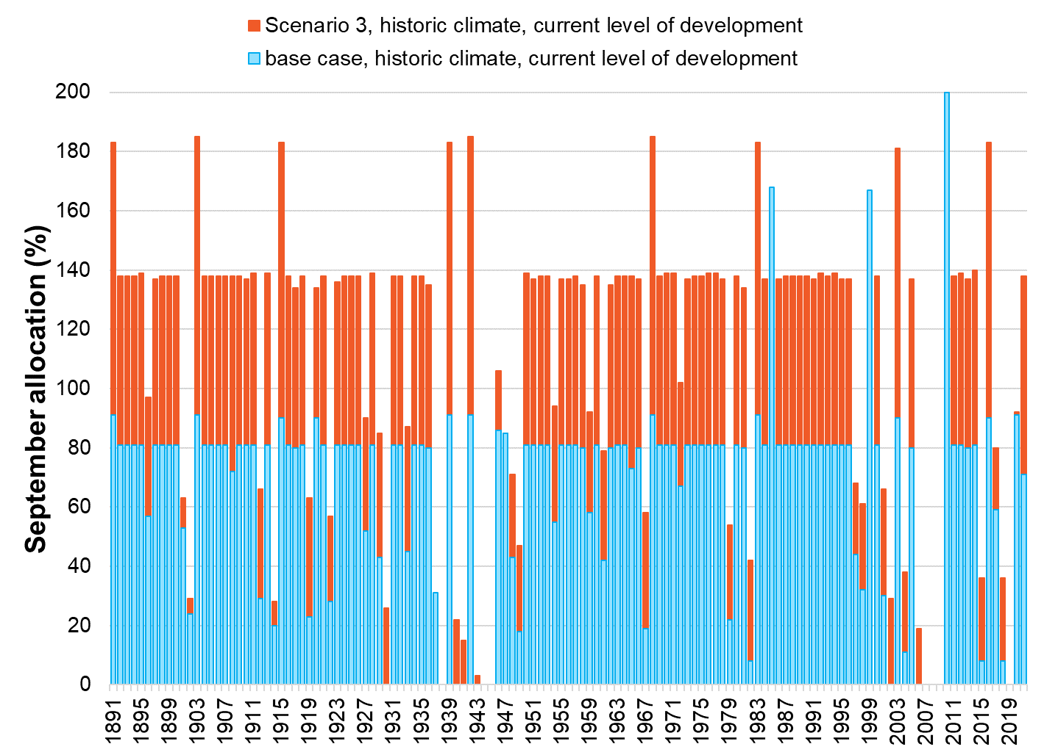

Figure 25: Modelled Historical Allocations under scenario 3

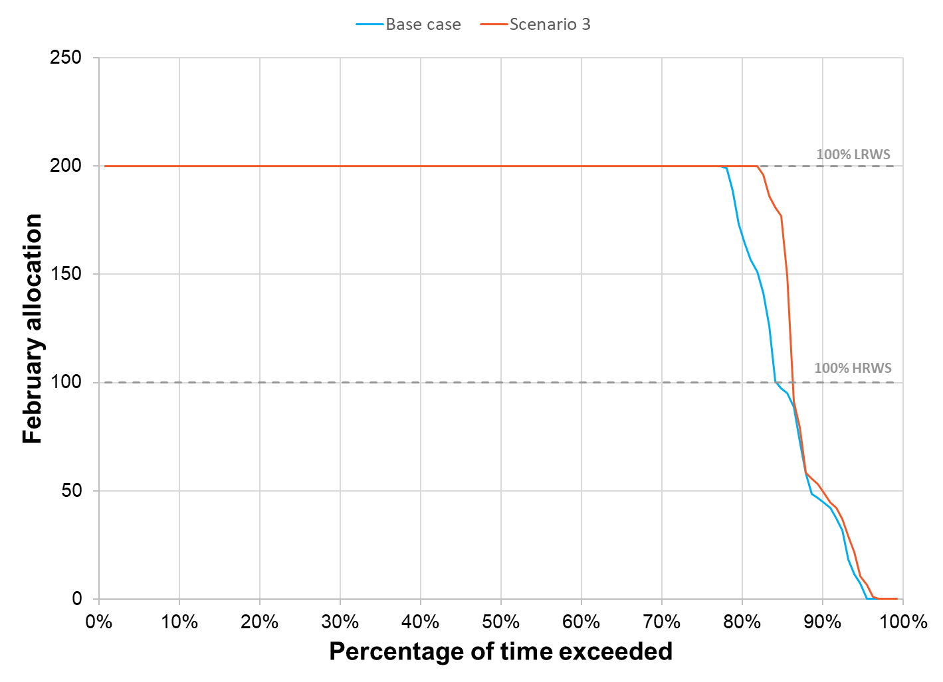

Figure 26: February Allocation Reliability for scenario 3

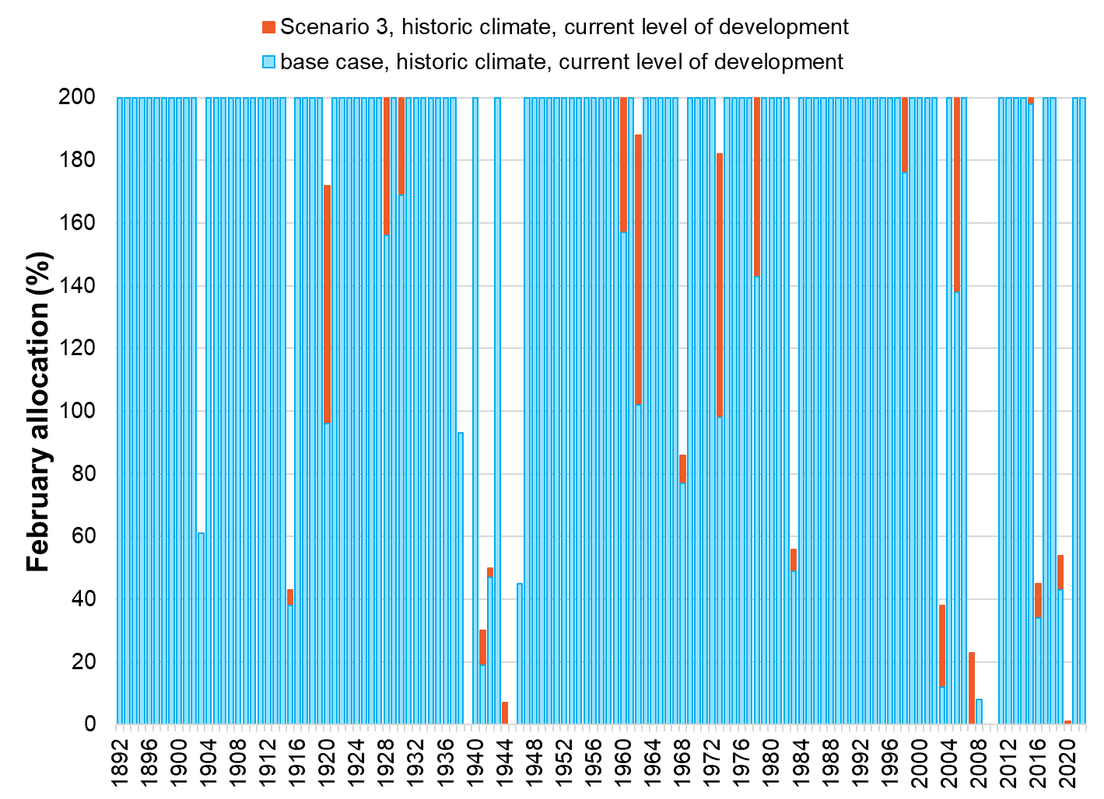

Figure 27: Modelled Historical February Allocations Under scenario 3

#### Alignment with Success Criteria

Scenario 3 involves the reconfiguration of Zone 5 utilising a mix of connection opportunities to existing irrigation and/or D&S infrastructure serviced by the Goulburn System and voluntary entitlement purchase for those seeking to transition away from irrigation. This section of the Broken System would supply no irrigation demand and would be able to be managed to achieve enhanced environmental outcomes through the restoration of natural flow patterns. Customers transitioning to the Goulburn System would be required to obtain Goulburn Water Shares and/or trade allocation. The pipeline supply from the Goulburn System in isolation is a high-cost connection and if not considered across whole of system benefits may not be considered economically feasible.

| Achieving multiple benefits​ | Creating change​​ | Future ready​​ | Community  Acceptance​ | Value for Money |
| --- | --- | --- | --- | --- |
| Badge Tick1 with solid fill | Badge Tick1 with solid fill | Badge Tick1 with solid fill | Badge Tick1 with solid fill | Badge Unfollow with solid fill |

## scenario 4 – Remove or Reconnect all Services in Zone 3

#### Summary

* This Scenario would result in the resupply or removal of all services in Zone 3 (Broken Creek).​
* Annual loss provision for Broken Creek is 4,323 ML.
* 10-year average use for all Zone 3 properties is 278 ML. ​
* There are currently 24 irrigation Service Points and 32 D&S Service Points in this zone.​
* 6 Service Points have more than 10 ML/y use on average, most of which are at the upper end of the creek​ which may support efficient reconnection.
* The zone borders the Tungamah Pipeline District, which may provide an alternate D&S supply source for some properties.​

#### Map

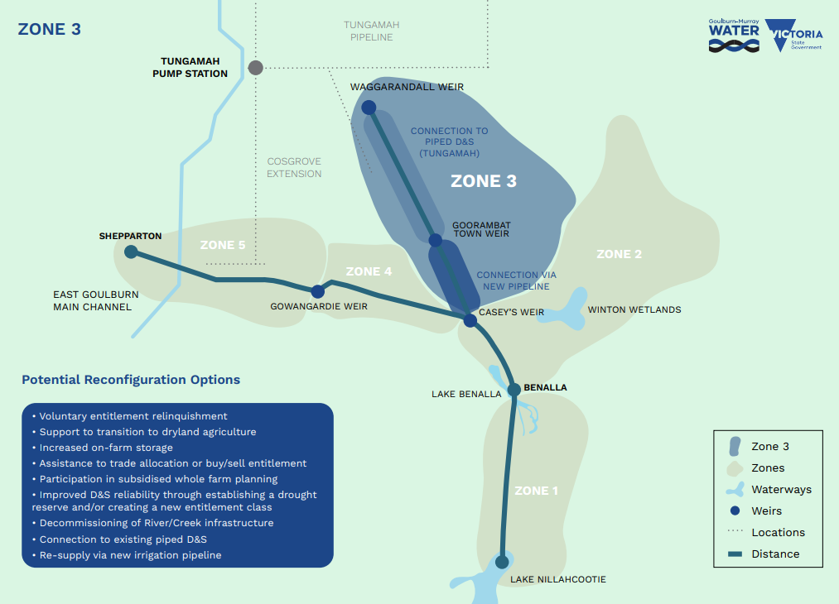

Figure 28: Map showing Zone 3 of the Broken System.

#### Options Applied

* Voluntary entitlement relinquishment
* Support to transition to dryland agriculture
* Increased on-farm storage
* Assistance to trade allocation or buy/sell entitlement
* Participation in subsidised whole farm planning
* Decommissioning of River/Creek infrastructure
* Connection to existing piped D&S
* Re-supply via new irrigation pipeline.

#### Estimated Cost to Complete

Based on an assessment of potential activities and costs to implement Scenario 4, the total estimated cost is **$23 million**, comprising of:

Business Case Development: $3.3 million

Implementation: $12.5 million

Project Delivery and Administration: $6.8 million

Key elements included in the implementation estimate are:

* Construction of pipelines to resupply properties.
* Entitlement purchases.
* Brokerage and legal fees associated with entitlement purchases.
* Professional farm planning advice to support landowners to transition to non-irrigation practices.

#### Assumptions

* All Zone 3 properties would be resupplied from outside of Zone 3 (New Irrigation and D&S pipeline at the southern end supplied from Zone 2, northern end supplied with D&S only via an extension to the Tungamah Pipeline).
* The concept irrigation pipeline design is based on the current level of water use in the zone.
* For the purpose of modelling, it is assumed that 50% of the unused entitlement (based on 10 years average annual use) would be relinquished. The estimated water recovered through purchase is 1302 ML of HRWS and 304 ML of LRWS.
* The Tungamah Pipeline has the capacity or can be upgraded to meet the increased demand to resupply the northern extent of Zone 3.

#### Stakeholder Feedback

The feedback received in relation to Zone 3 included:

* In general, Broken and Majors Creek entitlement holders were wary of changes that could result in less water passing through the creek. Reasons offered include concern for the impact on environmental values and loss of amenity.
* Retaining access to D&S water is a high priority.
* Only a small portion of the Zone 3 properties have engaged in irrigation practices over the last decade. Some property owners held a preference for selling allocation to downstream systems over using it on property in recent times.
* Some Zone 3 property owners have land already connected to the Tungamah Pipeline or have neighbours who are connected. There was a level of apprehension shown for connecting to the pipeline due to existing problems with the service (pressure loss and maintenance downtime).

#### Comparison to Base Case

Compared with the base case, the implementation of Scenario 4 would result in a minor improvements to early and late-season allocations. In this scenario environmental water holdings in the system would increase by 651 ML HRWS and 152 ML LRWS increasing the total from 647 ML to approximately 1,450 ML. Removal of Broken Creek demand would also provide an opportunity to reapportion the substantial loss provision that is currently in place.

Table 8: Indicative results for scenario 4 (measured against the base case)

| **Metric** | **Baseline (current)** | **Scenario results** |
| --- | --- | --- |
| Full season reliability  (100% HRWS allocation by February) | 84% | 85% |
| Early season reliability  (100% HRWS allocation by September) | 2% | 9% |
| Change in losses compared to base case (ML) | 19,584 | -4,432 |
| Entitlement reallocated to environment (ML)  HRWS  LRWS |  | 651  152 |
| Entitlement retired for reliability (ML)  HRWS  LRWS |  | 651  152 |
| Long-term diversion limit equivalence (LTDLE) (ML) reallocated to environment |  | 4,816 |

Figure 29- Figure 32 shows the modelled changes in reliability for September and February compared to the base case if recovered shares are distributed equally between the environment and improvements to reliability (retired shares).

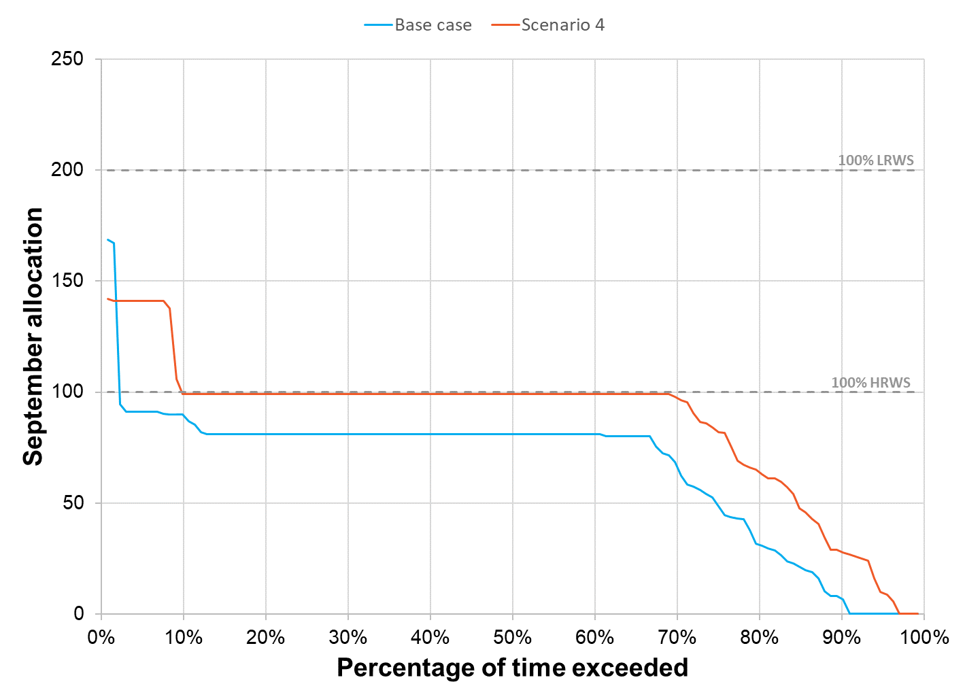

Figure 29: September allocation reliability for scenario 4

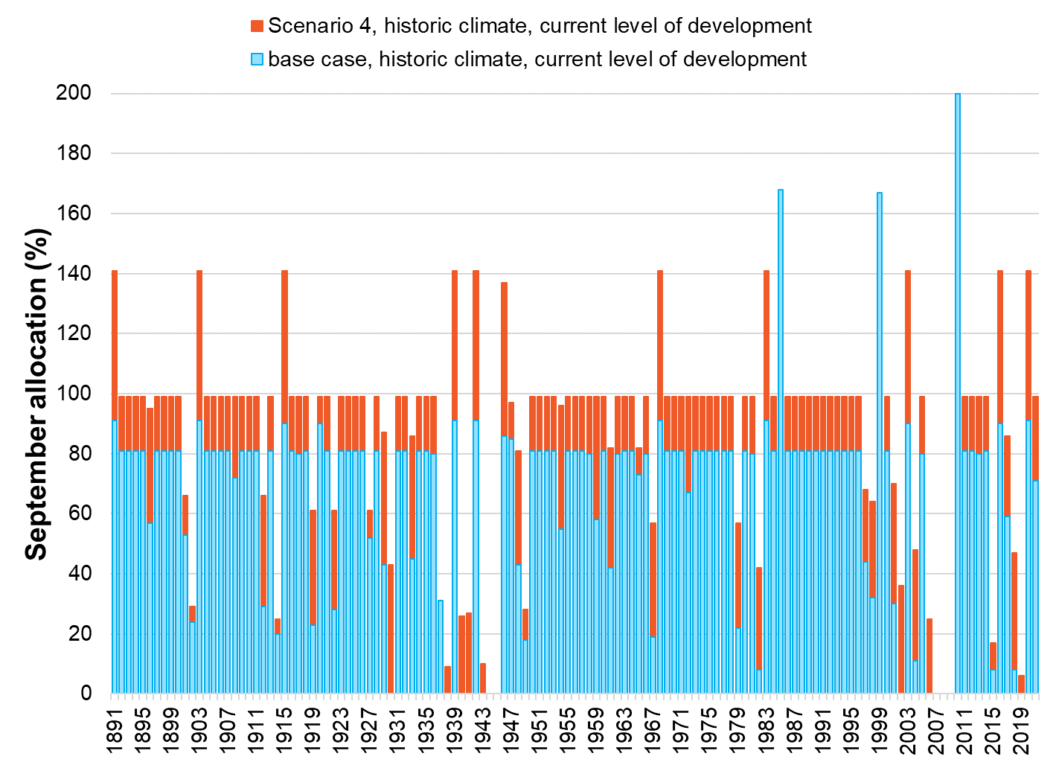

Figure 30: Modelled historical allocation under scenario 4

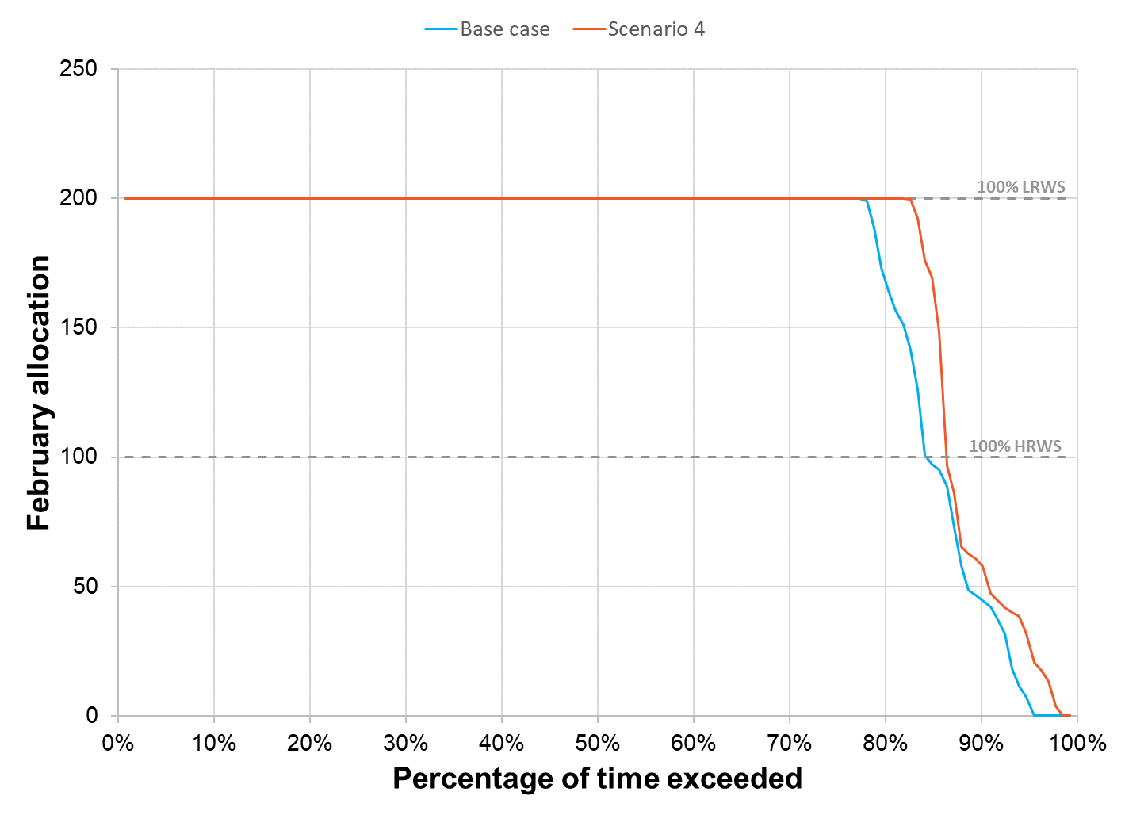

Figure 31: February allocation reliability for scenario 4

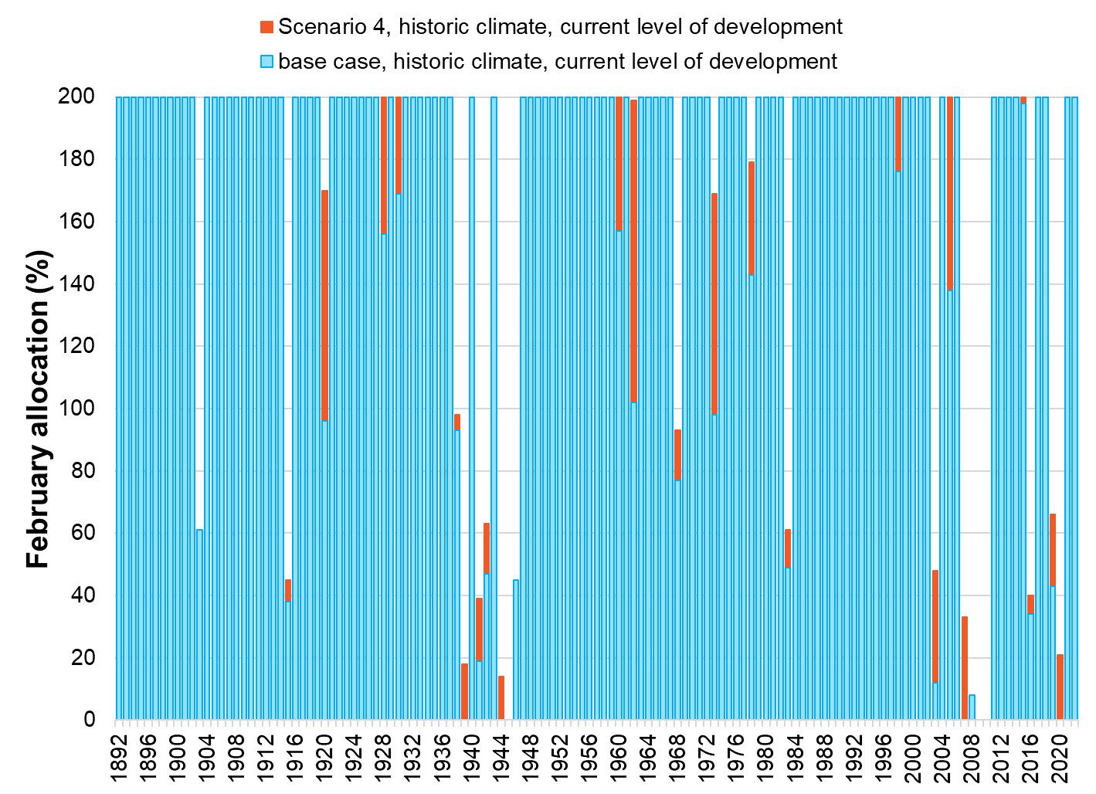

Figure 32: Modelled historical allocation under scenario 4

#### Alignment with Success Criteria

Scenario 4 represents the reconfiguration of Zone 3 utilising a mix of connection opportunities to existing irrigation and/or D&S infrastructure serviced by the Broken and Goulburn Systems. This option also includes voluntary entitlement purchases for those seeking to transition away from irrigation. This section of the Broken System would supply irrigation and domestic and stock supplies via pipelines as opposed to a reliance on the natural creek system. It is envisaged that the creek would continue to be supplied based on the achievement of desired environmental outcomes as opposed to remaining artificially high to support irrigation and D&S demand. Community acceptance of this scenario is likely to be contingent on a greater understanding of the environmental flow regime that would be employed if the system were to be reconfigured. This would require the Goulburn Broken CMA to complete an updated flow study for this section of the System during the business case stage. This Scenario provides the largest opportunity to reduce System operation losses through system reconfiguration. It would also provide an opportunity to manage the creek in a manner that is better suited to meeting environmental objectives.

| Achieving multiple benefits​ | Creating change​​ | Future ready​​ | Community  Acceptance​ | Value for Money |
| --- | --- | --- | --- | --- |
| Badge Tick1 with solid fill | Badge Tick1 with solid fill | Badge Tick1 with solid fill | Badge Unfollow with solid fill | Badge Tick1 with solid fill |

## scenario 5 - Mokoan Pipeline Supply Channel Upgrades

#### Summary

* The Mokoan Pipeline draws from an 8km-long delivery channel (Stockyard Creek).
* The channel is shallow and full of silt.
* 80 – 100 ML/y of estimated loss from evaporation in the delivery channel.
* Water delivery is further hampered by excessive weed growth in the channel.
* The pipeline is designed for 24 ML/d however flow conditions are reported to limit available flow to the pipeline to 10 ML/d.
* Contributed to excessive wear of the pumping equipment.
* Contributed to excessive wear of the pumping equipment.
* Upgrading the Mokoan pipeline supply channel would reduce losses and have water quality and service benefits for pipeline water users.

#### Map

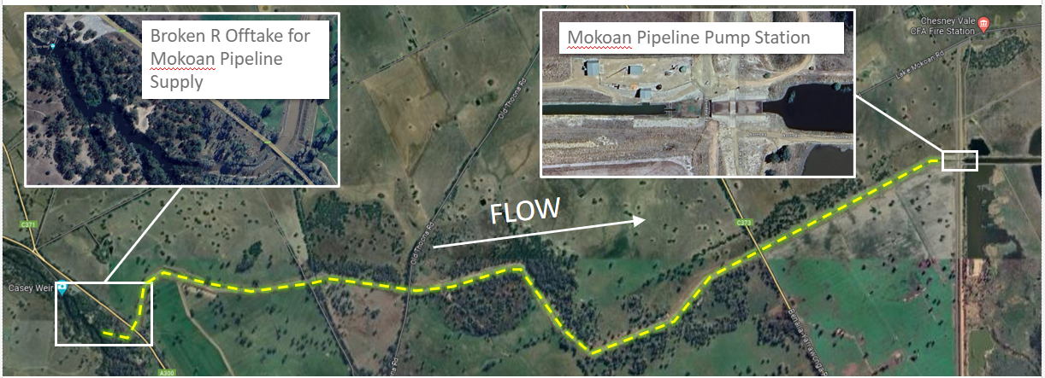

Figure 33: Map showing location of Mokoan pipeline supply channel

#### Options Applied

* Re-supply via a new irrigation pipeline (Casey’s Weir to the existing Lake Mokoan Pumping Station).
* Alternatively, channel remodelling or lining may be considered if it proves to be a more suitable option.

#### Estimated Cost to Complete

Based on an assessment of potential activities and costs to implement scenario 5, the total estimated cost is **$9 million**, comprising of:

Business Case Development: $1.3 million

Implementation: $4.7 million

Project Delivery and Administration: $3.3 million

Key elements included in the implementation estimate are:

* Construction of a pumped pipeline to from Caseys Weir to the existing Mokoan Pumping Station.

#### Assumptions

* Existing demand remains at the current level.
* The new infrastructure would be owned and operated by GMW.

#### Stakeholder Feedback

* Most stakeholders consulted were not directly impacted by the current arrangements.
* Properties currently supplied by the Mokoan pipeline shared the view that the pipeline is an important feature to maintain.
* To maintain service to Mokoan pipeline properties, GMW is required to undertake regular maintenance to repair and replace equipment degraded by the poor water quality.

#### Comparison to Base Case

Compared with the base case, the implementation of Scenario 5 makes very little difference to allocations. Environmental water holdings would not change. Scenario 5 would reduce overall System losses by 107 ML, which results from a reduction of evaporation and seepage losses in the supply channel.

Table 9: Indicative results for scenario 5 (measured against the base case)

|  |  |  |
| --- | --- | --- |
| **Metric** | **Baseline (current)** | **Scenario results** |
| Full season reliability  (100% HRWS allocation by February) | 84% | 85% |
| Early season reliability  (100% HRWS allocation by September) | 2% | 1% |
| Change in losses compared to base case (ML) | 19,584 | -107 |
| Entitlement reallocated to environment (ML)  HRWS  LRWS |  | 0  0 |
| Entitlement retired for reliability (ML)  HRWS  LRWS |  | -  0  0 |
| Long-term diversion limit equivalence (LTDLE) (ML) reallocated to environment |  | 107 |

Figure 34 – Figure 37 show the modelled changes in reliability for September and February compared to the base case if recovered shares are distributed equally between the environment and improvements to reliability (retired shares).

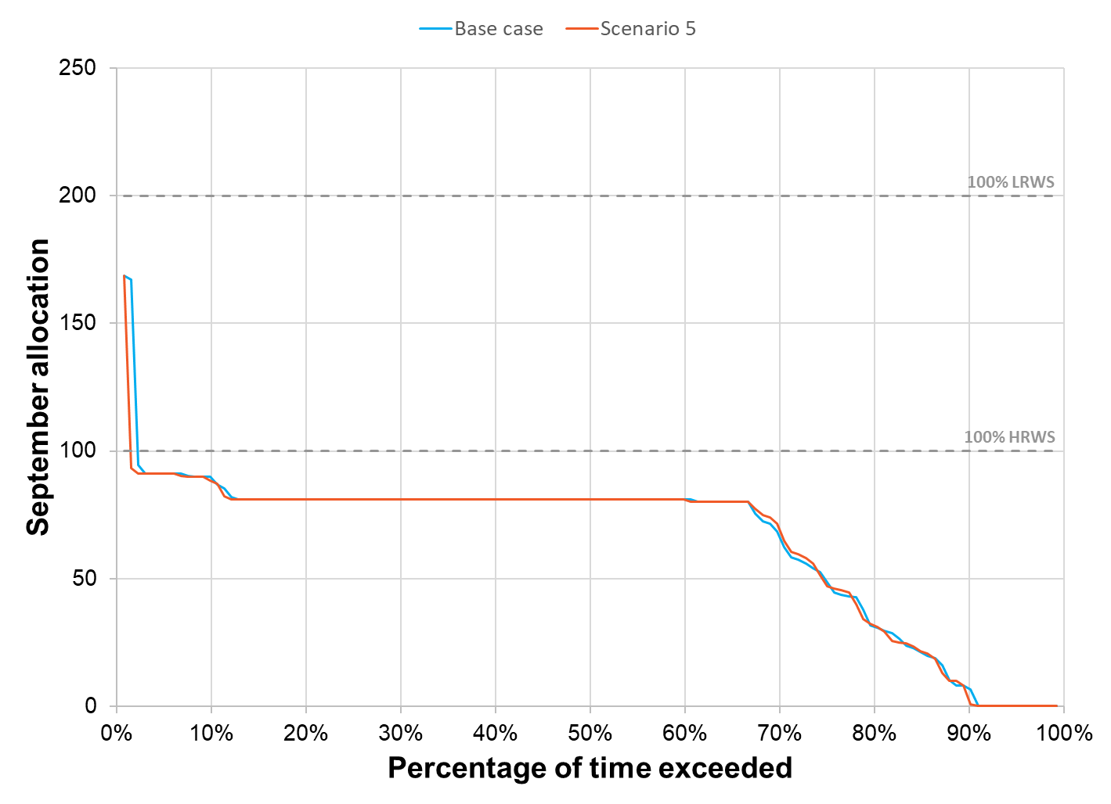

Figure 34: September allocation reliability for scenario 5

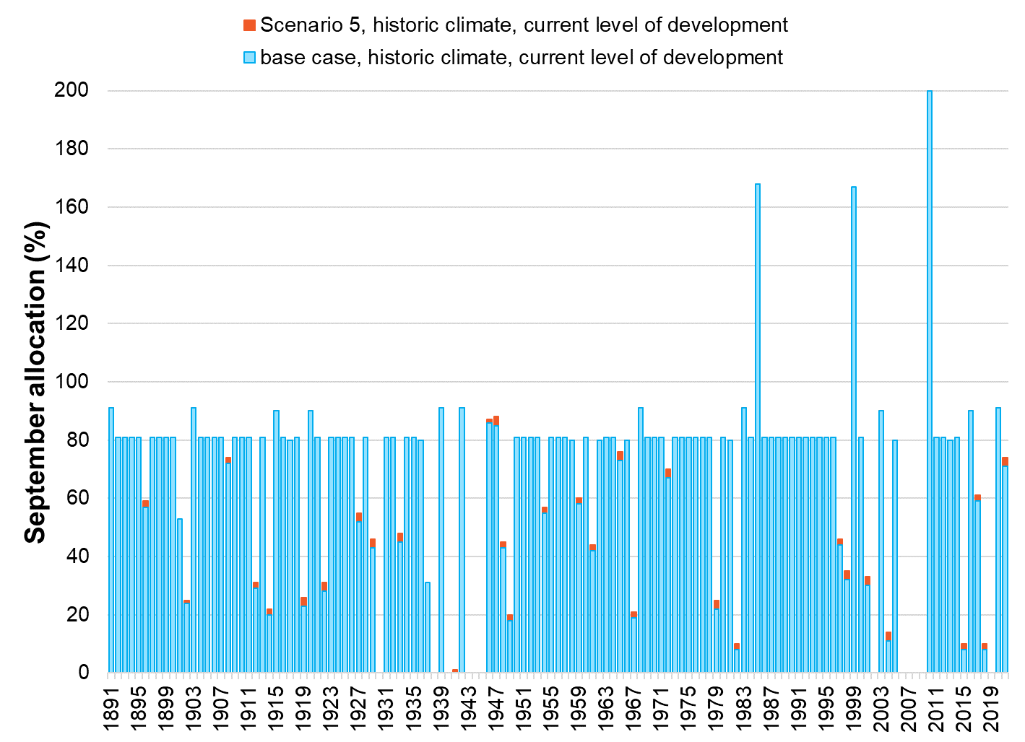

Figure 35: Modelled historical allocation under scenario 5

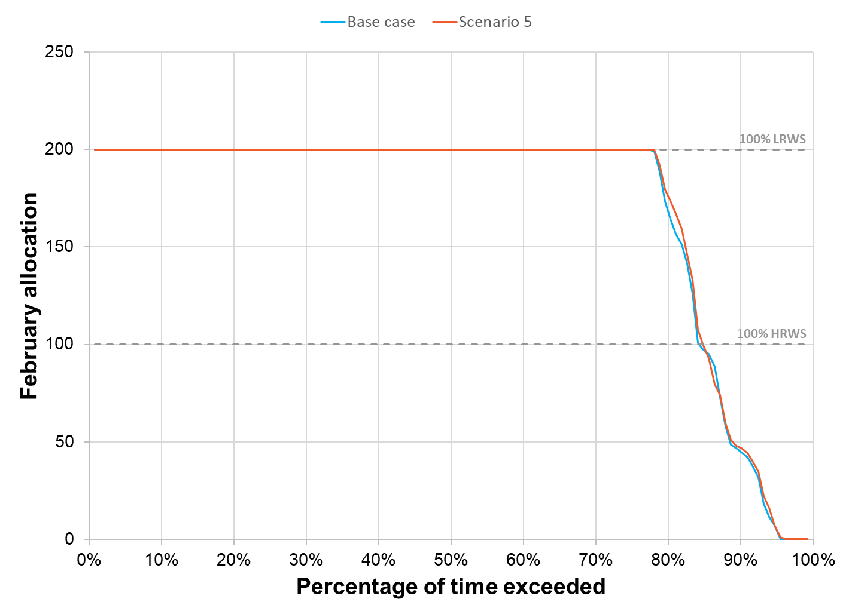

Figure 36: February allocation reliability for scenario 5

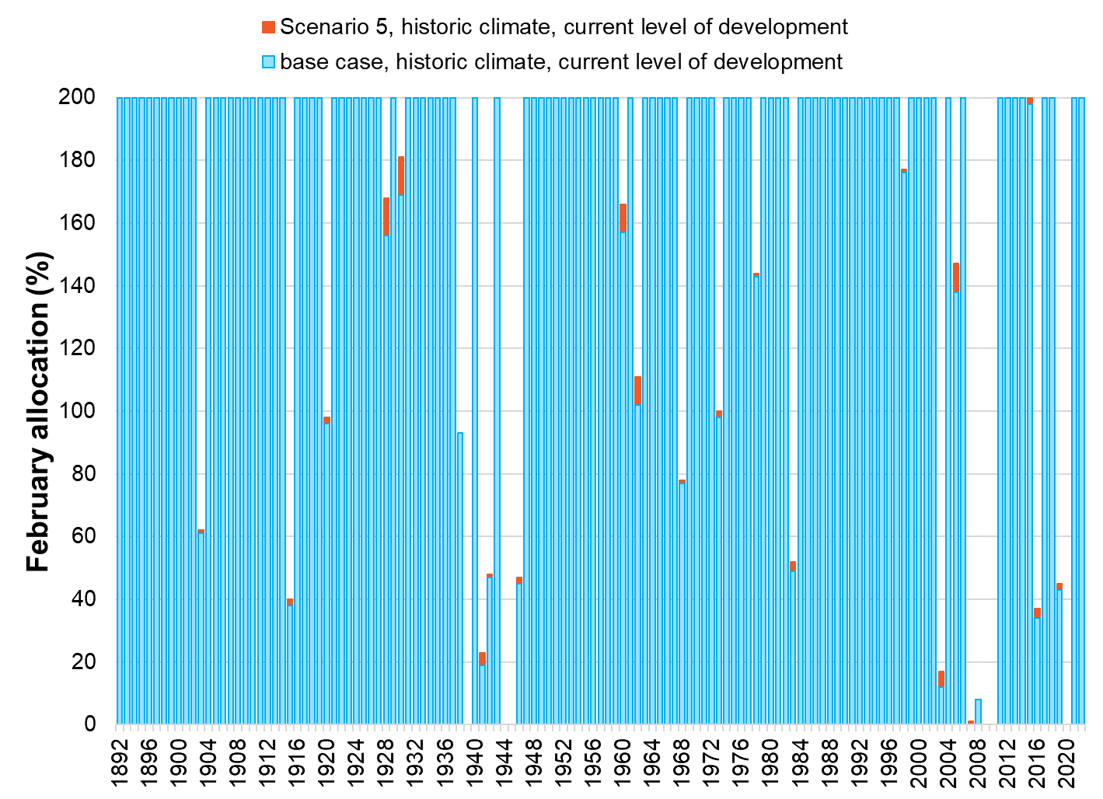

Figure 37: Modelled historical allocation under scenario 5

#### Alignment with Success Criteria

Scenario 5 assessed the benefits of resupplying the existing Mokoan Pipeline pumpstation directly from the Broken River. The assessment yielded limited benefits to system reconfiguration – notwithstanding there may be incentive for Goulburn-Murray Water as a method to manage the operation of the existing assets.

| Achieving multiple benefits​ | Creating change​​ | Future ready​​ | Community  Acceptance​ | Value for Money |
| --- | --- | --- | --- | --- |
| Badge Cross with solid fill | Badge Cross with solid fill | Badge Cross with solid fill | Badge Tick1 with solid fill | Badge Cross with solid fill |

## scenario 6 – SYSTEMWIDE INITIATIVES

#### Summary

Scenario 6 assessed a range of initiatives that would apply across multiple zones including:

* Voluntary purchase of water entitlements supported by an adjustment program which would include:
  + Advisory support to plan for a transition to dry land farming.
  + Whole farm planning incentives
* Fish passage enhanced at Gowangardie Weir through decommissioning or other works.

#### Options Applied

* Voluntary entitlement relinquishment
* Support to transition to dryland agriculture
* Increased on-farm storage
* Assistance to trade allocation or buy/sell entitlement
* Participation in subsidised whole farm planning
* Decommissioning of river/creek infrastructure
* Connection to existing piped D&S
* Re-supply via new irrigation pipeline.

#### Estimated Cost to Complete

Based on an assessment of potential activities and costs to implement Scenario 6, the total estimated cost is **$49 million**, comprising of:

Business Case Development: $3.5 million

Implementation: $37.5 million

Project Delivery and Administration: $8.4 million

Key elements included in the implementation estimate are:

* Entitlement purchases
* Brokerage and legal fees associated with entitlement purchases
* Professional farm planning advice to support landowners to transition to non-irrigation practices
* Whole Farm Planning (WFP) survey and design
* Works to transition properties to non-irrigation practices
* Works to transition properties to a more efficient form of irrigated use
* Increased on-farm storage
* Decommissioning of Gowangardie Weir.

#### Assumptions

* For the purpose of modelling and assessing the Scenario, the estimated number of shares relinquished through voluntary purchase is based on:
  + 50% of unused HRWS and LRWS, based on average use over the previous 10 years, in Zone 1-5 to be purchased, resulting in an estimated recovery of 6,692 HRWS and 1,627 LRWS.

#### Stakeholder Feedback

* 35% of respondents indicated they would be interested in participating in a voluntary entitlement purchase program. When filtering out responses from respondents who hold less than 10 ML (not in possession of entitlement surplus to meeting basic needs) the participation rate increases to 46%.
* Community members expressed a desire for equity across the zones in relation to the opportunity to participate in voluntary entitlement purchase.
* 20% of respondents indicated an interest in transitioning to dryland (non-irrigation) agriculture. However, many of the participants reported they would not need support because they had already made the transition.
* Over half of the respondents elected to remain neutral about the decommissioning of river infrastructure. A common explanation of this position during direct engagement was not understanding the benefits and impacts well enough to support or oppose the concept.
* Strong support was given to making the options presented available to the wider Broken community, with 78% of respondents confirming their support.
  + 65% of HRWS is held in accounts not linked to land to be purchased (excludes environmental water holders and GMW).
  + LRWS would be purchased.
* The assessment assumes that 50% of the recovered entitlement will be transferred to environmental water holders, and 50% will be retired to support system reliability.

#### Comparison to Base Case

Compared with the base case, the implementation of Scenario 6 would result in a reasonable improvement in September allocations, with full-season going up by 3%. In this scenario environmental water holdings in the system would increase by 3,346 ML HRWS and 814 ML LRWS increasing the total from 647 ML to approximately 4,807 ML.

Table 10: Indicative results for scenario 6 (measured against the base case)

| **Metric** | **Baseline (current)** | **Scenario results** |
| --- | --- | --- |
| Full season reliability  (100% HRWS allocation by February) | 84% | 87% |
| Early season reliability  (100% HRWS allocation by September) | 2% | 82% |
| Change in losses compared to base case (ML) | 19,584 | -228 |
| Entitlement reallocated to environment (ML)  HRWS  LRWS |  | 3,346  814 |
| Entitlement retired for reliability (ML)  HRWS  LRWS |  | 3,346  814 |
| Long-term diversion limit equivalence (LTDLE) (ML) reallocated to environment |  | 2,203 |

Figure 38: September allocation reliability for scenario 6

Figure 38 – Figure 41 shows the modelled changes in reliability for September and February compared to the base case if recovered shares are distributed equally between the environment and improvements to reliability (retired shares).

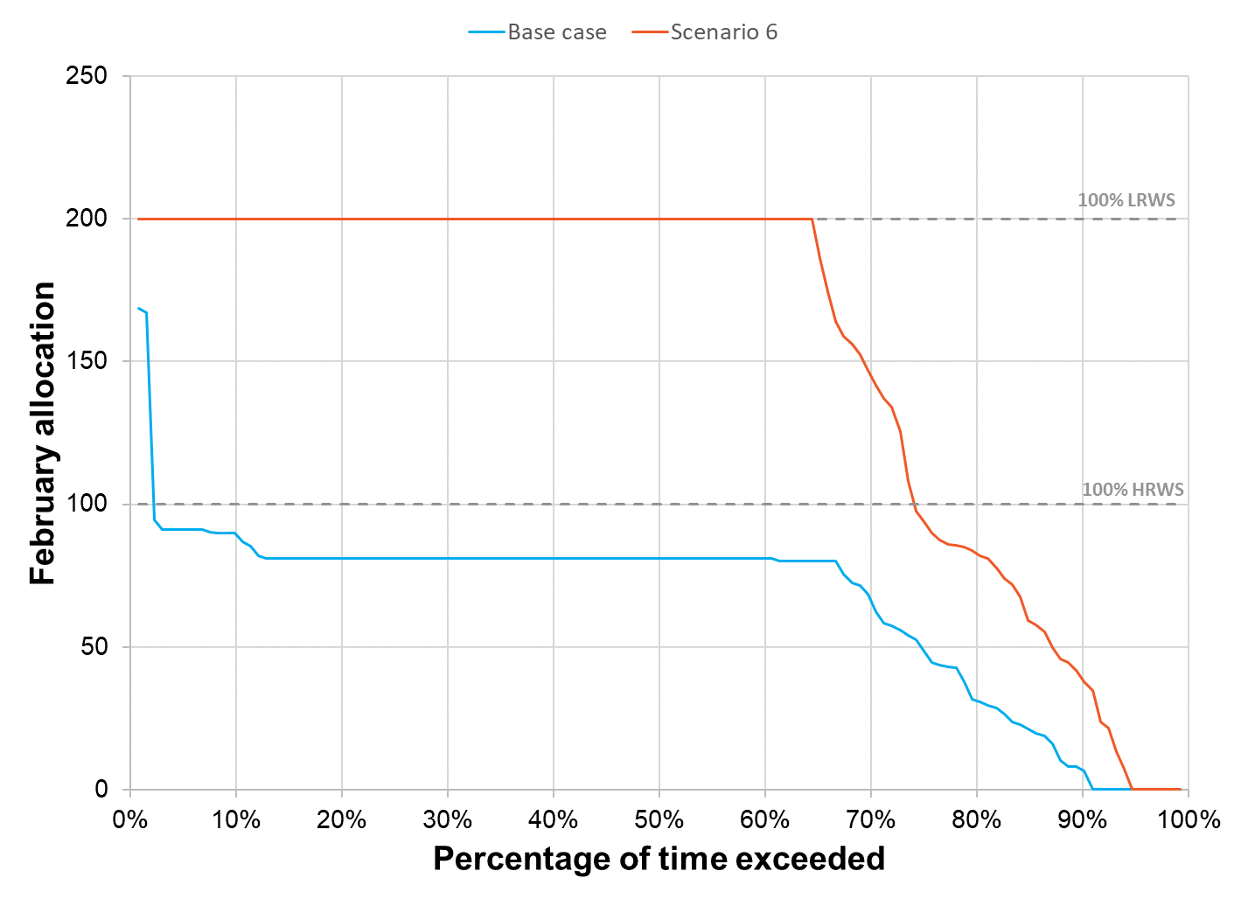

Figure 38: September allocation reliability for scenario 6

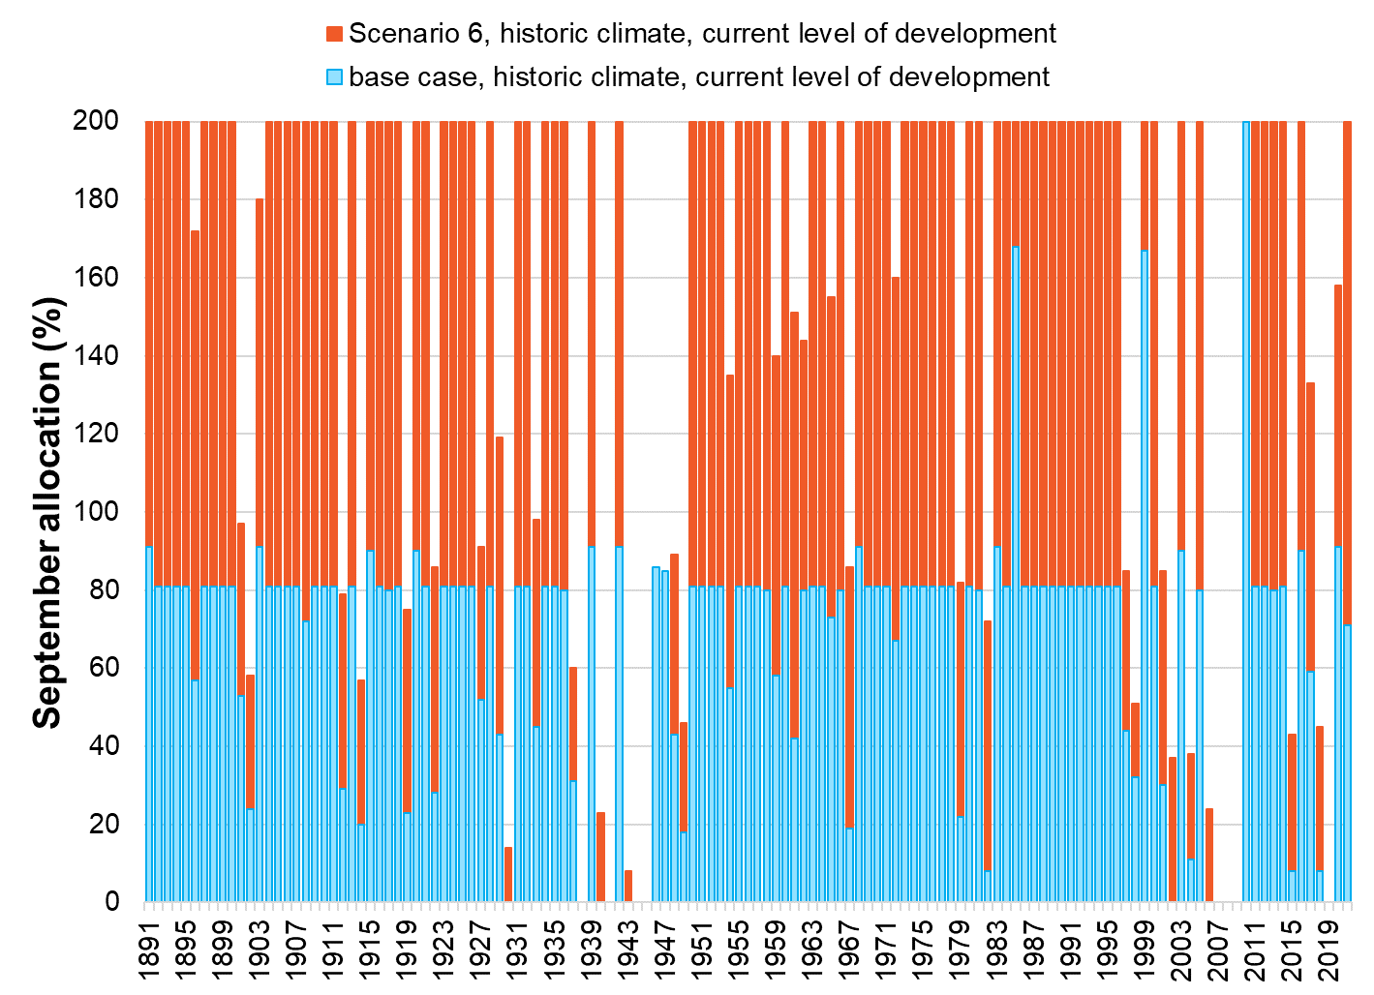

Figure 39: Modelled historical allocation under scenario 6

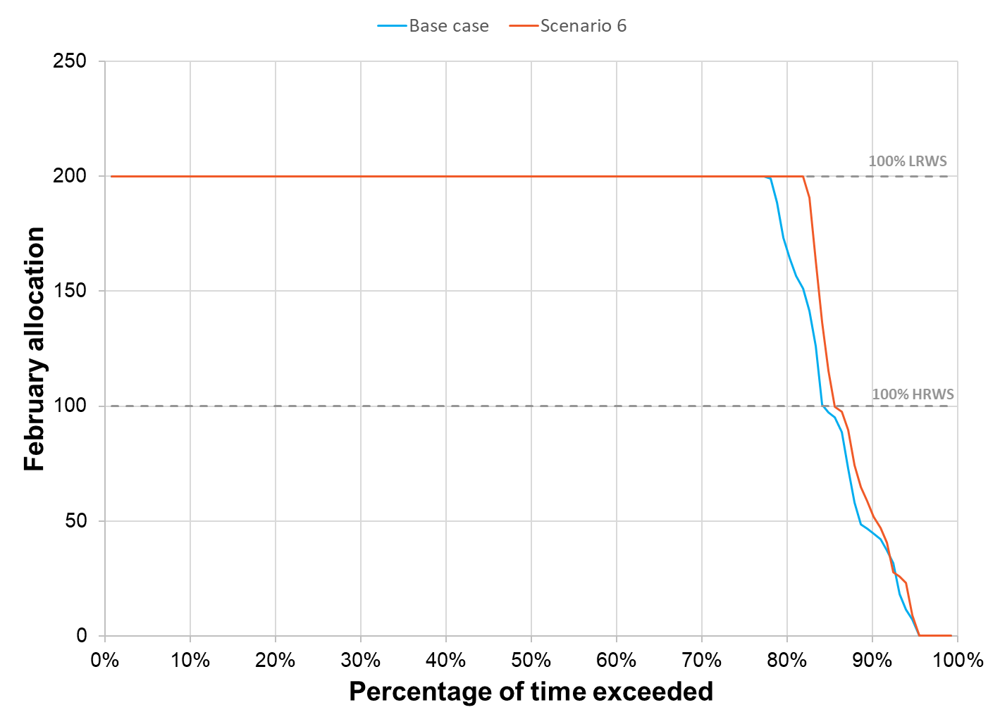

Figure 40: February allocation reliability for scenario 6

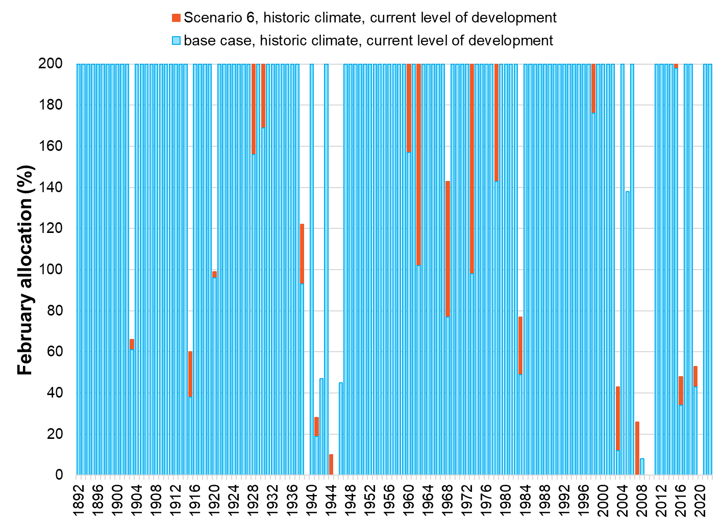

Figure 41: Modelled historical allocation under scenario 6

#### Alignment with Success Criteria

Scenario 6 assessed a range of initiatives that would apply across multiple zones (i.e. voluntary water entitlement purchase) and/or provide systemwide benefits (e.g. environmental benefits as a result of removing Gowangardie Weir to facilitate fish passage). The voluntary water entitlement purchase is considered a key enabling element to the facilitation of reconfiguration outcomes particularly in Zone 5 and Zone 3.

| Achieving multiple benefits​ | Creating change​​ | Future ready​​ | Community  Acceptance​ | Value for Money |
| --- | --- | --- | --- | --- |
| Badge Tick1 with solid fill | Badge Tick1 with solid fill | Badge Tick1 with solid fill | Badge Tick1 with solid fill | Badge Tick1 with solid fill |

## scenario 7 – SECURE ACCESS TO D&S WATER

#### Summary

* Broken customers are seeking an improvement in D&S reliability, particularly in dry years.
* Recommendations 1-6 of the previous Broken Review are investigating D&S reserve options.
* This Scenario looks at an option for greater security of access to water for domestic and stock needs.
* The modelling was based on 2 ML per property (syndicate/schemes factored in where 2 ML per property has been considered), amounting to 790 ML/yr.
* The Scenario could be supported by establishing a reserve using entitlement held by GMW (out of 830 ML Cosgrove savings).
* This Scenario applies across all zones and to all Entitlement Holders across the system.

#### Options Applied

* A more secure supply for basic D&S water needs for all existing water users in the Broken System.

#### Estimated Cost to Complete

Based on an assessment of potential activities and costs to implement Scenario 7, the total estimated cost is **$3 million**, comprising of:

Business Case Development: $0.4 million

Implementation: $1.0 million

Project Delivery and Administration: $1.4 million

Key elements included in the implementation estimate are:

* Water entitlement changeover
* Administration of entitlement changes.

#### Assumptions

* The specific mechanism to achieve the outcome of a more secure supply for basic D&S water needs would be further evaluated through the Business Case and would need to be achievable within current policy settings.
* For the purpose of modelling and assessment, it was assumed that entitlement held by GMW through the completion of the Cosgrove Project would form part of a reserve set aside each season to support D&S allocation.
* No potential additional D&S demand coming into the system is included.

#### Stakeholder Feedback

* The option for improved access to D&S received the highest level of support of all options in the survey with 88% in favour.
* The criticality of providing secure access to stock and domestic supply was consistently raised through community engagement session, one-on-one meetings and the online feedback forum.

#### Comparison to Base Case

Reliability for Scenario 7 was modelled to provide a comparison to other scenarios Table 11. However, Scenario 7 will have limited impact on reliability factors as it does not include any retirement of entitlement.

Table 11: Indicative results for scenario 7 (measured against the base case)

| **Metric** | **Baseline (current)** | **Scenario results** |
| --- | --- | --- |
| Full season reliability  (100% HRWS allocation by February) | 84% | 83% |
| Early season reliability  (100% HRWS allocation by September) | 2% | 2% |
| Change in losses compared to base case (ML) | 19,584 | -24 |
| Entitlement reallocated to environment (ML)  HRWS  LRWS |  | 0  0 |
| Entitlement retired for reliability (ML)  HRWS  LRWS |  | 0  0 |
| Long-term diversion limit equivalence (LTDLE) (ML) reallocated to environment |  | 24 |

Figure 42- Figure 45 shows the modelled changes in reliability for September and February compared to the base case if recovered shares are distributed equally between the environment and improvements to reliability (retired shares).

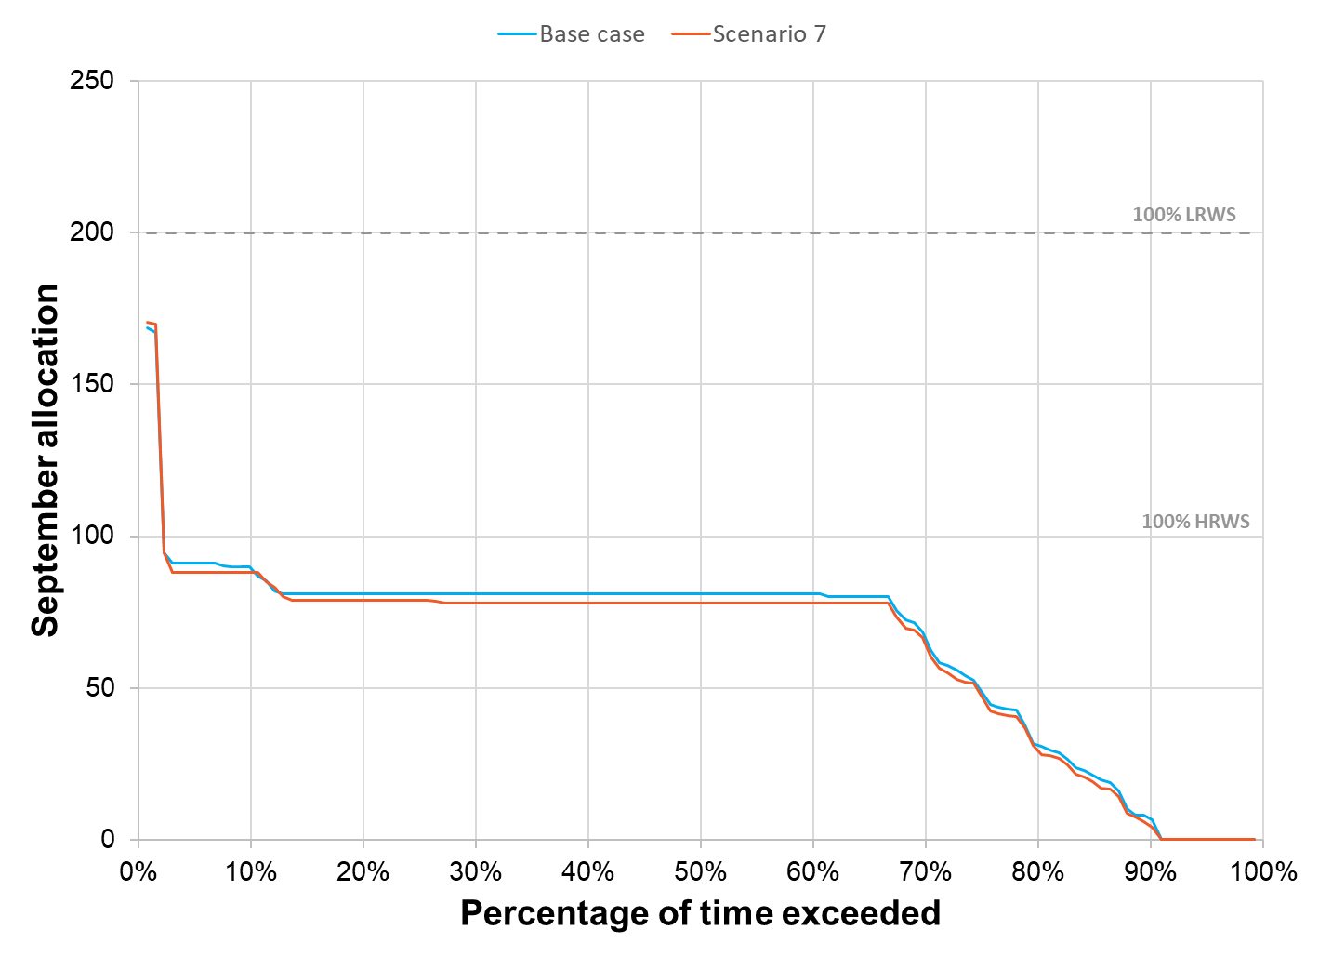

Figure 42: September allocation reliability for scenario 7

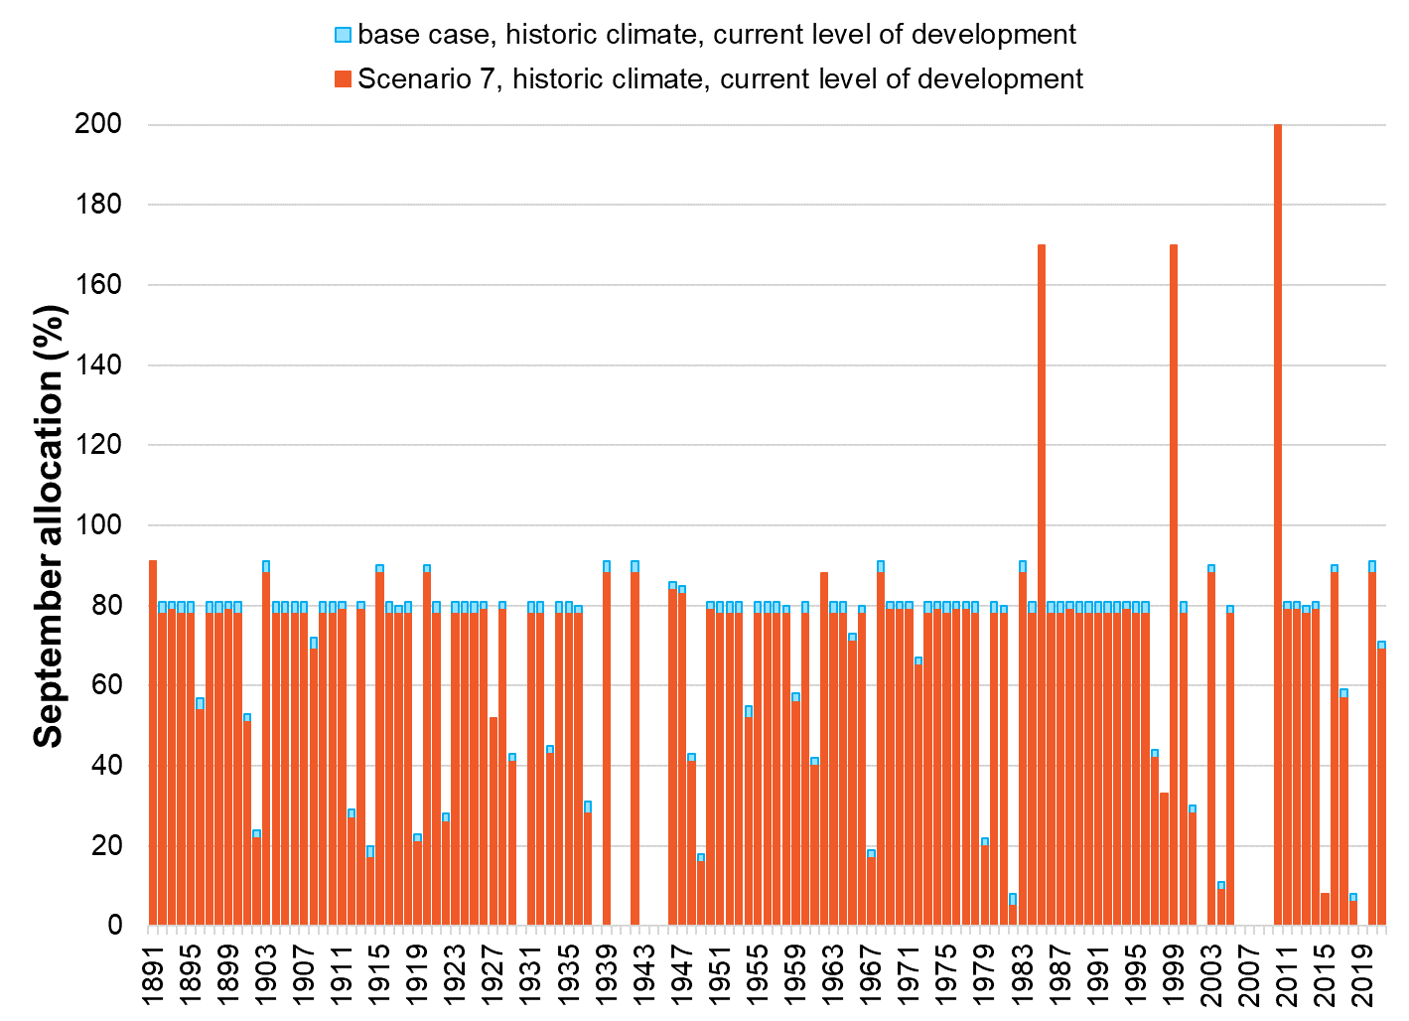

Figure 43: Modelled historical allocation under scenario 7

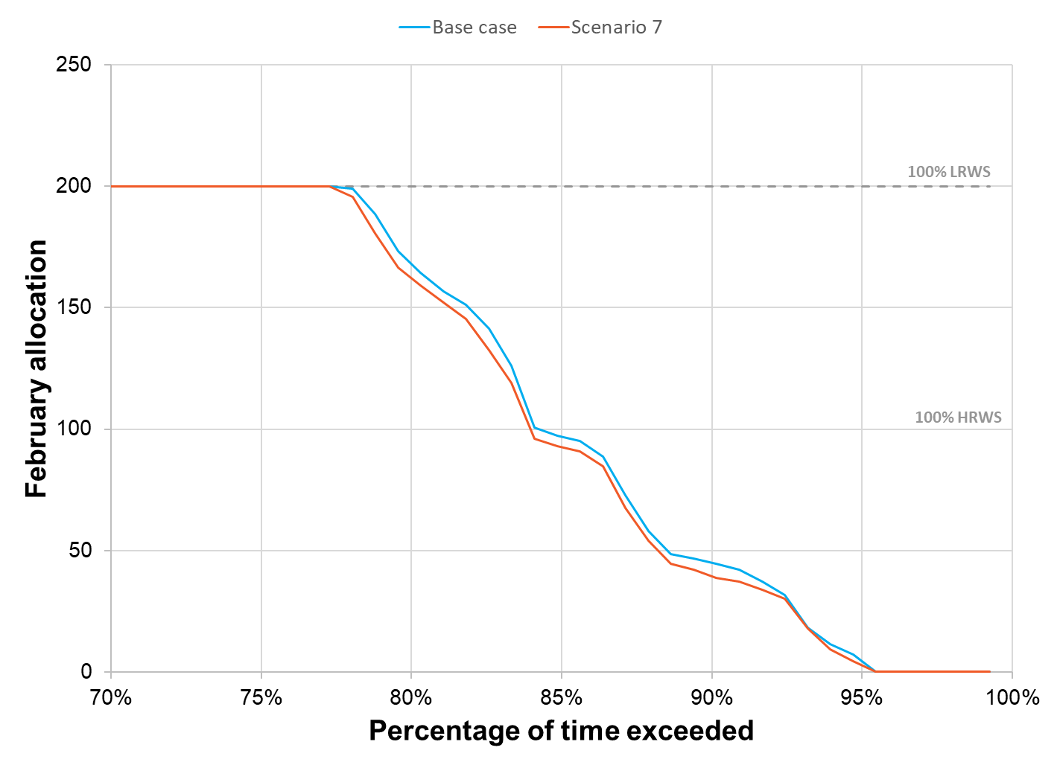

Figure 44: February allocation reliability for scenario 7



Figure 45: Modelled historical allocation under scenario 7

#### Alignment with Success Criteria

Scenario 7 addresses securing access to domestic and stock water supply, which has been demonstrated to be of high priority to Broken System users. In isolation, this scenario does not achieve multiple benefits or create system configuration change.

| Achieving multiple benefits​ | Creating change​​ | Future ready​​ | Community  Acceptance​ | Value for Money |
| --- | --- | --- | --- | --- |
| Badge Cross with solid fill | Badge Cross with solid fill | Badge Tick1 with solid fill | Badge Tick1 with solid fill | Badge Tick1 with solid fill |

## scenario 8: Combination option

#### Summary

* Scenario 8 is a combination of scenarios 3, 4, 6 & 7
* Scenario 8 initially included Scenario 5, but it was later deemed not feasible as a stand-alone scenario. Although Scenario 5 was considered during the modelling and MCA, it was not included in the Cost Benefit Analysis. A variation of this Scenario, Scenario 9, was added later in the study. Scenario 9 includes Scenario 5 along with options to remove or reconnect users in Zone 4. Details on this Scenario can be found in section 5.6.9.8.

#### Map

Map showing Zone 3 of the broken system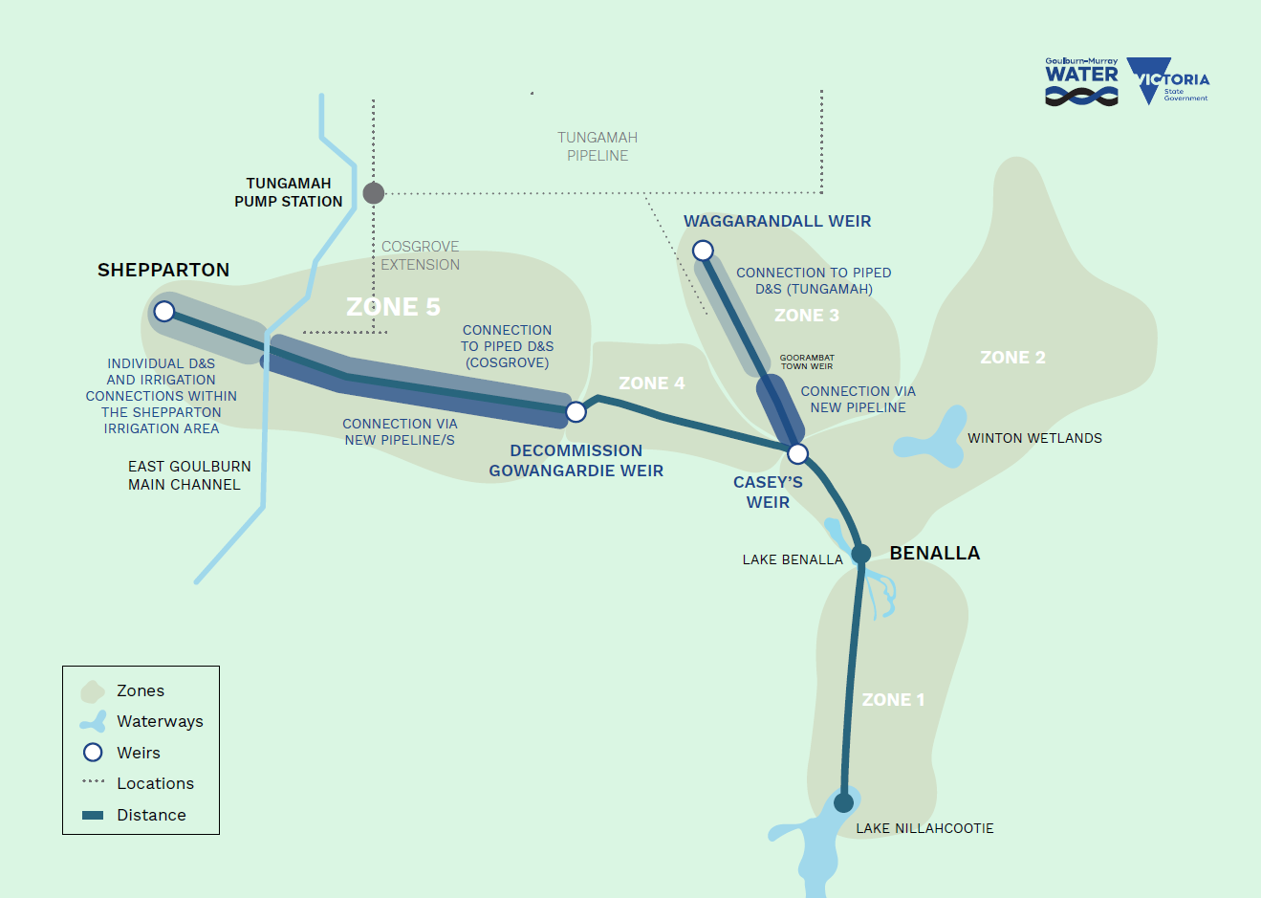

Figure 46: Map of Zones affected by scenario 8

#### Options Applied

* Voluntary entitlement relinquishment
* Support to transition to dryland agriculture.
* Increased on-farm storage.
* Assistance to trade allocation or buy/sell entitlement.
* Participation in subsidised whole farm planning
* Decommissioning of river/creek infrastructure
* Connection to existing piped D&S
* Re-supply via new irrigation pipeline.

#### Estimated Cost to Complete

Based on an assessment of potential activities and costs to implement scenario 8, the total estimated cost is **$99 million**, comprising of:

Business Case Development: $5.6 million

Implementation: $77.7 million

Project Delivery and Administration: $16.0 million

Key elements included in the implementation estimate are:

* Construction of pipelines to resupply properties.
* Entitlement purchases
* Acquisition of Goulburn shares
* Brokerage and legal fees associated with entitlement purchases
* Professional farm planning advice to support landowners to transition to non-irrigation practices
* Whole Farm Planning (WFP) survey and design
* Works to transition properties to non-irrigation practices
* Works to transition properties to a more efficient form of irrigated use
* Increased on-farm storage
* Decommissioning of Gowangardie Weir
* Water entitlement changeover.

#### Assumptions

* For the purpose of modelling and assessing Scenario 8, the estimated volume of water shares relinquished through voluntary purchase was based on:
  + 50% of unused (based on 10 years average annual use) HRWS in Zones 1,2 & 4 are to be purchased, for a total of 3,431 ML HRWS.
  + 65% of HRWS held in accounts not linked to land to be purchased (excludes environmental water holders and GMW) for a total of 1,593 ML HRWS.
  + LRWS would be purchased, for a total of 1,012 ML LRWS.
  + The estimated water recovered through purchase is 9112 ML of HRWS and 1012 ML of LRWS.
* The assessment assumes that 50% of the recovered entitlement will be transferred to environmental water holders and 50% will be retired to support system reliability.
* All Zone 3 properties would be resupplied from outside of Zone 3 (New Irrigation and D&S pipeline at the southern end supplied from Zone 4, northern end supplied with D&S only via an extension to the Tungamah Pipeline).
* All Zone 5 properties would be resupplied from outside of Zone 5 (from the Shepparton Irrigation Area, the Tungamah (Cosgrove extension) D&S Pipeline or from Zone 4).
* The concept irrigation pipeline designs are based on the current level of water use for affected properties.
* The Cosgrove Pipeline has the capacity or can be upgraded to meet the increased demand to resupply Zone 5 D&S users east of the East Goulburn Main on the north side of the Broken River.
* The Tungamah Pipeline has the capacity or can be upgraded to meet the increased demand to resupply the northern extent of Zone 3.
* The specific mechanism to achieve the outcome of a more secure supply for basic D&S water needs would be further evaluated through the Business Case and would be achievable within current policy settings.
* For the purpose of modelling and assessment, it was assumed that entitlement held by GMW through the completion of the Cosgrove Project would form part of a reserve set aside each season to support D&S allocation.

#### Stakeholder Feedback

* Refer to Stakeholder Feedback sections for Scenarios 3, 4, 6 and 7.

#### Comparison to Base Case

Compared with the base case, the implementation of Scenario 8 would result in a reasonable improvement in September allocations, with full-season going up by 5%. In this scenario environmental water holdings in the system would increase by 4,556 ML HRWS and 506 ML LRWS increasing the total from 647 ML to approximately 5,709 ML. System losses would be reduced by 4,565 ML, which is mostly attributable to removing the Broken Creek loss provision.

Table 12: Indicative results for scenario 8 (measured against the base case)

| **Metric** | **Baseline (current)** | **Scenario results** |
| --- | --- | --- |
| Full season reliability  (100% HRWS allocation by February) | 84% | 89% |
| Early season reliability  (100% HRWS allocation by September) | 2% | 86% |
| Change in losses compared to base case (ML) | 19,584 | -4,565 |
| Entitlement reallocated to environment (ML)  HRWS  LRWS |  | 4,556  506 |
| Entitlement retired for reliability (ML)  HRWS  LRWS |  | 4,556  506 |
| Long-term diversion limit equivalence (LTDLE) (ML) reallocated to environment |  | 7,204 |

Figure 47 - Figure 50 shows the modelled changes in reliability for September and February compared to the base case if recovered shares are distributed equally between the environment and improvements to reliability (retired shares).

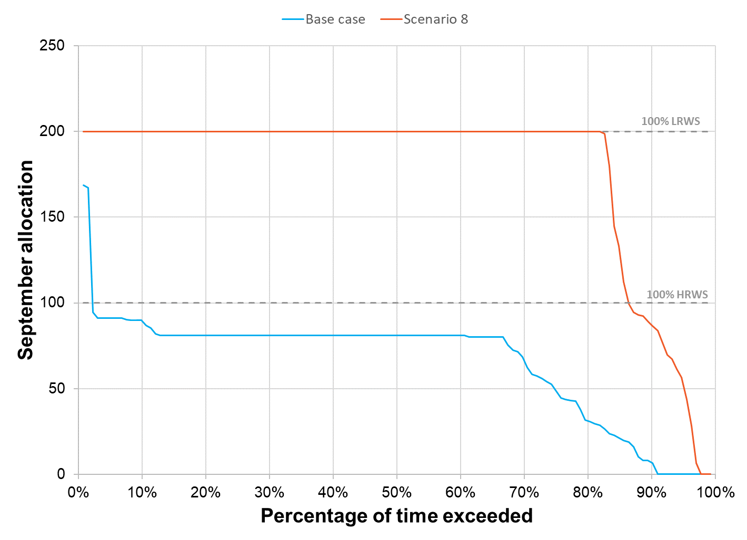

Figure 47: September allocation reliability for scenario 8

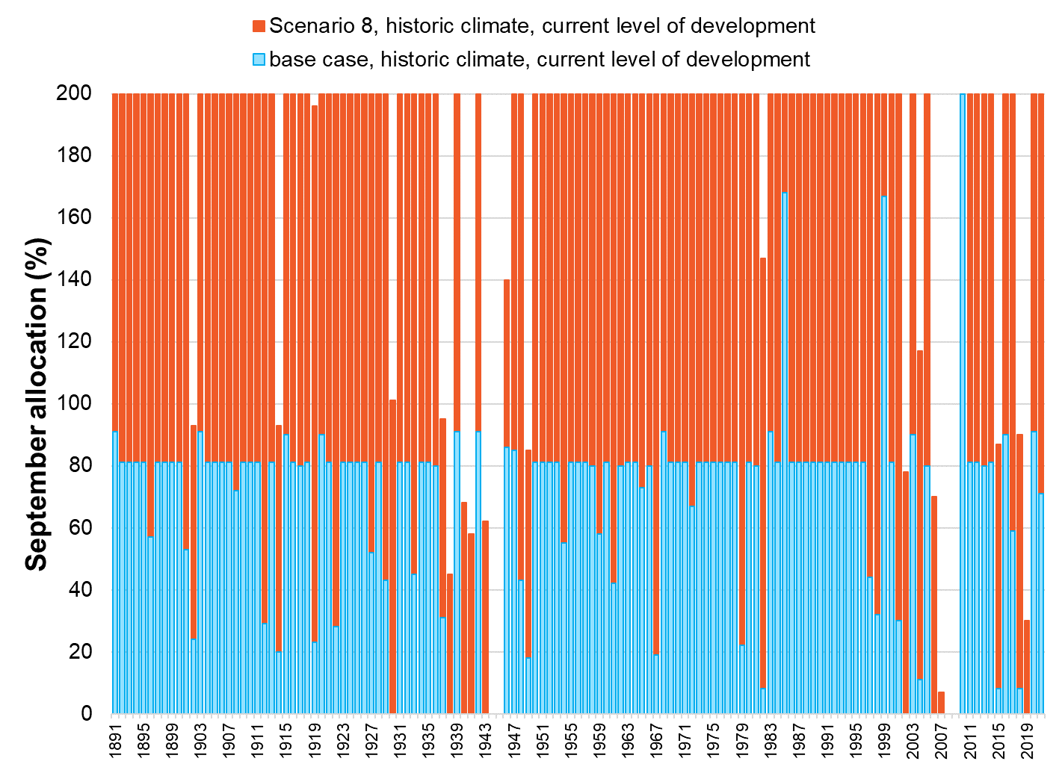

Figure 48: Modelled historical allocation under scenario 8

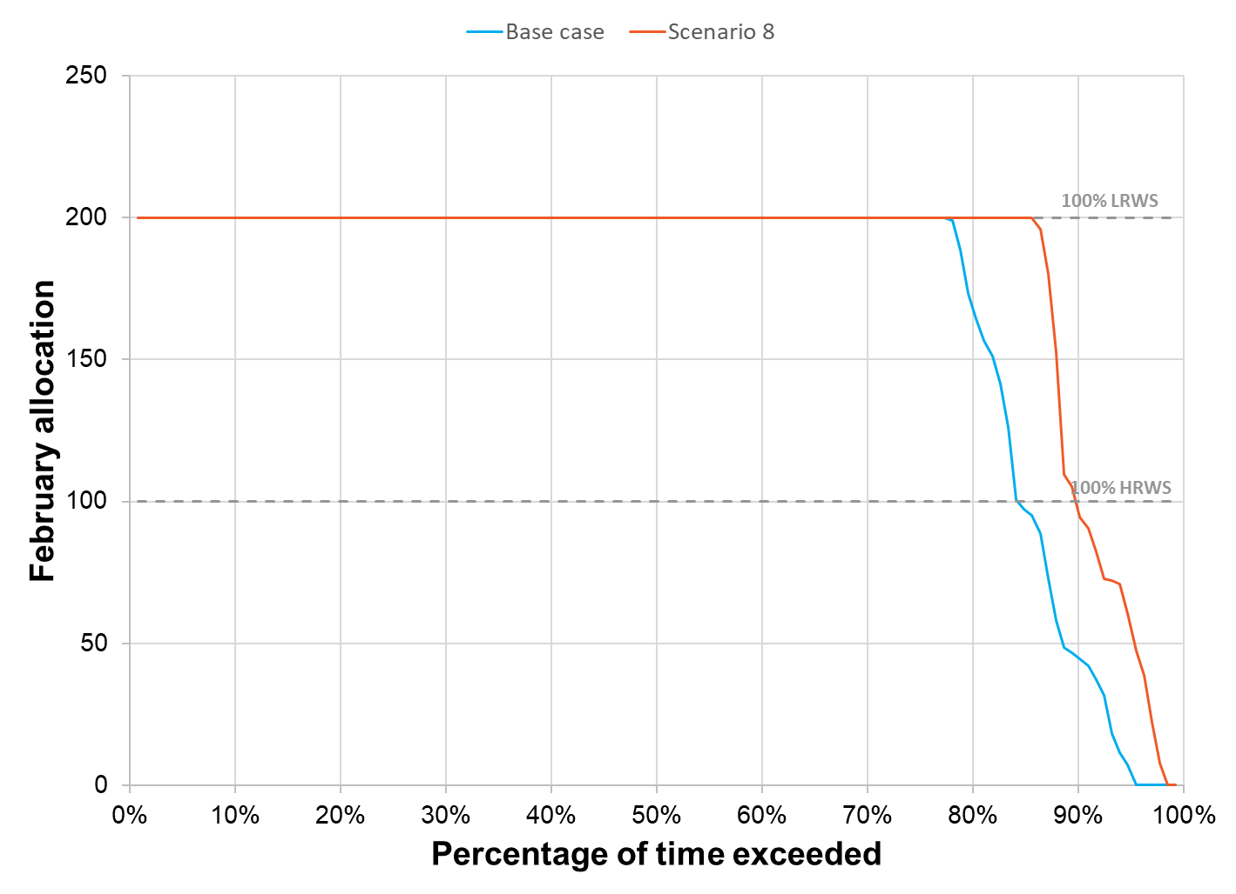

Figure 49: February allocation reliability for scenario 8

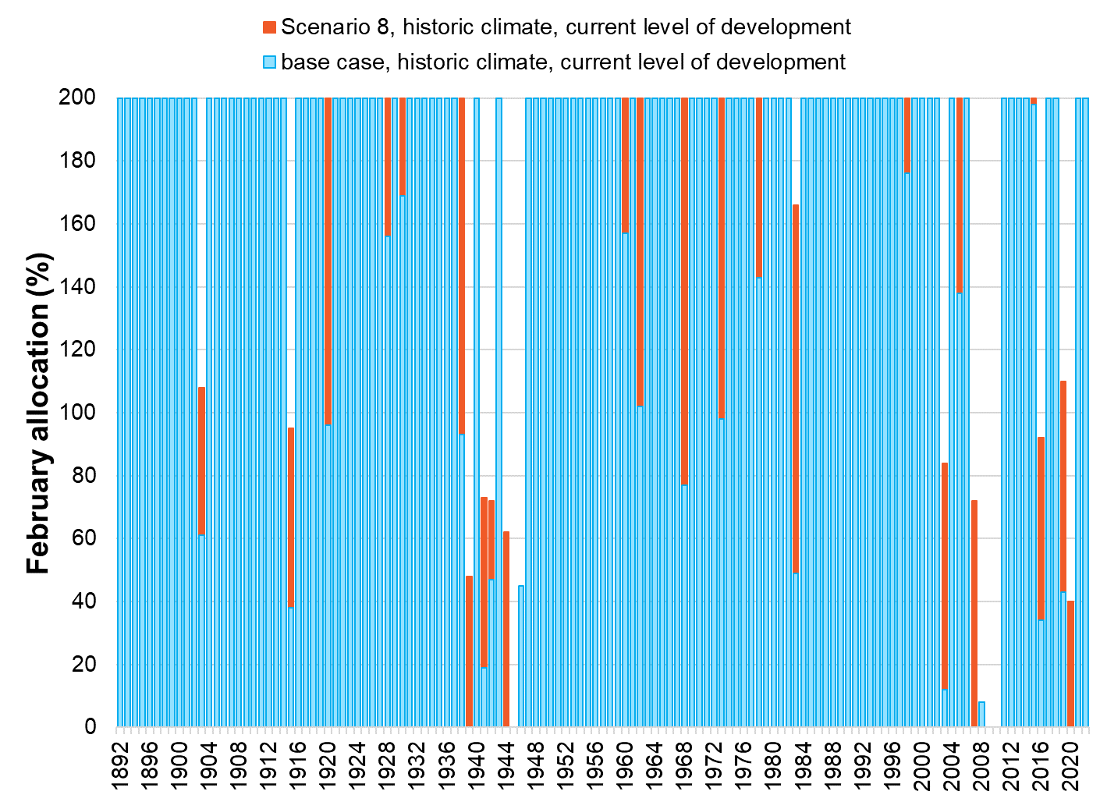

Figure 50: Modelled historical allocation under scenario 8

#### Alignment with Success Criteria

Scenario 8 assessed a range of scenarios and initiatives to maximise the benefit opportunity across all zones and user profiles. Substantial water recovery occurs under this Scenario, with large sections of the Broken System detached from the current need to meet irrigation requirements. The change would pave the way for the river to be managed in a way that improves existing ecological outcomes. Environmental objectives could be further supported through the decommissioning of Gowangardie Weir, restoring connectivity between important habitats.

Scenario 8 presents as a significant structural adjustment for the Broken System, providing system users with support to make an informed choice based on their individual circumstances to adapt in a way that best meets their needs.

| Achieving multiple benefits​ | Creating change​​ | Future ready​​ | Community  Acceptance​ | Value for Money |
| --- | --- | --- | --- | --- |
| Badge Tick1 with solid fill | Badge Tick1 with solid fill | Badge Tick1 with solid fill | Badge Tick1 with solid fill | Badge Tick1 with solid fill |

## scenario 9: Extended combination option

#### Summary

In addition to the 7 scenarios tested against the base case, an estimate for a variation to Scenario 8 was included in the final estimate of costs. The extended version of Scenario 8, Scenario 9, includes all the original elements of the Scenario, incorporates the scope of Scenario 5 and remove or reconnect all services in Zone 4. The Zone 4 reconfiguration is achieved through the extension of the Zone 5 pipeline to resupply properties for 6km upstream of Gowangardie Weir, with remaining properties in the zone resupplied via a branch line from the proposed Zone 3 pipeline.

#### Map

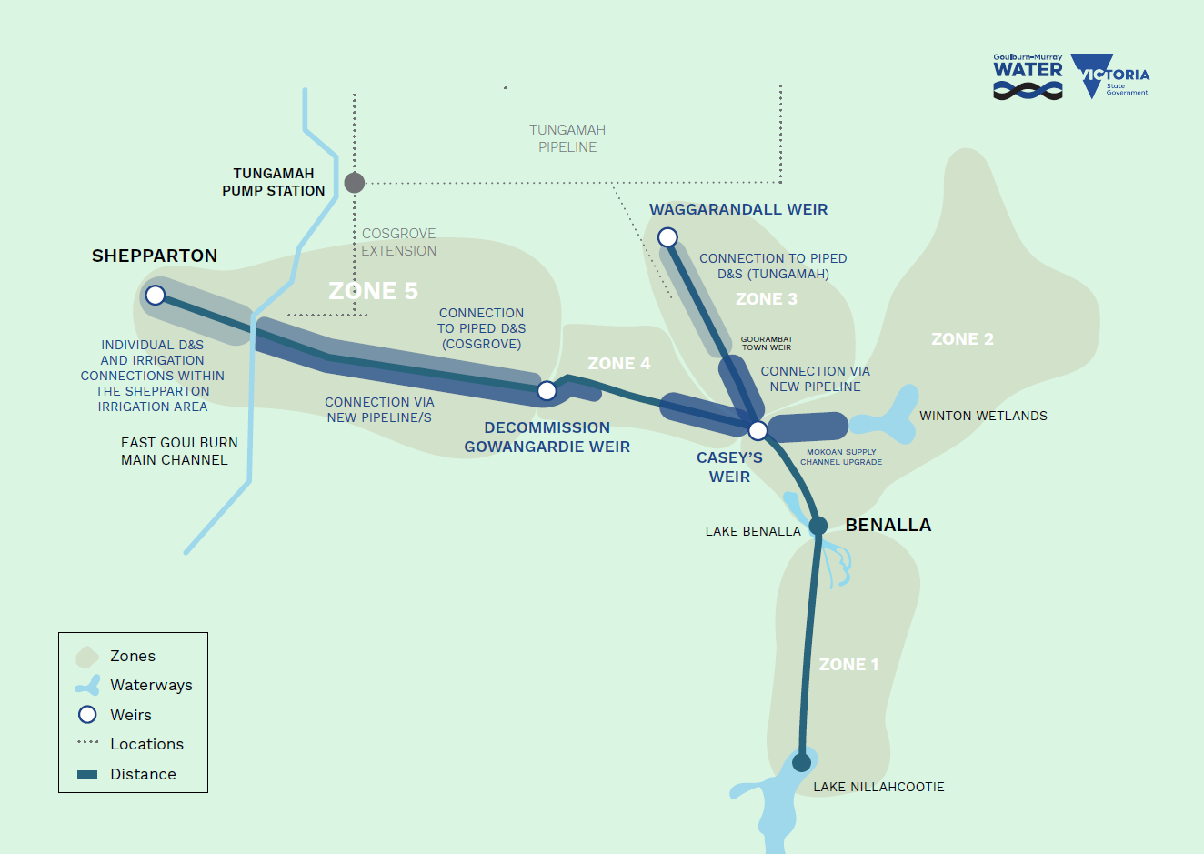

Figure 51: Map of Zones affected by scenario 9

#### Options Applied

* Voluntary entitlement relinquishment
* Support to transition to dryland agriculture
* Increased on-farm storage
* Assistance to trade allocation or buy/sell entitlement
* Participation in subsidised whole farm planning
* Decommissioning of River/Creek infrastructure
* Connection to existing piped D&S
* Re-supply via new irrigation pipeline.

#### Estimated Cost to Complete

Based on an assessment of potential activities and costs to implement Scenario 9, the total estimated cost is **$129 million**, comprising of:

* Business Case Development: $5.7 million
* Implementation: $107.7 million
* Project Delivery and Administration: $16.0 million

Key elements included in the implementation estimate are:

* Construction of pipelines to resupply properties
* Entitlement purchases
* Acquisition of Goulburn shares
* Brokerage and legal fees associated with entitlement purchases
* Professional farm planning advice to support landowners to transition to non-irrigation practices
* Whole Farm Planning (WFP) survey and design
* Works to transition properties to non-irrigation practices
* Works to transition properties to a more efficient form of irrigated use
* Increased on-farm storage
* Decommissioning of Gowangardie Weir
* Water entitlement changeover.

#### Assumptions

* For the purpose of modelling and assessing the Scenario, the estimated number of shares relinquished through voluntary purchase is based on:
  + 50% of unused (based on 10 years average annual use) HRWS in Zones 1,2 to be purchased, for a total of 2,130 ML HRWS.
  + 65% of HRWS held in accounts not linked to land to be purchased (excludes environmental water holders and GMW) for a total of 1,593 HRWS.
  + LRWS would be purchased, for a total of 1,012 LRWS.
  + The estimated water recovered through purchase is 10,606 ML of HRWS, and 1012 ML of LRWS.
* The assessment assumes that 50% of the recovered entitlement will be transferred to environmental water holders, and 50% will be retired to support system reliability.
* All Zone 3 properties would be resupplied from outside Zone 3 (New Irrigation and D&S pipeline at the southern end supplied from Zone 4, northern end supplied with D&S only via an extension to the Tungamah Pipeline).
* All Zone 5 properties would be resupplied from outside Zone 5 (from the Shepparton Irrigation Area, the Tungamah (Cosgrove extension) D&S Pipeline or from Zone 4).
* The concept irrigation pipeline designs are based on the current level of water use for affected properties.
* The Cosgrove Pipeline has the capacity or can be upgraded to meet the increased demand to resupply Zone 5 D&S users east of the East Goulburn Main on the north side of the Broken River.
* The Tungamah Pipeline has the capacity or can be upgraded to meet the increased demand to resupply the northern extent of Zone 3.
* The specific mechanism to achieve the outcome of a more secure supply for basic D&S water needs would be further evaluated through the Business Case and would be achievable within current policy settings.
* For the purpose of modelling and assessment, it was assumed that entitlement held by GMW through the completion of the Cosgrove Project would form part of a reserve set aside each season to support D&S allocation.
* Zone 4 reconfiguration is achieved through the extension of the Zone 5 pipeline to resupply properties for 6km upstream of Gowangardie Weir.

#### Stakeholder Feedback

* Refer to Stakeholder Feedback sections for Scenarios 3, 4, 5, 6 and 7.

#### Comparison to Base Case

Compared with the base case, the implementation of scenario 9 would result in a reasonable improvement in September allocations, with full season going up by 10%. In this scenario environmental water holdings in the system would increase by 5,303 ML HRWS and 506 ML LRWS increasing the total from 647 ML to approximately 6,456 ML. System losses would be reduced by 4,728 ML, which is mostly attributable to removing the Broken Creek loss provision.

Table 13: Indicative results for scenario 9 (measured against the base case)

| **Metric** | **Baseline (current)** | **Scenario results** |
| --- | --- | --- |
| Full season reliability  (100% HRWS allocation by February) | 84% | 93% |
| Early season reliability  (100% HRWS allocation by September) | 2% | 94% |
| Change in losses compared to base case (ML) | 19,584 | -4,728 |
| Entitlement reallocated to environment (ML)  HRWS  LRWS |  | 5,303  506 |
| Entitlement retired for reliability (ML)  HRWS  LRWS |  | 5,303  506 |
| Long-term diversion limit equivalence (LTDLE) (ML) reallocated to environment |  | 7,793 |

Figure 52- Figure 55 shows the modelled changes in reliability for September and February compared to the base case if recovered shares are distributed equally between the environment and improvements to reliability (retired shares).

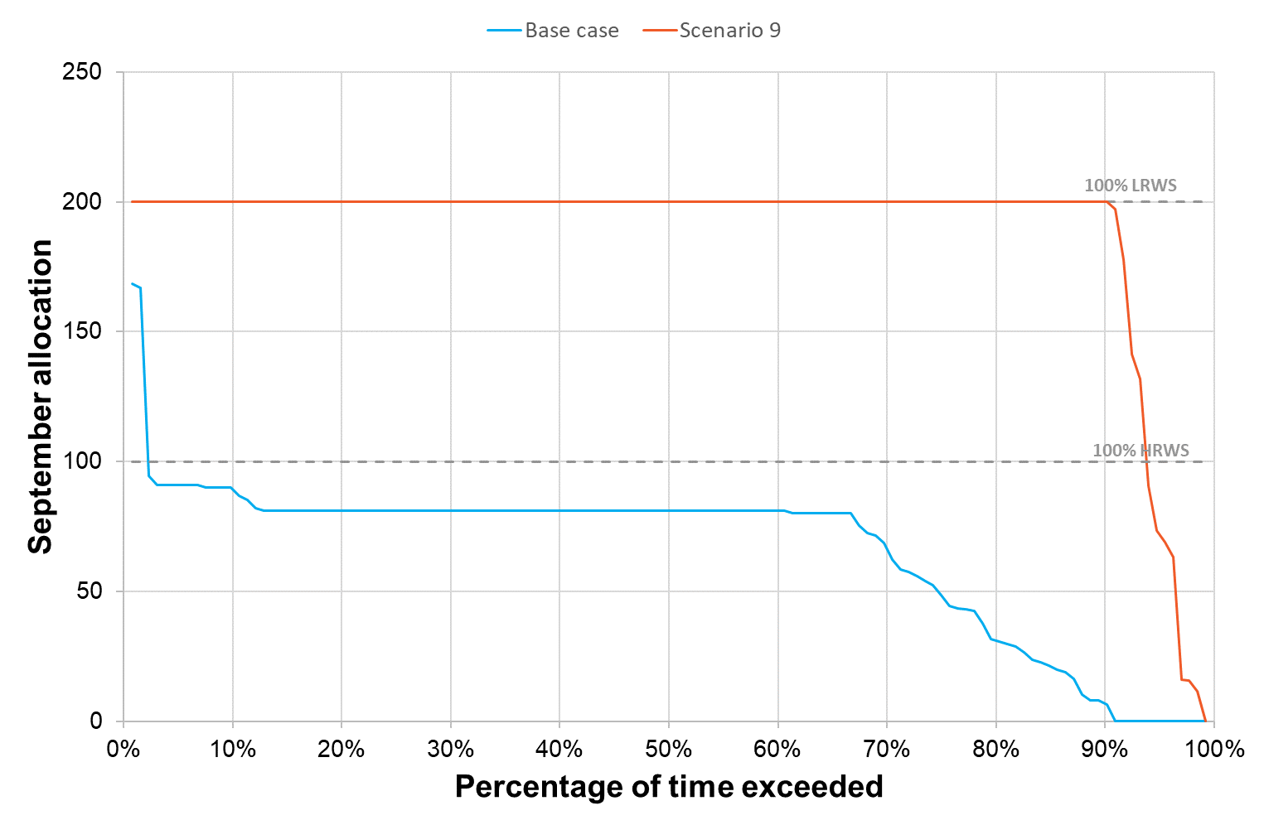

Figure 52: September allocation reliability for Scenario 9

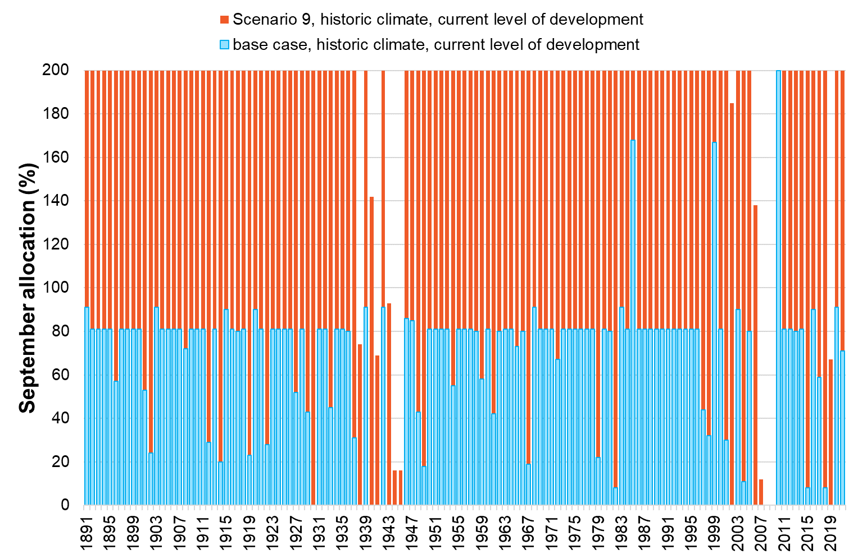

Figure 53: Modelled historical allocation under Scenario 9

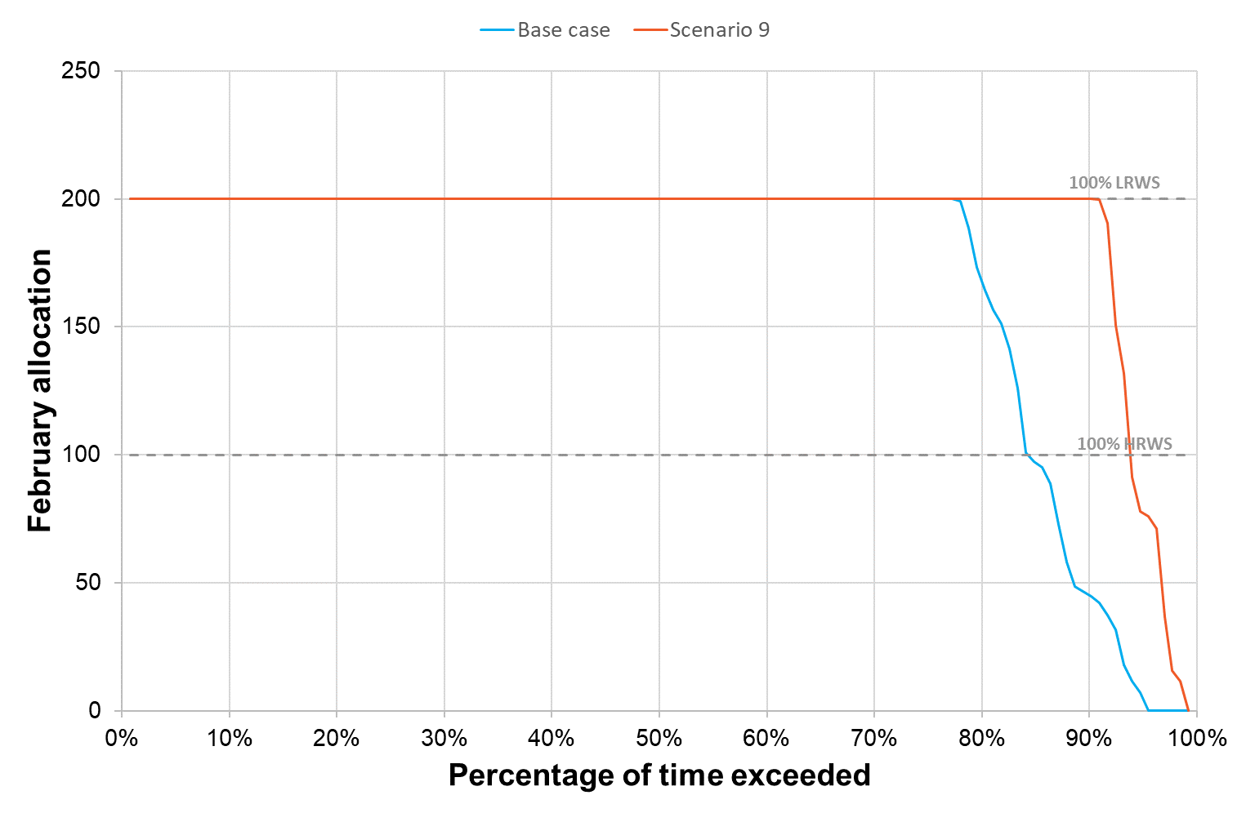

Figure 54: February allocation reliability for Scenario 9

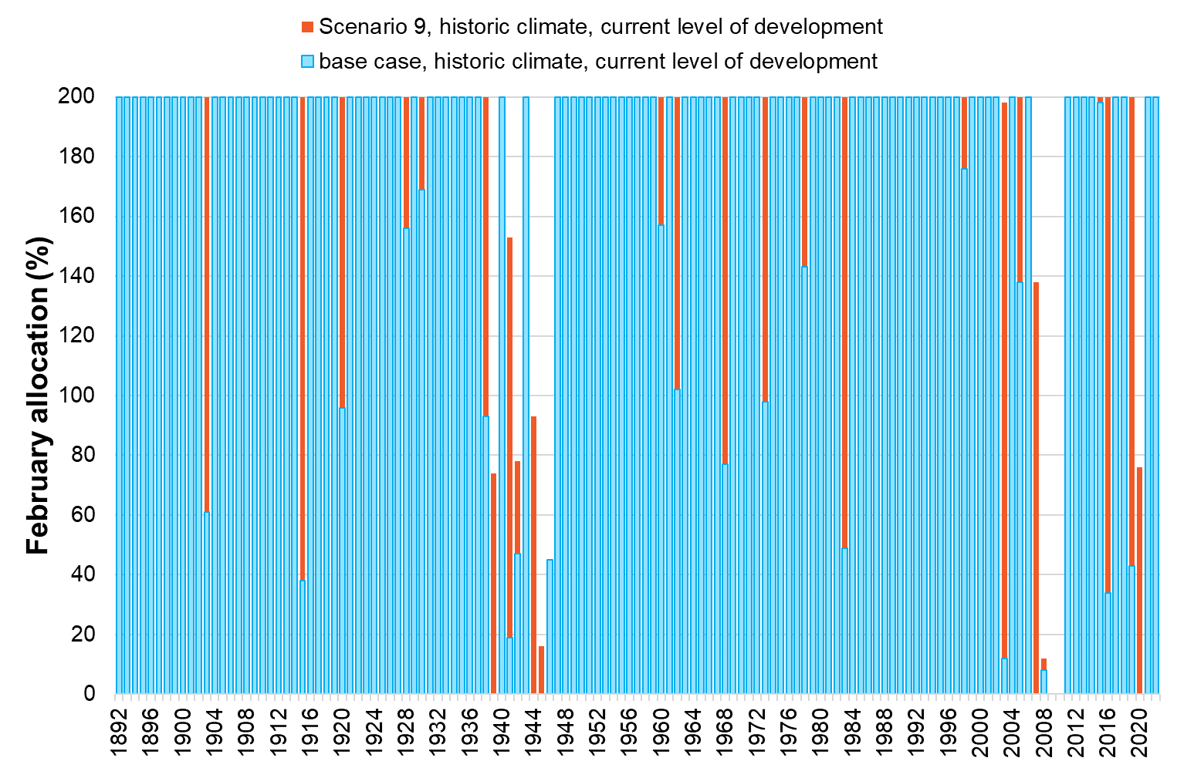

Figure 55: Modelled historical allocation under Scenario 9

## Multi-criteria analysis

A Multi Criteria Analysis (MCA) has been developed to examine the packaged scenarios. The final MCA provides a weighted score for each category of criteria, for each scenario. It can also be used to determine the net negative score (representing negative impacts or disbenefits) and the net positive score (representing positive impacts or benefits) for each option. The net negative and positive scores will provide an indication of the spread of benefits and disbenefits of each scenario to allow for a more detailed understanding of the trade-offs that may be involved in any particular option.

**Note:** As outlined in Section 4 and in accordance with Traditional Owner advice, the MCA does not include an assessment of impact on cultural values. The important task of working with Traditional Owners to provide input into future planning will continue as a part of the business case development.

## Multi-criteria analysis assessment and results

The assessment framework is centred around the application of a multi-criteria analysis (MCA).

MCA is a decision support tool that was developed as part of a field of study called “operations research”, where decision makers assess multiple options across a range of decision factors (reasons or considerations) that may have different and inconsistent assessment measures, including non-monetary valuation. MCA has been adopted for environmental management, as it is invaluable in assessing unique elements of a project that do not include financial components. Put simply, it is valuable as a technique for “comparing apples and oranges”.

When applied with care, consistency and transparency, an MCA provides a structured framework for comparing options. The basic structure of an MCA is shown in Figure 56. Weightings are applied to each of the categories of objectives to reflect their relative importance to decision-makers and stakeholders. Under each objective, there are typically a number of assessment criteria. These criteria are also typically weighted within the objective to reflect their relative importance. The assessments against each criterion can be based upon either the outputs of previous technical analysis (e.g. a hydrological model), or use a semi-qualitative approach based on expert discussion and/or community engagement. This approach enables different considerations to be incorporated into the same framework of options evaluation.

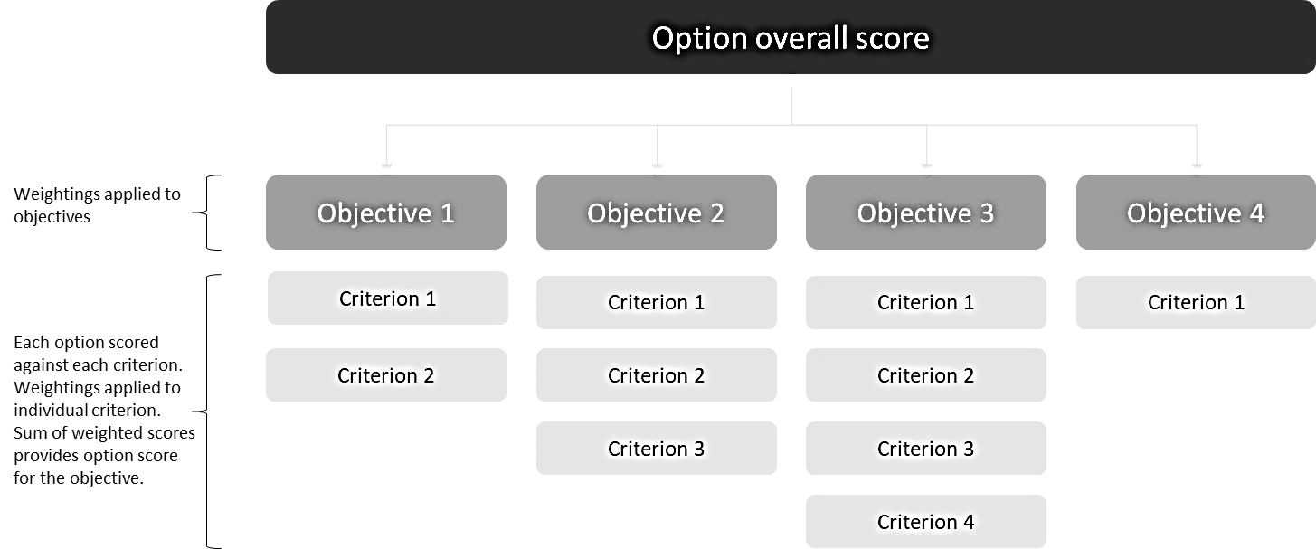

Figure 56: Typical structure of an MCA

MCA is most effective when there is a clear basis for scoring project options and where the evaluation framework is agreed to, and documented, before the analysis commences. However, MCA ultimately involves some subjective and non-testable judgements on values. In addition, it does not tell the decision-maker whether individual proposals are of net social benefit (i.e. whether anything at all should be chosen), or the optimal scale of any particular proposal.

MCA is therefore a decision support tool, not a decision-making tool. The MCA provides a framework to assess and summarise the evidence and attributes of options against common criteria, using weightings to suit the context of the project. The outputs can then be discussed with stakeholder advisory groups, and documented to support project decision-making. Project leads may ultimately make a decision that conflicts with the MCA output, providing the reasoning is clearly documented and supported by appropriate evidence. Advice from stakeholder advisory groups will be a key consideration in this decision-making.

Multi-criteria analysis assessment categories

To be consistent with the Victorian Government guidance on the use of a quadruple bottom line assessment for investments in rural water infrastructure, this assessment considers the social, cultural, environmental and economic outcomes of each scenario. It also includes a category that expressly measures the intended outcomes of the project, including robustness to future uncertainties and risk mitigation opportunities. The details of the categories of criteria are presented in Table 14.

At the request of the two Registered Aboriginal Parties that were consulted for this project, assessment of cultural criteria has not been included in this assessment. Both parties have been invited to provide their own statements regarding options.

Table 14: Objective category descriptions

|  |  |
| --- | --- |
| Objective Categories | Description |
| Project objectives | This category exists to capture the project objectives that sit outside the quadruple bottom line assessment (i.e. the other MCA categories). The criteria in this category relate to the objectives and principles of the Broken System Reconfiguration Project. Criteria within this category have been drawn from the project principles and feasibility criteria. |
| Social | This category exists to capture the social impacts of the project options. The social criteria will consider social, recreational and wellbeing benefits and impacts. |
| Environment | The environment category considers the impacts that project options have on the environment. This category will measure the impact or benefits to the waterway. |
| Economic | The economic category considers the impacts that project options have on the local economy and consider the distribution of costs and benefits amongst stakeholders. |
| Risk | The risk category considers major risks to the project objective or unintended consequences that may results from each option that are not considered in other criteria of this assessment. |
| Robustness to uncertainty | The robustness to uncertainty category exists to consider how resilient the benefits of each option are in the face of future uncertainties. This includes climate change, and changes to water demand in the catchment. |

Criteria will be placed into a category to allow differential weighting as part of the assessment. Criteria may fit in one or more category, and choice of category will be driven by the assessment type. For example, the assessment of how well each scenario supports environmental values under climate change could sit in either the robustness to future uncertainty category, or the environmental category. As the assessment approach for this criterion matches the assessment approach of the other environmental criterion, it has been kept in the environmental category.

Multi-criteria analysis criteria

Criteria within each assessment category are shown in Table 15. The criteria in this phase of the evaluation build on the project success criteria and align with the project principles and government policy direction. A draft set of assessment criteria were presented to the Consultative Committee and its feedback was included through the refinement and addition of some criteria.

Table 15: MCA Assessment criteria

|  |  |  |
| --- | --- | --- |
| **Number** | **Category** | **Criteria** |
| PO1 | **Project Objective** | **Sustainable irrigation sector future**: Reliability of water supply for High Reliability Water Shares |
| PO2 | **Project Objective** | **Sustainable irrigation sector future**: Reliability of water supply Low Reliability Water Shares |
| Rob1 | **Robustness to future uncertainty** | **Delivers value under projected future climate change:** Reliability of supply of HRWSs under a high climate change future |
| Rob2 | **Robustness to future uncertainty** | **Delivers value under a range of future water use scenarios:** Reliability of supply for HRWS under a demand scenario that represents full SDL demand. |
| Ris1 | **Risk** | **Risk of unintended consequences:** Scan of risks that have not been captured in other MCA criteria |
| Env1 | **Environmental** | **Environmental values**: To what extent does the option protect or enhance the environmental values of the Broken River system |
| Env2 | **Environmental** | **Support of environmental values under future high climate change projection**: To what extent does the option protect or enhance the environmental values of the Broken River system in a high climate change future |
| Soc1 | **Social** | **Change to recreational, amenity and social connection outcomes**: The impact of each option on the recreational, amenity and social connections values of the study area. |
| Soc2 | **Social** | **Wellbeing and social cohesion:** How does the scenario impact on the mental and physical wellbeing of the local community and aspects of liveability. |
| Eco1 | **Economic** | **Value for money – capital costs**: comparison of the capital cost of the project on a costs per ML saved basis between the different scenarios. |
| Eco2 | **Economic** | **Value for money - Project operating and maintenance costs:** comparison of the operating and maintenance costs per ML of water saved across the different scenarios |
| Eco3 | **Economic** | **Economic impacts and benefits:** comparison of the economic impacts or benefits associated with the changed water availability and agricultural use for each scenario. |

Multi-criteria assessment process

Each criteria was assessed using appropriate evidence. This may range from outcomes of water resource modelling, expert elicitation, literature reviews and stakeholder engagement outputs. The result of that assessment is then scored based on its level and type of impact on the criteria. Positive impacts (benefits) receive a positive score, and negative impacts receive a negative score. Assessment scales are developed for each criteria, from neutral to extreme end of the positive and/or negative spectrum.

The details of the assessment approach, results the assessment scales are outlined in the Technical Assessment Report.

## mca analysis results

### mca weightings

Category Weightings

As part of an MCA assessment, weightings are given to each category to represent its importance to the decision-making process. Given this project is a feasibility study with limited engagement with the broader community, there was little guidance on the level of importance the community would place on one category over another. Therefore, it was considered appropriate to apply equal weightings of 20% each to the categories related to the environmental, social and economic categories, as these are direct impacts of the scenarios. The robustness to future uncertainty and risk categories have been given a combined weighting of 15% as the key assumptions within these categories are less certain. For example, the increase in demand to SDL level of demand would require a significant increase in the water use in the catchment. The category weightings applied to the MCA assessment are shown in Table 16.

Table 16: MCA category weightings

|  |  |  |
| --- | --- | --- |
| **Category** | **Weighting** | **Reason for adoption** |
| Project objectives | 25% | Main drivers for the project |
| Robustness to future uncertainty | 12.5% | Important future consideration, however, the extent of the uncertainty has been assumed and may not play out according to those assumptions. Therefore, the category has been given a moderate weighting. |
| Risk | 2.5% | This category is a scan of risks on a feasibility level project. There are still opportunities to mitigate this risk as the project progresses and therefore it was given a low weighting. |
| Environmental | 20.0% | Environmental, social and economic criteria were given equal weightings as there was not enough broader community engagement in the feasibility study to determine which category the community would value more. |
| Social | 20.0% |
| Economic | 20.0% |
| **Total** | **100%** |  |

Criteria weightings

Weightings are assigned to the criteria to allow for differences in the relative importance of each criterion within a category. The details of the criteria weighting for the MCA assessment are shown in Table 17.

Table 17: Criteria Weightings

| Category | Criteria # | Criteria | Weighting | Proportion of Category | Reason for weighting |
| --- | --- | --- | --- | --- | --- |
| Project objectives | PO.1 | Reliability of water supply for HRWS | 15% | 60% | HRWS are more important to water security than LRWS so weighted higher |
| PO.2 | Reliability of water supply for LRWS | 10% | 40% |
| Robustness to future uncertainty | Rob.1 | Delivers value under a range of scenarios (climate change) | 6% | 50% | Equal weighting adopted |
| Rob.2 | Delivers value under a range of future water use (demand) scenarios | 6% | 50% |
| Risk | Ris.1 | Risk of unintended consequences | 3% | 100% | n/a |
| Environmental | Env.1 | Support of existing ecological function | 16% | 80% | Env1 weighted higher because impacts are experienced under current conditions. |
| Env.2 | Support of existing environmental values under high climate change projection | 4% | 20% |
| Social | Soc.1 | Change to recreational / amenity / social connection outcomes | 10% | 50% | Equally weighted to reflect equal importance of both criteria |
| Soc.2 | Wellbeing / social cohesion measure of increased certainty for community | 10% | 50% |
| Economic | Eco.1 | Project capital cost | 7% | 33% | Equally weighted to reflect the equal importance of all criteria |
| Eco.2 | Economic benefit of change to reliability of water supply | 7% | 33% |
| Eco.3 | Project operating and maintenance cost | 7% | 33% |

### MCA results

The net option scores that result from the assessment scoring and weighting detailed in this report are shown in Figure 57. The score for each category is shown, together with the net score (dashed box).

Overall, seven scenarios present net positive outcomes. These scenarios are:

* **Scenario 9** - The extended combined option with a net positive score of 1.2
* **Scenario 8** - The combined option with a net positive score of 1.09
* **Scenario 6** – Systemwide initiatives with a net positive score of 0.91
* **Scenario 2** - Transition out of irrigation with a net positive score of 0.54
* **Scenario 4** - Remove or reconnect Zone 3 with a net positive score of 0.20
* **Scenario 7** - Secure access to D&S water with a net positive score of 0.12
* **Scenario 3** - Remove or reconnect all services in Zone 5 with a net positive score of 0.09

The high MCA scores for Scenarios 8 and 9 are driven by strong alignment with the project objectives through the improvement of reliability of supply for water shareholders in the system. Although not scored explicitly in the assessment of project objectives, the inclusion of a greater security D&S product also aligns strongly with the project objectives and enjoys strong support from the community which is reflected in the high social wellbeing scores of these two options. These scenarios are further enhanced by positive economic scores being driven by more reliable water access to support irrigated agriculture.

The positive results for Scenario 6 and Scenario 2 are driven by strong positive environmental outcomes, however for Scenario 2, the net score is reduced by the significant economic impact associated with lost productivity resulting from removing irrigated agriculture from the region. Scenario 6 scores better on the economic and social criteria as it assumes water shares will be recovered from people who are not using them, whilst providing improved reliability for individuals who wish to continue irrigated agriculture. This is reflected in positive economic score for this scenario.

Scenario 7 achieves a small positive outcome through small benefits for each of the project objective criteria, and the wellbeing benefit associated with more security of critical water supplies.

Scenarios 3 and 4, as stand-alone options, do not provide an improvement in the reliability of supply for water share users under average conditions and therefore receive neutral or ‘0’ scores against the project objective criteria. They do perform better in the robustness to future uncertainty category, as a reduction in demand on the system is a benefit under future climate change scenarios. Both scenarios also result in positive economic scores resulting from increased productivity due to more reliable access to water.

One scenario received an overall net negative score:

* **Scenario 5** - Mokoan pipeline supply channel efficiencies with a net negative score of -0.49

The economic criteria were the drivers for net negative score for Scenario 5. The high cost of this option relative to the water saved is a major challenge for this option. There were no substantial benefits of this option for project objectives or robustness (driven by reliability of supply under various scenarios), or environmental benefits that were identified for this option.

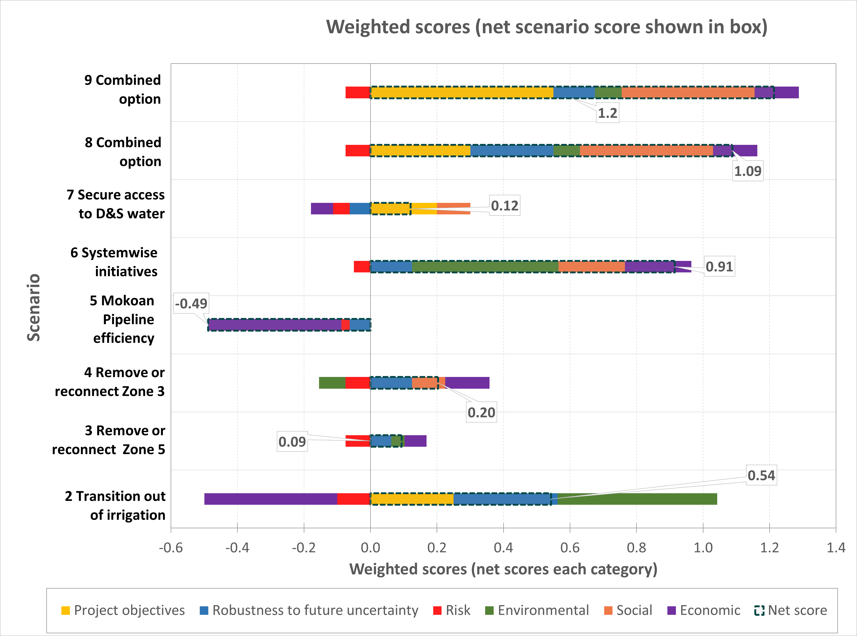

Figure 57: MCA weighted scores with net category scores (dashed boxes)

It is important to remember that an MCA is a decision support tool, not a decision-making tool. It is useful for comparing a group of criteria that do not have common metrics. The results may change depending on the assumptions that are made through the assessment process, the scoring process, and the weighting applied to each category and criterion. To understand the impact of the assumptions on the outcome of this assessment, sensitivity analysis on the results was completed. The sensitivity analysis was run using the ‘upper bound’ and ‘lower bound’ assessment scores for each assessment criteria. This analysis showed that the net scores are highly sensitive to the assumptions and judgement calls made during the assessment process. The results of this sensitivity analysis are presented in the Technical Report. The sensitive nature of the results of this assessment indicates that further investigation of each Reconfiguration Scenario is warranted as part of the cost benefit analysis.

# ASSESSING THE OPTIONS (Value for Money)

## Cost Benefit Analysis overview

Following a secondary round of community engagement sessions, the final list of assumptions and full package of preferred scenarios were refined and subsequently assessed. The scenarios were subject to a detailed Cost Benefit Analysis (CBA) that allowed for a more thorough analysis of each scenario, and the identification of likely benefits and/or risks to be mitigated.

A detailed CBA was subsequently undertaken for the remaining scenarios. This CBA complemented the outcomes of the detailed environmental, social and cultural assessments. The key questions that were addressed included:

* What is the net public benefit of each scenario – do the benefits outweigh the costs?
* What is the distribution of benefits amongst the different groups?
* What is the distribution of costs amongst the different groups?

The base case for the economic analysis reflected the expected outcome without new infrastructure. This 'business-as-usual' scenario provided the basis for estimating the incremental benefits and costs of alternative options. Given the variability in input data for multiple parameters (e.g., forecast water demand from changing crop production, changing input and output prices, climate, etc.), significant sensitivity analysis was undertaken to establish a probabilistic range for the base case.

Analysis of alternative options included:

* Assessing the overall benefit of each alternative option through the use of Cost Benefit Analysis (CBA), where benefits were estimated as the net margins from the use of water by end users.
* Other measures of economic benefits (and costs) were considered, where possible, including opportunity costs of alternative water supply projects and other relevant spillover benefits.
* Costs included the establishment cost of each option (or configuration of options), including capital costs of supply and related infrastructure, and expected maintenance and operating costs.
* The CBA model considered costs and benefits over a 30-year period, with all costs and benefits discounted to present value terms.

Decision rules in the CBA were as follows:

* The net present value (NPV) determined the economic viability of each option, with an NPV > $0 indicating benefits exceeding costs. The option with the highest NPV provided the greatest net social benefit.
* Incremental net present value (INPV) analysis enabled the assessment of incremental options or combinations of sub-options.
* Benefit-cost ratios (BCRs) and incremental benefit-cost ratios (IBCRs) were also calculated for each option or configuration of options.

Valuation of benefits and costs involved using a variety of techniques and data sources. Cost data for each option was provided, and the materiality of differences in cost estimates accuracy was tested through sensitivity analysis. Economic benefits from water use were based on margins from water use and were derived from modelling undertaken by NCE. For irrigation areas where no land use change was indicated, benefits were measured as the range of margin estimates ($/ML) for key crops (e.g., canola). For areas with land use change, simple net margins were used, reflecting the investment costs of converting to an alternative land use. Existing gross margin models were enhanced to include capital investments (e.g., irrigation equipment) and the opportunity cost of previous production margins foregone.

## Interpretation of results

The outcomes of the cost benefit analysis are presented alongside the outcomes of the environmental, social and cultural assessments and associated MCA for each scenario to provide a complete set of information to inform the final scenario evaluation.

## Initial Cost Estimations

In preparing the feasibility study, best endeavours were employed to compile an accurate estimation of costs despite the limited certainty surrounding the exact form and scope of the proposed project. This process was iterative, incorporating new information and feedback that necessitated adjustments to cost assumptions. Consequently, minor discrepancies may exist between figures used in earlier assessments and the final estimate of costs, reflecting the dynamic nature of the project's development. Table 18 shows the final estimate of costs for each scenario from Business Case development through to implementation.

Table 18: Estimate of costs by scenario

|  |  |  |  |  |  |
| --- | --- | --- | --- | --- | --- |
| **Scenario** | **Business Case Development Phase** | | **Estimated Scenario Cost** | **Project Delivery and Administration** | **Total Estimated Cost to Implement** |
| **Business Case** | **Farm Business Planning** |
| 2 | $2,728,398 | $1,368,900 | $58,052,688 | $9,791,860 | $71,941,846 |
| 3 | $3,759,089 | $187,200 | $32,803,078 | $9,643,987 | $46,393,354 |
| 4 | $3,186,545 | $117,000 | $12,460,576 | $6,801,054 | $22,565,175 |
| 5 | $1,326,145 |  | $4,705,392 | $3,326,288 | $9,357,825 |
| 6 | $2,982,140 | $479,115 | $37,504,600 | $8,381,187 | $49,347,043 |
| 7 | $405,709 |  | $952,000 | $1,393,210 | $2,750,919 |
| 8 | $5,031,673 | $565,118 | $77,707,907 | $15,962,917 | $99,267,614 |
| 9 | $5,031,673 | $693,818 | $107,691,870 | $15,962,917 | $129,380,278 |

## Assumptions

### general assumptions

To develop a system-wide reconfiguration concept for the Broken System, each zone was assessed for the potential application of the reconfiguration options. To support this assessment the following key assumptions were made:

* Several customers across all zones will elect to transition away from irrigation and will no longer require an irrigation connection to the Broken System. To quantify this, it was assumed that:
  + 50% of the Water Entitlement that has had zero usage recorded in the last 5 years would be recovered through voluntary purchase.
  + 65% of Water Entitlement not linked to land would be recovered through voluntary purchase (excludes entitlement held by environmental water holders and GMW).
* Of the Water Entitlement purchased:
  + 50% of entitlement will be retired (this would have the effect of marginally increasing reliability for remaining system users).
  + 50% of entitlement recovered will be provided to an environmental water holder.
* Customers seeking to remain in irrigation in Zones 3, Zone 4 and Zone 5 would be reconnected via a pipeline or connected to alternate Domestic & Stock supply.
* Reliable access to 2 ML of water for each property for D&S purposes will be provided by creating a reserve in Lake Nillahcootie.
* Demand for irrigation water within the systems will not increase from current rates.
* Professional support to strategically plan on farm changes will in some cases result in some property owners electing to transition to non-irrigated practices, and some property owners investing in more efficient irrigation practices.

These assumptions formed the basis of more detailed task specific assumptions used to undertake water resource modelling and cost benefit analysis.

### modelling assumptions

Water resource modelling was conducted for the purpose of understanding in impact of proposed changes on the water management regime. Details on the assumptions developed for each scenario are shown in Table 19 through Table 26.

Table 19: Scenario 2 – Transition out of Irrigation

| Model element | Assumption |
| --- | --- |
| Irrigation HRWS | Set to zero |
| D&S HRWS | No change from base case |
| Irrigation demand | Set to zero |
| D&S demand | No change from base case |
| Share of HRWS to environment | 90% (13,719 ML) determined by targeting reliability of 90% |
| Broken Ck loss provision | 2,920 ML |
| Inter-Valley Trade (IVT) | Set to zero |
| Allocation calculation | Reduce transmission and operating loss allowance by the ratio of old and new consumptive HRWS (95%) |
| Changes under climate change runs (post 97, 2065H) | None |
| Changes under full demand run | The same as the current case |
| Prioritised additional eflow release from storage | Historic, Post 97, 2065 High climate cases  Broken River summer-autumn low 100 ML/d (Dec-May applied)  Broken Creek summer-autumn low 10 ML/d (Dec-May applied)  Broken River winter-spring low 150 ML/d (15 days in Nov applied)  Broken Creek winter-spring low 15 ML/d (15 days in Nov applied) |

Table 20: Scenario 3 – Reconfigure Zone 5

| Model element | Assumption |
| --- | --- |
| Irrigation HRWS | Zone 5 set to zero. Transfer 430 ML to Zone 4 |
| D&S HRWS | Zone 5 set to zero |
| Irrigation demand | Zone 5 set to zero. Factor up Zone 4 demand by ratio of old and new HRWS (+8%) |
| D&S demand | Zone 5 set to zero |
| Share of HRWS to environment | 50% (1,484 ML) |
| Broken Ck loss provision | No change from base case |
| IVT | No change (function of in-valley use) |
| Allocation calculation | Reduce transmission and operating loss allowance by ratio of old and new consumptive HRWS (20%) |
| Changes under climate change runs (post 97, 2065H) | Recalculate additional eflow release from storage |
| Changes under full demand run | Divide irrigation demands by 0.4  Recalculate additional eflow release from storage |
| Prioritised additional eflow release from storage | Historic climate case  Broken River summer-autumn low 100 ML/d (Jan applied)  Broken Creek summer-autumn low 10 ML/d (Jan applied)  Post 97 climate case  Broken River summer-autumn low 100 ML/d (Jan applied)  Broken Creek summer-autumn low 10 ML/d (Jan applied)  Full demand, historic climate  Broken River summer-autumn low 100 ML/d (Jan, Feb, Dec applied)  Broken Creek summer-autumn low 10 ML/d (Jan, Feb Dec applied)  2065 High climate case  Broken River summer-autumn low 100 ML/d (Jan, Feb applied)  Broken Creek summer-autumn low 10 ML/d (Jan, Feb applied) |

Table 21: Scenario 4 - Reconfigure Zone 3

| Model element | Assumption |
| --- | --- |
| Irrigation HRWS | Zone 3 set to zero. Transfer 215 ML to Zone 4 |
| D&S HRWS | Zone 3 set to zero |
| Irrigation demand | Zone 3 set to zero. Factor up Zone 4 demand by ratio of old and new HRWS (+4%) |
| D&S demand | Zone 3 set to zero |
| Share of HRWS to environment | 50% (651 ML) |
| Broken Ck loss provision | Set to zero |
| IVT | No change (function of in-valley use) |
| Allocation calculation | Reduce transmission and operating loss allowance by ratio of old and new consumptive HRWS (15%) |
| Changes under climate change runs (post 97, 2065H) | Recalculate additional eflow release from storage |
| Changes under full demand run | Divide irrigation demands by 0.4  Recalculate additional eflow release from storage |
| Prioritised additional eflow release from storage | Historic climate case  Broken River summer-autumn low 100 ML/d (Jan applied)  Broken Creek summer-autumn low 10 ML/d (Jan applied)  2065 H, Post 97 climate cases  75% of month  Full demand, historic climate  70% of month |

Table 22: Scenario 5 – Mokoan Pipeline Supply

| Model element | Assumption |
| --- | --- |
| Irrigation HRWS | No change from base case |
| D&S HRWS | No change from base case |
| Irrigation demand | Reduce Lake Mokoan demands by 90 ML/yr |
| D&S demand | No change from base case |
| Share of HRWS to environment | n/a |
| Broken Ck loss provision | No change from base case |
| IVT | No change (function of in-valley use) |
| Allocation calculation | No change from base case |
| Changes under climate change | No change from base case |
| Changes under full demand | Pick up full demands derived for base case  Subtract 90 ML/yr from Lake Mokoan demands using same approach as for current case |
| Prioritised additional eflow release from storage | n/a |

Table 23: Scenario 6 – Systemwide initiatives

| Model element | Assumption |
| --- | --- |
| Irrigation HRWS | Reduce irrigation HRWS as per the table provided (see below). Reduction in unallocated HRWS spread across reaches in ratio of existing HRWS |
| D&S HRWS | No change from base case |
| Irrigation demand | No change from base case |
| D&S demand | No change from base case |
| Share of HRWS to environment | 50% (3,364 ML) |
| Broken Ck loss provision | Factor by ratio of old and new Broken Ck irrigation demand (60%) |
| IVT | No change (function of in-valley use) |
| Allocation calculation | Reduce transmission and operating loss allowance by ratio of old and new consumptive HRWS (50%) |
| Changes under climate change | Recalculate additional eflow release from storage |
| Changes under full demand | Divide irrigation demands by 0.4  Recalculate additional eflow release from storage |
| Prioritised additional eflow release from storage | Historic climate case  Broken River summer-autumn low 100 ML/d (Dec-Feb and 23 days in March applied)  Broken Creek summer-autumn low 10 ML/d ((Dec-Feb and 23 days in March applied)  2065 H climate case  Broken River summer-autumn low 100 ML/d (Dec-Feb and 23 days in March applied)  Broken Creek summer-autumn low 10 ML/d ((Dec-Feb and 23 days in March applied)  Post 97 climate case  Broken River summer-autumn low 100 ML/d (Dec-Feb and 10 days in March applied)  Broken Creek summer-autumn low 10 ML/d ((Dec-Feb and 10 days in March applied)  Full demand, historic climate  Broken River summer-autumn low 100 ML/d (60% Nov, Dec-Mar)  Broken Creek summer-autumn low 10 ML/d ((60% Nov, Dec-Mar) |

Table 24: Scenario 7 – Secure access to D&S Water

|  |  |
| --- | --- |
| Model element | Assumption |
| Irrigation HRWS | No change from base case |
| D&S HRWS | No change from base case |
| Irrigation demand | No change from base case |
| D&S demand | Allow D&S demand to access 400 ML reserve in Nillahcootie if demand can’t be fully supplied due to low/zero allocations or inadequate unregulated inflows downstream of Nillahcootie. 400 ML resets at the start of each water year. |
| Share of HRWS to environment | n/a |
| Broken Ck loss provision | No change from base case |
| IVT | No change (function of in-valley use) |
| Allocation calculation | Reduce available water by volume remaining in the D&S reserve |
| Changes under climate change | Check if 400 ML reserve is big enough, change if required |
| Changes under full demand | Divide irrigation demands by 0.4  Check if 400 ML reserve is big enough, change if required |
| Prioritised additional eflow release from storage | n/a |

Table 25: Scenario 8 – Combined scenarios

| Model element | Assumption |
| --- | --- |
| Irrigation HRWS | Zone 5 set to zero. Transfer 430 ML to Zone 4, Zone 3 set to zero. Transfer215 ML to Zone 4  Zone 1 reduced by 1079 ML, Zone 2 reduced by 1,051 ML, Zone 4 reduced by 1,301 ML  Reduction in unallocated HRWS spread across reaches in ratio of existing HRWS |
| D&S HRWS | Zone 5 set to zero, Zone 3 set to zero  All other zones unchanged |
| Irrigation demand | Zone 5 set to zero. Factor up Zone 4 demand by ratio of old and new HRWS (+8%)  Zone 3 set to zero. Factor up Zone 4 demand by ratio of old and new HRWS (+4%)  Reduce Lake Mokoan demands by 90 ML/yr  All other zones reduce by ratio of old and new HRWS |
| D&S demand | Zone 5 set to zero, Zone 3 set to zero  Allow D&S demand to access 400 ML reserve in Nillahcootie if demand can’t be fully supplied due to low/zero allocations or inadequate unregulated inflows downstream of Nillahcootie. 400 ML resets at the start of each water year |
| Share of HRWS to environment | 50% (4,556.2 ML) |
| Broken Ck loss provision | Set to zero |
| IVT | No change (function of in-valley use) |
| Allocation calculation | Reduce transmission and operating loss by ratio of old and new consumptive HRWS |
| Changes under climate change | Check if 400 ML reserve is big enough, change if required  Recalculate additional eflow release from storage |
| Changes under full demand | Divide irrigation demands by 0.4  Check if 400 ML reserve is big enough, change if required  Recalculate additional eflow release from storage |
| Prioritised additional eflow release from storage | Historic climate case  Broken River summer-autumn low 100 ML/d (15 days in Dec and Jan and Feb applied)  Broken Creek summer-autumn low 10 ML/d (15 days in Dec and Jan and Feb applied)  Post 97 climate case  Broken River summer-autumn low 100 ML/d (15 days in Dec and Jan and Feb applied)  Broken Creek summer-autumn low 10 ML/d (15 days in Dec and Jan and Feb applied)  2065 High climate case  Broken River summer-autumn low 100 ML/d (Dec- Feb applied)  Broken Creek summer-autumn low 10 ML/d (Dec- Feb applied)  Full climate case  Broken River summer-autumn low 100 ML/d (20% of Nov, Dec- Feb applied)  Broken Creek summer-autumn low 10 ML/d (20% of Nov, Dec- Feb applied) |

Table 26: Scenario 9 – Extended combined scenarios

| Model element | Assumption |
| --- | --- |
| Irrigation HRWS | Zone 5 set to zero. Zone 4 set to zero and Zone 3 set to zero.  Zone 1 reduced by 1,079 ML and Zone 2 reduced by 1,051 ML  Reduction in unallocated HRWS spread across reaches in ratio of existing HRWS |
| D&S HRWS | Zone 5 set to zero, Zone 4 set to zero and Zone 3 set to zero  All other zones unchanged |
| Irrigation demand | Zone 5 set to zero.  Zone 4 set to zero.  Zone 3 set to zero.  Reduce Lake Mokoan demands by 90 ML/yr  All other zones reduce by ratio of old and new HRWS |
| D&S demand | Zone 5 set to zero, Zone 4 set to zero & Zone 3 set to zero  Allow D&S demand to access 400 ML reserve in Nillahcootie if demand can’t be fully supplied due to low/zero allocations or inadequate unregulated inflows downstream of Nillahcootie. 400 ML resets at the start of each water year |
| Share of HRWS to environment | 50% (5,303 ML) |
| Broken Ck loss provision | Set to zero |
| IVT | No change (function of in-valley use) |
| Allocation calculation | Reduce transmission and operating loss by ratio of old and new consumptive HRWS |
| Changes under climate change runs (post 97, 2065H) | Check if 400 ML reserve is big enough, change if required  Recalculate additional eflow release from storage |
| Changes under full demand run | Divide irrigation demands by 0.4  Check if 400 ML reserve is big enough, change if required  Recalculate additional eflow release from storage |
| Prioritised additional eflow release from storage | Historic climate case  Broken River summer-autumn low 100 ML/d (Dec, Jan and 25 days in Feb applied)  Post 97 climate case  Broken Creek summer-autumn low 10 ML/d (Dec, Jan and 25 days in Feb applied)  2065 High climate case  Broken River summer-autumn low 100 ML/d (Dec-Mar and 18 days in April applied)  Full climate case  Broken Creek summer-autumn low 10 ML/d (Dec-Mar and 18 days in April applied) |

**Note:** Trade of water out of the Broken system is currently permitted under the Victorian trading rule that sets limits to protect the environmental condition of the Broken River, in accordance with Basin Plan trading rules.If future scenarios result in changes to Broken River operations, this may require review of the trade rule to ensure it remains fit for purpose.

The assumptions made in the scenarios above are such to inform initial high-level assessment and more detailed analysis is required during business case development.

### cost assumptions

In developing the feasibility study, cost estimates have been calculated using the best available information at the time, ensuring that the financial projections are as accurate and up to date as possible given current economic conditions. The following section details the key assumptions used in the estimate of cost.

All prices are based on 2024 costs and are exclusive of GST.

Business Case Development

* The Business Case Development phase is assumed to span a 9-month period and will be heavily focused on direct engagement and detailed scoping activities.
* The governance and community representative arrangements will be similar to what was used for the Feasibility Study.
* A dedicated project team with 4.5 FTE positions will be appointed to complete the business case investigations.
* Three specialist engagement resources will conduct multiple in-person consultations and follow-up communications with up to 150 landowners.
* Traditional Owner participation will be self-determined. Resource support for participation is included in the estimate.
* Engineering and technical investigations required to inform preliminary designs will be undertaken.
* Hydrological modelling work will be updated to reflect the refinement of solutions as they are further developed.
* An environmental flow study will be undertaken to inform options for using enhanced environmental holdings.
* Environmental and cultural heritage impact assessments will be conducted to confirm the regulatory approvals strategy.
* A contingency rate of 30% is adopted for the business case development phase.

Project Delivery and Administration

* The project implementation phase is assumed to span a period of 2 years.
* The governance and community representative arrangements will be similar to what was used for the Feasibility Study.
* A dedicated project team with 7.5 FTE positions will be appointed to administer the project.
* Three specialist engagement resources will consult directly with entitlement holders to obtain legal agreements with landowners for entitlement purchase, acquisition of any easements required for the proposed project infrastructure, property reconfiguration and on-farm works required by the project as well as coordinating the delivery of farm planning activities.
* Advisory services for cost estimation, probity legal matters, financial auditing and program assurance will be used on an as needed basis.
* A temporary project office will be established in the region to serve as the base for the project team.
* Traditional Owner participation will be self-determined. Resource support for participation is included in the estimate.
* All cultural heritage and environmental assessments and approval requirements identified through business case development will be undertaken.
* New or extended pipelines supplying current Broken entitlement holders with water from the Goulburn System will require a formal change to the district boundary.
* A contingency rate of 30% is adopted for the implementation phase.

Apportioning Cost by Zone

* For the purpose of determining zone specific option and scenario costs, estimates are based on zone-based data where possible.
* Where there is no clear way to quantify the portion of costs for each zone, a factor is applied to determine split costs.
* The metric used to determine the factor is portion of overall entitlement held in the zone.
* Table 27 shows the factors adopted for each zone.

Table 27: Cost Apportionment Factors

|  |  |
| --- | --- |
| **Zone** | **Factor** |
| Zone 1 | 0.18 |
| Zone 2 | 0.14 |
| Zone 3 | 0.08 |
| Zone 4 | 0.22 |
| Zone 5 | 0.17 |
| Not linked to land | 0.20 |

Entitlement Purchase

It is understood that the rate of participation will be influenced by the incentives offered, which are yet to be confirmed. For the purpose of producing an estimate to undertake a cost-benefit analysis, the following assumptions for participation were used:

* Existing levels of water use will continue. The 10-year average use volume (3,609 ML) is not included in the proposed purchase pool.
* Shares currently held by GMW, VEWH and DCCEEW (on behalf of CEWH) are not included in the proposed purchase pool.
* Project estimations are based on 50% of the unused entitlement in Zones 1-5 participating in the water entitlement purchase option, except for scenarios that include reconfiguring a whole zone. Where a whole zone is reconfigured, the amount recovered is based on the specific solution applied.
* For entitlement held in accounts not linked to land, project estimates are based on 65% of the entitlement participating in the water entitlement purchase option.
* Table 28 shows the HRWS assumed to participate in the water entitlement purchase option in each Zone.

Table 28: Estimated HRWS purchased by Zone

| **Zone** | **Water Entitlement Purchased (HRWS)** | **Water Entitlement Purchased (LRWS)** |
| --- | --- | --- |
| Zone 1 | 1,079 | 368 |
| Zone 2 | 1,051 | 214 |
| Zone 3 | 562 | 145 |
| Zone 4 | 1,301 | 454 |
| Zone 5 | 1,106 | 301 |
| Not linked to land | 1,593 | 226 |

* Government offers under previous entitlement purchase programs have been based on a market price multiplier.
* Based on recent sales data, the market value used in the estimate for HRWS is $2,700 per share (22/23 median price, 15 sales).
* The market value used in the estimate for LRWS is $250 (22/23 median price, 5 sales).
* A suggested market price multiplier range was provided to the feasibility study team for the purpose of estimating the likely cost to deliver the proposed scenarios.

Farm Business Planning

* The proposed farm business planning program involves professional specialist advice and support for farmers. It aims to develop a strategic business plan for their entire farming enterprise based on the current operating context.
* Cost assumptions are based on the Plan2Farm model used in the GMID.
* The participation rate used in the estimate is 35% and is based on survey results.

Whole Farm Planning

* Costings for whole farm planning are taken from previous programs in Northern Victoria and are based on a set rate per hectare (ha) and are capped.
* Different cost per ha factors were applied to account for economies of scale differences across the varied property sizes.
* Complete data on the portion of irrigated vs non-irrigated land for each property in the system is not available. For the purpose of producing a cost estimate, the extent of irrigated land is calculated based on an assumed rate of 4 ML/ha for productive irrigation.

On Farm Reconfiguration

* The WFP program will provide entitlement holders with an opportunity to inform decisions on reconfiguring their property and may involve changes to continue irrigation under a more efficient layout, and/or convert parts of the property for non-irrigated use.
* The participation rate assumed in the estimate for the construction of efficient irrigation systems is 35% based on survey responses.
* The participation rate assumed in the estimate for the transition to non-irrigated productive agriculture is 20% based on survey responses.
* Some property owners engaged through the study indicated an interest in investigating the benefits of increasing on farm storage through the WFP program. The participation rate assumed in the estimate for increased storage is 30% based on survey responses.

Pumped pipeline supply

* The pumped pipeline supply options proposed in this study are based on desktop level concept designs.
* The pipeline designs exist for the purpose of estimating the likely cost to construct pipeline options and are based on the recent history of water use in the designated zones.
* Cost estimations for pipelines are based on the Independent Survey Design Group (ISDG) cost estimation tool, which was widely used by GMW on the Connections and Water Efficiency Projects.
* Pumping cost outputs from the ISDG tool are Net Present Value (NPV) over 20 years at 4.5%.
* Operation costs are NPV over 20 years at 4.5%.
* Pump Stations are calculated at 7.5% to 33% of capital cost (to focus on the pumps and motors).
* Fittings and outlets are calculated at 5.0% of capital cost.
* Mokoan pump use is calculated on 2020 to 2022 seasons water use.
* Mokoan extension pumping costs are calculated based on the design head of the existing system (720 kPa) plus 130 kPa.
* It is assumed that the Tungamah Pipeline can be modified to accommodate D&S connections in the lower half of Zone 3 and to properties adjacent to the Cosgrove extension along the Midland Highway in Zone 5.
* All properties resupplied from the Goulburn System will need to acquire Goulburn shares.
* The market rate for acquiring HRWS used in the estimation is $4,100, which is the 22/23 median price for 767 sales.
* Brokerage fees for facilitating Goulburn share acquisition are estimated using a rate of 4%.
* Application and storage costs are based on GMW’s current fees.

Gowangardie Weir Removal

* The weir removal scope and cost estimate is based on Option 1 in *Gowangardie Weir Options Project Staging and Cost Estimate (A4419406)*, GMW 2022, with prices adjusted in line with CPI increases.
* No further investigation into the risks in the 2022 estimate has been undertaken. Therefore, the risk realisation component of the estimate is included in the total estimated cost.

Supported Market Correction

* To encourage sales of water shares to continuing irrigation users to manage reliability, the proposed incentive package includes relief on application, storage, and record of transfer fees.
* Based on responses from the engagement phase of the study, the estimate assumes a total of 20 participants with 50 ML average volume of transfer.

Deeds of Agreement

* The cost to establish the template Deed of Agreement and to facilitate individual agreements with property owners are based on the costs associated with undertaking similar activities on GMW’s Connections and Water Efficiency Projects.

Improving D&S Reliability

* The cost estimation is based on providing more secure access to D&S water for serviced properties in the Broken System.
* Costs are based on achieving 2 ML of secure D&S water per property per year.
* Costs based on establishing a reserve assume that a contribution toward the reserve may be made from entitlement acquired through the construction of the Cosgrove Pipeline.
* Costs for administration, amendment to Bulk Entitlement and water register data population are factored into the estimate.

## LIMITATIONS

The Feasibility study identified several limitations that would need to be further addressed as part of the development of a detailed business case:

* Further assessment of the opportunity to remove demand from Zone 4 (Caseys Weir to Gowangardie Weir) through the use of pipelines.
* To identify the optimal use of increased environmental water availability and ensure no un-intended consequences result from a change in irrigation demands undertake a detailed review of the Broken System Flow Study (incorporating the Broken River and Upper Broken Creek). This work will confirm the requirement for mitigation water to be provided to the Broken Creek (to maintain environmental outcomes) in the event that irrigation demand is serviced through alternate means. This may need to be delivered in two parts, the first part examining the scope of change to support the development of reconfiguration options, the second finalising the study once the adopted options are confirmed.
* Under current arrangements, entitlement held in the Broken System by environmental water holders can’t be credited as a return flow. Advice received through the study from the Victorian Environmental Water Holder (VEWH) confirms a preference for recovered water to be provided in a form that enables return flows to be credited. The use of Environmental Entitlement would maximise environmental outcomes both in system and at downstream sites. Further work is required to understand the actions required to facilitate that outcome, including a review of gauging infrastructure needs on the Upper Broken Creek.
* The environmental benefits of removing Gowangardie Weir are referenced as a key benefit. The extent of this benefit has not yet been quantified for inclusion in the MCA. As a result, the outputs of the MCA do not incorporate this benefit.
* A range of benefits are dependent on high levels of voluntary acceptance. In an extreme case, many of the benefits could go unrealised if any given customer in a particular area was not supportive. The need for controlled reconfiguration powers should be considered by the community as part of the next phase of the project. Discussion on the appetite for this aligns with the “Planning our Basin Future Together prospectus”[3] recently released by the Victorian Government.

# Cost-Benefit Analysis results

## overview

Following a secondary round of community engagement sessions, the final list of assumptions and a full package of preferred scenarios were refined and subsequently assessed. A Cost Benefit Analysis (CBA) was undertaken for the remaining scenarios. This CBA will complement the outcomes of the detailed environmental, social and cultural assessments. The key questions that were addressed include:

* What is the net public benefit of each scenario—do the benefits outweigh the costs?
* What is the distribution of benefits amongst the different groups?
* What is the distribution of costs amongst the different groups?

CBA is a holistic appraisal method that compares the base case (i.e., the ‘do nothing differently’ or status quo scenario) with one or more alternative options. It aggregates all the costs and benefits associated with the various options across a 30-year assessment period to estimate the net impact on society, and to different stakeholder groups. CBA includes both market impacts, such as capital and operating costs, but also impacts for which there are no market prices, such as changes to environmental values.

The CBA approach is useful to inform decision-making, providing valuable insights into the net impacts from different initiatives. The approach also underpins most business cases and government investment decisions.

All costs and benefits are estimated over a specified timeframe and discounted to current, present value terms.[4] The key metrics and decision rules for the assessment and comparison of options are:

* the present value of costs (PVC)—the total value of all costs discounted to present value terms.
* the present value of benefits (PVB)—the total value of all benefits discounted to present value terms.
* the net present value (NPV)—the net benefit based on the PVB less PVC; for a scenario to be economically viable, the NPV must be greater than $0 (i.e. total benefits exceed total costs).
* benefit-cost ratio (BCR)—a ratio of PVB divided by PVC; for a scenario to be economically viable, the BCR must be greater than 1.

## Impacts and assumptions

This chapter gives an overview of the key assumptions used in the estimation of costs and benefits for the following categories:

* capital costs
* operating and maintenance costs
* agricultural productivity
* environmental outcomes from changes in environmental water.

It should be noted that these options will also result in social impacts. However, these have not been assessed within the CBA. Further information of the social (and other) outcomes were assessed as part of the multi-criteria analysis.

**Key point** The inputs and assumptions outlined here were used to determine the incremental/additional costs and benefits of the scenarios, against the contextual base case.

## Capital costs

### Infrastructure costs

Four options included pipeline construction: Scenario 3, Scenario 4, Scenario 8 and Scenario 9; noting that Scenarios 8 and 9 would be a combination of options including the former two. All capital costs are assumed to be incurred in year 0 of the analysis period and therefore, not requiring discounting.

In Scenario 3, all Zone 5 properties would be resupplied from outside Zone 5. This would involve the construction of a pipeline from the Shepparton Irrigation Area to Gowangardie Weir, as well as on-farm reconnection works to connect some D&S properties to the Tungamah Pipeline District. These costs are listed in Table 29.

Table 29: Infrastructure cost assumptions scenario 3

|  |  |
| --- | --- |
| Category | Value ($) |
| Construction cost – Gowangardie Weir pipeline | $16,955,250 |
| Planning and design costs - Gowangardie Weir pipeline | $1,271,644 |
| On-farm reconnection works (Irrigation and D&S) | $1,420,000 |
| **Total** | **$19,646,894** |

Source: Assumptions prepared by Advance Survey Design on request from Sequana

In Scenario 4, all Zone 3 properties would be resupplied from outside of Zone 3, with a new Irrigation and D&S pipeline at the southern end (Casey’s Weir) supplied from Zone 4 and the northern end supplied with D&S only via an extension to the Tungamah Pipeline. The associated costs are presented in Table 30.

Table 30: Infrastructure cost assumptions scenario 4

|  |  |
| --- | --- |
| Category | Value ($) |
| Construction cost - Casey’s Weir pipeline | $7,820,203 |
| Planning and design costs - Casey’s Weir pipeline | $782,020 |
| Construction cost – Tungamah extension | $1,165,493 |
| Planning and design costs – Tungamah extension | $116,549 |
| On-farm reconnection works (Irrigation and D&S) | $685,000 |
| **Total** | **$10,569,266** |

Source: Assumptions prepared by Advance Survey Design on request from Sequana

In Scenario 9, the infrastructure costs of scenarios 3 and 4 are included. For Scenario 9, there were additional costs associated with the construction of a pumped pipeline from Caseys Weir to the existing Mokoan Pumping Station, as well as the extension of pipelines into Zone 4 (from Zone 5 and Zone 3). The total infrastructure costs associated with Scenario 9 are given in Table 31.

Table 31: Infrastructure cost assumptions scenario 4

|  |  |
| --- | --- |
| Category | Value ($) |
| Construction cost - Gowangardie Weir pipeline | $25,860,250 |
| Planning and design costs - Gowangardie Weir pipeline | $1,939,519 |
| Construction cost – Tungamah extension | $1,165,493 |
| Planning and design costs – Tungamah extension | $116,549 |
| On-farm reconnection works (Irrigation and D&S) | $2,450,000 |
| Construction cost – Broken Creek pipeline extension to Zone 4 | $12,038,000 |
| Planning and design costs – Broken Creek pipeline extension to Zone 4 | $1,203,800 |
| Construction cost – Mokoan supply channel, upgrade to pipeline | $4,277,629 |
| Planning and design costs – Mokoan supply channel, upgrade to pipeline | $427,763 |
| Decommissioning of Gowangardie Weir | $4,882,268 |
| **Total** | **$54,361,271** |

Source: Assumptions prepared by Advance Survey Design on request from Sequana

Operating and maintenance costs associated with the above-mentioned investments are described in section 8.4.

### Entitlement purchases

The assumed prices for voluntary entitlement purchases of HRWS and LRWS in the Broken River System are presented in Table 32. The prices were based on market data from recent sales. For the purpose of estimating potential costs associated with entitlement purchase a multiplier of 1.3 was applied. Financial benefits for entitlement holders who relinquish entitlement will be determined through the business case alongside discussions with landholders about reconnection options and support for transition out of irrigation.

Table 32: Price assumptions - Voluntary entitlement purchase

|  |  |
| --- | --- |
| **Assumption** | **Unit value ($/ML)** |
| **HRWS purchase price** | $3,510 |
| **LRWS purchase price** | $325 |

Source: Assumptions prepared by Sequana

In addition to the purchase price, the cost of entitlement purchases includes legal fees associated with the transfer of water entitlements.

Properties resupplied from the Goulburn System will need to acquire Goulburn shares. This is relevant for Scenario 3 and Scenario 4. The value of Goulburn shares is not equal to Broken Shares and a rate of conversion is likely to be applied. Based on recent sales prices, the market purchase price for Goulburn System HRWS was assumed to be $4,100 per ML.

The voluntary entitlement purchases are for the purpose of the CBA and considered a transfer from one party to another and therefore do not have a net impact on the costs. These transfers are however captured in the distributional analysis.

### Farm reconfiguration

Farm reconfiguration works include:

* farm business planning
* whole farm planning
* transition to non-irrigation
* transition to efficient irrigation
* increased on-farm storage
* supported market correction.

While most of the scenarios include some level of farm business planning, the remaining farm reconfiguration works listed above are features of Scenario 6 (systemwide initiatives) and consequently Scenario 8 and Scenario 9.

## Operating and maintenance costs

Annual operating and maintenance costs associated with the pipeline construction in Scenario 3 and Scenario 4 are summarised in Table 33, Table 34 and Table 35. These costs were assumed to remain consistent across the 30-year assessment period.

Table 33: Annual operating and maintenance costs scenario 3

|  |  |
| --- | --- |
| Category | Value ($/year) |
| Operating cost – Gowangardie Weir pipeline | $7,209 |
| Maintenance cost – Gowangardie Weir pipeline | $63,561 |
| **Total** | **$70,770** |

Source: Assumptions prepared by Advance Survey Design on request from Sequana

Table 34: Operating and maintenance costs scenario 4

|  |  |
| --- | --- |
| Category | Value ($/year) |
| Operating cost - Casey’s Weir pipeline | $3,458 |
| Maintenance cost - Casey’s Weir pipeline | $82,688 |
| Operating cost – Tungamah extension | $1,839 |
| Maintenance cost – Tungamah extension | $14,713 |
| **Total** | **$102,698** |

Source: Assumptions prepared by Advance Survey Design on request from Sequana

Table 35: Operating and maintenance costs scenario 9

|  |  |
| --- | --- |
| **Category** | **Value ($/year)** |
| Operating cost - Gowangardie Weir pipeline | $13,977 |
| Maintenance cost - Gowangardie Weir pipeline | $101,447 |
| Operating cost – Tungamah extension | $1,839 |
| Maintenance cost – Tungamah extension | $14,713 |
| Operating cost – Broken Creek pipeline extension to Zone 4 | $8,092 |
| Maintenance cost – Broken Creek pipeline extension to Zone 4 | $120,206 |
| Operating cost – Mokoan supply channel, upgrade to pipeline | $47,082 |
| Maintenance cost – Mokoan supply channel, upgrade to pipeline | $39,578 |
| **Total** | **$346,936** |

Source: Assumptions prepared by Advance Survey Design on request from Sequana

## Agricultural productivity

A range of agricultural practices are utilised within the Broken System, with livestock, cropping and dairy enterprises accounting for the majority of water use. The reconfiguration scenarios could affect agricultural production in the area, through changes to the reliability of water supply.

As identified in the Broken System Review 2020–2022, climate change is intensifying the impacts to this annual system, increasing variability between years, and decreasing volumes of inflows in the catchment. System users have reported low confidence to invest in irrigation infrastructure due to annual variability, uncertainty, and timing of allocations.

For the CBA, it was assumed that irrigators under the base case would be unable to maintain the current level of production into the future, while the reconfiguration options would increase the reliability of the system and thereby helping to avoid this reduction in production.

The change in agricultural productivity relative to the base case was estimated over a 30-year period and discounted to present value using a discount rate of 7%. The key components of this calculation included:

* the **avoided loss of production** from higher reliability (measured by the change in gross margins), and
* the **opportunity cost of dryland cropping**, which partly offsets the avoided loss of production.

These two components are explained in more detail below.

### Avoided loss of production

In the base case, it was assumed that enterprises would use more of their land for dryland cropping rather than irrigated land use due to the lower water availability. Under the reconfiguration scenarios, some of that conversion to lower value dryland use was assumed to be avoided due to higher reliability of water supply.

First, the value of agricultural production under the base case was calculated using the following method:

* Customer data on water use was collated for each land use type (horticulture, cropping, cattle, dairy, sheep and D&S) for each zone. The water use for the base case was calculated as the average annual use over the past 5 years, from 2018/19 to 2022/23.
* For each commodity type, water volumes were converted to a total irrigated area using the water consumption rates (ML/ha) given in Table 36. For example, if the current water use for cropping in a certain zone is 300 ML per year and using the water consumption rate for cropping of 2 ML per hectare, the irrigated area (ha) of cropping would be estimated to 150 ha.
* Gross margins for the respective commodities (shown in Table 37) were then applied to the estimated total irrigated areas to determine the estimated total gross margin for each commodity in each zone, as an approximation of the current value of agricultural production under the base case.

Table 36: Water consumption rates by commodity type

|  |  |  |  |
| --- | --- | --- | --- |
| Commodity | Stocking rate (head/ha) | Water consumption (ML/head) | Water consumption (ML/ha) |
| Horticulture | N/A | N/A | 7.6 |
| Cropping (wheat) | N/A | N/A | 2 |
| D&S | N/A | N/A | 0.029 |
| Cattle | 1.54 | 0.024 | 0.037 |
| Sheep | 11.20 | 0.003 | 0.029 |
| Dairy | 1.54 | 0.042 | 2.80* |

*Note: Dairy water consumption (ML/ha) includes allowance for irrigating pastures.

Table 37: Gross margin by commodity type

|  |  |
| --- | --- |
| **Commodity** | **Gross margin ($/ha)** |
| Horticulture | $6,766 |
| Cropping (wheat) | $980 |
| D&S | $609 |
| Cattle | $949 |
| Sheep | $609 |
| Dairy | $2,270 |

The incremental increase in total gross margins for **each scenario,** resulting from avoided loss in irrigated area, was estimated as follows:

* The relative *increase in reliability* for each scenario, compared to the base case, was used to estimate an associated avoided loss in water use, irrigated area, and gross margin.
* The *productivity change* was calculated as the difference between the estimated total gross margin in the base case and each scenario.

System reliability is expressed as the probability that users can expect to receive 100% allocation against their High Reliability Water Shares (HRWS) in a given water season. The reliability estimates for HRWS and LRWS from modelling and estimations performed by HARC and Alluvium Consulting are shown in Table 38. The reliability of Goulburn System HRWS was used for Scenarios 3 and 4, where some customers were assumed to be connected to the Goulburn System.

Table 38: Estimated reliability

|  |  |  |  |  |
| --- | --- | --- | --- | --- |
| Scenario | Reliability (%) | Increase in reliability (%) | | |
| **HRWS** | **LRWS** | **HRWS** | **LRWS** |
| 1 (Base Case) | 84.0 | 77.9 | NA | NA |
| 2 | 90.1 | 87.0 | 6.1 | 9.2 |
| 3 | 85.5 | 82.4 | 1.5 | 4.6 |
| 4 | 85.5 | 82.4 | 1.5 | 4.6 |
| 6 | 85.5 | 82.4 | 1.5 | 4.6 |
| 7 | 83.2 | 77.9 | -0.8 | 0.0 |
| 8 | 89.3 | 86.3 | 5.3 | 8.4 |
| 9 | 93.1 | 90.8 | 9.1 | 12.9 |
| Goulburn System HRWS | 93.0 |  | 9.0 |  |

Source: HARC modelling and calculations by Alluvium Consulting (for scenarios 1–8); Reliability for Goulburn has been advised by Sequana.

### Opportunity costs of forgone dryland cropping

Calculating the net benefit from agricultural productivity required consideration of the opportunity cost of each scenario. The opportunity cost is the value of the next best outcome that is foregone when a scenario is selected. This is a critical component of ensuring the net incremental benefits are not overestimated.

For the reconfiguration scenarios, the opportunity cost was assumed to represent the value of foregone dryland cropping. This was assumed to have been the outcome if there were no change in reliability from the base case, with agricultural producers and enterprises scaling down operations from irrigated agriculture to dryland cropping due to less reliable water supply. Thus, to estimate the incremental change from the base case for each scenario, the opportunity cost from dryland cropping was calculated using the corresponding gross margin.

D&S landholders are not ‘commercial’ in nature and idle land was assumed to not be converted to dryland cropping for these users.

In scenarios 3 and 4, some irrigators were assumed to be reconnected to the Goulburn System. This entailed the purchase of Goulburn HRWS entitlements. It was assumed that those selling entitlements from the Goulburn System currently use water for low value cropping, and this was used to represent the opportunity cost of the sale of those water shares.

## Environmental impacts

The environmental impacts associated with each scenario will be estimated using the approach detailed below. Due to time constraints, these impacts have not yet been estimated.

The approach will include the following components:

* *The volume of additional environmental water.* Changes to the average annual volume of environmental water for each scenario (relative to the base case) have been estimated by Alluvium Consulting.
* *Estimates of willingness to pay for the additional environmental water.* 
  + A benefit transfer approach will be taken to quantify the value of these changes, i.e. to use values from existing literature, given that the scope and study area is considered relevant and appropriate for a benefit value transfer.
  + With appropriate adjustments, these values will be used to estimate the willingness to pay for additional environmental water for households within a reference area.

## Results

### General assumptions

The general assumptions applied in the CBA were:

* The assessment period was assumed to be 30 years, consistent with the DTF’s (2013) guidelines.
* The discount rate used was 7% (with a range of 4–10% for sensitivity analysis), consistent with the DTF’s (2013) guidelines.
* Although climate change is expected to increase the variability of water availability between years and decrease volumes of inflows in the catchment, it was assumed that the net impact from this variability would be consistent across the base case and reconfiguration scenarios.

### Preliminary CBA results

Preliminary results of the CBA are shown in Table 39. It should be noted that the results are subject to change based on internal peer review and sensitivity analysis. Also, these preliminary results do not include estimations of environmental impacts.

The NPVs and BCRs were calculated for the net benefit of each scenario relative to the base case. This was done taking the outcomes for each scenario minus the outcomes from the base case. The NPVs and BCRs for each scenario are shown in Table 38.

While both NPV and BCR provide a similar picture of economic viability and are hence reported, only the NPV can be used to compare and rank scenarios when they are not all independent of each other.

Table 39: Preliminary CBA results, $million (FY2024 dollars)

|  |  |  |
| --- | --- | --- |
| Scenario | NPV ($M) | BCR |
| 2: Transition out of irrigation | -$205.05 | -2.47 |
| 3: Reconfigure zone 5 | -$8.10 | 0.75 |
| 4: Reconfigure zone 3 | -$5.80 | 0.56 |
| 6: Systemwide initiatives | -$9.69 | 0.74 |
| 7: Secure access to D&S water | $6.63 | 7.96 |
| 8: Combination scenario | -$23.38 | 0.70 |
| 9: Extended combination scenario | -$41.36 | 0.64 |

Source: NCEconomics estimates

Scenario 2 stands out as the scenario with the most negative result with a NPV of -$205 million (a net loss to society). The costs of this Scenario are largely driven by the loss of agricultural productivity as a result of a full transition out of irrigation for the whole district.

For Scenarios 3, 4, 6, 8 and 9, the costs are driven by implementation costs and ongoing costs, while productivity gains as a result of increased reliability of water supply drive the benefits.

Scenario 7 is generally a low-cost option, with productivity gains for D&S users driving the positive NPV for this scenario.

The assessment results are based on the level of information available at the feasibility review stage. There will be scope to refine and improve the BCR through business case development as opportunities to enhance benefits and reduce/improve cost certainty are explored.

Table 40 shows the NPVs split into two impact categories: lifecycle financial costs and productivity impacts. Lifecycle financial impacts include capital costs, operating costs and maintenance costs associated with the various scenarios. Productivity impacts measure the incremental gain or loss in agricultural productivity.

Table 40: CBA results by impact category, $million (FY2024 dollars)

|  |  |  |  |
| --- | --- | --- | --- |
| Scenario | Lifecycle financial costs (PV) ($M) | Productivity gain/loss (PV) ($M) | NPV ($M) |
| 2: Transition out of irrigation | $59.11 | -$145.95 | -$205.05 |
| 3: Reconfigure zone 5 | $32.79 | $24.69 | -$8.10 |
| 4: Reconfigure zone 3 | $13.27 | $7.47 | -$5.80 |
| 6: Systemwide initiatives | $37.71 | $28.01 | -$9.69 |
| 7: Secure access to D&S water | $0.95 | $7.58 | $6.63 |
| 8: Combination option | $78.54 | $55.16 | -$23.38 |
| 9: Extended combination option | $114.81 | $73.45 | -$41.36 |

Source: NCEconomics estimates

A simple distributional analysis was conducted to identify how the economic values would be attributed to different key stakeholder groups. In this case these were identified as the government and landholders. Table 41 shows the present value of costs and benefits, as well as NPVs, for these two stakeholder groups. With environmental values also included in the results, the general community would be included in the distributional analysis.

Table 41: CBA results by stakeholder group, $million (FY2024 dollars)

|  |  |  |
| --- | --- | --- |
| Scenario | Landholders NPV ($M) | General Community NPV ($M) |
| 2: Transition out of irrigation | -$200.57 | $0.16 |
| 3: Reconfigure zone 5 | $11.99 | $0.09 |
| 4: Reconfigure zone 3 | $5.77 | $0.04 |
| 6: Systemwide initiatives | $3.33 | $0.11 |
| 7: Secure access to D&S water | $6.88 | -$0.01 |
| 8: Combination option | $22.67 | -$0.04 |
| 9: Extended combination option | $30.43 | -$0.09 |

Source: NCEconomics estimates

# Risk Framework

To conduct a comprehensive evaluation of risks at both macro and micro levels, with the goal of enhancing the outcomes of the feasibility study, a multi-layered risk framework was implemented.

This framework, aligned with the Victorian Government Risk Management Framework (VGRMF), was designed to provide a structured approach to managing risks.   
  
The establishment of this multi-layered risk framework allowed stakeholders to effectively navigate uncertainties, make well-informed decisions, and optimise the viability of the feasibility study. This laid a strong foundation for sustainable and successful future implementation. The framework, illustrated in Figure 58, was utilised at key stages of the study to ensure the robustness of the approach throughout:

* At the feasibility delivery level
* At the communication and engagement level
* At the option and scenario level.

By integrating this multi-layered risk framework into the feasibility study process, it ensured a systematic and thorough evaluation of risks, ultimately leading to more informed decision-making and increased project success potential.

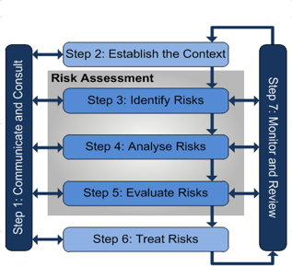

Figure 58: Multi-layered risk framework

## Risk Framework execution

### feasibility delivery

Developed at feasibility commencement, this focused on assessing risks associated with the overall feasibility study process. This involves identifying project constraints, stakeholder expectations, resource availability, and project timelines to ensure successful project delivery.

### Communication & engagement

Developed during communications planning, this helped to identify risks and evaluate their impact on communication and engagement efforts.

### Option and scenario

Developed at the detailed assessment stage this framework offered a methodical and transparent approach in evaluating the various scenarios aimed at reconfiguring the Broken System. It enabled the systematic evaluation of scenarios through a quadruple bottom-line approach, ensuring a consistent consideration of both negative and positive social, cultural, environmental, and economic impacts and advantages.

The developed assessment framework incorporates the identification of option and scenario risks as part of the process. As a decision support tool, this framework equips the project with essential information necessary for assessment of different scenarios. Feasibility for the scenarios under study hinges on their evaluation against specific criteria, ultimately relying on endorsement by both the Project Oversight Group and the Consultative Committee. This endorsement consolidates the feedback garnered throughout the community co-design process.

The framework has been developed as a Multi Criteria Assessment (MCA) to allow for the broad range of feasibility criteria and project principles to be considered through one clear and transparent process.

The assessment criteria have been developed to examine specific risks, using a scale that captures both negative impacts (disbenefits) and positive impacts (benefits). Risks for each option were considered during the preliminary options assessment phase of the project. Where a risk mitigation action was identified during this phase of the assessment process, the options was refined to incorporate this action in the relevant scenario. The risks were then further considered during the MCA process, with a specific criterion developed to capture high level risks that were not considered in any of the other MCA criteria.

## Risk Development

The risk development for each level of risk is detailed below:

### feasibility delivery risk development

A risk workshop was conducted during phase 1 of the project with the Project team, DEECA, and GMW in attendance. The workshop focused on various aspects:

* Reviewing overall project risks to facilitate decision-making, with a consideration of ongoing and future treatments.
* Identifying key risks for each phase of the project, emphasizing the most critical ones.
* Developing mitigation strategies for the key risks identified.

The workshop adhered to the DEECA Risk Management Framework and highlighted key risks that need to be addressed:

* Lack of political and Key Government Agency support
* Balancing competing demands in project management and delivery
* Challenges in obtaining social license from the community, Traditional Owners, and other stakeholders
* Budget constraints for proposed works
* Technical Interface Risk
* Dependence on data provision from government agencies
* Ineffective engagement with Traditional Owners
* Possibility of Consultative Committee members leaking information to the media
* Inadequate representation of community views by the Consultative Committee.

All identified risks, along with their respective mitigation strategies and risk ratings, were documented in a project risk register. This comprehensive approach ensures that the risk development process aligns with the feasibility delivery of the project.

### communication & Engagement risk development

The examination of communication and engagement risks was a crucial step in the development of the communication strategy. This process included stakeholder mapping to pinpoint risks linked to various stakeholder groups and segments within the community. One key objective of the communication plan was to identify communication risks and contentious issues.  
  
In the development of the framework, risks to effective stakeholder relations were thoroughly reviewed from a strategic engagement perspective. While the review encompassed all identified risks, the focus was on the most impactful and highest-risk items for engagement. This approach ensured that the communication and engagement risk development process was thorough and strategic, leading to a more effective and targeted communication strategy.

Risks to effective stakeholder relations identified in the development of the framework were reviewed from a strategic engagement perspective. While the review covered the full list of identified risks, the most impactful and highest risks items for engagement included:

* Unable to obtain social licence amongst the community, Traditional Owners, and other stakeholders.
* Consultative Committee formation.
* Traditional Owner engagement is not effective.
* Funding Agreements with Traditional Owners to support Engagement.
* Lack of publicly available communications materials.
* Consultative Committee members provide information to the media.
* Consultative Committee is unable to provide adequate representation of community views.
* Reduced entitlement holder appetite for reconfiguration due to present conditions.
* Community expectations on reconfiguration cannot be met.
* Role of directly impacted water licence holders is compared to other stakeholders who are not directly impacted.
* Concern over storage management for flood operations.
* Ability to successfully engage with the community on a broader scale to generate interest and awareness of the project.
* Communicating climate change implications.
* Community distrust.
* Perception of the study’s outcomes and results are forgone conclusion.
* Perception of favouritism of one stakeholder group over another.
* Confusion with other programs with different/competing objectives.
* Opposition generated from perception outcomes will create other issues.
* Lake Mokoan decommissioning legacy.

### Option and scenario risk development

The risk framework at the Option and Scenario level examines the technical, environmental, social, cultural, and economic risks associated with the reconfiguration options. Through this phase, the review team monitored and reassessed risk profiles as options were refined and adapted to scenarios.

As referenced in section 5.4.1, a risk review for individual options was incorporated into the preliminary option assessment process. Under the risk assessment criterion for each option, a panel of experts examined the potential risks and mitigations for implementing options at a concept level.

Three of the 22 options identified were graded as high risk through this process. On the basis of a high risk rating and unfavourable assessments against other shortlisting criteria, all three of the high-risk options did not make the shortlist for detailed review.

Under the MCA outlined in Section 5.8, a further assessment of the scenario provided further insights into the impact of risk realisation and potential mitigations strategies.

Throughout the project, the project’s risk appetite and tolerance levels guided assessments, and a preliminary risk register was formed, capturing likelihood, impact, and mitigation measures. Environmental and social risks are also specifically managed to ensure compliance and community acceptance. Continuous stakeholder and community engagement developed and refined mitigation strategies developed into the final option and scenario packages. Final decisions balanced potential benefits and managed risks, with risk management integrated into implementation plans and continuous monitoring processes ensuring ongoing risk management and updates based on project progress. This comprehensive integration of risk framework ensured systematic risk management, leading to informed decision-making and increased likelihood of project success.

During the options and scenario development process, it was noted that some options required the participation of all water users in a reach to be effective and to deliver the identified benefits. This is particularly relevant for options that involve major changes to the flow regime in a reach of the River, to achieve water savings or support environmental improvement. Relying on voluntary participation by individuals was identified as a significant risk to the successful implementation of these types of options. As part of the development of the business case, the need for controlled reconfiguration powers should be considered by the community as part of the next phase of the project. Discussion on the appetite for this aligns with the “Planning our Basin Future Together prospectus”[5] recently released by the Victorian Government.

## Assessment criteria

The Risk Assessment Criteria (RCA) outlined in Table 42 were applied consistently throughout each level of the risk framework, with a particular focus on the option and scenario level risk assessment. This involved evaluating each option's ability to address and manage major risk issues that could hinder the achievement of success criteria.  
  
The assessment scale provided in Table 43 allowed for both negative impacts (disbenefits) and positive impacts (benefits) to be captured, where relevant. Each assessment round included a specific step dedicated to exploring options for mitigating any identified negative impacts. These mitigation options were then presented as part of the assessment process and scored as part of the detailed options evaluation. This scoring process was known as a control effectiveness rating (Table 44).  
  
If a risk mitigation action was determined to have an overall positive impact on the proposed scenario, it was incorporated into a refined version of the scenario. Conversely, if a risk mitigation measure was found to have an overall negative impact on the proposed scenario, it was not included in the refined version of the scenario. This rigorous evaluation process ensured that only the most effective risk mitigation strategies were integrated into the final scenarios, contributing to a more robust and successful project outcome.

Table 42: Assessment Criteria

| Category | Criteria |
| --- | --- |
| Project Objective | Sustainable irrigation sector future: Does the option offer a pathway to support productive irrigated agriculture |
| Project Objective | D&S Supplies: Is the options capable of providing for secure, year-round access to water for D&S and urban needs |
| Environmental | Environmental values: To what extent does the option protect or enhance the environmental values of the Broken River System. |
| Social | Social: Does the option support social values, including recreational fishing and passive enjoyment of the river system? |
| Cultural | Cultural: Does the option support Traditional Owner cultural values and self-determination? |
| Robustness | Robustness: Is the option robust, adaptable and capable delivering benefits under potential future climate change? |
| Risk | Risks: What is the ability of each option to mitigate and manage major risk issues that could limit or prevent achievement of success criteria? |
| Economic | Value for Money: Is the option affordable and represents value for money to project funders and to water users, and expected to be able to attract the necessary funding? |
| Project Objective | Community Acceptance: Is the option consistent with stakeholder aspirations and likely to achieve support from the community? |
| Project Objective | Regulatory and policy alignment: Is the option consistent with government strategy and polices, and expected to be able to comply with relevant regulatory provisions (including water legislation and planning approvals etc) |
| Economic | Impacts and benefits: Is the distribution of benefits or impacts between the involved parties likely to be judged as fair and reasonable overall. |

Table 43: assessment scale

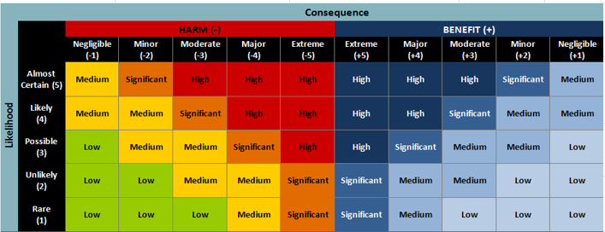

Table 44: Control effectiveness rating



# BRINGING IT TOGETHER – STUDY OUTCOMES AND NEXT STEPS

## Study outcomes

Scenario 9 (a combination of Scenarios 3, 4, 5, 6 & 7, plus remove or reconnect all services in Zone 4) is the preferred option resulting from the Broken System Reconfiguration Feasibility Study and forms the basis of an application to the Resilient Rivers Water Infrastructure Program (RRWIP) for the completion of the Business Case.

In addition to it having the highest reduction in system operating losses, the possible additional benefits of the proposed reconfiguration of the Broken System can be summarised as follows:

1. Irrigation reliability (percentage of years with 100% HRWS in February) is estimated to increase from **84% to 93%** under this scenario.
2. Irrigation reliability early in the season (percentage of years with 100% HRWS in September) is estimated to increase substantially from **3% to 94%** under this scenario.
3. Water will be recovered for use by the environment. This will be achieved through a reduction in the system’s operating losses and the voluntary purchase of water entitlements. This will provide the Environmental managers enhanced flexibility in determining how available environmental water in the System can be used to maximise environmental outcomes.
4. A reserve of 400 ML is established to support more secure access to Domestic and Stock supply in the Broken System.
5. Increased benefits for native fish passage as a result of the proposed removal of Gowangardie Weir.
6. A structured transition for landowners who have expressed interest in transitioning away from irrigation.
7. A net positive MCA score of 1.2 and a preliminary BCR of 0.64 that shows the scenario performs well in the project objectives category, with positive results from the economic and social categories.
8. It is the only Scenario that does not record a negative result, when the lower bound assessment score is used.

To confirm that the proposed reconfiguration options are aligned with the intended outcomes, they were assessed against the success criteria developed in conjunction with the Consultative Committee at the beginning of the feasibility study.

Scenario 9 provides benefits across all success criteria as follows:

**Achieving Multiple Benefits** – supports those seeking to continue in irrigation (some with access to the more reliable Goulburn System), supports a transition for those seeking to exit irrigation and provides environmental benefits (including the removal of Gowangardie Weir).

**Creating Step Change** – provides real options to support people seeking to transition away from irrigation agriculture.

**Future Ready** – reduces reliance on the Broken System for irrigation purposes, enhances access to reliable Domestic and Stock supplies and provides flexibility for the Environmental Water Holders.

**Community Acceptance** – has been tested with the community with a level of support for the individual options evident. The application of the options will be further tested through the business case development.

**Value for Money** – supports an appropriate level of investment consistent with reconfiguration programs of similar complexity.

| Achieving multiple benefits​ | Creating change​​ | Future ready​​ | Community  Acceptance​ | Value for Money |
| --- | --- | --- | --- | --- |
| Badge Tick1 with solid fill | Badge Tick1 with solid fill | Badge Tick1 with solid fill | Badge Tick1 with solid fill | Badge Tick1 with solid fill |

## Alignment with Resilient Rivers Water Infrastructure Program objectives

The objectives sought through the commissioning of this study closely align with the Resilient Rivers Water Infrastructure Program (RRWIP) objectives. Recommendations from the feasibility study are centred around reconfiguring water use to better meet the needs of the community under a drying climate, supporting resilience and the ongoing viability of productive agriculture in the region.

The solutions contemplated involve investment in public and private infrastructure to improve the efficiency of water delivery and on-property use. In addition to supporting the community to adapt to a changing climate, the implementation of recommendations would result in water being recovered for the environment, providing an enhanced arrangement for supporting environmental objectives in the System and contributing to Basin Plan targets.

In line with Recommendation 7 from the 2022 Broken Review, the identification of options focused on:

* A thorough investigation into all feasible options for system reconfiguration in terms of the regulated Broken System, from small-scale local adjustments to water supply for individuals through to decommissioning of areas currently under irrigation.
* Investigating how the risks posed by options could have been mitigated or further benefits to the system achieved.

A detailed analysis was undertaken and presented to identify possible options for the reconfiguration of the Broken System and to pinpoint those aligning with the feasibility and success criteria established. Options were explored across a wide range of scales, encompassing supply to individual properties and potential alterations or modifications to the operation of water regulation infrastructure.

Assessments considered short-term, medium-term, and long-term impacts on water availability, water demand, area under irrigation, and the value of agricultural production. These assessments drew upon research outcomes and lessons from prior projects conducted through the course of the study. Water availability encompassed both consumptive (irrigation, domestic, and stock) and non-consumptive (environmental, recreational, cultural) values and demands. Anticipated effects of climate change were considered in the analysis, informed by the department’s water availability climate change guidelines. This included examining the potential need for fundamental changes to the Broken System to adapt to forecast changes in water availability and agricultural production.

Consultation with the broader Broken System irrigation community and GMW was required to challenge assumptions and enrich the assessments.

## Considerations for future implementation

The preferred scenario from this feasibility study aims to provide significant long-term benefits through strategic investment in infrastructure that supports the ongoing viability of productive agriculture in the region. In addition to recovering water for the environment, the complementary infrastructure solutions offer a pathway for community members to choose between remaining in irrigation or transitioning to non-irrigated practices.

The construction of irrigation supply pipelines will provide connected properties with an enhanced level of service with multiple benefits. Current challenges around managing the impact of low flows and river debris on private pumping off the river would be addressed through managed pipe supply. Shared pipelines achieve a greater level of energy efficiency than can be attained at the individual property level. The implementation would also result in a reduction of private assets (pumps) in environmentally sensitive locations.

Improving the supply infrastructure to the Mokoan pumping station will help to curtail significant water quality and weed control issues. Important supply infrastructure downstream will require less frequent maintenance caused by the current poor water quality.

The preferred scenario also paves the way for the removal of a significant fish migration barrier at Gowangardie Weir. This outcome would help to improve aquatic biodiversity in the river and contribute to a heathier river ecosystem. Restoring natural river pathways will enhance the connectivity between different habitats, promoting genetic diversity and resilience among aquatic species.

Further benefits will be realised through on-farm infrastructure upgrades that result from professional advice and support for transitioning to a climate-resilient layout.

## Resilience to changing climate.

Climate change resilience was considered in water resource modelling that underpins the MCA assessment. The water resource modelling included running each of the scenarios under the following climate projections:

* Historic climate.
* Inputs adjusted via decile scaling to match post-1975 climate conditions.
* Inputs adjusted via decile scaling to match post-1997 climate conditions.
* Inputs adjusted according to 2040 low climate change projections using the RCP 8.5 emissions scenario.
* Inputs adjusted according to 2040 medium climate change projections using the RCP 8.5 emissions scenario.
* Inputs adjusted according to 2040 high-climate change projections using the RCP 8.5 emissions scenario.
* Inputs adjusted according to 2065 high-climate change projections using the RCP 8.5 emissions scenario.

Table 45 and Figure 59, show that only small reliability gains are realised under scenarios 3, 4, 5 & 6. Gains are larger under scenario 2, 8 and 9 because a greater redistribution of HRWS is assumed. When a more secure D&S arrangement is created under scenario 7 reliability reduces slightly but results in very high reliability for D&S demands.

September allocations increase substantially for scenarios where the volume of consumptive HRWS is substantially reduced and/or when Broken Creek loss provision is not needed.

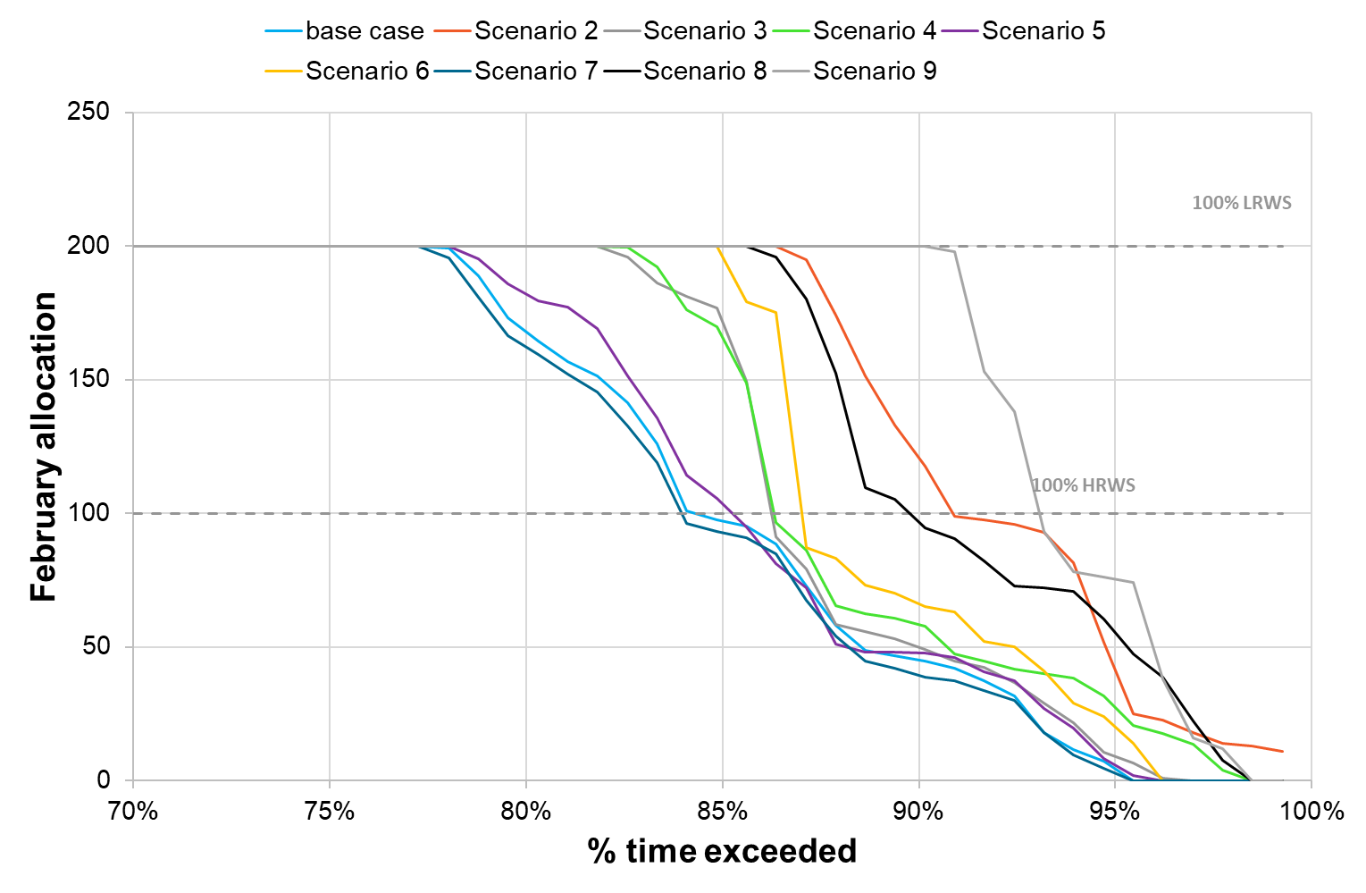

Figure 59: February allocation (reliability) comparison, historic climate current demand case

Results showed that that the impacts of climate change on system performance are similar for the base case and for reconfiguration scenarios due to there being a similar impact of climate on water availability. Where the model was run with historic climate and full demand, results showed that the impact of this demand increase on reliability is like the impact of post 1975 climate.

Table 45: Scenario performance comparisons

|  | Base case | 2 | 3 | 4 | 5 | 6 | 7 | 8 | 9 |
| --- | --- | --- | --- | --- | --- | --- | --- | --- | --- |
| February reliability | 84% | 90% | 85% | 85% | 85% | 87% | 83% | 89% | 93% |
| Reliability D&S* |  |  |  |  |  |  | 99.7% | 99.0% | 98.7% |
| September reliability | 2% | 89% | 69% | 9% | 1% | 82% | 2% | 86% | 94% |
| Unrestricted demand supplied | 92% | 90% | 93% | 95% | 93% | 95% | 95% | 98% | 98% |
| Losses compared to base case | 19,584 | -523 | -137 | -4,432 | -107 | -228 | -24 | -4,565 | -4,728 |
| *Provision of low flows compared to base case (scenarios with stored env water only)* | | | | | | | | |  |
| Broken R reach 1 | 27,983 | +5,547 | +462 | -108 | n/a | +1,558 | n/a | +231 | +326 |
| Broken Ck reach 1 | 3,390 | -265 | +139 | -887 | n/a | +10 | n/a | -583 | -558 |

* % of D&S demand supplied when applying improved access to D&S

The recommended approach under Scenario 9 not only offers the highest reduction in system operating losses but also presents a range of additional benefits that underpin long-term climate change resilient primary production:  
  
1. Enhanced Reliability for entitlement holders in February: The percentage of years with 100% HRWS in February is projected to increase from 84% to 93% under the proposed scenario. This improvement in irrigation reliability is a direct outcome of retiring 50% of the water recovered through voluntary purchase. This increased reliability is crucial for sustaining primary production activities amidst changing climate conditions.  
  
2. Improved Early Season Reliability for entitlement holders: Modelling suggests that the percentage of years with 100% HRWS in September is expected to significantly rise from 3% to 94% with the implementation of the proposed changes. This substantial enhancement is also attributed to retiring 50% of the recovered water through voluntary purchase, indicating a more reliable water supply for agricultural operations at the beginning of the season.  
  
3. Water Recovery for Environmental Use: Through a combination of reducing system operating losses and voluntary purchase of water entitlements, water will be recovered for environmental purposes. This recovered water will provide environmental managers with greater flexibility in utilising available water resources to maximise environmental benefits and enhance ecosystem resilience to climate change impacts.  
  
4. Establishment of Domestic & Stock Water Reserve: The establishment of a 400ML reserve will ensure more secure access to domestic and stock water supplies within the system. This reserve acts as a strategic buffer to support primary production activities during periods of water scarcity, contributing to the long-term climate change resilience of the agricultural sector.  
  
5. Benefits for Native Fish Passage: The proposed removal of Gowangardie Weir will lead to increased benefits for native fish passage, promoting biodiversity and ecosystem health. This enhancement in fish migration pathways aligns with climate change resilience efforts by supporting the sustainability of aquatic ecosystems in the face of environmental challenges. Further improvements to fish passage may be considered during the development of the Business Case through the review of other structures in the system, including Broken Weir and disused/abandoned structures on Broken Creek.

## Detailed Business case - Governance, and resources to deliver program outcomes.

The detailed business case for Scenario 9 (a combination of Scenario 3, 4, 5, 6 and 7) will underscore the critical importance of this initiative for enhancing environmental sustainability, economic development, and community well-being in the broken system.

Opportunities for aspirations of Traditional Owners to be achieved through the reconfiguration of the Broken System will be considered through Traditional Owner engagement based on self-determined participation in the development of the business case.

### Project approach

The expected timeline for completion of the Detailed Business Case process is 9 months. Based on the short timeframe and the need for most project activities to be conducted at the same time, the project is proposed as having only 3 stages:

* Stage 1 – Establishment.
* Stage 2 – Investigations and Stakeholder Engagement.
* Stage 3 – Business Case Preparation and Submission.

The planned stages are set to encompass the following activities:

#### Establishment

* Establish a clear governance and management structure for project delivery.
* Appoint or procure project resources to undertake the delivery of the Business Case.
* Confirm and implement the process for appointing a representative committee to provide input into the development of the Business Case.
* Develop a detailed project management plan outlining timelines, milestones, deliverables, and performance metrics.
* Implement a comprehensive risk management framework to identify, assess, and mitigate risks throughout the project lifecycle.
* Develop and implement a comprehensive communication strategy to keep stakeholders informed about project progress and findings.
* Leverage legal and policy advice to set the parameters of options pursued through the development of the Business Case.

#### Investigations and Stakeholder Engagement

* Commence environmental and Cultural Heritage impact assessments, along with regulatory approvals scoping.
* An environmental flow study will be undertaken to inform options for using enhanced environmental holdings.
* Engagement with Traditional Owners based on self-determined participation in the development of the business case. Reassess the baseline data for water usage, including historical water consumption patterns, current irrigation practices, and previous water-saving measures.
* Confirm the accuracy and relevance of this data to establish a solid foundation for comparison.
* Update the stakeholder map to ensure comprehensive identification of all stakeholders.
* Engage professional advisors for a Farm Planning Program to support individual property owners to make an informed decision on which available options best suit their needs.
* Consult with property owners to understand their specific needs, preferences and likely participation in reconfiguration options.
* Undertake engineering and technical investigations to develop concept designs in alignment with outcomes from landowner engagement activities.
* Incorporate stakeholder feedback into the business case to address concerns and demonstrate responsiveness.

#### Business Case Preparation & Submission

* Finalise the scope of works for the proposed project.
* Confirm the assessed benefits and impacts of the proposed project.
* Confirm the regulatory approvals strategy.
* Develop detailed financial projections, including capital expenditure (CAPEX), operational expenditure (OPEX), and maintenance costs.
* Economic Impact Assessment: Assess the broader economic impacts.
* Submit the final business case in accordance with all relevant guidelines and requirements.

### Resources to Deliver

The roles, activities and capabilities contained within the cost estimate for Scenario 9 are detailed in Table 46 below. The cost estimate assumes that the existing governance arrangements will transition to a Project Control Group, which will provide governance oversight of the project throughout the 24-month project delivery phase.

These roles and assumptions are essential to ensure the success of the delivery of the business case.

Table 46: Roles, activities and capabilities

|  |  |
| --- | --- |
| **Roles/activities and Capabilities** | **Resources** |
| Project Governance and **Management** |  |
| Project Control Group | 3 members. |
| Community Representative Committee | 1 Chair and 6 ordinary members |
| DEECA Project Coordination and Interface Team | 2 FTEs |
| Delivery Team | 7.5 FTEs |
| Engagement and Negotiation Team | 3 FTEs |
| Cost advisor | Engaged on an as-needs basis |
| Probity Advisor | Engaged on an as-needs basis |
| Legal Advisor | Engaged on an as-needs basis |
| Financial Audit | Engaged on an as-needs basis |
| Program Assurance | Engaged on an as-needs basis |

In addition to the roles nominated in Table 45, the project team will engage specialised contracted services to complete tasks that require specific expertise.

### governanace

A robust governance framework will be implemented to oversee the subsequent phases of the business case. It is assumed that a similar governance structure that was established for the Feasibility study will be utilised for the delivery of the business case.

* A project oversight group comprising representatives from government agencies, local councils, Indigenous communities, environmental organisations, and other key stakeholders to ensure transparent and accountable decision-making, with regular reporting and independent audits to maintain high standards of governance.
* A Consultative Committee to continue to facilitate the community-centred and place-based approach using co-design principles.
* A Consultant Lead to co-ordinate and manage efforts across the governance structure

The governance structure will facilitate effective coordination, stakeholder engagement, and compliance with regulatory requirements.

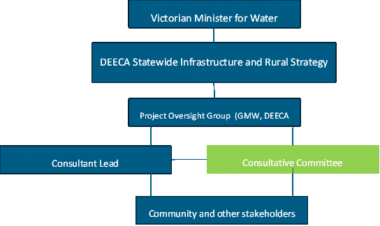

)

Figure 60: Governance framework for BRFS

### approvals

The business case would be delivered in accordance with all relevant Victorian Government guidelines and Frameworks including the following:

#### Governance and oversight

* Appointment of members to advisory committees, including governance and/or oversight committees, in accordance with the [Victorian Government’s Guidelines for Appointment and Remuneration](https://www.vic.gov.au/guidelines-appointment-remuneration).
* Engage with the Project Oversight Group and other regulatory authorities throughout their review process, providing additional information and addressing any queries or concerns they may have.
* Submit the business case and supporting documents to relevant regulatory authorities for review and approval.

#### Stakeholder engagement

* All community engagement must be undertaken in line with:
  + the Victorian Government [Public Engagement Framework 2021-2025](https://www.vic.gov.au/public-engagement-framework-2021-2025).
  + the DELWP [community charter](https://www.delwp.vic.gov.au/communities-and-regions/community-charter).
* Engagement and consultation with Aboriginal communities must align with
  + the Victorian Government [Traditional Owner Engagement project](https://www.firstpeoplesrelations.vic.gov.au/victorian-government-traditional-owner-engagement-project)
  + the DELWP [Traditional Owner Engagement framework](https://www.delwp.vic.gov.au/aboriginalselfdetermination/how-we-engage-with-traditional-owners)
  + Traditional Owner nation statements provided as part of [Water is Life](https://www.water.vic.gov.au/__data/assets/pdf_file/0033/599505/WiL-Summary.pdf).
* Other
  + [Water availability climate change guidelines](https://www.water.vic.gov.au/climate-change/adaptation/guidelines).

#### Regulatory Compliance and Environmental Approvals

* Complete a detailed Environmental Impact Assessment, addressing potential impacts on ecosystems, water quality, and biodiversity, and propose mitigation measures.
* Obtain necessary water licenses and permits from relevant regulatory bodies, ensuring compliance with water management regulations.
* Secure clearances related to cultural heritage, particularly if the project impacts areas of cultural or historical significance to Indigenous communities.

#### Financial Approvals and Funding

* Detailed Budget Submission: Prepare and submit a detailed budget outlining the financial requirements for the project, including projected costs, funding sources, and financial justifications.
* Funding Applications: Complete and submit funding applications detailing the expected water savings and economic benefits of the project.
* Financial Audits: Undergo financial audits and reviews as required by funding bodies to ensure transparency and accountability in budget management.

#### Technical and Design Approvals

* Engineering Design Review: Submit detailed engineering designs to relevant technical bodies for review and approval, ensuring adherence to industry standards and best practices.
* Provide technical feasibility assessments, including hydrological models, infrastructure plans, and technology evaluations.
* Submit safety and risk assessments to demonstrate that all potential hazards have been identified and mitigated.

#### Stakeholder Endorsements and Letters of Support

* Secure letters of support from key stakeholders to demonstrate broad-based support for the project.
* Formalise agreements with stakeholders, outlining their roles, responsibilities, and contributions to the project.

### Program delivery timeline

The program delivery timeline is visualised in Table 47 below.

Table 47: Business Case Program Delivery Timeline

|  |  |  |  |  |  |  |
| --- | --- | --- | --- | --- | --- | --- |
| Staging | July – Oct 2024 | | Oct – Dec 2024 | Jan – Mar 2025 | April – Jun 2025 | |
| Stage 1 – Establishment |  |  |  |  |  |  |
| Stage 2 – Investigations and Stakeholder Engagement |  |  |  |  |  |  |
| Stage 3 – Business Case Preparation and Submission |  |  |  |  |  |  |

### Risk Management

A multi-layered risk framework was developed and implemented during the feasibility study as shown in Section 9

This framework aligns with the Victorian Government Risk Management Framework (VGRMF) and was designed to provide a structured approach to managing risks.

It is proposed that the same framework be adopted for the management of risks during the Business Case development  
  
The establishment of this multi-layered risk framework during the Business Case development is to allow stakeholders to effectively navigate uncertainties, make well-informed decisions, and optimise the viability of the business case outcome. Key stages of the business case where the framework will be utilised to ensure the robustness of the approach are:

* Confirmation of water savings and rural customer/stakeholder requirements
* Stakeholder and customer engagement
* Business case development (including design, approvals etc)

### cost estimates and Procurement

The procurement model for developing a business case will be based on Victorian Government Procurement Guidelines and will be conducted using a structured and transparent approach to ensure the selection of the most suitable service providers. The process will be designed to attract competitive bids from capable providers that meet the requirements of the selection criteria.

The assessment of the candidate bids will be undertaken by suitably qualified personnel under the supervision of DEECA, with support from specialist probity, legal and financial advisors.

The selection of the preferred bidder will be assessed through the procurement approval process and, if appropriate, authorised by the holder of delegated authority.

# Conclusion

The Broken Reconfiguration Feasibility Study (BRFS) has been a testament to the power of community-led initiatives in addressing the challenges of an annual system with reduced water availability. Initiated in response to concerns raised by the Broken System community, the study aimed to explore reconfiguration options for the Broken River Irrigation System, ensuring a sustainable future for the Valley.

Throughout the study, the input and engagement of the community, guided by the Consultative Committee and various stakeholders, has been invaluable. The active participation of over 10% of water users, representing 60% of the Broken System's water entitlement holders, underscored the collaborative and inclusive nature of the BRFS.

By assessing and identifying feasible options for system reconfiguration, the study aligned with the community's vision for a sustainable future and sought to achieve multiple benefits, create a step change, and ensure readiness for future challenges. The rigorous evaluation process, in conjunction with the Consultative Committee, highlighted the importance of community acceptance and value for money in determining the preferred option.

Among the options considered, Scenario 9 emerged as the preferred option meeting all success criteria and providing value for money at an investment of $129 million. This option not only enhances the environmental sustainability of the system but also offers transitional support for irrigators and secure supplies for domestic and stock needs.

As the BRFS moves forward into the Business Case development phase, the solid foundation laid by the study's findings and recommendations sets the stage for a more resilient and sustainable Broken system. The compelling evidence and strong case presented by the study underscore the potential for this community-led initiative to create lasting positive impacts for the community and the environment.



For more information,   
please contact:

Daniel Irwin  
0427 805 804  
Daniel.Irwin@sequana.co

Contact us

Sydney

Level 6, 201 Kent Street, Sydney NSW 2000

Melbourne

Level 1, 477 Collins Street, Melbourne VIC 3000

Brisbane

Level 7, 123 Eagle Street, Brisbane City QLD 4000

**enquiry@sequana.co  
sequana.co**

1. Water resources are also set aside to meet passing flow obligations outlined in the [Bulk Entitlement (Broken system – Goulburn-Murray Water) Conversion Order 2004](https://www.waterregister.vic.gov.au/index.php?option=com_waterregister_reports&task=loadFile&fileName=Bulk+Entitlement+%28Broken+System+-+Goulburn+Murray+Water%29+Conversion+Order+2004+as+at+September+2017.pdf&filePath=%2FDocumentRepository%2FActive%2FMiscellaneous%2F&type=R02). Passing flow supports river operations, riparian rights and maintains community and environmental benefits.
2. LRWS is an acronym for low reliability water shares
3. [Planning our Basin future together (water.vic.gov.au)](https://www.water.vic.gov.au/our-programs/murray-darling-basin/planning-our-basin-future-together)
4. Discounting is necessary because a dollar of benefit in the future is worth less than a dollar of benefit today. The discount rate represents the social opportunity cost of capital used in the project: what benefits to society the funds would return if left in the private sector (Infrastructure and Transport Ministers, 2022).
5. [Planning our Basin future together (water.vic.gov.au)](https://www.water.vic.gov.au/our-programs/murray-darling-basin/planning-our-basin-future-together)