# **Western Region Sustainable Water Strategy**

Information sheet for stakeholders on the Five-Yearly Assessment

The picture shows the Wimmera river with Dimboola in background.

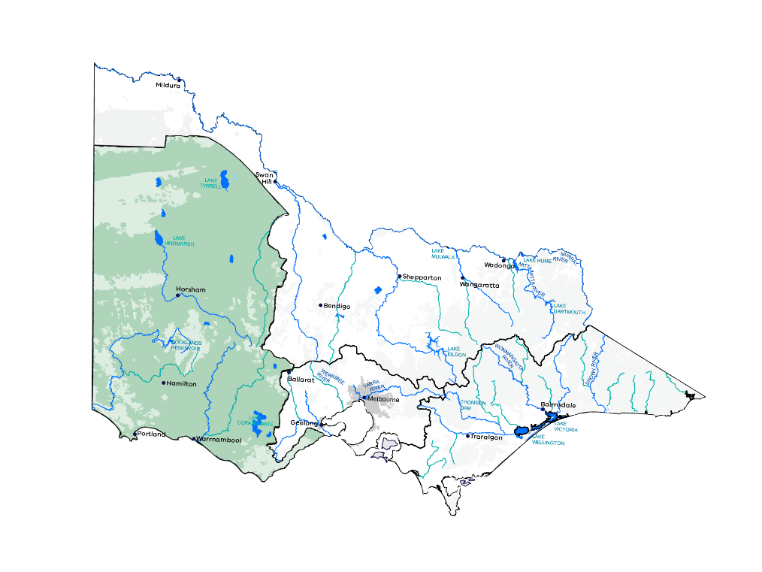

## **Reviewing Victoria’s sustainable water strategies**

Sustainable Water Strategies are long term plans for Victoria’s water resources so there are secure supplies for cities and towns, industry and the environment well into the future.

This information sheet provides background for the Five-Yearly Assessment of the Western Region Sustainable Water Strategy. Outcomes of the assessment will inform any future development of a new sustainable water strategy.

## **Sustainable Water Strategies**

Sustainable water strategies are long term plans for water resources within Victoria. Sustainable water strategies were completed for the Central, Northern, Western and Gippsland regions between 2006 and 2011.

These landmark strategies identified risks to water supply and quality. They included actions to help water users, water corporations and catchment management authorities manage and respond to risks over the next 50 years.

The Water Act 1989 requires each Sustainable Water Strategy to be reviewed at least every 10 years.

The Victorian Government’s Water for Victoria plan (2016) introduced five-yearly assessments of sustainable water strategies to help deal with climate change, drought and population growth and consider changes in land use.

The government started the review of the Central Region Sustainable Water Strategy in 2016 and five-yearly assessments of the Gippsland Region and Western Region Sustainable Water Strategies in 2017.

## **Snapshot of the region**

The Western region covers around one-third of Victoria from Colac and Lorne in the south-east to Ouyen in the north-west. Its agricultural and urban centres include Colac, Port Campbell, Horsham, Stawell, Ararat, Hamilton, Warrnambool and Portland. Communities are involved in farming, forestry, recreation and tourism and processing, energy and mining industries.

Waterways are highly valued by local residents and visitors and are widely used for recreation such as fishing, camping, swimming, boating, bushwalking and wildlife watching. They are vital to local economies and are a high priority for local communities. Traditional Owners in the region have cultural, spiritual and economic connections to land, water and resources.

The region has diverse landscapes, climates and water resources, from heavily forested areas with reliable rainfall and water supplies to drier saline areas that depend on groundwater and pipeline supplies from other parts of the region. Surface water makes up 62 per cent of the water supplied to towns, farms and industries, with 37 per cent from groundwater and about one per cent from alternative supplies like recycled water.

### Want to know more?

[Click here for more information on managing groundwater](https://www.water.vic.gov.au/groundwater/managing-groundwater)

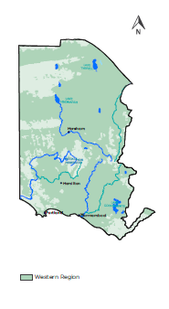

## **Five-yearly assessment Western Region Sustainable Water Strategy**

The Five-Yearly Assessment of the Western Region Sustainable Water Strategy started in 2017.

The assessment will:

• report on the timing of the strategy’s actions

• check how well the aims and targets have been met

• outline how water management has changed since the strategy’s release

• identify lessons learned to inform a new sustainable water strategy.

It will combine information from the original strategy, Water for Victoria and targeted consultation.

The Department of Environment, Land, Water and Planning (DELWP) assessment will consider the shared benefits since the Western Region Sustainable Water Strategy was released, including recreational and Aboriginal values.

The picture shows Lake Colac boardwalk, Victoria.
Image: Copyrights State of Victoria, DELWP. Credit Sal Ahmad




The timeline shows:
Between 2004 and 2009
• Picture showing a lake in a drought event (Image: Credit Alison Pouliot) - Prolonged drought (1997 to 2009) flows up to 90% lower than long-term average
• Our Water Our Future launched
• Water Act 1989 Amendments
• Our Water Our Future: The next stage of the Government’s Water Plan
Between 2010 and 2011
• Picture showing a flood event (Image: Credit Paul Lloyd) - Severe flooding (2010 to 2011) highest floods on record in parts, 1 in 20 year floods in Wimmera
• Draft Western Region Sustainable Water Strategy
• Public consultation
• Targeted engagement with Traditional Owners
• Final Western Region Sustainable Water Strategy
Between 2012 and 2016
• Victorian Waterway Management Strategy
• Basin Plan signed (for Wimmera and Mallee)
• Stocktake of Sustainable Water Strategies actions
• Water for Victoria launched
Between 2017 and 2019
• Progress update of actions for Western Region Sustainable Water Strategy
• Five-Yearly Assessment of the Western Region Sustainable Water Strategy
Footnotes
Regional stakeholders provided guidance, advice and oversight of the Western Region Sustainable Water Strategy’s development, meeting 22 times between October 2008 and August 2011
1. Indicative dates.
2. The review of the Central Region Sustainable Water Strategy began in 2016 and a draft report will be released for public consultation in 2018.
3. The five-yearly assessment of the Gippsland Region Sustainable Water Strategy started in 2017.
4. The review of the Northern Region Sustainable Water Strategy is due to start in 2019.

## **Highlights of the Western Region Sustainable Water Strategy**

The original strategy aimed to secure supply for water users and the environment, promote sustainable water use and protect and improve the health of waterways, aquifers, wetlands and estuaries. That included:

• Managing and operating the Wimmera-Mallee Pipeline to make the best use of existing water supplies and sharing them between different water users.

• Capitalising on water savings from the Wimmera-Mallee Pipeline and managing entitlements and flows to improve the environmental health of connected rivers that had been stressed by low flows.

• Providing certainty for water users by developing local management plans for unregulated surface water and groundwater management areas, better groundwater monitoring and extending the length of licences.

• Formalising water sharing rules for supplying unregulated flows into Lake Condah, an ancient Aboriginal settlement and aquaculture site in southwest Victoria.

## **Working together**

The sustainable water strategy assessments will involve people from across state and local government, the water sector and communities.

The Victorian Government, through the Aboriginal Water Program, is including Traditional Owners and Aboriginal people in water management. DELWP’s Aboriginal Water Unit is working with communities on ways to share the benefits of Victoria’s water with Traditional Owners and their communities.

The assessments currently underway will explore links with key DELWP projects such as the long-term water resource assessment, water grid and markets and integrated water management forums.

## **Stocktake of actions**

The original Western Region Sustainable Water Strategy included 69 actions, 46 of which have been completed. Of the remaining actions, 11 are ongoing, 11 form part of Water for Victoria and one will be dealt with in the Wimmera Mallee Water Resource Plan being developed to meet Victoria’s obligations under the Murray-Darling Basin Plan. Update on the status of all actions will be incorporated in the assessment.

### Want to know more?

[Click here for the Stocktake of the Western Region Sustainable Water Strategy](https://www.water.vic.gov.au/planning-and-entitlements/water-resource-planning/sustainable-water-strategies/western-and-gippsland-region-sustainable-water-strategies)

[Click here for the Victorian Waterway Management Strategy](https://www.water.vic.gov.au/waterways-and-catchments/rivers-estuaries-and-waterways/strategies-and-planning)

[Click here for the Western Region Sustainable Water Strategy](https://www.water.vic.gov.au/__data/assets/pdf_file/0025/52882/WRSWS_accessible_linked_final.pdf)

[Click here for the Gippsland Region Sustainable Water Strategy](https://www.water.vic.gov.au/__data/assets/pdf_file/0026/52883/DSE_GRWS_accessible_linked.pdf)

[Click here for the Central Region Sustainable Water Strategy](https://www.water.vic.gov.au/planning-and-entitlements/sustainable-water-strategies)

[Click here for the Northern Region Sustainable Water Strategy](https://www.water.vic.gov.au/__data/assets/pdf_file/0018/63270/NRSWS-Full-Document.pdf)

[Click here for Water for Victoria, Chapters 6 to 9](https://www.water.vic.gov.au/water-for-victoria)

### For more information

Email [SWS.Team@delwp](mailto:SWS.Team@delwp). vic.gov.au or contact the DELWP Customer Service on 136 186

[Click here for information on the long-term water resources assessment](https://www.water.vic.gov.au/planning-and-entitlements/long-term-water-resource-assessment)

[Click her for information on realising the potential of the grid and markets](https://www.water.vic.gov.au/water-grid-and-markets/water-grid-and-markets)

[Click here for information on Integrated Water Management Forums](https://www.water.vic.gov.au/liveable-cities-and-towns/resilient-and-liveable-cities-and-towns/iwm-framework)

Front cover image: Credit Paul Lloyd

## **Footer**

Copyright The State of Victoria Department of Environment, Land, Water and Planning 2018

This work is licensed under a Creative Commons Attribution 4.0 International licence. You are free to re-use the work under that licence, on the condition that you credit the State of Victoria as author. The licence does not apply to any images, photographs or branding, including the Victorian Coat of Arms, the Victorian Government logo and the Department of Environment, Land, Water and Planning (DELWP) logo.

To view a copy of this licence, [click here](https://creativecommons.org/licenses/by/4.0/).

ISBN 978-1-76047-962-6 (print)

ISBN 978-1-76047-963-3 (pdf/online)

Disclaimer

This publication may be of assistance to you but the State of Victoria and its employees do not guarantee that the publication is without flaw of any kind or is wholly appropriate for your particular purposes and therefore disclaims all liability for any error, loss or other consequence which may arise from you relying on any information in this publication.

[Click here to the DELWP website](http://www.delwp.vic.gov.au)