* Water is Life: Traditional Owner Access to Water Roadmap*

Progress Report September 2024

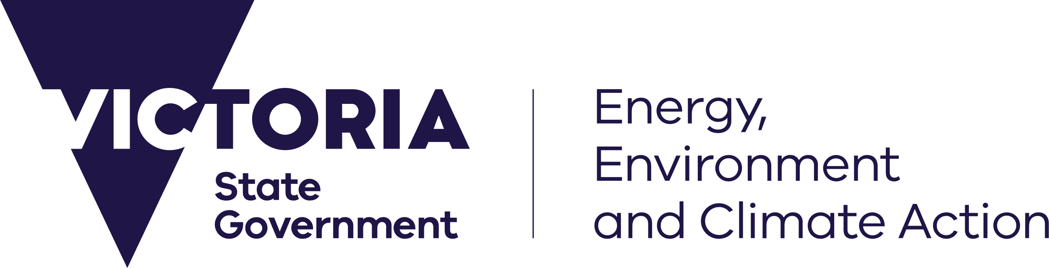



deeca.vic.gov.au

Design credit

Front page graphic design by Mazart Communications. Supply Nation and Kinaway certified.



We acknowledge and respect Victorian Traditional Owners as the original custodians of Victoria’s land and waters, their unique ability to care for Country and deep spiritual connection to it.

We honour Elders past and present whose knowledge and wisdom   
has ensured the continuation of culture and traditional practices.

DEECA is committed to genuinely partnering with Victorian Traditional Owners and Victoria’s Aboriginal community to progress their aspirations.

© The State of Victoria Department of Energy, Environment and Climate Action September 2024.

Table of Contents

*Water is Life:* Introduction2

Summary of Progress3

Progressing Water Returns12

Water returns currently in progress12

Work being undertaken to support future water returns12

Lessons Learnt14

Yoorrook Justice Commission – Land Injustice Inquiry14

Environmental Watering15

Barriers in the current water entitlement framework 16

Working to support appropriate resourcing18

Case Studies19

Musk Duck – First Peoples of the Millewa Mallee 20

Returning Water to Wadawurrung Country 21

# *Water is Life*: Introduction

Released in September 2022, *Water is Life: Traditional Owner Access to Water* *Roadmap* (*Water is Life*) sets out the Victorian government commitments and policy pathways in the short, medium, and long term to increase decision-making and resources for Traditional Owners in the management of water landscapes, as well as increasing Traditional Owner access to water.

Development of *Water is Life* was led by Traditional Owners over 2021 and 2022. It includes 27 Nation Statements prepared by Traditional Owner groups, expressing their cultural and water-related values, goals, aspirations, outcomes, and any other relevant information deemed important by each Nation in their own words.

*Water is Life* is founded in the Victorian government’s recognition of Traditional Owner sovereignty, self-determination, and the need for a restorative justice approach to the way water is managed in Victoria. Implementing the 12 Targeted Outcomes within *Water is Life* is a long-term commitment, and one that requires enduring, sustainable change.

Two years since its release, this report provides an update on the implementation progress being made and includes lessons learnt to-date.

# Summary of Progress

Implementation of *Water is Life* is progressing with almost all actions on track. Funding to continue implementation was announced by the Victorian Government in the 2024-25 budget. Over the next four years, $7.72m of funding will support Traditional Owners’ involvement in pilot and research projects with a focus on activities designed to deliver short- and medium-term targeted outcomes. This funding will also ensure the payment of fees and charges associated with water returned to Traditional Owners.

The table below provides an update on all actions in *Water is Life.* The status descriptions have been revised since the last update from April 2024 and are:

* **Not yet started:** This action is due to be delivered in future years
* **Behind schedule (action needed):** This action requires attention, unlikely to be fulfilled within committed timeframes
* **Behind schedule (progressing):** This action may not be fulfilled within committed timeframes, but action is being taken to either get this action back on track or modify the timeframe
* **Started**: Collaboration or a scope of work has commenced
* **Progressing**: The action has been partially achieved and still has remaining tasks to complete
* **Achieved and completed**: The action has been completed in full
* **Achieved and ongoing**: The action has been achieved and the strategy’s requirements have been met, but ongoing effort is needed to ensure the intended outcome of the action continues to be maintained.

Almost all short- and medium-term outcomes are progressing and initial stages of work has commenced on two long-term outcomes: Recognition of Traditional Owners as waterway managers (Outcome 5) and Traditional Owners can hold and manage water in culturally appropriate ways (Outcome 11).

Whilst delivery is behind schedule, work continues to develop a legislative proposal to recognise waterways as living entities (Outcome 1). The team is considering feedback provided to date by Traditional Owners, statements and evidence submitted to Yoorrook Justice Commission hearings, and emerging policy to further develop the legislative proposal. It is unlikely that a legislative proposal will be ready by 2025 as originally committed in *Water is Life*.

Table 1: Summary of Progress on Water is Life implementation

| **Outcome​** | | **Action​** | | **Action Lead (DEECA Branch)** | **Timeframe​** | **Implementation status​** | **Update  September 2024** |
| --- | --- | --- | --- | --- | --- | --- | --- |
| 1​ | Living entity and voice​ | 1.1​ | Develop new legislative proposals to recognise waterways as living entities through engagement with Traditional Owners and wider stakeholders for Government consideration | Resilient Cities and Towns | Due 2025 (short-term action) | **Behind schedule (progressing)** | * Discussion paper on proposed legislative changes is being prepared. * Work is underway on a state-wide engagement and resourcing plan. * Victorian Waterway Management Strategy (VWMS) renewal will provide an opportunity to explore implementing recognition of waterways and their surrounding lands as living, integrated, natural and cultural entities through policy. |
| Next steps:   * January 2025: Ministerial endorsement of consultation approach including proposed content of discussion paper. * March 2025: Development of legislative proposals (options) to take to consultation. * Mid-late 2025: Statewide engagement with Traditional Owners. This will be followed by consultation with stakeholders and wider community. | | | | | | |
| 2​ | Partnerships with the water sector  ​ | 2.1​ | Develop new provision in statements of obligation for Ministerial consideration requiring formal partnerships between Traditional Owners and Catchment Management Authorities (CMAs) and water corporations | Sector Governance and Support | Due 2025 (short-term action) | **Progressing** | * Amendments to Statement of Obligations (General) for water corporations have been drafted and are with water corporations for comment. * Amendments to Statement of Obligations for CMAs and the VEWH’s Ministerial Rules are in the initial preparatory stages. * DEECA has met with water sector to discuss obligations. |
| 2.2​ | Develop new provision in Ministerial rules for the Victorian Environmental Water Holder (VEWH) requiring formal partnerships with Traditional Owners for Ministerial consideration | Sector Governance and Support | Due 2027 (medium-term action) | **Started** |
| Next steps:  Action 2.1   * February 2025: finalise proposed responses to sector feedback on Statement of Obligations (General) (SoO) for water corporations. * June 2025: Ministerial consultation with the Essential Services Commission and the Treasurer. * October 2025: Gazettal of new SoO for water corporations and development of Catchment Management Authority SoOs. * Post-2025: DEECA will work with Traditional Owner groups and the water sector to develop appropriate guidelines to support formal partnership agreements with Traditional Owners.   Action 2.2   * October 2027: Ministerial rules for the VEWH will be developed, implementing learnings from changing the Statement of Obligations (General) for water corporations and informed by the Victorian Waterway Management Strategy (VWMS) renewal. | | | | | | |
| 3​ | Traditional Owners have increased role in environmental water management​ | 3.1​ | Develop new guidelines for Traditional Owners to submit seasonal watering proposals to the VEWH | Waterway Programs | Due 2025 (short-term action) | **Progressing** | * The VEWH, DEECA, Parks Victoria and CMAs have been working with Traditional Owners to support development of Traditional Owner-led Seasonal Watering Proposals (SWPs) for 5 trial sites. * Workshops are being held to develop guidelines for Traditional Owner-led SWPs to be submitted directly to the VEWH. * Legal advice is being prepared regarding multi-year transfers of environmental water allocation to Traditional Owners. |
| 3.2​ | Undertake localised pilot environmental watering projects | Waterway Programs | Due 2025 (short-term action) | **Progressing** |
| 3.3​ | Develop framework for agreements for transfer of environmental water allocation to Traditional Owners for dual environmental and cultural benefit in accordance with environmental water requirements | Waterway Programs | Due 2027 (medium-term action) | **Progressing** |
| Next steps:   * December 2024: First version of guidelines for Traditional Owner-led Seasonal Watering Proposals (SWP) to be released. * January 2025: Commence engagement with Nations not involved in the SWP trials and other water sector program partners. * June 2025: Pilot environmental watering projects confirmed (based on the seasonal watering proposals that are submitted by Traditional Owners). * June 2025: DEECA, VEWH and legal services collaborate on developing case studies that work through the legal and practical obligations likely to be required of Traditional Owners and partners in agreements that transfer environmental water allocation. | | | | | | |
| 4​ | Traditional Owners have increased involvement in public land management​ | 4.1​ | Explore a range of public land management opportunities for Traditional Owners through the renewal of Victoria's public land legislation​ | Land Policy | Due 2027 (medium-term action) | **Progressing** | * New Public Land Act being prepared. * First Peoples’ Assembly of Victoria and Traditional Owner Corporation Caucus have been briefed on reforms and will continue to be engaged. |
| Next steps:   * October 2024: Traditional Owner groups to be invited to meetings to provide an update on the draft Bill. * Early 2025: Further engagement with Traditional Owners, including discussion of draft Bill (timing subject to drafting of Bill by Office of Chief Parliamentary Counsel). * Mid-2025: Legislation anticipated to be introduced into Parliament. | | | | | | |
| 5​ | Recognition of Traditional Owners as waterway managers for specific locations ​ | 5.1​ | Identify and address barriers to Traditional Owners taking on sole management of waterways and develop new legislative proposals through engagement with Traditional Owners and wider stakeholders for Government consideration | Waterway Programs | Due after 2027 (long-term action)  2027+ | **Started** | * Preliminary work initiated to understand legislative barriers of Traditional Owners preparing Regional Waterway Strategies. * This is a long-term outcome that will build on the learnings from Outcomes 2 and 3, and opportunities identified in the Victorian Waterway Management Strategy. |
| Next steps:   * Post-2025: Once Outcome 2 and 3 have completed, lessons learnt during their implementation will be collected and used to inform the delivery of this Outcome. * Post-2025: Traditional Owners will be supported to work with DEECA and other stakeholders to develop legislative proposals. | | | | | | |
| 6​ | Recognition of Traditional Owners as environmental  water holders​ | 6.1​ | Identify barriers to Traditional Owner management of environmental water and consider any potential new legislative proposals through engagement with Traditional Owners and wider stakeholders for Government consideration | Waterway Programs | Due after 2027 (long-term action)  ​ | **Not yet started** | * Planned activity - long-term outcome that will build on the learnings from Outcome 3. |
| Next steps:   * Post-2027: Once Outcome 3 is completed, lessons will be collated and barriers identified to inform potential changes needed, including legislative change. | | | | | | |
| 7​ | Water is returned to Traditional Owner groups across Victoria​ | 7​.1 | Enable water to be returned to Traditional Owners across the state by:​   * Acting quickly on existing opportunities within the current entitlement framework ​ * Developing guidance for unallocated water​ * Developing guidelines for water infrastructure projects​ * Developing future opportunities as part of infrastructure projects and regional management plans (Water Grid)​ * Developing future opportunities as part of infrastructure projects and regional management plans (excl. Water Grid) * Developing a framework to support Traditional Owners entering the water market for when no alternative pathways to water for economic development are available​ | Environmental Policy and Community Partnerships, Water Access and Planning, Statewide Infrastructure Projects, Policy Partnerships | Due 2025 (short-term action)  2023-2025 | **Progressing** | * Four water returns completed in southern Victoria. * Detailed updates on water returns currently being progressed are found on page 13 below. |
| Next steps:   * Ongoing to December 2025: Continue working with licensing delegates and Traditional Owners to progress water returns across the state, including applications for unallocated water and providing guidance on the interpretation of policy and legislation in assessing these applications. | | | | | | |
| 8​ | Access to land will not be a barrier to Traditional Owners water returns​ | 8.1​ | Work with public land managers to identify available land ​ | Water Access and Planning | Due 2025 (short-term action) | **Progressing** | * Work to date has focused on improving the process for Traditional Owners to nominate a suitable parcel of land as part of the section 51 take and use water licence application process. This has been managed on a case-by-case basis working with Traditional Owners, land managers and licencing delegates. |
| 8.2​ | Work with water corporations as licensing authorities to streamline licence application processes ​ | Water Entitlements, Licencing and Modelling | Due 2025 (short-term action) | **Progressing** |
| Next steps:   * January 2025: DEECA will provide all Victorian Traditional Owner Groups with information summarising Crown land parcels within their RAP boundaries. * March 2025: DEECA will work with Victorian Traditional Owner Groups, public land managers, water corporations to develop guidance to identify and nominate suitable Crown land parcels as a ‘point of take’ on s51 licence applications. * December 2025: DEECA will work with Traditional Owners Groups and licensing delegates to identify licensing improvements, including to licensing application forms. | | | | | | |
| 9​ | Coverage of fees and charges​ | 9.1​ | Provide funding to pay for fees and charges associated with water entitlements held by Traditional Owners unless water corporations can waive the fees and charges ​ | Environmental Policy and Community Partnerships, | Due 2025 (short-term action) | **Progressing** | * A set budget allocation to cover fees and charges for expected water returns has been secured for July 2024 to June 2028. * Work has started to develop funding options for a long-term framework to cover fees and charges for water returns post-2028. |
| Next steps:   * December 2024: DEECA to confirm that for July 2024 to June 2028, water returns for all end use purposes, including commercial, will be covered by EC6 funding (unless waived). * June 2025: DEECA to develop and release a guidance note for water corporations that provides guidance on how covering fees and charges will be operationalised. | | | | | | |
| 10​ | Progressive cost recovery for purely commercial uses of water ​ | 10.1​ | Undertake pilot commercial project funding agreements with Traditional Owners to inform framework ​ | Environmental Policy and Community Partnerships, | Due 2025 (short-term action) | **Progressing** | * Funding for pilot projects has been secured. |
| 10.2​ | Develop a framework for identifying commercial use and timelines to transition to full cost recovery ​ | Environmental Policy and Community Partnerships, | Due 2027 (medium-term action) | **Progressing** |
| Next steps:   * April 2025: DEECA will develop a grants program for Traditional Owners which includes an option to undertake pilot projects for Outcome 10. | | | | | | |
| 11​ | Traditional Owners can hold and manage water in culturally appropriate ways​ | 11.1​ | Identify barriers to culturally appropriate use of water and develop new legislative proposals through engagement with Traditional Owners and wider stakeholders for consideration by Government if needed ​ | Water Access and Planning | Due after 2027 (long-term action) | **Started** | * To inform our understanding of the barriers, DEECA has drawn from multiple sources of information, including:   + Lessons shared by Traditional Owners through the development of *Water is Life* and the *Central and Gippsland Region Sustainable Water Strategy (CGRSWS).*   + Lessons learnt during the process of returning water to Traditional Owners under *Water for Victoria, Water is Life*, and the *CGRSWS*. * Water returns to date have involved section 51 ‘take and use’ licences. Barriers and challenges facing Traditional Owners under the water licencing system and the *Water Act 1989* are a key area of focus. Some of these lessons are detailed in the Lessons Learnt section of this report (page 16). |
| Next steps:   * December 2025: Working closely with Traditional Owners and water corporations involved in water returns to date, prepare case studies and a paper describing barriers identified through lessons learnt from water returns and other sources, including potential options for legislative reform. * Ongoing to December 2025: Work with Victorian Traditional Owner Groups to identify opportunities and remove barriers – in parallel to exploring options for potential legislative reform. * Ongoing to 2027: Continue to work across DEECA Water and Catchments Group and engage with Traditional Owners more broadly to better understand their views and experiences of barriers encountered in the entitlement framework during water returns processes and to consider potential reform options and priorities for reform. | | | | | | |
| 12​ | Oversight of *Water is Life*  implementation​ | 12.1​ | Traditional Owners have oversight of the implementation of *Water is Life*. ​ | Environmental Policy and Community Partnerships, | Due 2025 (short-term action) | **Progressing** | * April 2024 progress paper was circulated:   + Via June Statewide Caring for Country Partnership forum   + To Traditional Owner contacts held by the Aboriginal Water Unit * Progress update has been presented to Aboriginal Water Officer Network on 4-5 September 2024. * Progress update has been presented to MLDRIN on 29 August 2024. * DEECA will report through existing forums and meetings throughout late 2024 – early 2025 and will continue to be guided by Traditional Owners regarding appropriate oversight. |
| Next steps:   * September 2024: This Progress Report will be circulated to Traditional Owners via the Aboriginal Water Unit. * Early 2025: Meetings to be arranged between Traditional Owner Nations and DEECA decision makers. * Ongoing: DEECA will continue to respond to requests for oversight and be adaptive in ensuring its delivery. | | | | | | |

## Progressing water returns

DEECA is working with Traditional Owners and water corporations to progress a number of water returns already in progress and establish the policy guidance and frameworks required for future possible returns. This section provides more information on the water returns listed in the table above.

#### Water returns currently in progress include:

* Water to be returned from the Moorabool system to the Wadawurrung Traditional Owners Aboriginal Corporation (WTOAC) and the environment by the end of 2025. Work is well underway to return water to Wadawurrung and provide further water for the environment (Actions 4.3 and 4.4 of the *Central and Gippsland Region Sustainable Water Strategy (CGRSWS)*). This includes discussions of entitlement options, water resource modelling and a WTOAC-led project that trialled water delivery in the Moorabool Yulluk (Moorabool River). Further information on the water delivery trial can be found here: [Media release: A Flowing Future: Water releases back to Wadawurrung Country](https://053de3ec-6a5c-48af-86bc-dcd57b05b79d.usrfiles.com/ugd/053de3_e0c573a3b10f4f68bbdc5fc5132be819.pdf).
* The ‘Latrobe 3-4 Bench’ water entitlement is a 25 GL bulk entitlement in the Latrobe River system, originally set aside for future coal fired power generation and no longer needed for this purpose. The Victorian Government has committed to reallocate 16 GL of this entitlement to contribute to priority environmental flows, support cultural values and self-determined outcomes for Gunaikurnai Land and Waters Aboriginal Corporation (GLaWAC), and to underpin the resilience and growth of agriculture (Action 4.8 of the *CGRSWS*). DEECA is leading this action and is working with GLaWAC and the water sector to establish a preferred sharing arrangement. The project is on track for reallocation of the 16 GL by the end of 2024.
* The federally funded Sunraysia Water Efficiency Project is expected to be completed in 2026. Any water savings above the 1.8 GL already contracted between the State and Commonwealth for the environment as part of the Murray Darling Basin Plan will be shared equally between Traditional Owners and improving urban water security for Mallee towns. As part of this process, if the additional water savings are realised, DEECA will identify and work with relevant Traditional Owner groups on returns.
* DEECA is working through barriers to progress the return of 1.36 GL in northern Victoria. The return of these water shares is complex as the water is recovered across different river systems that cover many Countries of Traditional Owner groups. Further information will be provided to the Traditional Owner groups involved over the coming months.
* Applications for the return of unallocated water to Traditional Owners in various water systems in southern Victoria are progressing. DEECA and Southern Rural Water are currently focusing on progressing delivery of *CGRSWS* actions 6-5 (for applications in the Franklin and Albert Rivers) and 6-8 (for applications in the Powlett and Bass Rivers). DEECA is supporting Southern Rural Water in adapting established licensing processes to deliver on policy commitments within *Water is Life* and *CGRSWS*.

#### Work being undertaken to support future water returns includes:

* DEECA is working with water corporations in the Central and Gippsland region to assess and progress projects that could return water to Traditional Owners and the environment from river entitlements held by Melbourne’s water corporations. Projects are being investigated, with feasibility studies underway for some proposed options (Action 4.2 of the *CGRSWS*).
* DEECA is also working with Traditional Owners within the Melbourne Supply System to ensure that water return options are identified as part of readiness activities to plan for new regional-‑scale manufactured water supply options (Action 4.1 of the *CGRSWS*).
* The Victorian Water Infrastructure Investment Framework is in development. The document will provide guidance to water corporations and establish a consistent approach to the development of projects which may require or seek Government support to proceed. The document will clarify expectations for Traditional Owner engagement and collaboration at the localised level through the development of projects. The document is not the Victorian Government investment strategy for returning water to Traditional Owners. The Framework is being developed in line with existing government policies regarding Traditional Owner engagement, including *Water is Life*.

# Lessons Learnt

*Water is Life* embeds the principle of ‘learning by doing’ into its scope of work. Long-term outcomes are designed to be built on the lessons learnt and progress of short-term and medium-term outcomes. It is a staged process of change. Within DEECA, work is being undertaken to capture these lessons and ensure they are shared both internally and externally. DEECA is committed to working with Traditional Owners and the water sector to ensure everyone is learning and progressing together. This section includes a number of these lessons and reflections on how they are re-shaping the work.

#### Yoorrook Justice Commission – Land Injustice Inquiry

As part of the truth telling process in Victoria, the Yoorrook Justice Commission is investigating systemic injustice experienced by First Peoples in relation to their land, waters, sky and resources. Traditional Owners, leaders of the First People’s Assembly, First Nations water experts, and Victorian Government representatives made submissions and appeared at the hearings as Witnesses.

First Peoples testified to the Commission about the continued importance of land, sky, and waters despite the dispossessing impacts of colonisation, and their desire to have management roles in caring for Country. Further statements were made about the importance of waterways to their family, health, and culture and Witnesses shared aspirations for how they want waterways and Country to be managed.

During the hearings, three of DEECA’s Ministers testified on the legacy of their portfolios, on historic and ongoing land injustice and the significant economic benefits derived by the State to the exclusion of Traditional Owners and First Peoples. They also acknowledged the generations of resilience, advocacy and self-determination of First Peoples, and the ongoing maintenance of cultural practices and rights to care for Country.

On 24 April 2024, the Hon. Harriet Shing MP, Minister for Water appeared at Margooya Lagoon and Robinvale. Minister Shing reaffirmed her commitment to working with and alongside First Peoples to navigate the path towards self-determination in managing water to heal Country. Minister Shing also acknowledged that the current system of water management in many instances does not align with First Peoples’ perspectives on water.

A recurring focus of the hearings was the substantial revenue that the water sector generates for the Victorian Government, while by comparison the allocation of funding for First Peoples’ water programs is very small. Further, the percentage of water entitlements held by First Peoples is approximately 0.2% of privately held consumptive water entitlements within Victoria.

*Water is Life* was also a key theme – in particular the slow progress in delivering the 12 Targeted Outcomes and the need for transparent reporting and governance. Witnesses expressed frustration at the pace at which water licence applications (the return of water) are assessed. Commissioners expressed concern there is no Traditional Owner governance body overseeing *Water is Life* delivery.

While the Yoorrook Justice Commission’s final report is yet to be released, DEECA has spent time reflecting on the evidence provided to Yoorrook and begun implementing some changes.

At the hearing, Minister Shing committed to ensuring Traditional Owners had effective oversight, and that regular progress reports would be provided. As a start, DEECA has reviewed all opportunities to provide progress reports on *Water is Life,* including: the September 2024 Progress Report (this report) and providing updates to the Statewide Caring for Country Partnership Forum and the Aboriginal Water Officer Network. The Aboriginal Water Unit will be coordinating meetings with Traditional Owners across the state to hear feedback, provide opportunities for questions to be asked on progress and take actions back to teams leading *Water is Life* outcomes in DEECA. If required, oversight arrangements will be adjusted in 2025.

DEECA has redirected resources to progressing the return of 1.36 GL to Traditional Owners in the north of the state and continues to identify further opportunities for water returns. DEECA is also considering what is required to explore the suggestion of a Traditional Owner Water Authority, or voice to Government, a request that was raised at the Yoorrook hearings. The crucial first step is to work with Traditional Owners to understand the concept further, before establishing options.

The Yoorrook Justice Commission is an integral step in Victoria’s truth-telling process and the pathway to Treaty. DEECA remains committed to supporting the Commission and truth-telling about Victoria’s history and will continue to grow our relationships with First Peoples. The Commission’s final report on land and social injustice inquiries and recommendations, due in mid-2025, will further guide DEECA’s work into the future.

#### Environmental Watering

Work to increase the role of Traditional Owners in environmental watering has been underway since the end of 2022 (Outcome 3). Development of guidelines to support Traditional Owner-led Seasonal Watering Proposals (SWPs) across the state is progressing, which in turn will inform how DEECA progresses work on Recognition of Traditional Owners as waterway managers for specific locations (Outcome 5) and commences work to Recognise Traditional Owners as environmental water holders (Outcome 6). Through a series of workshops, the guidelines will be co-developed by Traditional Owners for the 5 trial sites and the VEWH, followed by broader consultation with all Victorian Traditional Owners.

A key learning from this work is that progress can be achieved with open and collaborative communication, as well as project partners doing what they can to ensure the environment is authorising. Each trial site requires involvement from the Traditional Owner Organisation, DEECA, and the VEWH, with some sites also involving Parks Victoria, relevant CMAs, and private landholders. Therefore, having a shared vision has been crucial in navigating these partnerships, and conversations are unfolding regarding any potential shifts or changes in responsibilities depending on the role Traditional Owners determine they would like in environmental water management. These conversations need to continue to occur in ways that minimise any additional burden for Traditional Owners and waterway managers.

Existing environmental water management frameworks (and broader water management frameworks) are not set up to enable Traditional Owner self-determination. Current legislation and procedures are designed so that environmental watering is undertaken by responsible agencies under good governance and with transparency in decision-making for taxpayers. However, these layers of administration pose significant barriers to increasing the role of Traditional Owner groups in planning and managing environmental watering.

Partners involved in the trial sites are exploring options to change existing frameworks to better enable Traditional Owner participation in and/or management of environmental watering. This process of change is both lengthy and complex and needs to occur in a manner that allows for flexibility of differing contexts at different watering sites and Traditional Owners’ self-determined aspirations. Similarly, the VEWH recognised early in this work the need to streamline their SWP requirements to better enable Traditional Owner participation, while still meeting their legislated obligations. By working alongside Traditional Owners, the potential outcome is a streamlined process for all waterway managers.

Some of the progress made so far has been slowed by the emergence of unforeseen barriers relating to individual sites, and the work required to navigate these. Each trial site is unique and comes with its own set of challenges – partners are upholding the commitment to work through these. A balance is being struck between following the explicit *Water is Life* commitments in promised timeframes while allowing space for learning by doing, evolution in the environmental watering needs and delivery parameters, evolving aspirations, and any associated resourcing implications.

#### Barriers in the current water entitlement framework for Traditional Owners to hold and manage water in culturally appropriate ways

Outcome 11 of *Water is Life* commits DEECA to identify and address barriers in the water entitlement framework that may prevent Traditional Owners from holding and managing water in culturally appropriate ways.  To achieve this outcome, DEECA is exploring all the aspects of the entitlement framework that create barriers and constraints to Traditional Owners. We will use the findings of this investigation to propose solutions, including options for legislative reform.

To inform our understanding of the barriers, we are currently drawing from multiple sources of information, including:

* what we learned from Traditional Owners through the development of *Water is Life* and the *Central and Gippsland Sustainable Water Strategy (CGRSWS)*; and
* what we have been learning through water returns to Traditional Owners under *Water for Victoria* and *CGRSWS* projects.

Water returns to date have involved ‘take and use’ licences, issued under section 51 of the *Water Act 1989* (the WaterAct).  As such, barriers and challenges facing Traditional Owners under the water licensing system are currently a key area of focus. The following broad themes of barriers identified to date appear to be generally consistent with issues that Traditional Owners have already told us about, including:

* **Land access** – Traditional Owners who do not own or occupy land close to the water source and do not have the consent of landowners to access and use water on land, face barriers in accessing water rights via a section 51 licence. DEECA has developed an interim process, in collaboration with Parks Victoria, for nominating Crown land on section 51 licence applications. However, more work is needed to clarify this process and to provide Traditional Owners with the flexibility to determine how they use water.
* **Limited duration of water rights** – Traditional Owners told us, through the development of *Water is Life*, that they seek perpetual water rights to mirror their enduring cultural water connections and inherent rights and obligations to care for water.  The limited duration of section 51 licences (maximum 15 years) and the requirement to apply to renew these licences, continues to be an issue for Traditional Owners, particularly when there isn’t an alternative water entitlement that provides enduring rights available to them.
* **Complex approval processes** –The complexity of the current entitlement system and navigating licensing approval processes was identified as an issue during the development of the *CGRSWS* (see action 6-4) and has been demonstrated more recently through water returns (*CGRSWS* actions 6-5 and 6-8), where Traditional Owners have had challenges meeting information requirements, e.g. description of land in which water is to be taken, the purpose of water access and use and volume of water to be allocated. This has resulted in delays and increased frustration. With DEECA support, water corporations are taking action to assist Traditional Owners to navigate the licensing application process and complete the information required on a licensing application.  However, DEECA recognises that more can be done to make the licensing process easier to understand and navigate.

Through water returns projects we have also learned about new challenges and issues facing Traditional Owners that were not previously identified in the development of *WiL* or the *CGRSWS*. They include:

* **Risk assessments conducted under section 40 of the Water Act** –Traditional Owners who seek to access water under a section 51 licence are required to address section 40 matters of the Water Act, including an impact assessment as part of their application - even if the water accessed under the licence is to remain instream or in-aquifer, as part of the licence approval process.  Two barriers associated with this process have been identified:
* There is limited guidance to support a common understanding of the type and scale of assessment needed when Traditional Owners make, and licensing delegates determine, an application.
* The cultural safety associated with Traditional Owners being asked to undertake impacts assessments – to demonstrate that their ways of caring for water on Country will not impact negatively on others, for subsequent approval, has also been identified as a barrier.
* **Flexibility on point of take and purpose of use –** The water licensing system requires that applicants provide specific details about the ‘point of extraction’ (e.g. coordinates of land parcels) and the purposes of water use. This information enables a licensing authority to carry out an impact assessment under section 40 of the Water Act.  DEECA understands that Traditional Owners are seeking greater flexibility, for example, to enable water to be used for multiple purposes and at different places on Country, with the exact location not being certain at the time of submitting a licence application.
* **Expression of interest and notification processes** – Through water returns involving the distribution of unallocated water, DEECA has learned that the ‘expression of interest’ processes that are sometimes used by licensing authorities to assess the ‘needs of other potential applicants’ (a requirement under section 40(1)(m) of the Water Act), and ‘neighbour notification’ processes, may not be culturally safe for Traditional Owners.

**Water returns – improvements made to date**

In response to issues that have emerged during water returns, DEECA has been working with Southern Rural Water to adapt and make improvements to the licensing system where possible, to better meet the needs of Traditional Owners. This includes the following:

* **Application process** - Adding ‘cultural use’ as a new category of use to the Victorian Water Register for section 51 licences, to recognise self-determined use within existing systems and processes supporting the water entitlement framework. DEECA has also heard from Traditional Owners that this change should also be reflected in the water corporation’s application forms for section 51 Licences. We will work with the water corporations on this.
* **Supporting the issuing of section 51 Licences for instream/in-aquifer use -** licensing processes have been adapted in some cases, where possible, to go some way to addressing the barrier of cultural safety. This includes processes such as notifications. Further work will be required to support trade and extraction of water while ensuring cultural safety.
* **Building connections** - DEECA is working on building our cultural capability through training and experience, and improving cultural safety, a key foundation of building meaningful relationships with Traditional Owners in implementing policy and reforms. Through delivering on WiL Outcome 7 and CGRSWS actions 6-5 and 6-8, DEECA has established new relationships with, and will continue to build on, our connections with Traditional Owner groups.

Capturing the barriers in the water entitlement framework that may prevent Traditional Owners from holding and managing water in culturally appropriate ways is proposed to become an ongoing conversation as more water is accessed, held and used by Traditional Owners.

In parallel to this ongoing work, we plan to build on this preliminary tranche of barriers, by listening to and incorporating what Traditional Owners see and have directly experienced as barriers in the entitlement framework.  We will also invite Traditional Owners to work with us on assessing and prioritising options to address barriers through both legislative and non-legislative mechanisms that can be implemented over the short, medium and long term.

The priority in which reforms are implemented will be informed by Traditional Owner views and influenced by the complexity of the actions involved to address the barrier.  For example, some barriers may be resolved relatively quickly and easily through non-legislative measures, such as the development of information products to support land access, which is currently in progress.  Other reforms that could involve substantive changes to water access pathways under the Water Act, would entail legislative reform processes that require a longer time to implement.  To ensure Traditional Owners are benefiting from increased water access as soon as possible, DEECA aims to work on delivering reforms in the short term, at the same time as progressing work on complex, longer term reform options.

#### Working to support appropriate resourcing

The Aboriginal Water Unit has heard that government budget and funding models are impeding progress towards self-determination. Traditional Owner organisations report being over-stretched and needing to consistently balance competing priorities and demands on their time. Funding tied to government budget cycles, the need to manage multiple funding agreements, and the burden of multiple requests from government for partnership and engagement create burden for Traditional Owners. This affects Traditional Owners' capacity and ability to plan strategically, retain staff, and sustainably develop their organisations.

Without sufficient resourcing, Traditional Owner organisations expressed that they are likely to continue to face the challenge of balancing and triaging competing priorities - that often suit the needs of government and/or the water sector, rather than their own - and therefore reduce their ability to exercise self-determination in water management. For Traditional Owners to partner with government and contribute to government processes from an informed position, Traditional Owners must first to be able to determine and articulate their water priorities. This is critical for enabling self-determination and requires dedicated staff in Traditional Owner organisations and resources to undertake water-related projects.

Through the Environmental Contribution Tranche 6 (EC6), the Victorian Government has committed funding of $41.17m over the next 4 years (2024-2028) for Traditional Owners’ self-determined priorities related to water management and to support implementation of *Water is Life.*

From the total committed funding, an investment of $21.2m will ensure the continuation of the Aboriginal Water Program (AWP). This will enable Traditional Owner organisations to employ Aboriginal Water Officers to deliver self-determined projects and activities in line with their water priorities. The Aboriginal Water Unit (AWU) is working with existing AWP partners to develop new funding agreements and a grants round will be available to Traditional Owner organisations not currently funded through the AWP but who were involved in the development of *Water is Life.*

$7.72m has been committed to the implementation of *Water is Life* through targeted activities such as pilot and research projects with Traditional Owners, DEECA and the water sector. This funding will focus on activities designed to deliver short- and medium-term targeted outcomes in *Water is Life.* This funding will also ensure the payment of fees and charges associated with water returned to Traditional Owners over 2024 - 2028.

The remainder of the budget covers the secretariat support to the Aboriginal Water Officer Network, and costs associated with resourcing meetings with Traditional Owners for *Water is Life* oversight. These roles are undertaken by DEECA’s Aboriginal Water Unit and Self Determination Support teams, who also ensure internal DEECA administration of the Aboriginal Water Program.

# Case Studies

Alongside the work being done by Government to deliver on *Water is Life*, Traditional Owners are leading significant projects that reflect and operationalise their priorities for managing water and waterways on their Country. This work is essential to delivering on the intent of *Water is Life* and forms an important step towards self-determined management of waterways. The below examples demonstrate some of the work being undertaken by Traditional Owner organisations to deliver great outcomes for Country and community.

### Aboriginal Water Officer Case Study – Dylan Lawson, First People of the Millewa Mallee Aboriginal Corporation

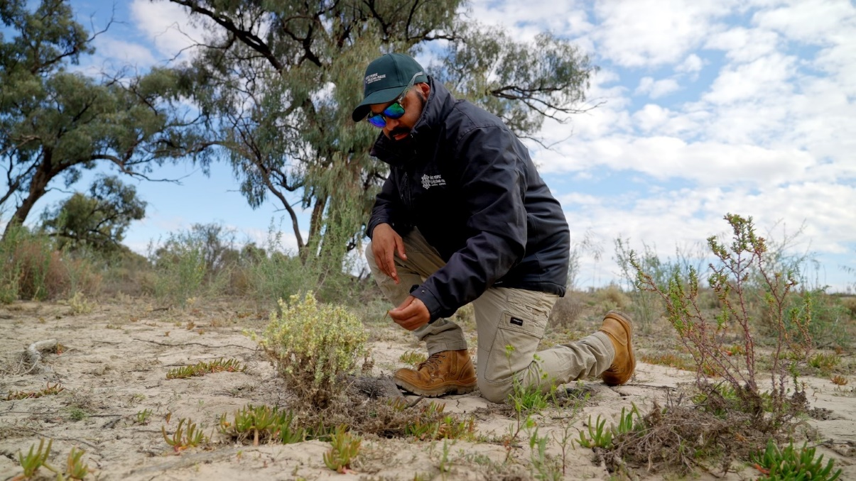  
Dylan Lawson

Dylan Lawson, Aboriginal Water Officer at the First People of the Millewa Mallee Aboriginal Corporation (FPMMAC), a proud Latji Latji – Barkindji Man, is helping bring water back to Musk Duck. Dylan manages waterways and surrounding Country in partnership with Traditional Owners, the Department of Energy, Environment and Climate Action (DEECA) and other stakeholders. It’s a labour-intensive role, but Dylan loves being out on Country.

Dylan is one of many Aboriginal Water Officers (AWOs) across the state of Victoria. AWOs engage with community on Country, take care of Country, and facilitate (re)connection to waterscapes, often with opportunities for Elders to share their water knowledge. Funded through the Aboriginal Water Program, AWOs deliver self-determined priorities and projects as well as engaging with government and the water sector to advocate Traditional Owner water priorities.

Dylan stands proud next to Musk Duck Wetland. New saltbush shrubs and black box trees are growing, frogs and birds are chirping, and kangaroos and emus come by for a drink. This healthy Country was completely dry not long ago. Musk Duck was chosen by FPMMAC for an environmental watering (e-watering) trial site. The wetland sits about 75 kilometres from Mildura, on Latji Latji Country. In 2022, the site was flooded and then dried out, leaving it without water for two years. Dylan and his team worked in collaboration for e-water to be delivered to the wetland, re-filling it and rejuvenating surrounding Country.

The trial involved direct input from community and Elders, with 50 Traditional Owners visiting Musk Duck for cultural assessments and aspirations yarns. Getting guidance from Elders is an important part of Dylan’s job. It is also important for Dylan to make young ones feel welcome when they come out on Country. “As long as we keep teaching, our culture doesn’t die out. We need a strong cultural lens over everything to keep our kids proactive. Fishing, gathering – that’s enjoying life.”

Dylan approaches his work through a whole-of-Country lens – you can’t change one part of Country without thinking about the ripple effects. “You need to know Country like the back of your hand, by getting out there, exploring and observing what Mother Nature is doing.” Bringing Elders’ vision to reality, the FPMMAC water team began introducing 10 megalitres of e-water to Musk Duck per day, until the wetland was up to 100 megalitres full and the Country entered a healing wet cycle. “When Country’s sick, Aboriginal people feel sick as well,” Dylan says.

For Dylan, healthy Country means being able to facilitate traditional ways of being. For his ancestors, Country was where it all began. “The river was more or less a black man’s highway – we travelled downstream and upstream along river systems,” Dylan says. Dylan hopes to fill Musk Duck up to 200 megalitres, to be able to reintroduce native fish to the wetland, growing and nurturing them so they can return to the Murray River.

Dylan’s vision is for the larger FPMMAC team – including the seed collection and nursery crew, river rangers and cultural burn team – to act out their long-term aspirations for healing Country. This would create continued opportunities for connection and employment within community. “I want to be able to pave the way, like my father, nana and loved ones before me to keep us going strong,” Dylan says.

When the water was delivered, two full buses came to visit Musk Duck for a community day. For some Elders, it was their first time seeing the wetland filled with water. Since the water delivery, Dylan is involved in writing a set of guidelines to help other Traditional Owners write Seasonal Watering Proposals (SWPs), so they can implement their vision for their own Countries and have an increased role in e-water management.

Aboriginal Water Officer roles like Dylan’s have improved Traditional Owner capacity across the state to work with the water sector, with increased opportunities for Traditional Owner organisations to lead self-determined and Traditional Owner-led water projects and programs. Instead of being allocated water, Dylan sees a future where Traditional Owners are water holders.

Musk Duck Wetland

### Returning water to Wadawurrung Country: a learning-by-doing watering trial for cultural outcomes in the Moorabool catchment

In February and March 2024, the Wadawurrung Traditional Owners Aboriginal Corporation (WTOAC) led a project delivering water to the Moorabool Yaluk (Moorabool River) and Durdidwarrah Wetland from Lal Lal and Bostock reservoirs and the Upper Stony Creek reservoirs. The water (300 ML in total) was made available by Central Highlands Water and Barwon Water, and WTOAC worked collaboratively with many partner organisations to facilitate its delivery.

Wadawurrung people once used canoes on the Moorabool Yaluk, and in calmer waters, bark floats or punts pushed by long poles to gather from the abundance of food. On the natural rises along the waterways, Wadawurrung people camped and caught eels, other fish and waterbirds to eat.

The project was planned as a learning-by-doing exercise, allowing WTOAC to gain hands-on experience and knowledge in water management and delivery and achieve cultural outcomes from returning water to Country. WTOAC plans to use the learnings of the trial watering to inform how more permanent water rights outlined in the State Government’s *Central and Gippsland Region Sustainable Water Strategy* (CGRSWS) will be transferred to WTOAC for self-determined use. This is an example of self-determination and partnership, with a Traditional Owner-led action delivering tangible outcomes and understanding for both Traditional Owners and partners in the project.

*Paleert Tjaara Dja – Let’s make country good together 2020-2030* – Wadawurrung’s Country Plan, has a goal that by 2030, there is enough water in the waterways of the Barre Warre Yulluk that it flows through the system, without barriers and is clean enough to drink.

Claire, Wadawurrung woman and Wadawurrung Traditional Owners Aboriginal Corporation Water Project Officer, said, “I believe our Ancestors would be proud of what we’ve accomplished. We continue their legacy by nurturing our waterways, just as they did.”

These water releases could not take place without the support of Barwon Water and Central Highlands Water, who actively contributed to making the releases happen.

WTOAC acknowledges the Department of Energy, Environment and Climate Action, Corangamite CMA, Parks Victoria, Southern Rural Water, the Victorian Environmental Water Holder, Arthur Rylah Institute for Environmental Research, Clear Advice and Strategy and Environmental Justice Australia, who supported WTOAC releasing water on Country.

For more information on the project you can find WTOAC’s video link and media release here:

[A Flowing Future: Water releases back to Wadawurrung Dja (Country)](https://www.youtube.com/watch?v=VsS9hDKQ4LE)

<https://053de3ec-6a5c-48af-86bc-dcd57b05b79d.usrfiles.com/ugd/053de3_e0c573a3b10f4f68bbdc5fc5132be819.pdf>

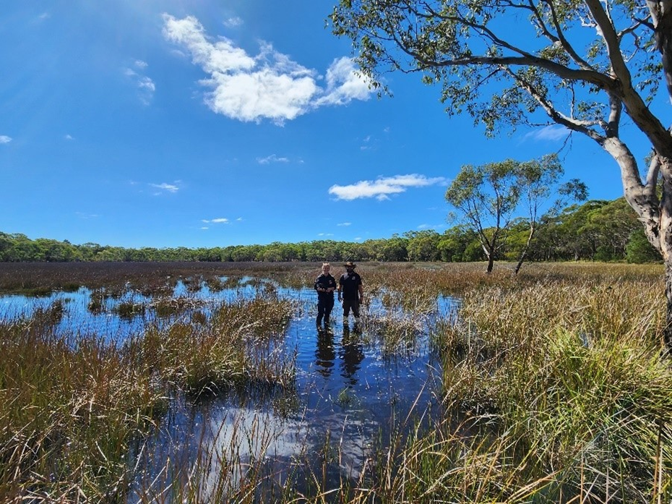Durdidwarrah Wetland while water was being delivered in March 2024, photo by Angeline Poole. 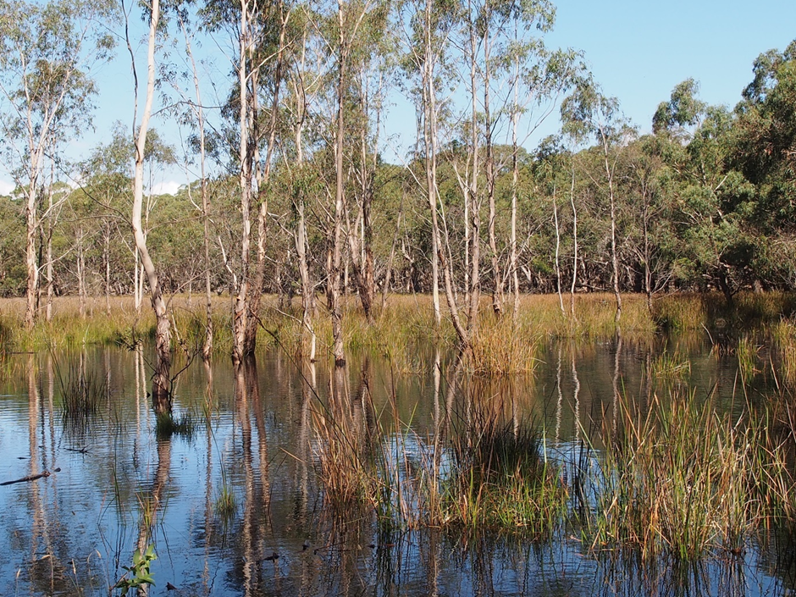Durdidwarrah Wetland while water was being delivered in March 2024, photo by Chloe Wiesenfeld.