Planning our Basin future together – Response to Consultation – Next steps

Table of contents

Introduction 1

Consultation feedback 1

Potential water recovery opportunities 2

Infrastructure efficiency projects 3

Water system reconfiguration projects 3

On-ground environmental works and operating rules 4

Proposed water recovery initiatives 5

# Introduction

Victoria has worked with a sense of urgency and purpose to improve water management and environmental outcomes in the Basin for decades, and particularly since the establishment of water extraction caps in 1992. The Basin Plan presents our biggest opportunity in generations to make a significant and enduring difference in our river rehabilitation work across the southern connected Basin. As the second step to the Living Murray Program, the Basin Plan allows us to accelerate our own local catchment improvement work with communities in ways that support them to thrive into the future.

The Planning our Basin future together prospectus, released in May 2024, outlined that in the context of upcoming Commonwealth Government open-tender water purchases, we need to continue to work with communities and in partnership with Traditional Owners to develop projects that achieves further water recovery in Victoria.

We are building on the lessons and achievements of the past and propose alternative ways to get environmental benefits, without running open tender buyback programs. This approach will not completely eliminate the negative socio-economic impacts that further water recovery from the consumptive pool will have on our communities. But it will enable us to identify and mitigate these negative impacts in a way that sets up regional water supply systems for the future, as well as delivering environmental outcomes that can’t be achieved with water purchases alone.

# Consultation feedback

The feedback we have had from our engagement across northern Victoria and through formal submissions and surveys has strongly supported the strategic approach to water recovery and confirmed that using a catchment scale is the best way to develop options and get community input.

We have also updated our principles to reflect feedback including considering risk of flooding on any water recovery project and meeting our existing obligations to partner with Traditional Owners. You can access the Closing the Loop Report on the Engage Victoria website – <https://engage.vic.gov.au/planning-our-basin-future-together>.

# Potential water recovery opportunities

The prospectus outlines that the scale of change and potential water recovery in each catchment will depend on the characteristics of the area. In some catchments, there are water savings projects that have not already been completed. In other catchments the opportunities will be more dependent on how much water may be sold by entitlement holders, where those entitlements are sold from, and the reconfiguration opportunities resulting from changes to water supply and demand.

While public consultation has continued, Water Corporations, Catchment Management Authorities (CMAs) and the Department of Energy, Environment and Climate Action (DEECA) have been identifying potential water recovery opportunities in Northern Victoria which align with our principles outlined in the prospectus.

We have developed initiatives to build the basis for feasibility studies and business case development. Opportunities that were identified by community members and stakeholders through consultation are considered as part of these initiatives.

We know from our experiences achieving environmental outcomes for over thirty years that we can recover water in a number of ways – focusing on three overall types of projects:

* Infrastructure efficiency projects
* Water system reconfiguration projects
* On-ground environmental works and operating rules

# Infrastructure efficiency projects

Water is recovered in these projects by upgrading water infrastructure, like channels, regulators, pipes and outlets, to reduce losses which are occurring through the system – particularly evaporation and seepage.

This may involve remediation works or upgrades of existing infrastructure like irrigation channels or replacing inefficient infrastructure with new pipelines. Once water savings are confirmed, they can be converted to water entitlements and transferred to the Commonwealth.

# Water system reconfiguration projects

Water recovery is achieved in these projects through a combination of water entitlement purchase by the Commonwealth and major changes to water supply and delivery infrastructure to better suit changing supply and demand patterns.

To get the best outcomes, water entitlement purchases must be done in a strategic way which can support the rationalisation or reconfiguration of irrigation districts or regional water supply systems. These actions can reduce ongoing operational and maintenance costs for remaining customers, as well as generating additional water recovery opportunities by reducing losses across the system. Losses can be reduced by changing the size or type of water delivery infrastructure, or by changing how rivers and storages are managed. Once water savings are confirmed, they can be converted to water entitlements and transferred to the Commonwealth.

System reconfiguration can also significantly improve local environmental or cultural outcomes by changing how rivers are operated to restore more of the natural flow regime and reduce the impacts of river regulation, including removing barriers to fish passage. Strategic purchases of land, as well as water entitlements could be part of system reconfiguration projects where there are additional environmental benefits.

# On-ground environmental works and operating rules

The highly regulated nature of the Murray River and its tributaries means that flows through some of our natural waterways have been significantly changed to balance a range of values and critical riverine landscapes are not getting the water they need when it is required, and for the duration that supports healthy ecosystems.

These types of projects look at developing rules, infrastructure works and operating arrangements which can deliver on-ground environmental outcomes through more natural flow regimes in rivers, delivering water directly to key environmental sites, or removing barriers to flow and fish passage.

The Basin Plan was designed to recognise the importance of these types of actions to support environmental outcomes in highly regulated water systems and are critical for the long-term health of Victorian rivers, wetlands and floodplains These types of projects have been recognised as providing an environmental outcome that is equivalent to water recovery volumes as they delivery outcomes which cannot be achieved with water alone.

# Proposed water recovery initiatives

DEECA, Water Corporations and Catchment Management Authorities have been identifying initiatives which required feasibility studies and business cases for potential water recovery opportunities. These have been identified based on previous programs which have been undertaken, feedback during the consultation process and making sure they align with the principles outlined in the ‘Planning our Basin future together’ prospectus. These initiatives provide the starting point for the discussion with communities around what areas to focus on and the benefits to Victorian rivers, wetlands and floodplains and how to reduce the impacts to irrigation communities.

The list of water recovery initiatives and their current status is listed in Figure 1 and   
Table 1.

Our next step is to seek funding from the Commonwealth Government to undertake feasibility studies and/or business cases, including getting community and stakeholder input.

Subject to Commonwealth funding, water corporations, CMAs and DEECA will set up consultive committees at a regional scale to work through the opportunities, costs, benefits and water savings which could be achieved. We will also work with Traditional Owners on how they want to partner on projects on their country.

DEECA is also continuing to work with the Commonwealth Government to seek support for future water purchase tenders taking a more strategic approach, including targeted water purchase in our unregulated and semi-regulated rivers systems downstream of the major dams in Victorian tributaries.

Water flowing from these rivers and creeks can support and restore critical parts of the natural flow regime in unregulated rivers which flow through to our major regulated rivers downstream. Targeted water recovery, coupled with Victoria’s proven mechanisms for protecting these flows downstream, can deliver improved environmental outcomes without the significant challenges of delivering more water from the major dams.

Figure 1: Victoria's Basin catchments and irrigation districts.

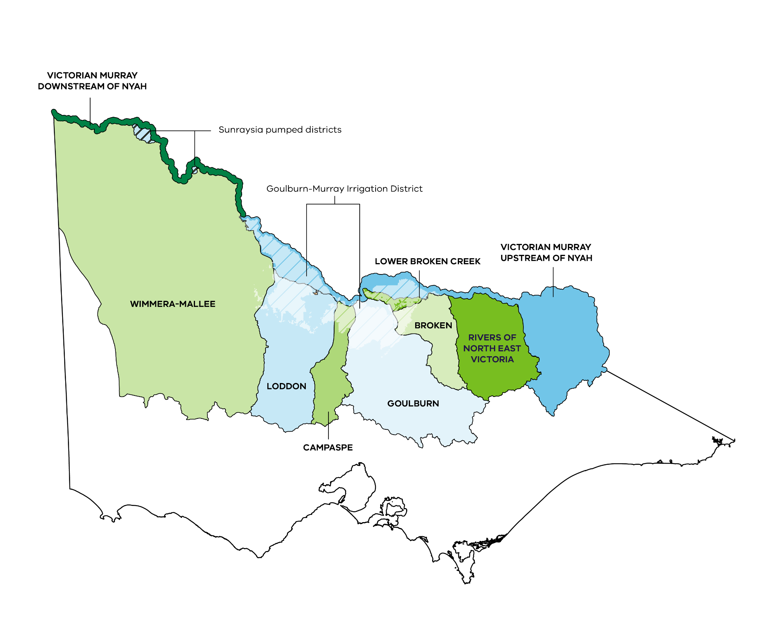

Table 1: A list of water recovery initiatives and their status

| Project title | Project description | Project type | Project stage |
| --- | --- | --- | --- |
| **Restoring flows to  Avoca Marshes** | Improve the condition of this Ramsar-listed wetland by enabling the delivery of environmental water | Environmental works and rules | Feasibility |
| **Wakiti Lagoon reconfiguration** | Targeted purchase of water entitlements and recovery of water delivery losses, based on voluntary agreement of syndicate members | System reconfiguration | Feasibility |
| **Broken, Loddon and Campaspe system reconfiguration** | Reconfigure water supply and delivery systems in the Broken, Loddon and Campaspe catchments where targeted purchase of water entitlements supports delivering objectives identified by the community | System reconfiguration & Environmental delivery | **Broken:**  Business case  **Campaspe and Loddon:** Feasibility |
| **Lower Murray streamflow restoration** | Remove barriers to fish passage in Victorian creeks along the Murray | Environmental works and rules | Feasibility |
| **Restoring flows to the  Mallee floodplain** | Improve floodplain connectivity in the Mallee region | Environmental works and rules | Feasibility |
| **Victorian Murray  (non-district) system reconfiguration** | Improve environmental condition at key sites in Victorian rivers, creeks and wetlands along the River Murray | Infrastructure efficiency & Environmental works and rules | Feasibility |
| **Sunraysia private diverter channels efficiency project** | Replace or line earthen channels in the Sunraysia region to reduce seepage and evaporation losses from delivery infrastructure | Infrastructure efficiency & System reconfiguration | Feasibility |
| **Coliban rural modernisation project** | Modernise aging channel and piped water supply systems to reduce seepage and evaporation losses | Infrastructure efficiency & System reconfiguration | Business case  (funded) |
| **Consumptive water en route** | Recognise the local environmental outcomes achieved from delivering consumptive water in a way that meets environmental objectives in Victorian rivers | Environmental works and rules | Feasibility |
| **LMW irrigation district reconfiguration** | Reconfigure irrigation districts in the Sunraysia area to strategically respond to any Commonwealth water purchase | System reconfiguration | Feasibility |
| **GMW domestic and stock pipelines** | Improve water efficiency within the former East  and West Loddon Waterworks Districts and in the Timmering area | Infrastructure efficiency & System reconfiguration | Feasibility |
| **GMW Irrigation District reconfiguration** | Reconfigure irrigation areas in the Goulburn-Murray Irrigation District (GMID) to strategically respond to any Commonwealth water purchase | System reconfiguration | Feasibility |

**End of document.**