Preparing Non-Urban Water Metering Action Plans

January 2025

Guidelines for Water Corporations with Non-Urban Water Users





[deeca.vic.gov.au](https://delwpvicgovau.sharepoint.com/Users/fionadurante/Downloads/deeca.vic.gov.au)

Photo credit

© State of Victoria (DEECA). Credit: Darryl Whitaker



We acknowledge and respect Victorian Traditional Owners as the original custodians of Victoria’s land and waters, their unique ability to care for Country and deep spiritual connection to it.

We honour Elders past and present whose knowledge and wisdom   
has ensured the continuation of culture and traditional practices.

DEECA is committed to genuinely partnering with Victorian Traditional Owners and Victoria’s Aboriginal community to progress their aspirations.

© The State of Victoria Department of Energy, Environment and Climate Action January 2025.

Creative Commons

This work is licensed under a Creative Commons Attribution 4.0 International licence, visit the [Creative Commons website](http://creativecommons.org/licenses/by/4.0/) (<http://creativecommons.org/licenses/by/4.0/>).

You are free to re-use the work under that licence, on the condition that you credit the State of Victoria as author. The licence does not apply to any images, photographs, or branding, including the Victorian Coat of Arms, and the Victorian Government and Department logos.

Disclaimer

This publication may be of assistance to you but the State of Victoria and its employees do not guarantee that the publication is without flaw of any kind or is wholly appropriate for your particular purposes and therefore disclaims all liability for any error, loss or other consequence which may arise from you relying on any information in this publication.

Accessibility

To receive this document in an alternative format, phone the Customer Service Centre on 136 186, email [customer.service@delwp.vic.gov.au](mailto:customer.service@delwp.vic.gov.au), or contact National Relay Service on 133 677. Available at [DEECA website](http://www.deeca.vic.gov.au/) (www.deeca.vic.gov.au).

Contents

INTRODUCTION 2

Victorian Water Corporations Delivering Non-Urban Water 2

THE GUIDELINES 3

Circumstances where the metering requirement can be varied 3

Metering Action Plans 4

*Plan publication* 4

*Plan content and authorisation* 4

*1.* *Introduction* 4

*2.* *Business Context* 4

*3.* *Meter fleet profile* 5

*4.* *Processes to assure meter accuracy* 5

4.1. Asset management for meters 5

4.2. Meter installation 5

4.3. Meter tamper evident seals 5

4.4. Meter validation 6

4.5. Meter verification 6

4.6. Meter maintenance 6

*5.* *Metered data management* 8

5.1. Meter reads 8

5.2. Telemetry/Automated reporting 8

5.3. Annual reporting 8

*6.* *Meter investment program and finances* 8

6.1. Improvement actions 8

ATTACHMENTS 9

Attachment A: Background to the national metering framework 9

Attachment B: Example validation schedule 10

Attachment C: Telemetry Cost-Benefit Analysis Tool 10

Attachment D: Metering Action Plan (MAP) template 11

*Metering Action Plan (MAP) template* 12

# **INTRODUCTION**

Under the Murray-Darling Basin Compliance Compact, the Victorian Government has committed to issue these guidelines for preparing non-urban metering actions plans to water corporations with rural water users.

These guidelines are to assist the water corporations to develop their non-urban metering action plans and are to be read in conjunction with the **Victorian Government Policy for Non-Urban Water Metering**, which includes a glossary of terms.

Most supply points in Victoria are metered. Approximately 85% of the 2019 Victorian non-urban meter fleet was installed before any pattern approved meters were available.

The typical use patterns in water resource management areas are very uneven with:

* the top 40% use sites often accounting for 80% of use,
* the bottom 30% use sites accounting for less than 5% of use.

Figure 1 provides real examples of meter use patterns for several water resource management areas. It highlights the diminishing benefits for water resource management objectives for metering the lowest 5% of meters.

Figure 1 – Example meter fleet profile based on their use.

## Victorian Water Corporations Delivering Non-Urban Water

There are six water corporations that supply and deliver water to most non-urban water users in Victoria. Of these, Southern Rural Water and Melbourne Water service water users exclusively outside the Murray-Darling Basin. Grampians Wimmera Mallee Water also services some groundwater users outside the Basin and their surface water is disconnected from the Murray River.

The water corporations act as regulators of the Victorian non-urban water sector under powers and functions delegated by the Minister or provided directly under the *Water Act 1989*. These activities include the extraction of water from rivers, waterways and channel systems for irrigation, commercial and licensed domestic and stock purposes as well as water supply, drainage, and salinity mitigation services.

Part 7-4 of the Statement of Obligations (General), issued under the *Water Industry Act 1994*, requires water corporations that undertake non-urban metering to do so in accordance with the State’s policies and plans. This guideline together with the Policy on Metering for Non-urban Water sets the obligations for the Part 7-4 of the Statement of Obligations.

Attachment A provides some history on the development of the national non-urban water metering framework, whilst Attachment B provides a Metering Action Plan (MAP) template to support MAP development.

# **THE GUIDELINES**

## Circumstances where the metering requirement can be varied

Victoria’s Policy for Non-urban Water Metering states that, apart from the circumstances where the metering requirement can be varied:

* new or upgraded extraction sites are to be metered with a meter that conforms with AS4747.
* meters on existing extraction sites that meet an interim standard are to be replaced at the end of their operational life with a meter that conforms with AS4747.
* meters that do not comply with contemporary (interim) standards or conform with AS4747 should be replaced by June 2025.

The cost of metering is high compared to the opportunity cost of water and is much higher than it is for urban water. The ratio of costs is very dependent on sites and water resource circumstances.

The cost of metering of take-and-use sites with full flowing pipe meters is of the order of $4,000/site to $25,000 depending on the meter size and the site modifications required. Adding telemetry can increase the site cost from $500/site to $15,000/site depending on the sophistication of the telemetry and the communication options. The typical service life for full flowing pipe meters is 15 to 20 years.

The cost to initially install open channel meters, that generally comes with telemetry and automated control, is of the order of $45,000+/site as they usually require significant civil works. Future replacement of open channel meters is of the order of $15,000 to $25,000. The design service life for open channel meters is in the range of 30 to 40 years.

The Metrological Assurance Framework (MAF) provides for the relevant jurisdictional government department or agency to exempt meters from the accuracy standard. The Compact restates the State’s power to specify exemptions and requires the State to publish its justification of the exemptions on the relevant state agency website.

Under this framework, the State’s allowable exemptions are for circumstances where water resource management risks are manageable, and the costs are disproportionate to the benefits – see Victoria’s non- urban water metering policy.

The low use exemption thresholds are:

* an existing surface water licence less than or equal to 10 ML per year or an annual use limit of 10 ML per year or less under a water-use licence or water-use registration
* an existing groundwater licence less than or equal to 20 ML
* in either of the above, a lesser volumetric threshold set by the water corporation
* sites where the costs are disproportionate to benefits, including but not limited to:
* where the site is not in use as it’s not equipped with a pump or physically cannot operate
* the low frequency or low annual volume of take (ten-year average less than 10 ML/year and no annual use > 20 ML) do not require a meter
* excessive costs imposed by site conditions
* adequate water measurement is provided by the bulk water meter, or
* the bottom 5 per cent of sites based on use within a water resource management area. Unless these sites are in a higher risk resource area, basic metering is adequate to fulfil water management objectives under the National Water Initiative

The water corporation can continue with the current metering standard for sites that make up the lowest 5 per cent of water use in a water resource management area that has regular use and require metering.

For sites where the costs are disproportionate to benefits, the water corporation is to demonstrate and document that the benefits of metering, or of meter to an AS4747 standard, are too low to justify the cost, and that water management risks remain manageable.

This would involve considering:

* The full cost of the meter and the average trade value of the water over the life of the meter in the specific water resource management area
* The benefit and costs of alternative options to quantify the use
* How to assure the management of water resource risks.

Where water corporations decide that it is not necessary to meter certain users of a defined resource, the corporation’s reasons and alternative method to estimate the take can be documented in a management plan that is publicly available.

The method of estimation should be based on an adequate sample of similar metered water users. Otherwise, the reasons are to be detailed in the application approval documents for individual entitlement holders.

The State does not require water corporations to replace contemporary standard meters by 2025.

Contemporary (interim) standard meters meet the accuracy objective and at many sites will still have significant residual life at 2025. For open channel meters sites contemporary meters may be still the only option to install as there are no pattern approved meters. The assurance benefits of upgrading contemporary meters before the end of their service life are very small.

Water corporations can plan to replace contemporary meters at the end of their service life with meters that conform with AS4747.

## Metering Action Plans

Rural water corporations are required under their Statement of Obligations to develop non-urban metering action plans.

The plans identify their current meter fleet profile relative to the measurement requirements and specify the authorities’ current processes to select, inspect, validate, maintain, and replace meters and their improvement actions.

### ***Plan publication***

Water Corporations must publish a summary of their metering action plans (MAPs) on their websites, outlining how they are intending to meet the Victorian non-urban water metering policy.

An up-to-date copy of the MAP must be provided to DEECA upon internal approval.

### ***Plan content and authorisation***

The content of the action plans should include as a minimum the elements outlined in Table 1 below. The relevant General Manager (or equivalent) or the Managing Director is to authorise the plan.

Water corporations should where practicable use the template provided by DEECA for the plan (See Attachment D: Metering Action Plan template).

Water corporations must include a date for the next review of the metering action plan.

The action plan review cycle is strongly recommended to align with ESC pricing submission timeframes to ensure initiatives to deliver the Victorian Government’s metering policy objectives are adequately funded.

Water corporations and DEECA will review metering action plans at least once every four-year economic regulation cycle.

Table 1 - Non-urban water metering action plan content

|  |  |  |
| --- | --- | --- |
| **No** | **Item** | **Description** |
| 1 | Introduction | Overview of the purpose and scope of the metering action plan. |
| 2 | Business Context | Provides business context relevant to current metering requirements and to future metering upgrades and their timing. |
| 3 | Meter fleet profile | For each water resource management area, summarise the volumes measured by meters of different compliance categories plus the metered volume that has telemetry. |
| 4 | Processes to assure accurate meters | An outline of the processes used for selection, installation and initial validation and for the on-going maintenance, validation and verification of meters. |
| 5 | Meter data management | Overview of the data collected, and the systems and databases used to transfer and store meter data. |
| 6 | Meter investment plan and finances | This is a summary of the rolling 5-year capital upgrade plan for meter replacements. |
|  | Appendix A | Meter statistics |

### ***Introduction***

The plan must provide an overview of the purpose and scope of the metering action plan.

For guidance, please see **sections 1a-b** and **2** of the MAP template (Attachment D).

### ***Business Context***

The plan must provide the business context relevant to the metering. This may include such items as:

* Areas that are being modernised or that have modernisation upgrade plans,
* Areas either planned or under investigation for reconfiguration, including termination of services,
* Water systems with a significant reduction in reliability and water use, resulting in only the occasional use of water,
* Water system statistics on use trends relative to entitlements or licences caps and on trading within and out of the water resource area.
* Higher risk water resource areas that have experienced sustainability risks such as seawater intrusion, overuse, problems with unauthorised use, compliance challenges on customer use.
* Water systems that require regulatory compliance checks or have a history of breaches of water management rules – such as managing environmental flows.
* A schedule of individual users that have an entitlement or licence greater than 5,000 ML.

For guidance, see **section 2** of Attachment. C.

### ***Meter fleet profile***

For the water corporation overall and for each water resource management area, Water Corporations must summarise:

* volumes measured by meters of different compliance categories (Table 9 & 10 of non-urban water metering policy);
* metered volume that has telemetry; and
* number of meters for each water resource management area that requires an accurate meter but does not have either a AS4747 conforming or contemporary meter (i.e., Outside contemporary standard (OT)) or is unmetered (i.e., UM).

This information must be tabulated within the Metering Action Plan.

For guidance, see **section 3** of Attachment C.

### ***Processes to assure meter accuracy***

All meters require processes to assure accuracy. The following section in the guideline has adopted an asset management approach as this provides an established process to manage assets.

For guidance, please see **section 4a-e** of Attachment D.

#### Asset management for meters

As an asset sub-class, meters require:

* Strategy
* Design specifications
* Procurement
* Construction
* Commission
* Operation and maintenance
* Disposal and
* Record keeping

Figure 4 shows an asset management framework for meter management with cross-references for the relevant AS4747 standards.

The plan must specify either the asset class management plan for meters or provide relevant cross-references to other water plans that provide the content.

The plan must document the internal processes:

* to implement AS4747 requirements
* to implement similar requirements to AS4747 for Contemporary meters
* for other meters.

#### Meter installation

The plan must detail processes for meter installation to ensure that:

* Meters meet standard meter design specifications, which may be adapted to suit site conditions; and
* Meters are validated by a CMI to ensure meters meet manufacturer specifications and national standards (operating within the ±5% limits of error) at the time of installation.

#### Meter tamper evident seals

Water Corporations must implement processes and plans to satisfy the requirements for tamper evident seals laid out in the Victorian non-urban water metering policy:

* Water corporations may select the processes, such as the use of a register or an asset management system, so long as the outcome of collecting relevant information provides traceability and ensures accountability over the fleet of meters with tamper evident seals.
* Additionally, as far as practical, water corporations should use a single supplier of seals to provide robust traceability over seals. This will also help to minimise potential issues with traceability and accountability of seals during reinstallation.

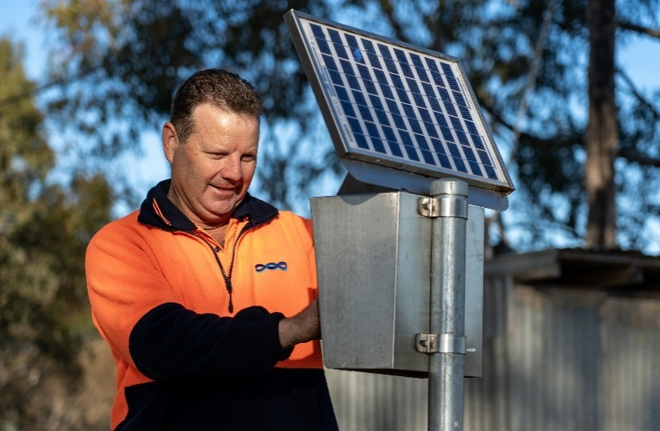

**Figure 2. Water corporation field staff reading non-urban meter (Gunbower, Victoria).**

#### Meter validation

The plan must include the validation requirements, tests and checks required to validate a meter consistent with AS4747 and MAF2 (Part 8) rules.

For high-risk users and areas, water corporations may decide to validate a meter on a more frequent basis.

Water corporations may also incorporate volumetric testing of meters within their validation programs to ensure meters are operating within the maximum permissible error rates. Several in-situ volumetric measurement checking instruments are available, for example a clamp-on ultrasonic device.

Following evaluation of risks, including assurance risks are managed or mitigated, water corporations may exempt themselves from (re-) validation guidelines in Part 8 of MAF2.

Any exemptions made by the water corporation must be supported by a justification in their MAP.

The plan must include the schedules to validate the meters by certified validators (CMIs), where:

* AS4747 specifies the requirement; and
* Attachment B provides an example schedule (Table 3).

#### Meter verification

The plan must include verification requirements to verify a meter consistent with MAF2 (Part 10) rules and undertaken by certified verifiers (CMIs).

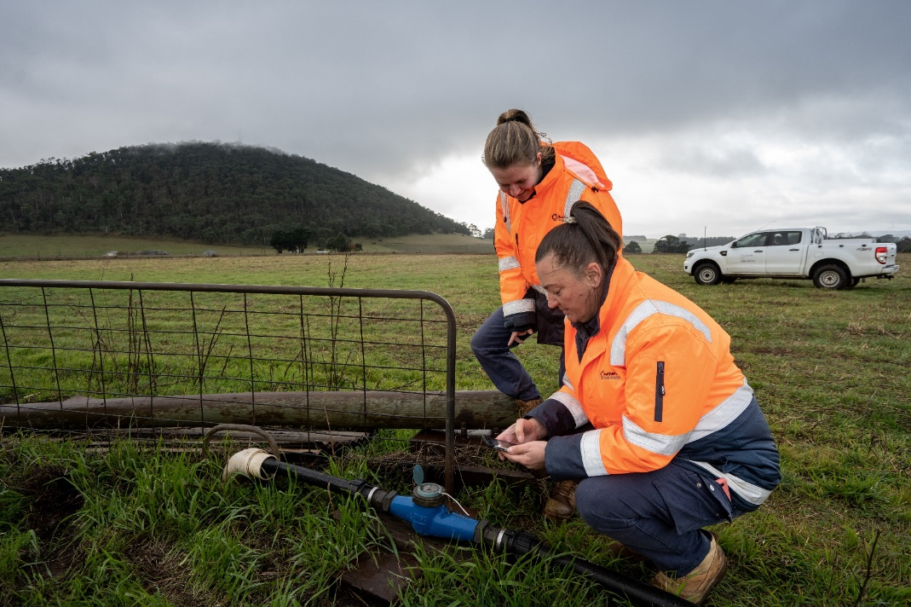

**Figure 3. Water corporation field staff reading non-urban meter measuring groundwater use (Dunnstown, Victoria).**

If meters are validated in line with the scheduled requirements, verification is not required unless it is to determine if the meter has been functioning accurately.

In locations where it is not possible to do on site calibration of bulk metering by a suitably qualified person or site constraints make it cost prohibitive, the bulk entitlement metering plan should document how the accuracy of the bulk meter is to be confirmed.

The following sites may be excluded from a verification program, following evaluation of risks and site condition:

* Domestic and stock use **[Note 2[1]]**
* Sleeper and dozer licences **[Note 3]**
* Sites with no works (i.e., pumps) **[Note 5]**
* Low volume water user **[Note 6]**
* Outside of contemporary standard **[Note 7]**

These sites must be maintained through water corporation’s meter reads and annual inspection programs.

#### Meter maintenance

The plan must include a typical maintenance schedule for each meter sub-class. This need not be at the level of each make and model but should account for differences in measurement technology for example Magnetic flow meters.

The schedule is to group tasks by preventive, corrective and predictive maintenance categories to match the AS4747 terminology.

## 4a. Closed Circuit Water Meters Asset Management Framework

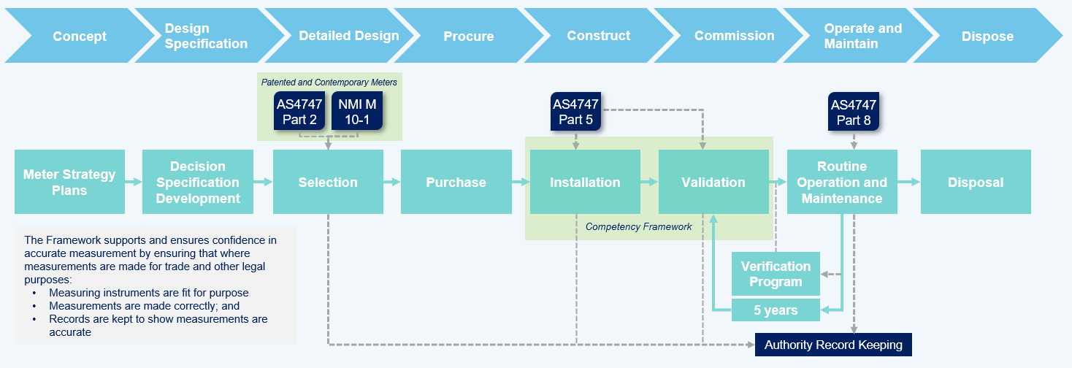

## 4b. Open Channel Water Meters Asset Management Framework

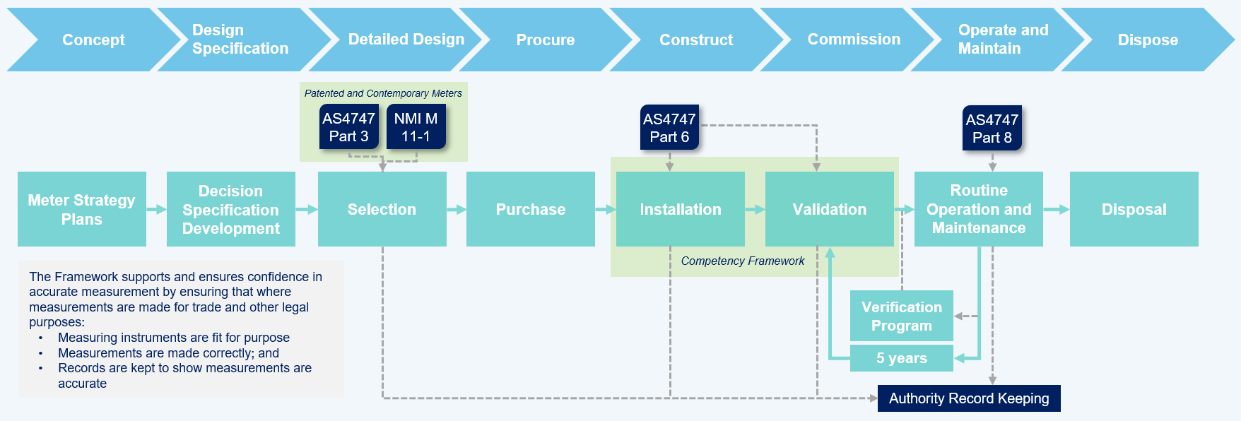

**Figure 4, a & b– Asset management framework for meters**

### ***Metered data management***

Water corporations must maintain their own metering databases. The plan should detail the water corporation’s approach to data management, including:

* how data is collected (e.g., meter reads; telemetry/automated reporting)
* systems, databases, and dashboards used to transfer and store meter data; and
* reporting requirements.

Water corporations should:

* utilise standardise terms to categorise meter requirements when reporting on meters (Table 9 and 10 of Victorian non-urban water metering policy); and
* ensure all internal date security policies and requirements are implemented.

For guidance, please see section 3 above or **section 5a-d** of Attachment D.

#### Meter reads

The minimum meter read frequencies as stipulated by the Victorian Policy are an appropriate starting point for water corporations to use.

* Water corporations should determine meter read frequencies based on an assessment of risks to water resources.
* Plans must document meter read frequencies and supporting rationale (considerations and risks used to determine meter read frequencies).

For example, meters of water users who have usage in excess of entitlement in previous irrigation season or past history of non-compliance, particularly within high-risk areas and during drier periods, are generally read more frequently. Metering action plans are required to document this meter read adjustment alongside the supporting rationale.

#### Telemetry/Automated reporting

To date there is a significant amount of telemetry across Victoria. Water corporations are continuing to invest in modern metering and telemetry to improve monitoring of groundwater and surface water use. The plan must include:

* Statement on the number and water resource areas with telemetry for the meters
* Outline of the investment framework and the assumptions used to decide where and when to add telemetry considering:
* Cost-effectiveness (see *Victorian Cost-Benefit Analysis Tool*, **Appendix C**); and
* Compliance requirements.

To effectively and regularly monitoring of water use data, Water corporations should develop interactive dashboards utilising their existing data management systems. These dashboards can support identification of water use trends, high-risk users and annual reporting requirements.

#### Annual reporting

Water corporations must report on metering asset and implementation activities to the Department of Energy, Environment and Climate Action (DEECA) each year. This requires water corporation representatives on the Non-Urban Water Metering Working Group to complete the data request and return to DEECA.

DEECA prepares and publishes a state-wide implementation report available on the [DEECA website](https://www.water.vic.gov.au/for-agriculture-and-industry/non-urban-water-metering)[2]. This reporting fulfills Victoria’s continuing obligation to monitor and report on Victoria’s progress in implementing non-urban water metering under the Compliance [Compact Action 3.7](https://www.water.vic.gov.au/our-programs/murray-darling-basin/compliance).

Plans must acknowledge reporting requirements.

### ***Meter investment program and finances***

The investment program must document the priority setting method used to design the program to upgrade the meter fleet over time to have:

* Meters that conform with AS4747, or
* Contemporary meters, where AS4747 are unavailable or unfeasible, or
* alternative measurement standard; and
* telemetry for either cost-effectiveness or compliance reasons

The capital program should include a rolling five-year forward look plus details on the budget and expenditure over the previous five years and to cross-reference the Water Plan periods. For guidance, see **section 6** of Attachment C.

#### Improvement actions

The plan must include improvement actions, expected timeframes and lead/responsible area to support transparency about how the requirements of the Policy will be met.

# **ATTACHMENTS**

## Attachment A: Background to the national metering framework

The general scope (circumstances) for non-urban water metering was established in s87 of the National Water Initiative in 2004.

87. *The Parties agree that generally metering should be undertaken on a consistent basis in the following circumstances:*

1. *for categories of entitlements identified in a water planning process as requiring metering,*
2. *where water access entitlements are traded,*
3. *in an area where there are disputes over the sharing of available water,*
4. *where new entitlements are issued; or*
5. *where there is a community demand.*

The 2004 NMI established the requirement for national standards and the general expectation for metering of non-urban water. Subsequently, standards were established in 2009 through the Measurement Assurance Framework (MAF).

The MAF’s primary objective is to: *provide an acceptable level of confidence that measurement performance under in situ conditions is within the maximum permissible limits of error of +5%.*

The MAF is supported by meter standards specified by the National Measurement Institute and by AS4747 that covers the installation, validation, maintenance, and verification of meters.

There are two main meter categories in these standards are:

* meters for full-flowing pipes which measure the actual volume of water flowing through fully charged, closed conduits; and
* meters for open channel situations which measure the actual volume of water flowing through open channels and partially filled closed conduits.

Table 2 summarises the assurance framework for meters.

Table 2 - Assurance framework for non-urban water meters

|  |  |  |
| --- | --- | --- |
| Requirement | Documents | |
| Overall measurement requirement | | Measurement Assurance Framework [2009] |
| Measuring instruments are fit for purpose | | NMI M 10 for full flowing pipe meters [2010] and  NMI M 11 for open channel meters [2009] Approved meters are called - pattern approved |
| Measurements are made correctly | | AS 4747 – Sections 1, 2, 5 & 8 for full flowing pipe meters  AS 4747 – Sections 1, 3, 6 & 8 for open channel meters  These standards include the requirement for duly qualified personnel for most tasks – called Certified Installers and Validators.  AS4747 first edition was 2008 and the current 93rd edition was in 2013 |
| Record-keeping to prove measurements are accurate | | NMI retains records on meter testing for pattern approval AS4747 specifies the data to record |

The MDB Compliance Compact in 2018 specified the following metering objectives:

*The objectives of metering water take are to ensure that:*

1. *The take of water can be accurately and reliably determined*
2. *Meters used to measure water take are auditable, verifiable and accurate*
3. *Data from meters can be easily communicated to relevant authorities and is able to be incorporated into state licensing systems (including compliance)*
4. *Mandatory requirements and resources are targeted to higher risk users (that is those that have a greater capacity to take water) and high-risk water systems*
5. *The benefits of water measurement outweigh the costs*
6. *The framework is simple to understand, comply with, administer and enforce.*

## Attachment B: Example validation schedule

The following table sets out the required meter validation schedules, noting that this will often be combined with maintenance tasks.

Table 3: Validation Schedule Content

|  |  |
| --- | --- |
| Activity | Interval year(s) |
| Validation upon meter installation (as per AS4747) |  |
| Annual inspection and maintenance as required1 | 1 (suggested) |
| Re-Validation (as per AS4747) | 5 (mandated) |
| Validation tasks may include:   * Physical check of the meter * Check on configurable parameters * Check on error detection conditions and log * Undertake system diagnostic check |  |
| Meter (re-)verification (as per MAF2 Section 10) | 3 - 5 (suggested) |
| Complete validation form and certificate by certificate meter validator (CMI) |  |

Note 1 – The suggested frequency for annual inspection and maintenance is one year in AS4747. The objective is to provide metrological assurance of in-service performance. If the Water Corporation is to adopt a longer maintenance frequency than one year for some meters, then in the plan it is to specify the controls to assure performance and to support this with relevant context and data for these meters.

AS4747 – Appendix B provides an example list of validation records.

* Some of the validation tasks may be completed and logged remotely using the telemetry system. The generic process for these remote testing processes requires approval by a certified meter validator.
* The schedule is to indicate which validation tasks are completed remotely.

MAF2 –

* Schedule A:
* Table 5 provides a maintenance checklist for closed conduit meters.
* Table 6 provides a maintenance checklist for open channel meters.
* Part 8, 9 and 10 provides guidance around the meter verification processes and in-situ volumetric measurement instruments.

## Attachment C: Telemetry Cost-Benefit Analysis Tool

The *Victorian Telemetry Cost-Benefit Analysis (CBA) tool* and guidance (2022) were developed to assist water corporations to undertake a CBA for the application of telemetry.

The tool aims to assist in:

* Identifying and considering all potential costs and benefits of having non-urban water meters telemetered.
* Highlight the scenarios where the benefits of installing telemetry would outweigh the costs.
* Establishing a consistent approach to the consideration and analysis of the costs and benefits and the rationale for conclusions to inform business cases for investment in telemetry.

The tool can be applied to the following water resources: regulated rivers, regulated channel or pipeline systems, unregulated rivers and streams, and groundwater resources.

For water corporations to make an informed decision around telemetry installation, the CBA tool considers the physical viability of the site, capital and operation and maintenance costs, water resource management, regulation, and organisational reputation benefits.

## Attachment D: Metering Action Plan (MAP) template

The following headings outline a MAP template that is encouraged to be used by Water Corporations.

This template aims to support the development of consistent MAPs across Water Corporations and includes mandatory requirements (**REQUIRED** headings) of MAPs and drafting notes as guidance.

The content of the action plans should include as a minimum the elements outlined in Table **4** below.

Table 4 - Non-urban water metering action plan content

|  |  |  |
| --- | --- | --- |
| **No** | **Item** | **Description** |
| 1 | Introduction | Overview of the purpose and scope of the metering action plan. |
| 2 | Business Context | Provides business context relevant to current metering requirements and to future metering upgrades and their timing. |
| 3 | Meter fleet profile | For each water resource management area, summarise the volumes measured by meters of different compliance categories plus the metered volume that has telemetry. |
| 4 | Processes to assure accurate meters | An outline of the processes used for selection, installation, and initial validation and for the on-going maintenance, validation, and verification of meters. |
| 5 | Meter data management | Overview of the data collected, and the systems and databases used to transfer and store meter data. |
| 6 | Meter investment plan and finances | This is a summary of the rolling 5-year capital upgrade plan for meter replacements. |
| 7 | Appendix A | Meter statistics. |

The following boxes consisting of headings and drafting notes detail the required and suggested content for MAPs. Water Corporations are encouraged to replicate the structure and headings within their MAPs.

### ***Metering Action Plan (MAP) template***

#### Introduction

#### *Executive Summary*

Suggested format:

* Meter Compliance (number of sites, number of metered sites and their compliance code, and any exemptions)
* Telemetry Compliance (number of sites, number of telemetered sites and their compliance code, and any exemptions); and
* Summary of actions and funding to implement actions.

#### *Plan authorisation and review*

**REQUIRED:** MAPs must include authorisation information (person, role, and date)

**REQUIRED:** MAPs must include a date for the next review of the MAP aligned with ESC pricing submission timeframes.

#### Business Context

Provides a summary of the water resources and services that the business manages, sets the objectives of metering, and provides the opportunity to identify strategic projects or specific management requirements that impact on metering.

**REQUIRED:** The plan is to provide the business context relevant to metering, such as:

* Water resources summary (summary of water resource management areas),
* Water services provided,
* Areas that are being modernised or that have modernisation upgrade plans,
* Areas either planned or under investigation for reconfiguration, including termination of services,
* Water systems with a significant reduction in reliability and water use, resulting in only the occasional use of water,
* Water system statistics on use trends relative to entitlements or licences caps and on trading within and out of the water resource area,
* High risk water resource areas that have experienced sustainability risks such as seawater intrusion, problems with unauthorised use, compliance challenges on customer use,
* Water systems that require regulatory compliance checks or have a history of breaches of water management rules – such as managing environmental flows; and
* A de-identified schedule of users that have an entitlement or licence greater than 5,000 ML>

#### Meter fleet profile

**REQUIRED:**

* Summary of sites meeting high-risk take definition Volume measured (ML)
* Table summary of the volumes measured by meters of different compliance categories (using standard codes and categories in the Policy), plus the metered volume that has telemetry, presented by water resource management area.

|  |  |  |  |  |  |  |  |  |
| --- | --- | --- | --- | --- | --- | --- | --- | --- |
| **Meter requirement status by water resource** | **Meter compliance status (Number)** | | | | **Meter compliance status (Volume ML)** | | | |
| **AS4747 (AS)** | **Contemporary (CO)** | **Outside Contemporary standard (OT)** | **Total** | **AS4747 (AS)** | **Contemporary (CO)** | **Outside Contemporary standard (OT)** | **Total** |
| **Groundwater** |  |  |  |  |  |  |  |  |
| Accurate Meter / Required (AM) |  |  |  |  |  |  |  |  |
| Exempt (EXOS/ EXLU/EXHC/MO) | N/A | N/A |  |  | N/A | N/A |  |  |
| **Surface water** |  |  |  |  |  |  |  |  |
| Accurate Meter / Required (AM) |  |  |  |  |  |  |  |  |
| Exempt (EXOS/ EXLU/EXHC/MO) | N/A | N/A |  |  | N/A | N/A |  |  |
| **Total** |  |  |  |  |  |  |  |  |

* Table summary of metering compliance exemptions, including reason for variation.

|  |  |  |  |
| --- | --- | --- | --- |
| **Water resource** | **Reason for exemption** | **Meters exempt** | **Comment** |
|  |  |  |  |
|  |  |  |  |

#### 

#### Processes to assure meter accuracy

All meters require processes to assure accuracy. The following sections detail the required assurance processes for MAPs to ensure accuracy of meters.

#### *Asset management for meters*

**REQUIRED:**

The plan is to specify either the asset class management plan for meters or provide relevant cross-references to other water plans that provide the content.

The plan is to document the internal processes:

* to implement AS4747 requirements
* to implement similar requirements to AS4747 for Contemporary meters
* for other meters.
* All meter asset information (i.e., design specifications, installation, maintenance, and validation requirements) are captured in the Water Corporation’s metering database.

#### *Meter installation*

**REQUIRED:**

The plan must detail processes for meter installation to ensure that:

* Meters meet standard meter design specifications, which may be adapted to suit site conditions.
* Meters are installed by a CMI, where practical, if not feasible, a non-certified person may install a meter.
* Meters are validated by a CMI to ensure meters meet manufacturer specifications and national standards (operating with the ±5% limits of error) at the time of installation.
* Meter installation and design specifications are stored within the water corporation’s metering database.

#### *Meter tamper evident seals*

**REQUIRED:** Practices for the use of tamper evident seals should be explained in water corporation metering action plans (alongside their general processes for assuring the accuracy of meters already required by the policy and guidelines) to provide assurance that the requirements are met. As a minimum, water corporations should detail the following processes to satisfy the requirements for tamper evident seals:

* Description/processes for tracing the unique ID numbers of seals to designated meters. This would include the unique identifier and a process for recording those numbers against meters whenever applied/broken (installation, maintenance, validation events) to ensure robust accountability. ­
* Processes for controlled issuance of the seals (for assurance of seal quality etc.) and a source of truth for their issuance, especially if there are multiple tamper evident seal suppliers. ­
* Processes for recording of seals against meters and installers/CMIs during installation and maintenance in the water corporation’s metering database.

#### *Meter validation*

**REQUIRED:**

The plan is to include the validation requirements, tests and checks required to validate a meter. The validation requirements should include those listed in Rule 8.1.5 of MAF2.

The plan is to include the schedules to validate the meters by certified validators (CMIs). AS4747 specifies the requirement and Attachment B provides an example of a possible schedule.

The plan is to also include verification requirements and processes listed in Part 10 of MAF2.

Any exemptions in relation to (re-)validation guidelines of Part 8 of MAF 2 made by the water corporation must be supported by a justification and published in the MAP.

#### *Meter maintenance*

**REQUIRED:**

The plan is to include a typical maintenance schedule for each meter sub-class. This need not be at the level of each make and model but should account for differences in measurement technology for example Magnetic flow meters. The schedule is to group tasks by preventive, corrective and predictive maintenance categories to match the AS4747 terminology.

#### Metered data management

Water corporations must maintain their own metering asset databases. The plan should detail the water corporation’s approach to data management, meter read frequencies and telemetry information.

#### Approach to data management

**REQUIRED:**

Plans must provide an overview of the data collected, and the systems and databases used to transfer and store meter data.

#### *Meter reads*

**REQUIRED:**

Plans must document meter read frequencies and supporting rationale (considerations and risks used to determine meter read frequencies).

#### *Telemetry / Automated reporting*

**REQUIRED:**

The MAP must include:

* Statement on the number and water resource areas with telemetry for the meters
* Outline of the investment framework and the assumptions used to decide where and when to add telemetry considering:
  + Cost-effectiveness (including use of **Victoria’s Cost-Benefit Analysis tool and guidance**, – see **Attachment C** for details); and
  + Compliance requirements.

#### 

#### *Annual reporting*

**REQUIRED:**

The MAP must document all internal and external metering reporting requirements. This could be in a table format capturing frequency, author, and audience.

#### Meter investment program and finances

The plan should adopt a consistent approach and provide an appropriate level for detailing meter investment plan and finance sections.

This includes the following requirements:

**REQUIRED:**

The investment program is to document the priority setting method used to design the program to upgrade the meter fleet over time to have:

* Meters that conform with AS4747, or
* Contemporary meters, where AS4747 are unavailable or unfeasible, or
* alternative measurement standard; and
* telemetry for either cost-effectiveness or compliance reasons

Outline a rolling five-year forward look capital program plus details on the budget and expenditure over the previous five years and to cross-reference the Water Plan periods.

The plan must include improvement actions and expected timeframes to support transparency about how the requirements of the Policy will be met. The improvement actions and expected timeframes may be documented in an executive summary.

**Preparing Non-Urban Water Meter Action Plan Guidelines | 2025 Update**

1. Victorian Non-Urban Water Metering Policy (2025).
2. Victorian [non-urban water metering](https://www.water.vic.gov.au/for-agriculture-and-industry/non-urban-water-metering) – www/water.vic.gov.au/for-agriculture-and-industry/non-urban-water-metering