Victorian Non-Urban Water Metering Policy

January 2025

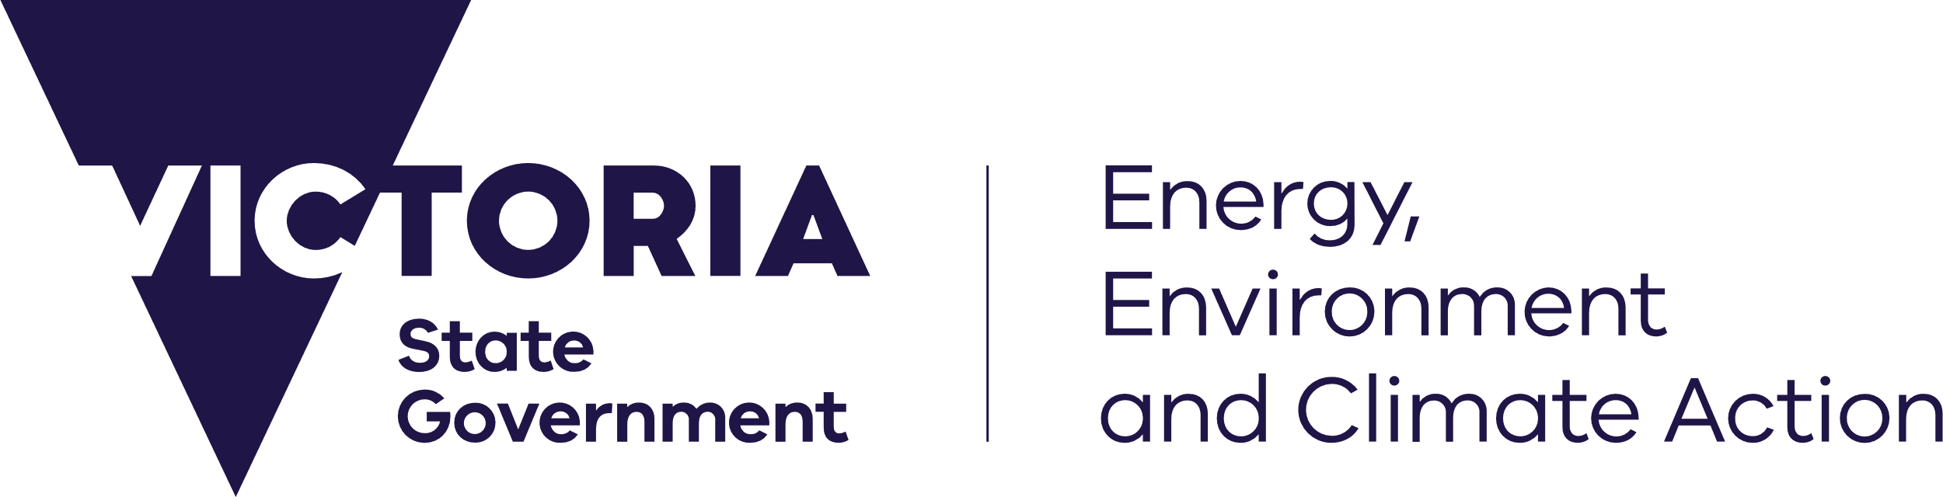



[deeca.vic.gov.au](https://delwpvicgovau.sharepoint.com/Users/fionadurante/Downloads/deeca.vic.gov.au)

Photo credit

© State of Victoria (DEECA). Credit: Darryl Whitaker



We acknowledge and respect Victorian Traditional Owners as the original custodians of Victoria’s land and waters, their unique ability to care for Country and deep spiritual connection to it.

We honour Elders past and present whose knowledge and wisdom   
has ensured the continuation of culture and traditional practices.

DEECA is committed to genuinely partnering with Victorian Traditional Owners and Victoria’s Aboriginal community to progress their aspirations.

© The State of Victoria Department of Energy, Environment and Climate Action January 2025.

Creative Commons

This work is licensed under a Creative Commons Attribution 4.0 International licence, visit the [Creative Commons website](http://creativecommons.org/licenses/by/4.0/) (<http://creativecommons.org/licenses/by/4.0/>).

You are free to re-use the work under that licence, on the condition that you credit the State of Victoria as author. The licence does not apply to any images, photographs or branding, including the Victorian Coat of Arms, and the Victorian Government and Department logos.

Disclaimer

This publication may be of assistance to you but the State of Victoria and its employees do not guarantee that the publication is without flaw of any kind or is wholly appropriate for your particular purposes and therefore disclaims all liability for any error, loss or other consequence which may arise from you relying on any information in this publication.

Accessibility

To receive this document in an alternative format, phone the Customer Service Centre on 136 186, email [customer.service@delwp.vic.gov.au](mailto:customer.service@delwp.vic.gov.au), or contact National Relay Service on 133 677. Available at [DEECA website](http://www.deeca.vic.gov.au/) (www.deeca.vic.gov.au).

Contents

INTRODUCTION 2

National agreements on metering 2

Water entitlement framework 3

Non-urban metering framework 3

Non-urban water meters 3

Telemetry and automated reporting and recording of take 7

THE POLICY 8

Objectives 8

Application 8

Requirements for metering 8

High risk take 9

Meter reading and automated recording and reporting of water take 9

Meter installation / validation 9

Meter verification 10

Timetable for installation of new meters and telemetry 10

Implementation 10

Annual reporting 10

Policy review 10

EXPLANATORY NOTES 12

Note 1: Varying the metering requirement 12

Note 2: Domestic and stock water use 12

Note 3: Sleeper and dozer licences 12

Note 4: Circumstances in bulk water distribution systems 12

Note 5: Costs of metering significantly outweigh the benefits 12

Note 6: Low volume water users 12

Note 7: Replacing Outside Contemporary Standard meters 13

Note 8: High-risk take 13

Appendix A: Legislation, policy, inter-governmental agreements, and standards for non-urban metering 14

Appendix B: Victorian Water Corporations 16

Appendix C: Implementation program 17

Appendix D: Alignment with the Murray-Darling Basin Compliance Compact 19

Appendix E: Glossary 21

# **INTRODUCTION**

Non-urban water metering has a vital role in the Victorian Government’s management of the state’s water resources. Water taken under entitlements is accurately and comprehensively metered so that water users and the community can be confident about our water management and accounting.

This state-wide policy applies to the management of non-urban water meters, which in Victoria are all managed by water corporations. It replaces Victoria’s non-urban metering Policy (2014, 2020) and Victoria’s state-wide implementation plan (2009).

Water measurement is essential to account for the distribution and use of water. It supports planning and allocation decisions and enables compliance with water resource management laws and initiatives like the Murray-Darling Basin cap and sustainable diversion limits under the Basin Plan.

Metered water use data can also be used to levy charges and to safeguard compliance with entitlement volume, trade or reporting obligations. Meters used for water measurement need to meet design, installation, and maintenance standards to make sure they provide accurate and reliable data.

## National agreements on metering

Governments signed the National Water Initiative[1] Agreement at the Council of Australian Governments’ meeting on 25 June 2004 and agreed on actions for a more cohesive national approach to the way Australia manages, measures, plans for, prices and trades water.

Paragraphs 87 and 88 of this agreement specify requirements for national metering standards and a nationally consistent framework for water metering and measurement.

A National Framework for Non-urban Water Metering Policy Paper (2009)1 (National Framework) sets out the structure agreed to by jurisdictional governments. It was designed to deliver the prime objective that national metering standards provide an acceptable level of confidence that measurement performance under in situ conditions is within a maximum error of ±5%.

The National Framework defines non-urban water metering broadly to include measuring systems, devices and their component parts owned by entitlement holders, water service providers and jurisdictional governments, and used as the basis for levying a charge and/or monitoring compliance with an entitlement and/or related resource management activities in a non-urban setting.

Non-urban water metering excludes:

* stream gauging stations or groundwater infrastructure used for monitoring water resources, and
* meters used in urban supply and distribution systems where water is treated to a potable standard.

In 2017, allegations of significant water theft and poor regulation in the northern part of the Murray-Darling Basin and compliance problems with water extraction and licensing systems in New South Wales led to several inquiries and reviews. The Commonwealth Government and all Basin states responded by agreeing to a Murray-Darling Basin Compliance Compact in June 2018 to improve transparency and accountability of water management systems and put more consistent compliance and enforcement practices in place. The Compact was endorsed by the Council of Australian Governments in December 2018.

The Compact outlines actions to be carried out by all Basin states, as well as individual actions for each state. It reaffirms the commitment for metering to conform with Australian Standards, with the national standard AS4747 – Meters for Non-urban Water Supply[2] - as the relevant standard.

See Appendix A for a summary of policy and legislation relevant to non-urban water metering and Appendix D for an outline of how this policy is aligned with the Compact.

### ***Inspector General of Water Compliance***

In 2019, an Inspector General of Murray-Darling Basin Water Compliance (IGWC) was established with the aim of improving transparency, accountability, and community confidence in water management[3]. The IGWC develops guidelines related to water management obligations and standards related to water metering and water market data. Victoria works collaboratively with the IGWC and Basin states and will ensure this policy has regard to any standards as they become available.

## Water entitlement framework

The Victorian Government manages the allocation of water resources across the state in accordance with the *Water Act 1989*.

Water entitlements and statutory rights authorise water users to access water from rivers, streams, and groundwater systems.

Statutory rights include water taken for domestic and stock use and water used by Traditional Owners.

Water entitlements include:

* Bulk and environmental entitlements
* A water share in a declared water system
* A take and use licence.

These entitlements are the basis for sharing, holding, and trading water in a system that balances demands for consumption, the environment and other non-consumptive uses with supply. Some water users are also supplied water under ‘supply by agreement’ arrangements.

This policy concerns the use of non-urban metering for managing these entitlements.

## Non-urban metering framework

In Victoria, water corporations own, operate, and maintain all non-urban water meters.

This policy applies to all water corporations that provide non-urban water supplies or delivery services in Victoria under powers and functions delegated by the Minister or provided directly under the *Water Act 1989*.

Most non-urban water supplies or delivery services are provided by six water corporations as shown in Figure 2:

* Coliban Water (CW)
* Goulburn-Murray Water (GMW)
* Grampians Wimmera Mallee Water (GWMW)
* Lower Murray Water (LMW)
* Melbourne Water (MWC)
* Southern Rural Water (SRW)

Water corporations tailor their approach to metering to the different water systems and customer needs across Victoria within the constraints of state and national policies and legislation (Figure 1).

**Figure 1 - Non-urban water metering is guided by state and national policies.**

More information on bulk water metering programs, can be viewed under ‘Bulk water measurement’ on Page 8. A description of the legislation, policy, inter-governmental agreements, and standards for non-urban metering are detailed in Appendix A.

## Non-urban water meters

Victoria has comprehensive meter coverage with about 52,565 non-urban water meters (as of 30 June 2023). This covers about 71 percent of customer service points across the six water corporations listed above (Table 1).

Urban water corporations own and operate a combined total of about 1,000 non-urban water meters.

The volume of water taken through each meter varies greatly across a water resource management area with:

* 40 per cent of meters often measuring 80 per cent of water taken, and
* 30 per cent of meters measuring less than 5 per cent of water taken.

Water corporations install the most accurate meters on the service points that take the most water or are the highest risk. For example, at least 424,060 megalitres (99 per cent) of all water diverted by LMW private diverters in 2022/23 was reported daily via telemetered flow meters that conform with AS4747 or are contemporary standard (also known as interim standard).

In Victoria many meters are for small outlets, where about half are 100 mm or less in diameter. Small (or low volume) water users typically represent a lower risk to the resource.

Figure 2 – Six water rural corporations service most non-urban water users.

Table 1 - Water corporation water meters and telemetry, as at 30 June 2024[4].

|  |  |  |
| --- | --- | --- |
| **Water Corporation** | **Total Meters** | **Meters with Telemetry** |
| CW | 965 | 0 |
| GMW | 22,924 | 10,433 |
| GWMW | 15,542 | 15,342 |
| LMW | 6,698 | 2,975 |
| MWC | 675 | 310 |
| SRW | 4,295 | 1,818 |
| Urban Water Corps (combined) | 1,000 | - |
| **Total** | **52,117** | **30,878** |

Total number of meters refer to both surface and groundwater meters across Victoria, captured in the 2023-24 Metering Implementation Report.

Contextual information about each water corporation can be viewed in **Appendix B**.

About 85 per cent of meters in Victoria (excluding meters for small outlets, equal to or less than 50mm in diameter) were installed before 2014.

As of 30 June 2024,

* Approximately 52 per cent of meters, or 26,463 meters, meet the goal of ±5 per cent error set via the National Framework.
* 4,982 of these meters are documented as meeting all the requirements of the AS4747 standard, with the remainder (21,481 meters) being of a contemporary standard, as they were contemporary at the time the meter was installed.

The National Framework recognised that due to a lack of meters approved by the National Measurement Institute conforming with AS4747 ([pattern approved](https://www.dcceew.gov.au/sites/default/files/documents/pattern-approved-meters-list-nov2022.pdf)), the responsible authorities would have to adopt contemporary standards that were likely to meet ±5 per cent error when installed. In Victoria, this means the meter has at least a manufacturer’s certificate of accuracy of ±2.5 per cent error and has been installed to manufacturer’s specifications. At least 304 contemporary standard meters meet these specifications, although meters at these sites do not conform with AS4747 if other requirements of the standard such as the design of the emplacement, qualifications of the installer or certification documentation are not met.

The main reason for the low number of meters that conform with AS4747 in Victoria is due to the historic lack of pattern approved meters and their relatively high cost. The National Measurement Institute approved the first meter for full flowing pipes in 2014. Prior to June 2022, there were no pattern approved open channel meters, there is now one. For more information, visit the Commonwealth [Department of Climate Change, Energy, the Environment and Water’s website](https://www.dcceew.gov.au/water/policy/policy/nwi/nonurban-water-metering-framework).

Contemporary standard meters may be as accurate and reliable as meters that conform with AS4747, including installations that have used pattern approved meters, modern open channel meters[5] in Southern Rural Water’s modernised irrigation systems, or where other modern contemporary standard meters have been installed that may be pattern approved by the National Measurement Institute in future. Some mechanical meters that are considered contemporary meters may become less accurate as they age. In general, meters installed under a contemporary standard are expected to continue to operate accurately if they are validated and maintained. Replacing contemporary standard meters with meters that conform with AS4747 by 2025 across Victoria would have an estimated net present cost of $84 million and would provide few benefits. These costs would inevitably be passed on to water users and reduce the affordability of metering services.

A wider range of pattern approved meters are now available for closed pipes and this is expected to further increase in the future.

Even with pattern approved meters, the design of the emplacement or pipes associated with the meter, and the maintenance of the pump, emplacement pipework or channels remain key determinants of whether the meter will be accurate when installed and will continue to measure accurately over time. The costs of constructing an emplacement and then installing and validating the meter are often more expensive than the metering equipment. If telemetry is installed, any interference in the connection between the meter and transmitter may affect the quality of the data reported. These issues are addressed by licensing of works, and regular inspections of meters and works conducted by water corporations.

Accurate meters are important however they are only one component of a compliance and water accounting system that provides confidence in the integrity of water markets and that ‘one person’s megalitre is the same as someone else’s’. Other important components of Victoria’s compliance and accounting system are:

* meters are read, inspected, and maintained by water corporation staff.
* 30,878 or over half of non-urban meters have telemetry (Table 1), which is used to monitor water take of many high-volume users or sites critical to protecting environmental flows in real time and sends data electronically to water corporations.
* bulk water measurement facilitates accounting and has a high level of public disclosure.
* automated control systems in many modernised irrigation districts give water corporations accurate information about deliveries and losses and prevent people from ordering more water than they are authorised to take.

### ***Bulk water measurement***

Water corporations are granted [bulk entitlements](https://www.water.vic.gov.au/about-us/water-entitlements-and-the-water-act/bulk-entitlements#:~:text=A%20bulk%20entitlement%20is%20a%20legal%20right%20to,customers%20and%20the%20conditions%20around%20taking%20that%20water.) by the Minister for Water under the *Water Act 1989*. The entitlements provide the right to take, store and use water subject to specified conditions and obligations.

In 2021-22, about 99 per cent (approximately 2,700 GL) of surface water in Victoria taken under an entitlement was taken under a bulk entitlement for consumptive use, excluding water taken under private rights. The measurement of water at the bulk level, and then again when the water is taken by the end user, facilitates water accounting and is a safeguard against systematic water theft.

In line with the *Water Act 1989* section 43 (h), bulk entitlements typically include a requirement that the holder of the entitlement has a metering program in place, to demonstrate how they comply with the obligations in their bulk entitlements. The bulk entitlement also requires that the metering program is prepared in accordance with guidelines issued by the Minister for Water.Metering programs are submitted to the Minister for Water and assessed to confirm consistency with guidelines.

The Minister for Water approved revised G*uidelines for Bulk Entitlement Metering Programs* in November 2021, which replaced the original *Guidelines for the Development of Bulk Entitlement Metering* issued by the Minister in 2009. The 2021 Guideline was updated to reflect contemporary water management policy, practices, and standards and to address specific issues identified by bulk and environment holders during the review process.

Water corporations publicly disclose take under bulk entitlements in annual reports tabled in Parliament and the annual Victorian Water Accounts.

The Victorian Environmental Water Holder (VEWH) holds bulk entitlements and environmental entitlements and has prepared metering programs for these entitlements. The VEWH mostly relies on meters that are owned and managed by water corporations.

Bulk entitlement meters measure a very large range of flows and tend to be a "modular metering system" that uses a broader range of technologies than meters for water corporations’ customers. Generally, there is no Australian Standard for these metering systems and some of their elements. They tend to be maintained by hydrographers rather than meter validators and require on-going calibration to confirm their accuracy.

Where there are non-metered service points in an irrigation district or distribution system, they are still covered by bulk water distribution metering.

Water users in the irrigation area and relevant water trading zones must be satisfied that meter inaccuracies have been accounted for, and that the approach taken strikes an acceptable balance between providing affordable water services and fair resource management.

### ***Metering of domestic and stock use***

Water can be taken for domestic and stock purposes under section 8 private rights, or under a take and use licence or water share.

Domestic and stock take under section 8 private rights does not have volumetric limits, so there is no need to meter for compliance or billing. Water taken by stock directly from a waterway is also impossible to meter.

Most domestic and stock extractions use small offtakes or bores. There are an estimated 18,058 domestic and stock bores in operation across Victoria and they extract around 14 per cent of annual groundwater use. Domestic and stock bores are not metered.

Excluding domestic and stock bores and other take under private rights, there are about 36,000 domestic and stock service points provided by water corporations and 63 per cent of these are currently metered for billing. In these cases, domestic and stock licences specify a low volume limit to match the restricted use, and while metering is not required it may provide valuable insights into individual water use.

In supply systems where water has already been measured when it was taken from the dam or stream, such as an irrigation district, un-metered service points are largely for domestic and stock purposes.

## Telemetry and automated reporting and recording of take

Telemetry involves automatically recording data and sending it electronically from the meter to another place for monitoring and recording.

The benefits of telemetry may include the opportunity for water users to assess their current water use and helping water corporations to improve occupational safety (e.g., reducing risks of travelling long distances, falling from heights, aggressive animals, and customers), detect metering faults and failures earlier, improve knowledge on customer water usage trends, process water trades faster, resolve customer complaints and detect breaches of limits on take.

Telemetry on groundwater bores gives much greater detail about the timing of take, and this can help reduce uncertainties in groundwater resource assessments.

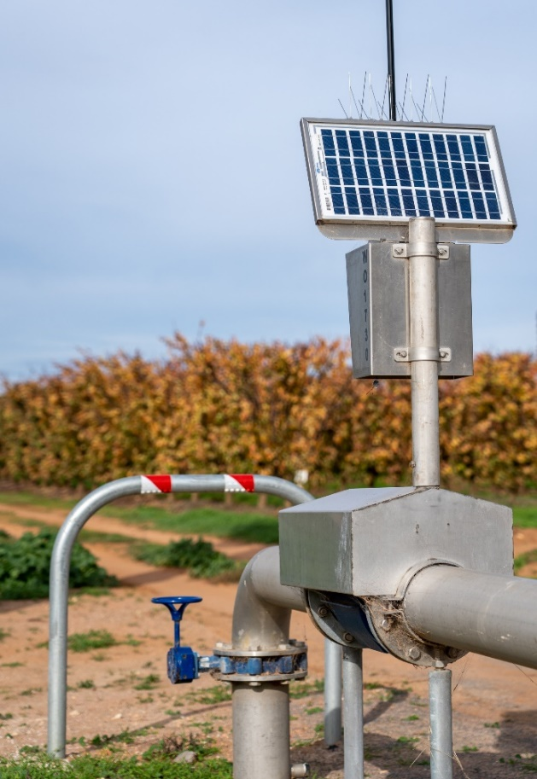

**Figure 3. Non-urban meter with fitted telemetry (Woorinen, Victoria).**

Victoria has approximately 30,878 non-urban water meters that are telemetered (see Table 1, as at 30 June 2024).

Telemetering of information from meters is recommended when the net cost of automation is lower than the cost of manual meter reading or to improve safety. Many water corporations have installed automated meter reading on that basis.

The key for telemetry is ensuring data accuracy and having a regular regime to check the dataloggers onsite. Telemetry needs power (usually batteries) and a telecommunications network, which results in ongoing operational costs.

It may be necessary to install a base station or network coverage extension device in areas without mobile communications network coverage. Where there are few metering installations, extending the mobile communications coverage may not be practical due to cost.

**Figure 4. Water corporation field staff reading non-urban meter with fitted telemetry (Woorinen, Victoria).**

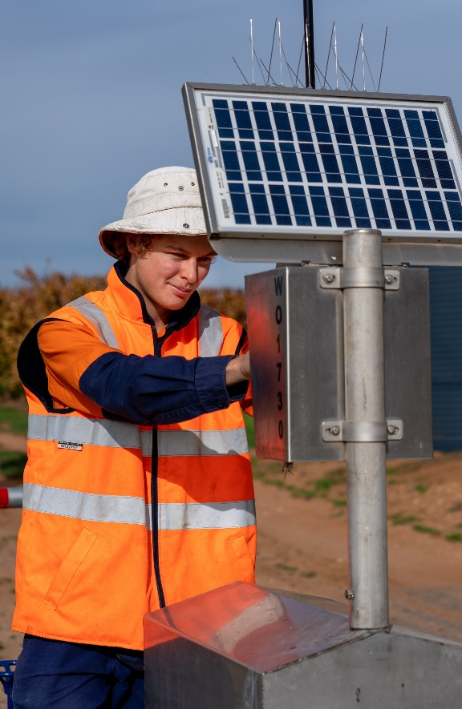

***Automated reporting and monitoring of take***

Water corporations have and continue to develop interactive dashboards utilising their existing data management systems to monitor water use.

Water corporations also report water take to the Victorian Water Register operated by the Department of Energy, Environment and Climate Action (DEECA).

At present Goulburn Murray-Water, Lower Murray Water and Southern Rural Water upload data daily into the Victorian Water Register.

# **THE POLICY**

## Objectives

This policy has the following objectives:

* To encourage comprehensive metering of non-urban water extraction in a way that is consistent with risks to water resources.
* To provide for water take to be measured accurately and reliably.
* To provide that meters installed are accurate and well-maintained.
* To ensure the benefits of water measurement outweigh the costs.
* To improve reporting by linking meter compliance data with water use data in the Water Register.

This policy replaces Victoria’s non-urban metering policy of March 2020, May 2014, and Victoria’s state-wide implementation plan of 2009.

## Application

This state-wide policy applies to non-urban water meters of water corporations (Figure 2).

## Requirements for metering

Apart from the circumstances where the metering requirement can be varied as described in the following section:

* new or upgraded extraction sites are to install meters that conform with AS4747.
* meters on existing extraction sites that meet a contemporary standard are to be replaced at the end of their operational life with a meter that conforms with AS4747.

### *Circumstances where the metering requirement can be varied*

In the circumstances described here:

* a meter may not be required, or
* a meter may be required, with the standard and maintenance regime determined by the water corporation.

Figure 6 provides a flow diagram for varying the metering requirement.

#### New and existing works

The metering requirement can be varied for new and existing works **[Note 1]** where the:

1. take is for domestic and stock purposes **[Note 2]**
2. cost of metering would significantly outweigh the benefits, including, but not limited to:
   1. where the site is not in use **[Note 3]**
   2. the low frequency or low annual volume of take **[Note 5]**
   3. excessive costs imposed by site conditions including water quality **[Note 6]**
   4. adequate water measurement is provided by bulk water metering **[Note 4]**, or
   5. the site is in the bottom 5 per cent of water taken (based on use) within a water resource management area.

In these cases:

* + 1. the reasons must be documented **[Note 6]** and
    2. if no meter is installed, there is a documented method for estimating the volume of water taken **[Appendix C]**

1. take is from an irrigation drainage system
2. take is authorised under a registration farm dam licence
3. a suitable pattern-approved meter is not available.
4. site requires stream gauging methods to be applied.

#### Existing works

The metering requirement can continue to be varied for existing low-volume users **[Note 5]**.

This can occur where the level of take is below the metering threshold within a certain water system (Table 2).

Table 2 – Metering thresholds for water systems and licence types.

|  |  |
| --- | --- |
| **Water System (Licence Type)** | **Threshold [Megalitres per year (ML/yr)]** |
| Unregulated surface water (take and use or registration licence) | Licence volume of less than or equal to 10 ML/yr |
| Regulated surface water (under a water-use licence or water-use registration) | Annual use limit of 10 ML/yr or less |
| Groundwater (take and use licence) | Licence volume of Less than or equal to 20 ML/yr |
| Any of the above | A lesser volumetric threshold set by the water corporation (see Table 4). |

### *Tamper evident seals*

Water corporations must install tamper evident seals on meters that conform with AS4747 and are of contemporary standard, and where practical on other meter categories captured in Table 9.

A tamper evident seal, for a non-urban water meter, means a seal that:

1. has the function of ensuring the metrological integrity of the meter,
2. has a sole supplier designated by the water corporation, and
3. will provide visible evidence that tampering of the meter has or may have occurred.

Important features include that the seal must:

* have a unique identifier number that enables seals to be monitored when linked to a meter and validation records,
* provide visible evidence of tampering,
* be sufficiently durable to remain intact and functional over the validation period for metering requirements as outlined in MAF2 and defined by water corporations; and
* only be installed by a certified meter installer (CMI) after (re-)validation (post installation) and maintenance activities, or when a seal is found to be broken.

### **Outside Contemporary Standard meters**

Water corporations should prioritise outside contemporary standard meters (meters that are not contemporary or do not conform with AS4747) to be replaced with meters that conform with AS4747 by June 2025 (Table 3) **[Note 7]**.

Water corporations should consider the circumstances for varying metering requirements when setting priorities for replacing meters.

## High risk take

Water take that is more than 5,000 megalitres average annual usage for an individual service point, excluding take under bulk water metering, is considered high risk take.

Water corporations are to install meters that conform with AS4747 and telemetry at these sites and document these sites in their metering action plans.

Water corporations may devise different definitions for high risk take that have a lower threshold than in this policy, and document them in metering action plans or statutory or local management plans.

## Meter reading and automated recording and reporting of water take

In Victoria, water corporations are to read meters on operational service points based on risk with a minimum standard of at least once a year on low volume or low risk water users and at least two times per year for surface water winter-fill licences. Water corporations should read meters more frequently than the minimum standards in higher risk systems, or for higher risk water users.

Water corporations are encouraged to work with their customers on whether more frequent meter reads would help them meet their licence obligations, for example by providing more time to trade water in if needed or to detect meter faults earlier.

To increase the value of groundwater water use data for assessment and planning, where entitlement holders move their irrigation equipment including the meter around their land and take water from several bores, water corporations should where possible record the different locations of the meters and the date when the meter changes location.

Water take that is more than 5,000 ML per year for an individual service point, excluding take under bulk water metering, is high risk. Water corporations are to have telemetry for high risk take and document these sites in their metering action plans.

Metered water take is to be telemetered by June 2025, based on an assessment of the full range of costs and benefits including benefits of stronger compliance. Water corporations may retain manual meter reading where telemetry is not viable (e.g., in valleys with poor reception or difficult sites), or an alternative technology can be applied.

## Meter installation / validation

New meter installations must conform with the AS4747 standard.

Where practical, a certified meter installer (CMI) and validator should install meters. CMIs engaged will have the required skills, competencies and qualifications required within the [Metrological Assurance Framework (2) (pg., 11).](https://www.agriculture.gov.au/sites/default/files/documents/metrological-assurance-framework-2.pdf)

Where installation by a CMI is not feasible, a non-certified person may install a meter, provided that the meter is validated by a CMI, installs a tamper evident seal, and provides confidence that the meter operates within the maximum permissible limits of ±5% allowed when installed.

The installer for each installation should be documented within internal metering database.

## Meter verification

If meters are validated in line with the scheduled requirements, verification is not required unless it is to determine if the meter has been functioning accurately.

In locations where it is not possible to do on site calibration of bulk metering by a suitably qualified person or site constraints make it cost prohibitive, the bulk entitlement metering plan should document how the accuracy of the bulk meter is to be confirmed.

## Timetable for installation of new meters and telemetry

Table 3 shows the timetable for implementing this policy. Water corporations’ metering action plans address auditing and maintenance requirements.

Table 3 - Timetable for installation of new meters and telemetry

|  |  |
| --- | --- |
| Action | Date for compliance |
| Apply requirements for metering in this policy | From March 2020 (date Minister approved policy) |
| Metering and telemetry of high risk take | All high-risk take is to have meters that conform with AS4747 and telemetry from March 2020. |
| Replace outside contemporary standard meters considering circumstances for varying metering requirements | June 2025 |
| Metered water take is to be telemetered | June 2025 |

## Implementation

Appendix C sets out the implementation program for this policy.

**Figure 7. Non-urban water meter along channel (Myall, Victoria) (right).**

The management of:

* meters associated with bulk entitlements will continue to be guided by *Guidelines for the development of bulk entitlement metering programs (2009, updated in 2021)*.
* all other non-urban meters will be guided by *Guidelines for preparing non-urban water metering action plans (updated 2025).*

## Annual reporting

Water corporations report on metering assets and implementation activities to DEECA. DEECA prepares and publishes a state-wide implementation report available on the [DEECA website](https://www.water.vic.gov.au/for-agriculture-and-industry/non-urban-water-metering/non-urban-water-metering-reports)[6].

DEECA also actively works with the Inspector-General of Water Compliance and other Basin states to develop public reporting on water metering reforms in the form of the Metering Report Card. The first report card was published in January 2023. All recent reports are available on the [IGWC website](https://www.igwc.gov.au/publications/reviews-reports)[7].

## Policy review

DEECA will review the policy and implementation of the policy every four years and/or as required due to guidance or policy change.

**Next review is required by 2028.**



**Policy was previously reviewed in 2023/24.**



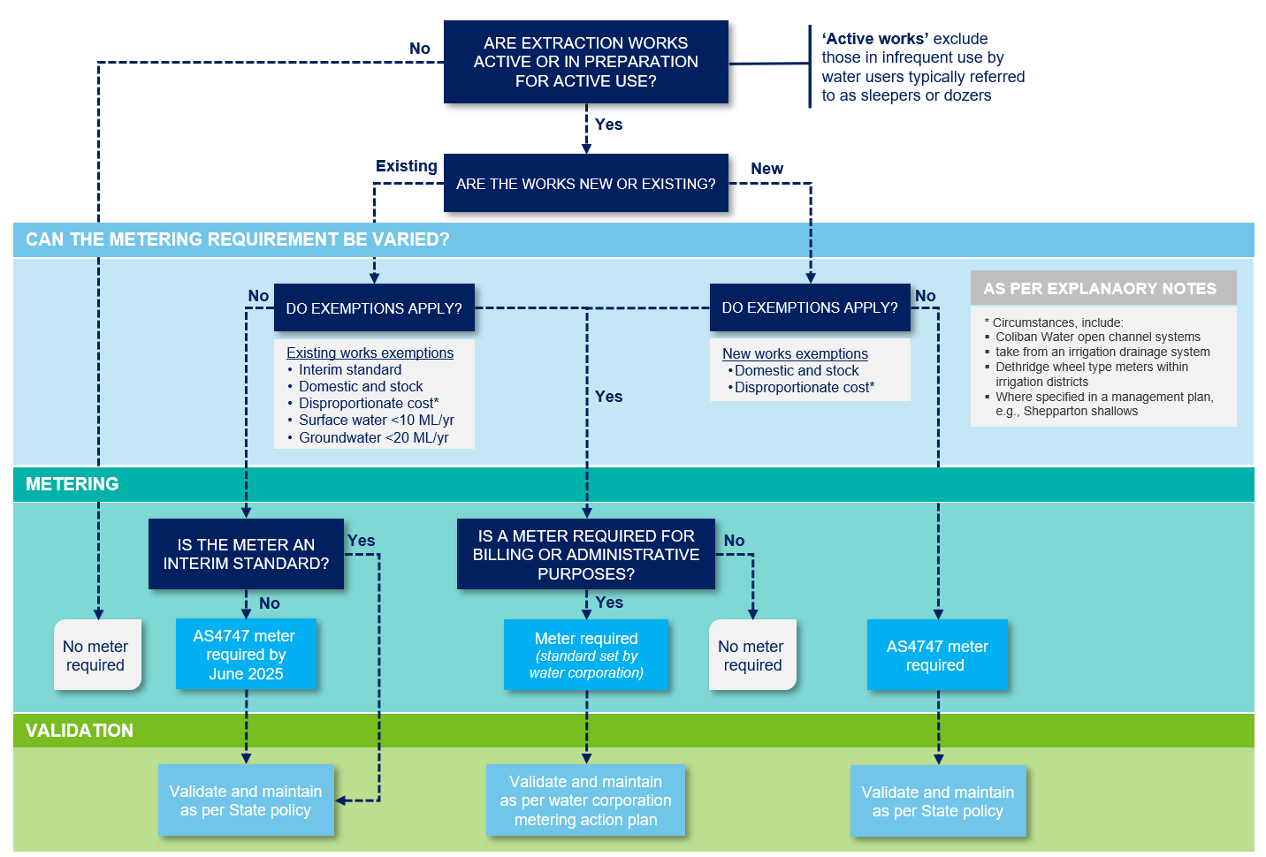

**Figure 6. Requirement for metering – flow diagram**

# **EXPLANATORY NOTES**

## Note 1: Varying the metering requirement

Water corporations install meters to measure the amount of water supplied or delivered to the land, or the amount of water taken or used. The installation of meters allows for accurate billing and accounting, fairness across the customer base, operational efficiencies, resource management and compliance.

Trading water or transferring licences where either the buyer or the seller do not have meters may lead to an overall increase in the amount of water taken. Trades should not be approved without both parties having a meter in place unless:

* it is the seller who does not have a meter and they are selling all their entitlement, and the transfer commences on 1 July (i.e., start of the season), or
* the seller does not have works or an equipped bore.

Exemptions from the requirements of the Compact are included in this document as circumstances where the metering requirement can be varied.

Water users who are not metered still need to comply with the obligations of their entitlement or statutory rights, which are enforced by water corporations.

## Note 2: Domestic and stock water use

This policy continues existing arrangements for metering take for domestic and stock purposes.

A meter is required where a work is used to take water for domestic and stock purposes as well as for irrigation under an entitlement unless there are circumstances where the metering requirement can be varied.

## Note 3: Sleeper and dozer licences

These circumstances cover sleeper and dozer licences.

## Note 4: Circumstances in bulk water distribution systems

The metering requirement can be varied for:

* All water users on open channel systems in the irrigation districts managed by Coliban Water.
* Existing Dethridge wheel-type meters in irrigation areas where the bulk water meter is a meter that conforms with AS4747 by June 2025, or under a metering system where an accuracy of +/-5 per cent can be demonstrated. There are around 3,000 Dethridge wheels remaining in districts across Victoria. There are more expensive to upgrade with a meter that conforms with AS4747 than a closed conduit meter, with a total estimated replacement cost of $107 million. The timetable for replacing these meters will depend on the available funding and/or plans for modernisation or reconfiguration.
* Surface water take with an annual use limit of 10 megalitres per year, or less under a water-use licence or water-use registration, in an irrigation district with accurate bulk water metering.
* Channels or distribution systems that may be subject to future rationalisation or reconfiguration.

## Note 5: Low volume water users

Government policy introduced requirements to meter new irrigation or commercial use licences from 2004 and for water corporations to meter existing surface water licences of 10 megalitres per year or greater and 20 megalitres per year or greater for groundwater. Successive metering policies have maintained these grandfathering arrangements.

There has not been a requirement to install a meter when the licence is renewed, however meters are needed for the water users to trade water. Water corporations have in some cases adopted lower thresholds than the state policy (Table 4).

As of 30 June 2023, entitlements less than the thresholds of 10 megalitres for surface water and 20 megalitres for groundwater make up only a small proportion of total entitlement volume, at about 4.4 per cent of surface water entitlements and about 2.6 per cent of groundwater entitlements.

## Note 6: Costs of metering significantly outweigh the benefits

Where water corporations decide that it is not necessary to meter certain users of a defined resource, the corporation’s reasons, and alternative method for estimating take should be documented in a management plan that is publicly available. The method of estimation should be based on an adequate sample of similar metered water users.

Otherwise, the reasons are to be detailed in the application approval documents for individual entitlement holders.

DEECA and water corporations with rural customers will share information on meter performance, implementing the policy consistently, and improving metering practice (see Appendix C Implementation Program).

Table 4. Water corporation metering thresholds for existing meters

|  |  |  |
| --- | --- | --- |
| **Water Corp** | **Surface water (Megalitres(ML)/yr)** | **Groundwater**  **(ML/yr)** |
| CW | 10 ML/yr | n/a |
| GMW | 10 ML/yr | 20 ML/yr |
| GWMW[8] | 10 ML/yr | 10 ML/yr |
| LMW | 2 ML/yr | 2 ML/yr |
| MWC | 5 ML/yr | n/a |
| SRW | 10 ML/yr | 10 ML/yr |

**Figure 7. Water corporation field staff reading non-urban meter on groundwater pump (Dunnstown, Victoria) (right).**

## Note 7: Replacing Outside Contemporary Standard meters

The Compact specifies June 2025 as the date by which meter fleets are to conform with AS4747, and existing meters are to be ± 5 per cent accurate in the field, except where the state provides for an exemption (e.g., where costs are disproportionate to benefits).

This policy’s approach of replacing contemporary (interim standard) meters installed in good faith at the end of their operational life is consistent with the National Framework. The cost of replacing these meters before the end of their operational life would significantly outweigh the benefits.

Most outside contemporary standard meters (that is, meters that do not conform with AS4747 or are not contemporary standard) are installed in circumstances where the metering requirement can be varied.

## Note 8: High-risk take

Water take that is more than 5,000 megalitres per year from a single service point is high risk because of the potential for inaccurate metering or failure to comply with the entitlement to have adverse impacts on other water users or the environment. Take from bulk water meters is not considered high risk because there is a high level of supervision and public disclosure through the yearly Victorian Water Accounts and annual reports tabled in Parliament.

# **Appendix A:** Legislation, policy, inter-governmental agreements, and standards for non-urban metering

Table 5 - Legislation, policy, inter-governmental agreements, and standards for non-urban metering

|  |  |
| --- | --- |
| **Legislation, policy, frameworks, and standards** | **Description** |
| *The Water Act 1989* (Vic) | The Act provides the legal basis for the management of water in Victoria.  **Section 142** of the Act provides, in relation to their customers’ meters, for water corporations to provide, install and maintain meters on any land, to estimate the volume of water delivered if the water corporation believes a meter is functioning inaccurately, and that a meter provided or installed by the water corporation remains the property of the corporation.  **Section 43 (g)** provides, in relation to a bulk entitlement, that a water corporation must install and maintain metering equipment approved by the Minister and **section 43(h)** provides that the water corporation must carry out a metering program approved by the Minister. |
| Statement of Obligations (General) | Part 7-4 of the Statement of Obligations (General) issued under the *Water Industry Act (1994)* requires that water corporations that provide non-urban water supplies or delivery services must prepare and implement metering action plans that comply with the Victorian Implementation Plan for the National Metering Standards for Non-Urban water metering. |
| NMI M 10 and NMI M 11 | The National Measurement Institute (NMI) was established on 1 July 2004. The NMI is responsible for the Australian Government's measurement functions detailed in the *National Measurement Act 1960* (Cth). The NMI develops and maintains measurement standards and supporting guidelines and this includes non-urban water meter standards for pattern approval—NMI M 10[9] and NMI M 11[10]. |
| National Water Initiative (2004) | The [National Water Initiative (NWI)](http://www.agriculture.gov.au/SiteCollectionDocuments/water/Intergovernmental-Agreement-on-a-national-water-initiative.pdf), is the national blueprint for water reform agreed in 2004 by the Council of Australian Governments (COAG). Paragraphs 87 and 88 of the agreement specify requirements for national non-urban metering standards and a nationally-consistent framework for water metering and measurement[11] . |
| *National Trade Measurement Regulations 2009* (Cth) | Made under the *National Measurement Act 1960* (Cth), *the National Trade Measurement Regulations 2009* (Cth) (the Regulations) support the Commonwealth system of trade measurement. Specifically, Division 11 of the regulations deals with the maximum permissible errors for water meters. The regulations effectively exempt non-urban water meters from needing to conform with the standard. |
| National Non-Urban Metering Framework (2009) | The [National Non-Urban Metering Framework](http://www.agriculture.gov.au/SiteCollectionDocuments/water/national-framework-non-urban-water-metering.pdf) (the National Framework), agreed through COAG, deals with the metering commitments made under the National Water Initiative. It provides a nationally-consistent basis for water metering and outlines the implementation of national standards for meter construction, installation and maintenance, use of certified installers, maintainers and validators, and requirements for compliance, auditing and reporting.  Key elements of this National Framework include the metrological assurance framework, the Australian standard for non-urban meters (AS4747) and the National Measurement Institute’s standards for pattern approval. |
| Metrological Assurance Framework (2) | The Metrological Assurance Framework (MAF) sets out the key requirements to make sure there is an acceptable level of confidence in meter performance. MAF2 was released in 2021 and describes the nationally consistent compliance management approach for non-urban water meters in Australia. MAF2 is updated intermittently, as required. |
| Australian standard for non-urban meters – AS4747 | AS4747 is effectively a component of the Metrological Assurance Framework. It sets the technical specifications for non-urban water meters as well as the installation, calibration and maintenance processes required to achieve pattern approval conformance. |
| Victorian State-wide Implementation Plan for Non-urban Water Metering (2010) | The Victorian State-wide Implementation Plan for Non-urban Water Metering (the Implementation Plan) was completed in March 2010. The Implementation Plan sets out Victoria’s pathway to achieving compliance with the National Framework. |
| Victorian Non‐Urban Water Metering Policy (2014, 2020) | The [Victorian Non‐Urban Water Metering Policy](https://www.water.vic.gov.au/__data/assets/pdf_file/0015/52233/Non-urban-Water-Metering-Policy_Final_jg85_20140513.pdf) [12] applies to non-urban water meters of water corporations, and guides how water corporations manage these meters. |
| Murray-Darling Basin Compliance Compact (2018) | The [Murray-Darling Basin Compliance Compact](https://www.mdba.gov.au/publications/independent-reports/basin-compliance-compact) agreed on 8 June 2018, is a collaborative, joint commitment by the Australian Government and Basin states. The compact seeks to provide transparency and accountability for surface and groundwater management and regulation, and a consistent approach to compliance and enforcement practices by governments across the Basin. Section 3 of the compact deals specifically with metering and measurements and sets out an action plan to improve non-urban metering across the Basin. |

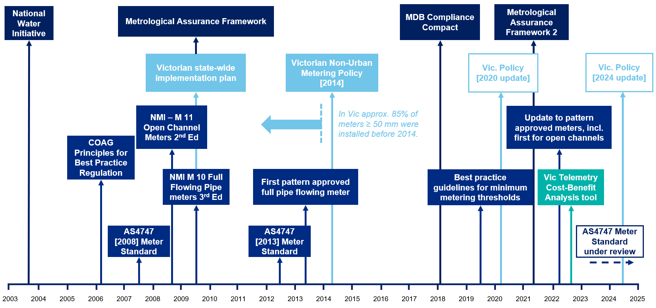  
Figure 8 - Progression of non-urban water metering [13]

# **Appendix B:** Victorian Water Corporations

Table 6 – Rural Water corporation water meters and telemetry, as at 30 June 2024.

**Note:** *The entitlement volumes and use exclude water held by environmental water holders and water corporations.*

|  |  |  |
| --- | --- | --- |
| **Water Corporation** | **Total Meters** | **Meters with Telemetry** |
| **Coliban Water** operates a regulated system that for most of its approximately 500 km length consists of small (< 1m2 cross section) open channels. As of 17 November 2023, there are 1,350 take and use licences, amounting to 15,741 megalitres (ML) on this system and 2,266 ML use in 2022/23. | 965 | 0 |
| **Goulburn Murray Water** (GMW) is Victoria’s largest rural water corporation. About 86 per cent of water used by GMW’s rural customers is in supply systems including irrigation districts that have the most accurate meters and greatest level of monitoring, 6 per cent is taken directly from regulated streams, 3 per cent from unregulated surface water and 5 per cent from groundwater. GMW is also responsible for bulk water diversions to urban water corporations and delivery of environmental water. There are 59,075 privately held entitlements, amounting to 4,210,626 ML on these systems, and 943,706 ML use in 2022/23. | 22,942 | 10,433 |
| **Grampians Wimmera Mallee Water** (GWMW) Around 90 per cent of GWMWs meter and telemetry installations are for low volume domestic and stock customers on about 14,000 km of rural water pipelines. GWMW also manages groundwater licences, which are the main source of water for entitlement holders, and a limited amount of take from unregulated surface water systems. There are 9,095 privately held entitlements, amounting to 95,381 ML on these systems, and 23,116 ML use in 2022/23. | 15,542 | 15,342 |
| **Lower Murray Water** (LMW) rural customers in 2022/23 use surface water from the River Murray, with approximately 20 per cent in irrigation districts and 80 per cent directly taken from the river. There are 6,107 privately held entitlements (water shares), amounting to 307,815 ML on these systems, and 425,953 ML use in 2022/23. | 6,698 | 2,975 |
| **Melbourne Water** (MWC) manages licences to unregulated streams and stormwater – the data in this table relates to these licences. There are 1,844 privately held entitlements (registration and take and use licences), amounting to 48,470 ML on these systems, and 9,121 ML use in 2022/23. Melbourne Water is also responsible for bulk water and wastewater services in the greater Melbourne area. | 675 | 310 |
| **Southern Rural Water** (SRW) manage water shares in regulated surface water systems, licences to unregulated stormwater, surface water and groundwater, as well as recycled water contracts across the southern half of Victoria. There are 17,767 privately held entitlements, amounting to 970,703 ML on these systems, and 94,178 ML use in 2022/23. | 4,295 | 1,818 |
| **Urban Water Corporations** (combined) | 1,000 | - |
| **TOTAL** | **52,117** | **30,878** |

# **Appendix C:** Implementation program

Table 7 - Implementation program

Water corporations (or * water corps) refers to Goulburn-Murray Water, Lower Murray Water, Southern Rural Water, Coliban Water, Grampians Wimmera Mallee Water and Melbourne Water.

|  |  |  |  |
| --- | --- | --- | --- |
| **^Status Key:** | Badge Tick outline In progress | Badge Tick with solid fill Complete | Repeat with solid fill Ongoing |

|  |  |  |  |
| --- | --- | --- | --- |
| **Action** | **Responsible** | **Status^** | **Update (as of January 2025)** |
| Water corporations and DEECA will review metering action plans at least once every four-year economic regulation cycle. | Water corporation * |  | Water corporations review their MAP at least once per four-year economic regulation cycle. |
| Water corporations will report annually on their meter assets | Water corps |  | Water corporations report on metering implementation at their jurisdictional level to DEECA on an annual basis. |
| DEECA will publish an annual update of Victoria’s meter assets and implementation of metering on its website (Compact action 3.7) | DEECA |  | DEECA reports annually on metering implementation at the state level and across northern Victoria. DEECA published the sixth report for [2023-24](https://www.water.vic.gov.au/for-agriculture-and-industry/non-urban-water-metering/non-urban-water-metering-reports/non-urban-metering-implementation-annual-report-2023-24) in January 2025. |
| DEECA and water corporations will develop the means to report more easily and consistently on meters across the state and the amount of water measured by different categories of meters. | DEECA |  | Key statistics and metrics reported on through DEECA’s annual metering report are continually refined, and more closely align with the Inspector General of Water Compliance’s Metering Report Card. |
| Water corporations will consistently use standard terms to categorise meters and to identify the meter requirements when reporting on meters (see Tables 8, 9 and 10 below). DEECA will consult with water corporations to develop the standard specification for the fields. | Water corps |  | Water corporations have and continue to develop interactive dashboards utilising their existing data management systems to monitor water use data. Water corporations capture and categorise metering information in relation to standardised fields, codes, categories, and requirements in their metering dashboard/databases. |
| DEECA and water corporations will review meter policy and metering action plan guidelines to consider outcomes from a Commonwealth investigation into the Metrological Assurance Framework (MAF2) for Non-Urban Water Meters. | DEECA |  | The review of the metering policy and metering action plan guidelines was completed by January 2025.  Updates ensured alignment with MAF2 and incorporated guidance on evident tamper seals. |
| Metering coordinators from water corporations with rural customers will share information on meter and telemetry performance, implementing the policy, and improving metering practice. | Water corps |  | Metering insights and experiences are shared between metering experts, facilitated through the Victorian Non-Urban Metering Working Group. The working group is chaired by DEECA and meets as required. |
| DEECA will review the Guidelines for the Development of Bulk Entitlement Metering Programs. | DEECA |  | The review of the Guidelines for Bulk Entitlement Metering Programs was completed and endorsed by the Minister in November 2021. |
| Water corporations will assess the costs and benefits of installing telemetry on meters that are still being read manually and update their metering action plans. | Water corps |  | Water corporations analyse the cost and benefits to installing telemetry. A framework and tool were created by September 2022 to guide these decisions. |
| DEECA and water corporations will undertake a policy implementation review. | DEECA |  | Between 2024/25 – 2025/26 |

Table 8 – Non-urban water meter data fields to enable consistent state-wide reporting

|  |  |  |  |
| --- | --- | --- | --- |
| Item | Data | Description | Notes |
| 1 | Service Point | Service Point | Will use the same format as used for the Water Register. These fields will enable a match and check for anomalies. |
| 2 | Licence | Water Share or Licence to match Water Register |
| 3 | ABA | Allocation Bank Account |
| 4 | Manufacturer | The manufacturer name | Will require consistent use across the water corporations so it is possible to aggregate records. |
| 5 | Model | The model name |
| 6 | Nominal Size (mm) | DN for Fully Flowing Pipe meter or Nominal width for Open Channel meter | Will either water corporation to include a new field in their metering database system for Nominal Diameter, as in most cases actual diameters are recorded. |
| 7 | Serial number | Meter serial number on meter | This would be optional initially to allow time for water corporations to collect this data for meters that conform with AS4747 meters and contemporary standard meters. |
| 8 | Telemetry code | Code to indicate if the meter has telemetry and if so, broadly its type | The proposed codes are: None (default),  4-20mA, Pulse and MODBUS. |
| 9 | Installation date | The installation date of the meter | Year of installation. |
| 10 | VIC Compliance Code | Compliance Code of current meter | Compliance Code as specified in Table 9. |
| 11 | Meter requirement | Requirement Code for site | Requirement Code as specified in Table 10. |

Table 9 - Non-urban water meter compliance codes

| Compliance category | Code | Description |
| --- | --- | --- |
| AS4747 | AS | Pattern approved meter, installed by a certified installer, conform with the AS4747 standard, and has a certificate |
| Contemporary (Interim standard) | CO | A meter that can operate within the maximum permissible error of +-5% under in situ conditions and provides for on-going validation. This would include pattern approved meters that fail to meet all the requirements of AS4747. |
| Outside contemporary standard | OT | All other measurement devices that are unable to meet validation requirements. These devices may or may not measure within the accuracy standards. |
| Unmetered | UM | Unmetered |

Table 10 - Non-urban water meter requirement codes

|  |  |  |
| --- | --- | --- |
| Requirement | Code | Description |
| Accurate meter required | AM | Site is to have a maximum permissible error of +-5% under in situ conditions |
| Exempt - outside scope | EXOS | Exempt as water use is for D&S licence, drain diversion licence, stormwater, meters managed by other Water Corporations |
| Exempt - low use | EXLU | Below the threshold for high accuracy meters |
| Exempt - high cost | EXHC | Disproportionate cost to benefit.  This may be due to extra costs required to overcome technical challenges such as iron bacteria in groundwater causing changes to flow patterns outside the meter requirements.  The benefit assessment would consider the use volume together with the management objectives for the water resource area. |
| Exempt - supply system change planned | MO | Meter is located within an area planned for modernisation or reconfiguration and the meter upgrade, relocation or removal will be part of modernisation or reconfiguration. |

# **Appendix D:** Alignment with the Murray-Darling Basin Compliance Compact

Victoria is committed to implementing the Murray-Darling Basin Compliance Compact where it is cost-effective to do so. Table demonstrates how this policy is aligned with the Compact.

Table 11 - Alignment with the Compact

|  |  |  |
| --- | --- | --- |
| **Compact action** | **Requirement** | **Victorian response** |
| **3.2** | **Meter accuracy** |  |
| 3.2 (i) | All new and replacement meters to conform with AS4747 including pattern approval and verification, by no later than June 2025 | This policy requires:   * new or upgraded extraction sites to install meters that conform with AS4747 from the date the Policy is published; * outside contemporary standard meters to be replaced with a meter that conforms with AS4747- by June 2025; and * meters on existing extraction sites that are contemporary (interim) standard or conform with AS4747 to be replaced at the end of their operational life with a meter that conforms with AS4747.   The policy does not require meters that are contemporary standard to be replaced by June 2025, if their operational life extends past June 2025, due to the high cost for little benefit as explained in page 11.  Circumstances where the metering requirements can be varied to avoid costs exceeding the benefits of metering are set out in *Requirements for metering* (page 10). |
| 3.2 (ii) | Commencing immediately, and until June 2025:   1. All new and replacement meters to conform with AS4747 where available. 2. Where an AS4747 meter is not available the use of an interim meter that has been verified with a manufacturer’s certificate of accuracy to within +/- 5% is acceptable. |
| 3.2 (iii) | When an existing meter no longer meets +/- 5% accuracy in the field it must be repaired and validated so that it is accurate to within +/- 5% in the field or replaced (see 3.2(i)). |
| 3.2 (iv) | All meters to be periodically validated consistent with the requirements of AS4747. | This policy requires meters to be validated in line with AS4747 except in circumstances where the metering requirements can be varied to avoid the costs of metering exceeding the benefits. |
| **3.3** | **Meter coverage** |  |
| 3.3 (i) | All take via water entitlements to be metered by June 2025 and a plan for achieving this. | This policy requires all extraction sites to be metered except in certain circumstances as described above by June 2025 to avoid the costs of metering exceeding the benefits. |
| **3.4** | **Transmission of Data** |  |
| 3.4 (i) | A program to progressively automate the reporting of take, regardless of how that is measured, no later than 2025 | This policy (page 12) requires all metered water take to be telemetered by June 2025 except where telemetry is less suitable or practical than manual meter reading, or an alternative technology can be applied based on an assessment of the full range of costs and benefits. |
| **3.5** | **High risk take** |  |
|  | The highest risk take, including large users in the Barwon–Darling, to be accurately metered by December 2019 and will publish what constitutes highest risk in their metering policies. High risk take should also be telemetered by December 2019 with any exemptions published. | This policy (page 15) requires water take that is more than 5,000 ML per year for an individual service point, excluding take under bulk water metering, (high risk take) to be telemetered from the date this policy is published. As described in page 8, the requirements for bulk metering are covered under a different and comprehensive metering program. |
| **3.6** | **Timetable for installation** |  |
|  | A timetable for the installation of new meters and telemetry, and auditing and maintenance of the metering fleet to meet the above requirements. | A timetable for installation of new meters and telemetry is set out in *Table 3 (*page 12*)*. |

# **Appendix E:** Glossary

|  |  |
| --- | --- |
| **Term** | **Definition** |
| **Bulk water meter** | a meter for measuring the flow under the approved bulk entitlement metering program. |
| **Contemporary standard** | also referred to as *interim standard*, and contemporary at the time the meter was installed, is a standard under which an installed water meter is likely to meet the ±5% accuracy range, and which has a manufacturer’s certificate of accuracy of ±2.5% and has been installed to manufacturer’s specifications. |
| **Domestic and stock use** | the *Water Act 1989* provides this definition of domestic and stock water use:  *“’domestic and stock use’, in relation to water, means use for—*   1. *household purposes; or* 2. *watering of animals kept as pets; or* 3. *watering of cattle or other stock; or*   *(ca) in the case of the curtilage of a house and any outbuilding, watering an area not exceeding 1·2 hectares for fire prevention purposes with water obtained from a spring or soak or water from a dam; or*   1. *irrigation of a kitchen garden—*   *but does not include use for dairies, piggeries, feed lots, poultry or any other intensive or commercial use.”* |
| **‘Dozer’** water licence | a water licence that is regularly inactive for significant periods of time. The term is often used interchangeably with ‘sleeper’ water licences (see definition below). |
| **Emplacement** | is the structure on or in which the meter is installed. |
| **High-risk take** | is defined in this policy as take that is more than 5,000 megalitres average annual usage for an individual service point, excluding take under bulk water metering. |
| **Irrigation system** | a network of pipes and/or channels that distribute water to customers for use. Uses include irrigation but may include other uses like domestic and stock. |
| **Jurisdiction** | the state and territory governments of Australia. |
| **Licence volume** | is the maximum volume that the take and use licence holder is authorised to take under that licence during a water season or during any shorter period of take stated in the licence. |
| **Meters that conform with AS4747** | a water meter that has been either pattern approved or verified in conformance with the processes and procedures outlined in AS4747 – Meters for Non-Urban Water Supply, which sets the technical specifications for non-urban water meters as well as the installation, calibration and maintenance processes required to achieve pattern approval conformance (Standards Australia, 2013). |
| **Metrological Assurance Framework** | is part of the National Framework for Non-urban Water Metering and sets out the key requirements to make sure there is an acceptable level of confidence in meter performance. |
| **Meter** | is *‘a measuring device or system (including its component parts) used to measure the volume of water passing through a closed conduit or open channel over a known period’*[14]but does not include the measurement of flow in natural channels (see stream gauging). |
| **Murray-Darling Basin Compliance Compact** or **Compact** | An agreement designed to improve consistency, transparency, and accountability in managing water resource compliance and enforcement across the Basin. All Basin states and the Australian Government committed to the Basin Compliance Compact in June 2018. |
| **Non-urban water metering** | is water metering used as the basis for levying a charge and/or monitoring compliance with an entitlement and/or related resource management activities in a non-urban setting[15]  Non-urban metering does not include:   * stream gauging stations or groundwater infrastructure used for resource monitoring. * meters used in urban supply and distribution systems where water is treated to a potable standard |
| **Outlet size** | refers to either the diameter of the conduit meter piping or the width of the meter channel. |
| **Outside contemporary standard** | is a water meter that does not conform with contemporary (interim standard) or AS4747 standards. |
| **Pattern approval** | is a process for verifying the accuracy of a water meter, where the National Measurement Institute examines the pattern (design) of a meter prototype against the requirements of AS4747. |
| **Registration farm dam licence** | A registration farm dam licence is an ongoing entitlement to take and use water from a catchment dam, spring, or soak. Registration farm dam licences were issued between 1 July 2002 and 30 June 2003 based on historical use of water. |
| **‘Sleeper’** water licence | is a water licence that is permanently inactive but can be reactivated. The term is often used interchangeably with ‘dozer’ water licences (see earlier definition). |
| **Stream gauging** | is ‘*the measurement in accordance with AS3778 of stream discharge (flow) past a given point on a watercourse for a range of flow height conditions, enabling calibration of the site and establishment of a rating curve (height-discharge relationship). A stream gauging station is the site for which the rating curve is established and is generally instrumented with a range of specialised equipment’*[16]. |
| **Take and use licence** (section 51 licence) | is a fixed term entitlement to take and use water from a waterway, catchment dam, spring, soak, or aquifer. Each licence is subject to conditions set by the Minister and specified on the licence. |
| **Telemetry** | involves automatically recording data and sending it electronically from the meter to another place for monitoring and recording. |
| **Validation** | inspection and/or testing of the meter and installation by a certified validator to make sure there is enough confidence that it operates within the maximum permissible limits of error of ±5% allowed when installed. |
| **Verification** | a process or procedure for independently assessing the accuracy of a meter. This can be done in a laboratory to test the meter only, or in the field to test the meter performance in existing conditions. |
| **Water accounting** | the processes and procedures used to track water system inflows, outflows, and storage volume changes. |
| **Water share** | Is an ongoing entitlement to a share of the water available in a declared water system. |
| **Water take** | Water extracted under a licence or entitlement granted under the *Water Act 1989*. |
| **Winter-fill licence** | A take and use licence that only permits taking water from a waterway during the winter months, typically July to October. |
| **Works licence** | A licence that authorises the construction, alteration, operation, removal or decommissioning of any works on a waterway, or a bore, or a dam belonging to a prescribed class of dams. |

For more information about water management terms in Victoria, please see the Water Register’s [water dictionary](https://waterregister.vic.gov.au/water-dictionary) at <http://waterregister.vic.gov.au/water-dictionary>

**Victorian Non-Urban Water Metering Policy | 2025 Update**

1. National Water Commission <http://nwc.gov.au/nwi>
2. AS4747 – Meters for Non-urban Water Supply, Standards Australia, 2009
3. IGWC <https://www.igwc.gov.au>
4. Non-urban metering implementation annual report 2023-24 (www.water.vic.gov.au/for-agriculture-and-industry/non-urban-water-metering/non-urban-water-metering-reports/non-urban-metering-implementation-annual-report-2023-24).
5. Rubicon slip meters used in SRW irrigation modernisation projects are designed and built to an interim standard and have undergone pattern approval testing that has demonstrated their accuracy, however meter testing facilities in Australia do not have the capability to complete all the tests needed for the National Measurement Institute to pattern approve these meters.
6. Victorian [non-urban water metering](https://www.water.vic.gov.au/for-agriculture-and-industry/non-urban-water-metering) – www/water.vic.gov.au/for-agriculture-and-industry/non-urban-water-metering/non-urban-water-metering-reports
7. IGWC [Reviews and reports](https://www.igwc.gov.au/publications/reviews-reports) – [www.igwc.gov.au/publications/reviews-reports](http://www.igwc.gov.au/publications/reviews-reports)
8. . smaller volume licences may be metered when deemed necessary by the water corporation.
9. NMI 2008, *Meters intended for the metering of water in full flowing pipe - Part 1: Metrological and technical requirements*, NMI M10-1, National Measurement Institute, Lindfield.
10. NMI 2008, *Meters intended for the metering of water flowing in open channels or partially filled pipes - Part 1: Metrological and technical requirements*, NMI M 11-1, National Measurement Institute, Lindfield.
11. Department of Agriculture and Water Resources, 2009. *National Framework for Non-urban Water Metering: Policy paper.* Department of Agriculture and Water Resources, Canberra.
12. Department of Environment and Primary Industries (DEPI), 2014. *Victorian Non‐Urban Water Metering Policy*. DEPI, Melbourne.
13. Department of Climate Change, Energy, the Environment and Water (DCCEEW), *Best Practice Guidelines for Minimum Metering Thresholds* (2019), *Metrological Assurance Framework 2* (2021), and *Pattern Approved Non-urban Water Meters* (2022) – [www.dcceew.gov.au/water/policy/nwi/nonurban-water-metering-framework](http://www.dcceew.gov.au/water/policy/nwi/nonurban-water-metering-framework)
14. National Framework for Non-urban Water Metering – Policy Paper, Department of Agriculture and Water Resources, 2009
15. National Framework for Non-urban Water Metering – Policy Paper, Department of Agriculture and Water Resources, 2009.
16. Department of Agriculture and Water Resources, 2009