|  |
| --- |
| North East  Strategic Directions Statement  2022 |

Acknowledgements

The North East Integrated Water Management Forum area includes the lands and waters of the Taungurung, Jaithmathang, Bangerang, Yorta Yorta, Dhudhuroa, Duduroa, and Waywurru Nations, whose ancestors and their descendants are the Traditional Owners of this Country.

The forum proudly acknowledges Victoria's Aboriginal communities and their rich culture and pays its respects to their Elders past and present. The government also recognises the intrinsic connection of Traditional Owners to Country and acknowledges their contribution to the management of land, water and resources. We acknowledge Aboriginal people as Australia’s first peoples and as the Traditional Owners and custodians of the land and water on which we rely. We recognise and value the ongoing contribution of

Aboriginal people and communities to Victorian life and how this enriches us. We embrace the spirit of reconciliation, working towards the equality of outcomes and ensuring an equal voice.

This Strategic Directions Statement has been developed by the forum, which includes the following organisations (including other relevant Traditional Owners and Aboriginal communities):

* Alpine Shire Council
* Benalla Rural City Council
* Benalla Rural City Council
* Department of Land, Water and Planning
* Goulburn Broken Catchment Management Authority
* Goulburn-Murray Water
* Indigo Shire Council
* Moira Shire Council
* North East Catchment Management Authority
* North East Water
* Taungurung Land and Waters Council
* Towong Shire Council
* Wangaratta Rural City Council
* Wodonga Council
* Yorta Yorta Nation Aboriginal Corporation

This publication has been endorsed by all North East IWM Forum partners with the exception of those who have abstained. All partners listed in this publication were engaged in its development and are committed as project delivery partners. Each Forum partner also acknowledges their mutual commitment to increase the integration of Traditional Owner priorities and values into future opportunities for integrated water management in the North East region.

*The new Department of Energy, Environment and Climate Action (DEECA) was established on 1 January 2023. This department includes the previous functions of the Department of Environment, Land, Water and Planning, excluding the Planning portfolio and those areas supporting it which are now part of the new Department of Transport and Planning.*

© The State of Victoria Department of Energy, Environment and Climate Action January 2023.

**Creative Commons**

This work is licensed under a Creative Commons Attribution 4.0 International licence, visit the Creative Commons website (http://creativecommons.org/licenses/by/4.0/).

You are free to re-use the work under that licence, on the condition that you credit the State of Victoria as author. The licence does not apply to any images, photographs or branding, including the Victorian Coat of Arms, and the Victorian Government and Department logos.

ISBN 978-1-76176-043-3 (print)

ISBN 978-1-76176-040-2 (pdf/online/MS Word)

**Disclaimer**

This publication may be of assistance to you but the State of Victoria and its employees do not guarantee that the publication is without flaw of any kind or is wholly appropriate for your particular purposes and therefore disclaims all liability for any error, loss or other consequence which may arise from you relying on any information in this publication.

**Accessibility**

To receive this document in an alternative format, phone the Customer Service Centre on 136 186, email [customer.service@delwp.vic.gov.au](mailto:customer.service@delwp.vic.gov.au), or contact National Relay Service on 133 677. Available at DEECA website ([www.deeca.vic.gov.au](http://www.deeca.vic.gov.au)).

Table of Contents

Foreword 3

Executive summary 4

Vision 4

Our purpose 4

Our focus areas 4

Climate resilience and liveable communities 4

Healthy waterways and landscapes 5

Planning for water-sensitive sustainable growth 5

IWM opportunities 5

Region-wide projects 5

Place-base projects 5

North East Integrated Water Management Forum 8

Strategic Directions Statement 2022 summary 8

Region-wide projects 8

Place-based projects 8

Better together: integrating water management across Victoria 10

The first water custodians 10

Pressures emerge and evolve 10

What is IWM? How can it help address challenges? 11

How are we delivering IWM state-wide? 14

Strategic outcomes 16

Strategic Directions Statement – how IWM is happening in the region 17

Relevant plans and strategies in place in the region 17

Water in the North East region 20

Snapshot of key climate, land use and populations statistics for the Goulburn Broken region. 20

A changing region 22

Traditional Owners are taking an increasingly active and leading role in water management 22

North East Victoria is already experiencing the impact of climate change, extreme events and shocks 22

Progress to date 24

Case study 27

Yackandandah Bells Flat Wetland 27

Case study 29

Water-Sensitive Urban Design Guidelines for Wangaratta 29

IWM opportunities 31

Region-wide projects 32

Meaningful Traditional Owner Participation in IWM 32

Managed Aquifer Recharge Decision-Support Tool: Lower Ovens Case Study 33

Place-based projects 35

Benalla IWM Plan 35

Diverse Water Sources for Bushfire Safety in Benalla Rural City 36

Analysis of Third Pipe Infrastructure in Small Town Developments 37

Porepunkah Fishway 38

Green and Blue Spaces in Bright 40

Diverse Water Sources for Victoria Park Precinct 41

Sumsion Gardens 43

HP Barr Reserve 44

Sustainable Subdivisions in Indigo Shire 45

Towong Shire Green and Water-Sensitive Towns 46

Water-Sensitive Subdivisions in Towong Shire 48

Foreword

Our North East region is a very special part of Victoria, known for its stunning landscapes of mountains, valleys, rivers, and lakes. Water is not only critical for the great diversity of life here; it also underpins the liveability and prosperity of our region.

We acknowledge the deep cultural and spiritual connection to these lands and waters of our First Nations Peoples. We recognise their wisdom and thank them for their ongoing role in caring for Country.

We recognise that the challenges of climate change, population growth and increasing urbanisation in our region will require a different approach to how we plan and design urban development and how we manage our water resources. Our recent experiences of fire, pandemic, algal blooms, and summer storm events have certainly heightened our awareness of the challenges ahead.

The North East Integrated Water Management (IWM) Forum has taken on this challenge with a commitment to work creatively in partnership to find innovations in water cycle management, water service delivery, urban design, and planning. IWM projects seek to ensure that we continue to build resilient and liveable communities while protecting the health of our waterways and catchments. Projects to date have included the development of Water-Sensitive Urban Design Guidelines for councils, mapping and management planning for highly valued community green spaces across the region, development of reuse schemes for reclaimed water, and wetland design to improve water quality.

As chair, I would like to acknowledge the outstanding contribution of all the IWM forum members, including all the councils in the North East region; the Department of Environment, Land, Water and Planning, the North East Catchment Management Authority, our Traditional Owner partners and our previous Chair, Susan Benedyka. I thank them for their continued commitment to collaboration to enable the IWM opportunities included in this document to progress, and for their dedication to playing their part in shaping the future of our region.

This document is the first update of the 2019 Strategic Directions Statement for the North East IWM Forum. We are now building on a solid foundation with a stronger sense of partnership, greater clarity of the challenges and opportunities, and a stronger belief in what we can achieve by working collectively.

As a forum, we look forward to achieving our vision of 'working together to ensure healthy, resilient and prosperous communities and regional environment'.

**Cath Botta**

Chair, North East IWM Forum

Executive summary

The Integrated Water Management Framework for Victoria (2017) is designed to help water managers and stakeholders work together to improve how the water cycle contributes to the liveability of towns and cities in Victoria, with communities at the centre of decision making.

The North East Integrated Water Management Forum is one of 10 regional integrated water management (IWM) forums enabling the collaborative, local implementation of the framework.

## Vision

Healthy, resilient and prosperous communities and environment.

## Our purpose

We work creatively in partnership across the water cycle to plan and deliver sustainable and holistic outcomes.

The 2019 Strategic Directions Statement (SDS) articulated the collaborative intent and shared agreement of all stakeholders involved in the North East IWM Forum. This 2022 update provides a progress report on the forum’s activity, its changing priorities, and future opportunities. It describes the water security challenges and opportunities in the region, sets the strategic direction for the next few years, and outlines the ‘best endeavours’ or ways in which IWM is and will be applied through the projects that are proposed, in progress and completed in the region.

## Our focus areas

The forum has identified three priority focus areas for integrated water management within the North East region. Project opportunities have been developed to meet the challenges of these focus area.

### Climate resilience and liveable communities

The North East region faces a warmer, drier future, with less snow cover in the Alps and more frequent and intense bushfires and heatwaves. Changes to rainfall patterns are leading to more extreme rainfall events which, along with increased urbanisation, are leading to more frequent major floods. IWM offers opportunities to change the way water resources are used to support ecosystems, agriculture, recreational facilities and green spaces in a changing climate, as well as helping to safeguard the community and assets against the impacts of natural disasters. Such measures enhance liveability and resilience for the community and environment.

### Healthy waterways and landscapes

The health of the region’s waterways and landscapes underpins the character, wellbeing and future of the region as a whole. Rivers and landscapes have particular significance for Aboriginal communities, and provide places for tourism, recreation, social and spiritual connection, and other community values. The catchment and waterways of the North East are a crucial part of the wider Murray-Darling Basin, and also include biodiversity hotspots within the landscape.

### Planning for water-sensitive sustainable growth

The Hume region is forecast to grow by 25,000 to a population of 150,000 by 2040[1]. This requires integrated planning to ensure

existing and new diverse water resources, such as stormwater and recycled water, can support the region’s economic and population growth. IWM also enables water-sensitive urban development, from small town water services to water-sensitive urban cities.

## IWM opportunities

Thirteen opportunities have been identified in the region.

### Region-wide projects

1. Meaningful Traditional Owner Participation in IWM
2. Managed Aquifer Recharge Decision-Support Tool: Lower Ovens Case Study

### Place-base projects

1. Benalla IWM Plan
2. Diverse Water Sources for Bushfire Safety in Benalla Rural City
3. Analysis of Third Pipe Infrastructure in Small Town Developments
4. Porepunkah Fishway
5. Green and Blue Spaces in Bright
6. Diverse Water Sources for Victoria Park Precinct
7. Sumsion Gardens
8. HP Barr Reserve
9. Sustainable Subdivisions in Indigo Shire
10. Towong Shire Green and Water-Sensitive Towns
11. Water-Sensitive Subdivisions in Towong Shire

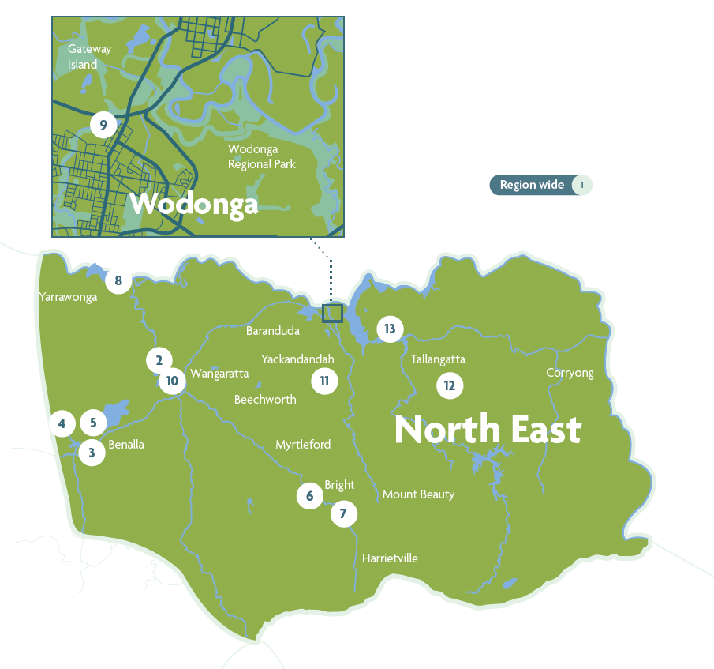

Figure 1: Locations of IWM opportunities across the North East region. Locations are approximate.

North East Integrated Water Management Forum

## Strategic Directions Statement 2022 summary

We work collaboratively with partners across the water cycle to find new ways to share resources and conserve water for multiple community and environmental benefits.

We work to meet the water needs of a changing region.

### Region-wide projects

1. **Meaningful Traditional Owner Participation in IWM**

Creating a framework for improving participation of Traditional Owners and a clear process for inclusion in the North East IWM Forum and its activities.

1. **Managed Aquifer Recharge Decision-Support Tool: Lower Ovens Case Study**

Testing a decision-making tool that could help improve the long-term sustainability of extracting groundwater.

### Place-based projects

1. **Benalla IWM Plan**

Managing stormwater and water quality while enhancing Benalla’s green spaces, including Winton Wetlands.

1. **Diverse Water Sources for Bushfire Safety in Benalla Rural City**

Exploring the feasibility of using diverse sources of water to meet the town’s needs for fighting bushfires.

1. **Analysis of Third Pipe Infrastructure in Small Town Developments**

Identifying the enabling policies, laws, levers, financial viability, and precedents for providing small town developments with access to recycled water.

1. **Porepunkah Fishway**

Enabling fish migration while improving the ecosystem, maintaining cultural values for Traditional Owners, and enhancing public spaces.

1. **Green and Blue Spaces in Bright**

Revegetating and enhancing green spaces and waterways for community and environmental benefits.

1. **Diverse Water Sources for Victoria Park Precinct**

Exploring the feasibility of using diverse sources of water for irrigation of the Victoria Park precinct.

1. **Sumsion Gardens**

Diverting stormwater from Wodonga’s central business district through a series of wetlands to improve the quality of water entering Sumsion Lake.

1. **HP Barr Reserve**

Securing diverse water sources for the future of Wangaratta’s Parklands.

1. **Sustainable Subdivisions in Indigo Shire**

Exploring diverse water sources, particularly stormwater, for irrigating public spaces in future land subdivisions.

1. **Towong Shire Green and Water-Sensitive Towns**

Replacing ageing wastewater treatment systems and finding diverse water supplies for open space irrigation.

1. **Water-Sensitive Subdivisions in Towong Shire**

Developing water-sensitive urban design requirements to enable the development of Tallangatta and Bellbridge growth areas

Better together: integrating water management across Victoria

Water is central to our lives. Many different groups, governments and organisations have various responsibilities and connections in relation to the water cycle. IWM brings these groups together to maximise outcomes for the community, the environment and the economy. In Victoria, IWM is facilitated through region-based IWM forums, whose members collaborate in partnerships to achieve strategic outcomes.

## The first water custodians

First Nations people have been living in balance with the natural environment in Victoria, practising culture, caring for Country and waterways, and maintaining sophisticated water management systems for tens of thousands of years.

Traditionally, each year the First Nations people of southern New South Wales and northern Victoria would meet along the banks of the Murray River to perform ceremonies, exchange goods and discuss tribal lore. They would then travel to the High Country to feast on Bogong moths[2], which spend their summers in the ecosystems of the alpine regions of Victoria, watered by melting snow. First Nations people have cultural, spiritual and economic connections to land, water and resources through their associations and relationship with Country.

Colonisation resulted in the dispossession and displacement of First Nations people from land and water. The effects of climate change are further impacting on traditional resources, cultural sites and aspirations for land and water management. As climate change increases the risks of extreme weather events, spiritually important species or objects (totems) may be lost, cultural sites of significance may be damaged and cultural practices may be impacted.

## Pressures emerge and evolve

European settlement and the gold rush of the 1850s saw thousands of people flock to Victoria to seek their fortunes. This created many towns, yet also had large and long-lasting impacts on the creeks and gullies, and displaced Traditional Owners from their Country.

Victoria’s regional towns and cities have thrived with the provision of urban drinking water and sanitation services. Irrigated agriculture and dryland farming have both played important roles in Victoria’s history and growth. Today, Victoria is the nation’s largest food and fibre exporter[3]. Much of the water flowing into the Murray-Darling Basin System comes from the Victorian high country and underpins irrigated agriculture in several states.

The complex challenges of water management continue throughout the state: we have lived through the Millennium Drought and experienced flooding, bushfires and extreme weather. We have seen the consequences of the overuse and overallocation of water in one area affecting the availability and/or quality of water in another. Significant investment and interventions have been required to start returning water to our rivers and floodplains, yet more remains to be done.

Water managers are now operating in an increasingly complex and uncertain environment. The drivers of change are both social and environmental, including climate change, population growth, shifting migration patterns associated with the coronavirus pandemic, economic challenges, and policy changes. But our beautiful state remains a wonderful place to live, and we continue to see the population increase. Regional Victoria is expected to grow from 1.5 million people in 2015 to 2.2 million over the next 30 years to 2051[4].

The liveability of our regional towns and cities and the health of our environment and economy depend on the availability of water. Access to water is also important for social wellbeing and holds intrinsic cultural value for Traditional Owners. Therefore, we need an integrated and collaborative approach to adapt to change and maximise value across the whole water cycle.

## What is IWM? How can it help address challenges?

The current water supplies and liveability of towns and cities owe much to the collaborative work done to date by water corporations, local and state government, planning and development authorities, communities and, in recent decades, catchment management authorities. While we face the challenges of population growth, climate change and natural disasters, we can also build on the benefits of past experiences and established relationships while increasingly, we seek to learn from Traditional Owners. Together, we can make decisions today that we will celebrate in the future.

Integrated water management considers all parts of the water cycle as an integrated system to optimise the environmental, cultural, social and economic outcomes for our communities.

While everyone has a responsibility to conserve and protect water, there are a number of key groups charged with making decisions about water within each region. These include:

* Traditional Owner groups, who have a deep knowledge of and connection to the region’s waterways, other water resources and Country
* water corporations, which manage the water storage, water supply, and wastewater services
* local governments, which manage surface water drainage, protect local waters from degradation and pollution, oversee onsite domestic wastewater planning, regulate local development, and undertake strategic planning for future growth
* catchment management authorities, which plan for flood management and work with landholders to consider the interactions of land, water and biodiversity.

The decisions these groups make individually, can have significant impacts on the quality and availability of the water for others in the catchment and further downstream. So, it makes sense they collaborate towards common goals to maximise water saving and reuse and share the benefits (Figure 2).

IWM is an approach that can be applied at multiple scales from water planning at the local park, right up to the whole of catchment. IWM can connect climate change adaptation, planning and open space, water security and other strategies, so that collaborators can add value to each other’s projects.

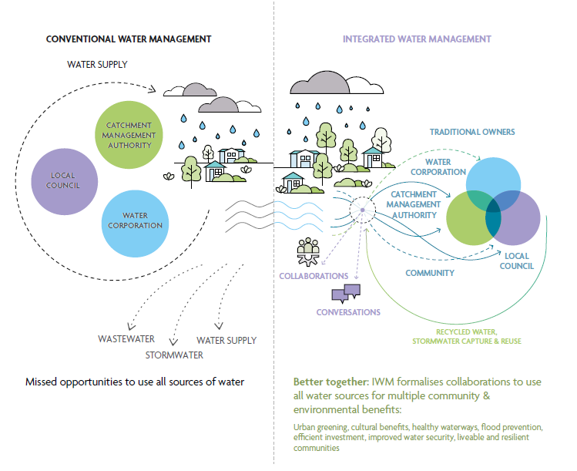

Figure 2: How does IWM work? Conventional water management saw a more siloed approach to water management, with a single supply source and two discharge systems to move stormwater and wastewater away as quickly as possible, resulting in missed opportunities to use all sources of water. The IWM approach brings water managers together to plan and deliver new opportunities to provide broader benefits to the community. Listening to and consulting with Victorian communities about how they want water managed is critical to informing IWM decision making. Communities are directly consulted on IWM plans and through existing catchment management authority, water corporation and local government strategies.

## How are we delivering IWM state-wide?

To facilitate IWM across Victoria, the Victorian Government’s Department of Environment, Land, Water and Planning (DELWP) supported the establishment of IWM forums across 10 regions of Victoria (Figure 3), in addition to five metropolitan IWM forums in Greater Melbourne. The forums bring together leaders of local water sector organisations to explore, prioritise and oversee the development of local IWM opportunities. Prioritised opportunities are managed and implemented by dedicated Working Groups and are captured within individual IWM plans. Where appropriate, forums involve other organisations and groups that are not part of the water sector but have direct or indirect interests in water management and land use planning, such as community and Indigenous groups, planning authorities, the Department of Transport, developers, educational institutions, or large landholders.

Being collaborative, IWM builds on existing partnerships and planning processes, and aims to break down silos between independently operating, water decision-makers – encouraging forum members to consider the water cycle of their own service delivery, and its interdependencies or overlaps with other members (Figure 2). Forum members consider waters in rivers, streams and bays, wastewater, drinking water, stormwater, and water treatment processes.

While collaboration can take more time and effort than planning for just one water service in isolation, working together achieves better outcomes for the environment, society, and economy by finding mutually beneficial ways to share water, assets and costs.

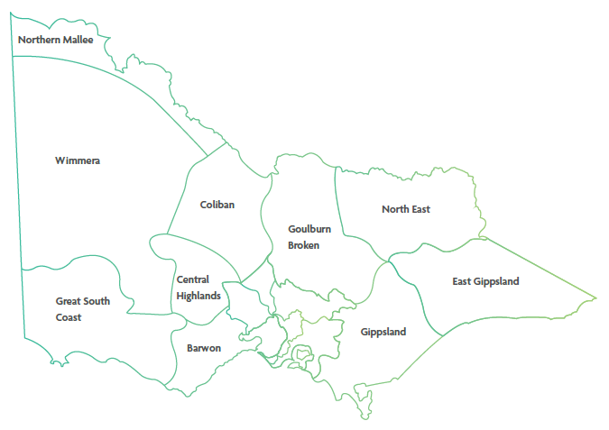

Figure 3: IWM forum regions of Victoria, which are based around water corporation boundaries.

## Strategic outcomes

The Integrated Water Management Framework for Victoria (2017) proposed several strategic water-related outcomes that will deliver on the vision in the State water plan, Water for Victoria (2016), to ‘build resilient and liveable cities and towns’. These strategic outcomes provide a way to identify the multiple economic, social and environmental benefits that can come from a single initiative. The original framework included five such strategic outcomes that have since been expanded to seven. The identification of strategic outcomes will continue to evolve as the water management context changes and the sector innovates.

Proposed project opportunities are assessed and prioritised against how well and how many of these strategic outcomes they meet.

To find out more about how Victoria is applying IWM through the Integrated Water Management Framework for Victoria (2017), visit: [www.water.vic.gov.au](http://www.water.vic.gov.au)

The strategic outcomes are:

* **safe, secure and affordable supplies in a changing future** – indicated by the amount of water conserved or alternative water volume supplied to meet an identified demand.
* **effective and affordable wastewater systems** – ensuring environmental and public health standards are met, while maximising resource recovery.
* **manage flood risks** – resilience to existing and future flood risk.
* **healthy and valued waterways and waterbodies** – indicated by the ecological health of riparian areas, hydrology and water quality.
* **healthy and valued landscapes** – maximising the connectivity, accessibility, greening and vegetation, cooling, aesthetic and recreational values of landscapes.
* **Traditional Owner and community values reflected in place-based planning** – ensuring that different communities are considered and included in planning and design and provided with water-systems literacy to enable involvement.
* **jobs, economic opportunity and innovation** – recognising that water management is an integral part of economic growth.

## Strategic Directions Statement – how IWM is happening in the region

This SDS articulates the collaborative intent and shared agreement of all stakeholders involved in the forum. It describes the water security challenges and opportunities in the region, sets the strategic direction for the next few years, and outlines the ‘best endeavours’ or ways in which IWM is and will be applied through opportunities that are proposed, in progress or completed in the region.

This is the first update to the North East SDS produced in 2019, and includes:

* an update on progress to date
* case studies illustrating IWM in the region
* details of planned and potential opportunities designed to meet the key themes and challenges over the next three to five years.

This SDS has been developed to complement the other water, climate change, First Nations’ rights, and catchment management (Figure 4).

### Relevant plans and strategies in place in the region

**Water for Victoria**

State government strategic plan for management of our water resources, now and into the future.

**Integrated Water Management Framework for Victoria**

Framework to help deliver the Water for Victoria plan to maintain and enhance the liveability, prosperity and resilience of Victoria’s cities and towns

**2022 North East IWM Forum SDS**

A revised statement of agreement between forum members of urban and peri-urban IWM priorities and collaborative projects.

**North East Urban Water Strategy**

A detailed 50-year forecast of water demands for local communities, along with supply options to meet these demands.

**Caring for Country Plans**

Guiding and promoting awareness, investment and rights of Aboriginal people and culture, working together now and for future benefits.

**Northern Region Sustainable Water Strategy**

Long-term plans and statutory processes for state-wide water resource planning to secure the water future of Victoria's regions.

**North East Regional Catchment Strategy**

A framework for actions to improve and protect the catchment’s natural resources (water, land, biodiversity). Looking after these precious natural resources underpins the social, cultural and economic wellbeing of the diverse communities that make up the catchment. Incorporating climate change, it is a partnership approach to catchment resilience.

**Hume Climate Change Adaptation Strategy**

Community-led vision capturing actions and strategic goals for Hume’s climate-ready present and future. Uniting individual, community and agency approaches.

**Local government plans and strategies**

Various strategies, plans, guidelines and other documents that have connections to the water cycle. Examples include open space plans, local climate change adaptation strategies, and natural disaster management plans.

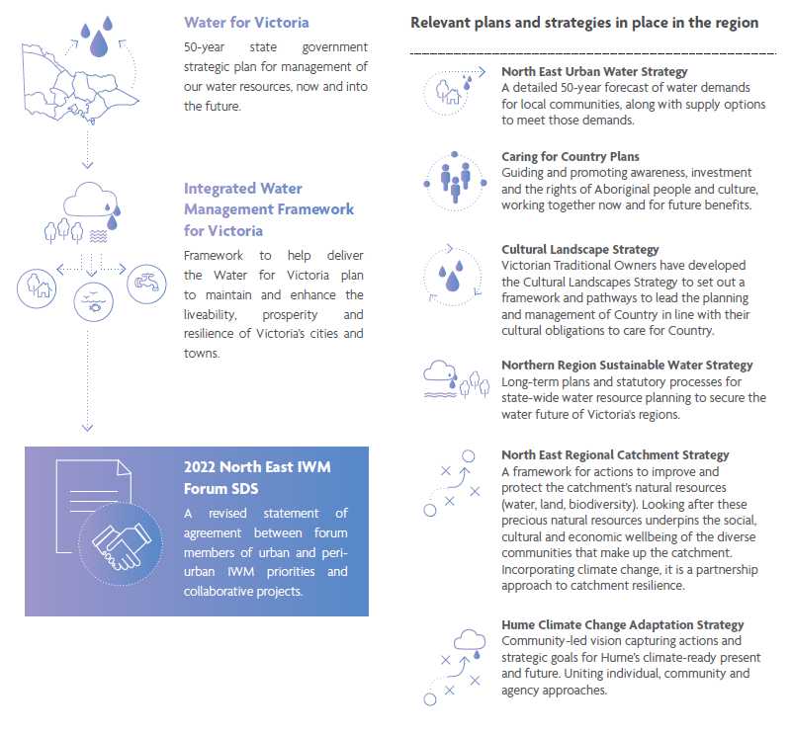

Figure 4: The SDS and related water policies, strategies and plans of the region.

Water in the North East region

Water is central to the wellbeing of the region’s Traditional Owners and residents. It underpins local agriculture, tourism and ecosystem health. However, the region is changing. The North East is already experiencing the effects of climate change and extreme weather, the economy is changing, the population is rapidly growing, and Traditional Owners are increasingly involved in water management.

The North East region is home to more than 120,000 people, a diversity of plant and animal life, and provides major flows into the mighty Murray River[5]. The area encompasses the lands and waters of the Taungurung, Jaithmathang, Bangerang, Yorta Yorta, Dhudhuroa, Duduroa, and Waywurru Nations. It includes pastures grazed by cattle and sheep, and produces a range of other foods, including cereals, berries, grapes, olives and apples. Alpine areas host ski fields, resorts, and mountain biking and hiking trails. Together with other tourism attractions, the region welcomes about 4.2 million day-trip and overnight visitors each year and in all seasons. Local wildlife includes the macquarie perch, the culturally significant Bogong moth, mountain pygmy possums, the regent honeyeater, and other keystone and iconic species.

The health and liveability of our thriving region is underpinned by water, from the provision of safe drinking water and the effective management of stormwater and wastewater in urban areas, to the rivers, rainfall and other environmental flows that support ecosystems, landscapes, agriculture and wildlife.

The North East region has many unique characteristics. It is Victoria’s entry point for the nationally significant Murray River and contains the entire course of the Ovens, Kiewa, Mitta Mitta and King Rivers. It also contains two significant water storages, Lake Hume and Dartmouth Dam.

The region comprises only two per cent of the geographic area of the Murray-Darling Basin, yet it provides 38% of its water. Consequently, water management in the region has implications for the wider basin.

### Snapshot of key climate, land use and populations statistics for the Goulburn Broken region.

**Population[6]**

* Population in 2021 – 124,500
* Population in 2036 – 144,800
* Population increase – 16.3%

**The region (land use)[7]**

* Urban land – 1%
* Public land – 42%
* Agricultural land – 56%
* Land cleared of native vegetation – 40%
* 49,000 hectares of water bodies and wetlands
* Area classified as special water supply catchments – 80%
* Comprises 25 of the geographic area of the Murray Darling Basin while providing 38% of inflows

**Condition of waterways[8]**

* Waterway condition
* Excellent – 19%
* Good – 24%
* Moderate – 51%
* Poor or very poor– 5%

**Climate[9]**

* Change in rainfall – by 2040, a decrease by 1% with more intense rainfall in some years
* Change in temperature – by 2040, an increase of 0.7 to 1.7 degrees Celsius

A changing region

This SDS identifies collaborative IWM opportunities in the region that aim to address key social and environmental drivers and create positive opportunities to adapt. The outcomes of these IWM opportunities will be more resilient and liveable cities and towns.

## Traditional Owners are taking an increasingly active and leading role in water management

The region includes the lands and waters of many Traditional Owner groups and Aboriginal communities that identify a connection to Country.

There is growing recognition of the right to self-determination of Traditional Owners and First Nations people and their inherent obligations to continually speak for and look after the Country of their ancestors for current and future generations. Traditional Owners in the North East are taking more of a leadership role and are exercising their rights to speak for Country. In areas where there is a Registered Aboriginal Party, IWM Forum Partners must adhere to their legal obligations under Recognition and Settlement Agreements or other relevant joint management arrangements.

Victoria is the first state to progress Treaty discussions, the First Peoples’ Assembly of Victoria has formed, and there is increasing understanding among Victorians of Indigenous rights, connection to Country, and the need for inclusion, consultation, and reconciliation. IWM is increasingly being considered in this context.

IWM opportunities included in this SDS that are driven by or involve Traditional Owners include:

* Meaningful Traditional Owner Participation in IWM
* Benalla IWM Plan
* Porepunkah Fishway
* Green and Blue Spaces in Bright.

## North East Victoria is already experiencing the impact of climate change, extreme events and shocks

The Black Summer bushfires of 2019-2020 transformed our understanding of bushfire risk in the North East. A State of Emergency was declared in the City of Wangaratta, Towong and Alpine shires, and the alpine resorts of Mount Buller, Mount Hotham and Mount Stirling. 431,100 hectares of land in the North East Catchment Management Authority area – more than one fifth of the catchment – was impacted by bushfires.

Multiple lines of evidence indicate that Victoria’s climate is becoming hotter and drier. It is likely the effects of fire, flood, drought and blue-green algae will worsen and become more frequent in the region which will significantly impact ecosystems and the community. Future fires will require water for firefighting. Fires and other natural disasters will demand an increased capacity to manage water quality and deal with dirty water events. Changing weather patterns will also influence the growing seasons of agriculture and timing of periods of high water demand.

These challenges and approaches to addressing them are detailed further in the North East Regional Catchment Management Strategy (2022), online at: [www.northeast.rcs.vic](http://www.northeast.rcs.vic)

IWM will assist with monitoring and adapting to climate change, as a shared responsibility.

IWM opportunities focused on climate change adaptation include:

* Diverse Water Sources for Bushfire Safety in Benalla Rural City
* HP Barr Reserve
* Managed Aquifer Recharge Decision-Support Tool: Lower Ovens Case Study.

IWM opportunities that involve environmental restoration and protection include:

* Benalla IWM Plan
* Porepunkah Fishway
* Green and Blue Spaces in Bright
* Sumsion Gardens
* HP Barr Reserve.

Progress to date

The North East IWM Forum has been operating for several years. Most of the IWM opportunities outlined in its first SDS are now complete or underway. Some have progressed to the next stage or have been re-scoped, in response to new knowledge. The forum's collaborative relationships and collective experience are informing its future work.

The first North East IWM Forum SDS was published in May 2019. It articulated the regional context, the shared vision and the strategic water-related objectives for the region. It also listed IWM opportunities as ‘ready to advance’ projects developed in collaboration by the forum partners. It can be viewed online at [www.water.vic.gov.au](http://www.water.vic.gov.au)

Many forum members have IWM at the forefront of their thinking and several are implementing IWM projects. The projects – past, current and future – listed in this document and endorsed by forum members are those that benefit from a collaborative, multi-party approach.

The first SDS identified 16 projects that reflected the North East IWM Forum’s initial priorities and opportunities. Most of these projects are underway or completed. The ‘Water-Sensitive Urban Design (WSUD) Guidelines by Council Region’ project was fast-tracked for the Rural City of Wangaratta in response to its rapid population growth. You can read more about this project on page 29.

The Baranduda Fields IWM Plan has been completed and will be implemented in the capital works for the sporting precinct. The ‘Climate Resilient Open Spaces’ project has mapped highly valued community green spaces with potential for climate change adaptation measures. The Tallangatta Urban Recycled Water Scheme design is ready to move to the compliance and business case stage, and works are complete at the Bells Flat Wetland, filtering the water that flows into Yackandandah Creek. Read more about the Bells Flat Wetland project on page 27.

The North East IWM Forum is flexible and responsive to the changing needs and priorities of local governments and other members. Three more 2019 SDS projects are underway. Some of these projects were delayed as forum members responded to bushfire emergencies and recovery.

Three projects have been superseded by re-scoped initiatives which build on the forum’s experience and with broader approaches. These are outlined later in this document. Finally, the ‘Water-Sensitive Industrial Land for Benalla’ project has been set to one side for now, as Benalla Rural City prioritises servicing a huge population boom.

Progress made on the 2019 SDS IWM opportunities is summarised in Table 1.

Table1: A summary of the status of IWM opportunities listed in the forums 2019 SDS.

|  |  |  |
| --- | --- | --- |
| IWM Opportunity | Status | Notes |
| WSUD Guidelines by Council Region | Completed | WSUD Guidelines were completed for Wangaratta in 2020. They are now informing WSUD in Alpine, Wodonga and other councils in the region. |
| Climate Resilient Open Spaces | Completed | The North East Green Space Database has been developed and mapped. GIS data is being shared with forum members. |
| Baranduda Fields | Completed | A plan has been developed and the next stage will involve implementation. |
| Yackandandah Bells Flat Wetland | Completed | This project was completed in 2020. See the case study on page 27. |
| Tallangatta Reclaimed Water Reuse | Completed | Designs for the Tallangatta Urban Recycled Water Scheme have been developed, a business case is next. |
| Myrtleford Integrated Water Plan | Completed | The ‘Myrtleford Breakaway Risk Management Strategy’ is a component of this IWM plan, which is currently being implemented. |
| Cluster Wastewater Management in Harrietville | Completed | North East Water and Alpine Shire partnered to develop an options analysis and report recommending the most suitable wastewater management option for new development in Harrietville. |
| Culture and Liveability at the Kiewa – Murray Confluence | Completed | Signage and artwork for a wetland trail have now been installed. |
| Gateway Island Master Plan | Completed | The Gateway Island Master Plan was updated. For the next stage, Council is now seeking implementation funding opportunities. |
| Corryong Reclaimed Water Reuse | Underway | A steering committee has been formed, the design process initiated, and funding options are being explored. |
| Wangaratta North West Growth Corridor | Underway | Development is underway; seeking opportunities to apply IWM. |
| Murray RiverConnect | Underway | Implementation underway through the Goulburn Broken IWM Forum. |
| Bright Alternative Water | Superseded | Elements of the project have been included in the ‘Green and Blue Spaces in Bright’ project included in this SDS on page 40. |
| Sumsion Gardens | Superseded | The original project scope was expanded to include works which improve the capture and treatment of stormwater as well as reuse opportunities. This rescoped project is in the implementation phase and included in this SDS. See page 43. |
| Engaging Aboriginal Communities in Integrated Water Management in the North East Region | Superseded | This project has been re-scoped and included in this SDS as ‘Meaningful Traditional Owner Participation in IWM’. This project is on page 32. |
| Water-Sensitive Industrial Land for Benalla | Not started | This project has not been initiated. Benalla has other IWM plans that could serve as a precursor for future development of industrial land. |

## Case study

### Yackandandah Bells Flat Wetland

**Stormwater filtering and harvesting, hidden on a tourist trail, cared for by the community**

Bells Flat Wetland has been turned into a haven for wildlife, a safe and engaging place for visitors to explore, and a natural filter to protect the Yackandandah Creek’s pristine environment from pollution. It will also provide a diverse source of water for irrigating a nearby sports field in the future.

New homes to accommodate Yackandandah’s growing population are being built upslope from the creek, north of Bells Flat Road. The development of this greenfield site presented a unique opportunity for including water-sensitive urban design features in a new residential development, turning the problem of increased stormwater runoff into an opportunity to improve and protect local green space.

Bells Flat Wetland was originally created as a planning permit condition of the Connel Street subdivision. Forum members saw an opportunity to develop an integrated water management project, which has ensured the site now provides many more shared benefits, to the community, environment, and Traditional Owners.

Led by Indigo Shire Council, this project involved the enhancement of Bells Flat Wetland to enable collection and filtration of increased amounts of stormwater resulting from residential development. The wetland has been revegetated with native plants to outcompete weeds, reducing the need for herbicides that may impact water quality. This ecosystem cleans the water before it enters the Yackandandah Creek catchment and provides habitat and food sources for local wildlife.

Previously, steep areas with loose gravel made the site unsafe for vehicles and pedestrians. The project incorporated safer access and a graded path that circumnavigates the Wetland, which also supports recreational and environmental educational opportunities. For example, displays introduce visitors to bandicoots and other wildlife they might meet along Yackandandah Creek.

The wetland site is on the Yackandandah tourist trail. It is frequented by residents and tourists on their way to the Gorge Walk and Yackandandah Sports Park. Looking to the future, sports park irrigation was identified as a risk in the region’s climate change adaptation action plan. Further subdivisions are planned for the surrounding area, which will increase the volume of stormwater flowing down to the wetland area, and the opportunity to extend the use of the treated stormwater.

Implementation involved partners North East Water, North East Catchment Management Authority, and community groups, including the Yackandandah Sports Park Committee, the Friends of Yackandandah Creek, and the local Landcare Group. The wetland is now well-loved, with locals and Landcare volunteers regularly supporting planting and weeding efforts.

## Case study

### Water-Sensitive Urban Design Guidelines for Wangaratta

**Building better urban stormwater management in growing rural cities, starting at the drawing board.**

North East IWM Forum member city and shire councils are developing locally relevant resources to make it easier for developers to design and plan precincts that manage stormwater in a better way, starting with Wangaratta.

Water-sensitive urban design (WSUD) is an approach to planning and design that mimics the natural water cycle in an urban built environment. WSUD uses stormwater as a resource, reduces the harm it causes to rivers and creeks, and reduces the risk of flash flooding.

Stormwater management is often left to the developer, a stakeholder that does not have a long-term role, resulting in poor design solutions for ongoing operation and maintenance, inconsistent treatment types, and products that increase council costs and lower the effectiveness of maintenance.

The forum’s 2019 SDS proposed a project to develop WSUD guidelines for developers for each local government area, recognising the need to complement each individual council’s planning requirements, tailor preferred input data (including rainfall and design parameters) to the council area’s needs, specify preferred treatment types (for example wetlands, swales or raingardens), and identify suitable plant species for the area. This would enable consistent water treatment across each local government area, certainty of requirements for developers, reduced maintenance costs for councils and, ultimately, healthier waterways.

Water-Sensitive Urban Design Guidelines for Wangaratta has been developed as a pilot, which the forum will work to promote, to increase its use. The first planning permit referencing the guidelines was issued in August 2020 for Warby Views Estate. Construction of the first of its two bioretention basins has been completed. Compliance with the guidelines is now a planning permit condition for subdivisions in Wangaratta.

This project was designed the help make WSUD ‘business as usual’ for those building the new developments that will accommodate the region’s growing population. For the community, the raingardens, wetlands and other ‘green infrastructure’ elements provide areas of urban nature that add to the beauty and liveability of their neighbourhoods. Next steps will be to develop and implement internal procedures to help council staff apply the guidelines. Learnings recorded from using the guidelines will be shared with forum members, with the intention of ensuring continuous improvement is made.

IWM opportunities

Opportunities that link to and address IWM challenges for the region were identified and developed by nominated practitioners of organisations participating in the forum.

A summary of the priority IWM opportunities in the North East region are detailed in the following section. This list is dynamic and will continue to be updated to reflect the forum’s priorities and opportunities as they arise.

Partners are committing their ‘best endeavours’ to ensure priority projects and strategies are moved forward, in line with the shared vision and strategic outcomes of the forum.

Region-wide projects

## Meaningful Traditional Owner Participation in IWM

Forum member organisations have struggled to engage with Traditional Owners in a meaningful way, lacking a clear understanding of Traditional Owners’ processes, obligations and priorities.

This project will seek to support increased representation and participation of Traditional Owners in IWM activities in north east Victoria by reviewing and recommending changes to internal forum procedures (including the forum’s terms of reference) and working with Traditional Owner groups to develop their own IWM projects.

Table 2: A summary of the impact that the Meaningful Traditional Owner Participation in IWM opportunity has towards achieving the IWM outcomes.

|  |  |
| --- | --- |
| IWM outcome | Impact status |
| safe, secure and affordable supplies in a changing future | Medium impact |
| effective and affordable wastewater systems | Medium impact |
| manage flood risks | Medium impact |
| healthy and valued waterways and waterbodies | Medium impact |
| healthy and valued landscapes | Medium impact |
| Traditional Owner and community values reflected in place-based planning | Medium impact |
| jobs, economic opportunity and innovation | Medium impact |

Table 3: A summary of key details for the Meaningful Traditional Owner Participation in IWM opportunity.

|  |  |
| --- | --- |
| Subject | Details |
| **Status** | Implementation |
| **Lead organisation** | Aboriginal Water Officers |
| **Implementation partners** | All other forum member organisations |
| **Location** | Forum area |
| **Scale** | Town |

## Managed Aquifer Recharge Decision-Support Tool: Lower Ovens Case Study

North East Water is interested in investigating the long-term sustainability of extracting groundwater in the Lower Ovens and the potential to use managed aquifer recharge (MAR) as a strategy to ensure extraction is sustainable. MAR is where water is purposefully put in a groundwater aquifer, with the intention of extracting and using that water later. To be successful, all MAR projects must find a source of water, an aquifer that can store the water and a use for the water when it is extracted.

The Coliban IWM Forum developed a decision-support tool to assist water corporations and other organisation considering investment in MAR to easily identify the ingredients required. The Coliban IWM Forum also tested the technical feasibility of the tool, using the Lower Campaspe Valley Water Supply Protection Area as a case study.

North East Water will collaborate with other forum partners to also test the ‘Managed Aquifer Recharge Decision-Support Tool’ in the Lower Ovens. The project will complement North East Water’s existing groundwater activities and improve understanding of groundwater management in the Lower Ovens.

North East Water is currently seeking access to additional groundwater from the Lower Ovens aquifer, to improve water security for Wangaratta. Water resource modelling completed for their Urban Water Strategy showed that supplementing Wangaratta’s water supply with additional groundwater would reduce the frequency and severity of water restrictions during periods of extended drought. The project will complement North East Water’s application to access additional groundwater entitlement and ensure safe, secure and sustainable water supplies for Wangaratta into the future.

There is also potential for the project to build on and improve the existing tool. This would have broader benefits for other’s interested in using MAR, which will contribute to further integrating groundwater and surface water management.

Table 4: A summary of the impact that the Managed Aquifer Recharge Decision-Support Tool: Lower Ovens Case Study opportunity has towards achieving the IWM outcomes.

|  |  |
| --- | --- |
| IWM outcome | Impact status |
| safe, secure and affordable supplies in a changing future | High impact |
| effective and affordable wastewater systems | Medium impact |
| manage flood risks | Low impact |
| healthy and valued waterways and waterbodies | Medium impact |
| healthy and valued landscapes | Medium impact |
| Traditional Owner and community values reflected in place-based planning | Low impact |
| jobs, economic opportunity and innovation | Medium impact |

Table 5: A summary of key details for the Implementing Managed Aquifer Recharge Decision-Support Tool: Lower Ovens Case Study opportunity.

|  |  |
| --- | --- |
| Subject | Details |
| **Status** | Committed |
| **Lead organisation** | North East Water |
| **Implementation partners** | Goulburn-Murray Water |
| **Location** | Lower Ovens |
| **Scale** | Catchment |

Place-based projects

## Benalla IWM Plan

resident population and tourist numbers. The town’s green spaces, in particular the Winton Wetlands, are important environmental assets for residents and tourists. The wetlands form part of the Benalla-Mokoan Discovery Trail, a popular attraction for cyclists.

Benalla Rural City Council is exploring options for an IWM plan that both improves the amenity of Benalla’s green spaces, and also reduces the risks of flooding and poor water quality in Lake Benalla, in the centre of town.

It’s envisaged that an IWM plan will:

* secure diverse water supplies for irrigating green spaces
* seek opportunities for large-scale redirection of stormwater away from the city’s centre for treatment and to reduce flood risks
* investigate the possibility of using treated stormwater to maintain the environmental and cultural values at Winton Wetlands in a drying climate.

An engagement phase will provide the opportunity to further understand community objectives for the local area.

Table 6: A summary of the impact that the Benalla IWM Plan opportunity has towards achieving the IWM outcomes.

|  |  |
| --- | --- |
| IWM outcome | Impact status |
| safe, secure and affordable supplies in a changing future | Medium impact |
| effective and affordable wastewater systems | High impact |
| manage flood risks | High impact |
| healthy and valued waterways and waterbodies | Medium impact |
| healthy and valued landscapes | High impact |
| Traditional Owner and community values reflected in place-based planning | High impact |
| jobs, economic opportunity and innovation | Medium impact |

Table 7: A summary of key details for the Benalla IWM Plan opportunity.

|  |  |
| --- | --- |
| Subject | Details |
| **Status** | Identified |
| **Lead organisation** | Benalla Rural City Council |
| **Implementation partners** | North East Water, Goulburn Broken Catchment Management Authority, Goulburn-Murray Water, Yorta Yorta Nation and Friends of the Winton Wetlands |
| **Location** | Benalla |
| **Scale** | Town |

## Diverse Water Sources for Bushfire Safety in Benalla Rural City

Access to a reliable water supply is vital for saving lives and assets during a bushfire emergency. The town of Benalla relies heavily on its drinking water supply to fight bushfires. The current water supply system is also vulnerable to bushfire damage, which could cause water mains pressure to drop – preventing water flow when it is needed most.

Benalla Rural Council will explore diverse sources of water to meet the town’s needs for fighting bushfires. As well as saving lives, access to diverse water sources could reduce the risks of bushfire damage to property, natural assets, and drinking water supplies.

Table 8: A summary of the impact that the Diverse Water Sources for Bushfire Safety in Benalla Rural City opportunity has towards achieving the IWM outcomes.

|  |  |
| --- | --- |
| IWM outcome | Impact status |
| safe, secure and affordable supplies in a changing future | High impact |
| effective and affordable wastewater systems | Medium impact |
| manage flood risks | Low impact |
| healthy and valued waterways and waterbodies | Low impact |
| healthy and valued landscapes | Medium impact |
| Traditional Owner and community values reflected in place-based planning | Medium impact |
| jobs, economic opportunity and innovation | Medium impact |

Table 9: A summary of key details for the Diverse Water Sources for Bushfire Safety in Benalla Rural City.

|  |  |
| --- | --- |
| Subject | Details |
| **Status** | Identified |
| **Lead organisation** | Benalla Rural City Council |
| **Implementation partners** | North East Water, DELWP, Country Fire Authority, Goulburn Broken Catchment Management Authority, Goulburn-Murray Water |
| **Location** | Benalla |
| **Scale** | Service area |

## Analysis of Third Pipe Infrastructure in Small Town Developments

As our climate dries and rural population grows, access to recycled water is likely to become a viable supplement to conventional water supplies. In preparation for this future, Benalla Rural City Council is looking into how it could require developers to install a ‘third pipe’ in all new residential and industrial developments, to carry recycled water in the future. This pipe would be in addition to the two standard pipes for drinkable water and wastewater.

By requiring developers to install the third pipe at the start of a new development, savings could be made by avoiding the costs of retrofitting this infrastructure later, after recycled water is made available.

A paper will be written to explore the policies, laws, levers, financial viability and precedents for requiring a third pipe in regional developments. It is likely to be of great interest to other regional forums experiencing similar population growth.

Table 10: A summary of the impact that the Analysis of Third Pipe Infrastructure in Small Town Developments opportunity has towards achieving the IWM outcomes.

|  |  |
| --- | --- |
| IWM outcome | Impact status |
| safe, secure and affordable supplies in a changing future | Medium impact |
| effective and affordable wastewater systems | Medium impact |
| manage flood risks | Medium impact |
| healthy and valued waterways and waterbodies | Medium impact |
| healthy and valued landscapes | Medium impact |
| Traditional Owner and community values reflected in place-based planning | Medium impact |
| jobs, economic opportunity and innovation | Medium impact |

Table 11: A summary of key details for the Analysis of Third Pipe Infrastructure in Small Town Developments opportunity.

|  |  |
| --- | --- |
| Subject | Details |
| **Status** | Committed |
| **Lead organisation** | Benalla Rural City Council |
| **Implementation partners** | North East Water, Goulburn Valley Water |
| **Location** | Benalla |
| **Scale** | Town |

## Porepunkah Fishway

Many fishes and other aquatic species need to migrate to complete their life cycles. Weirs create barriers for fish, preventing them from completing their migrations. This is a threat to biological diversity and the sustainability of fisheries. With planned fishways for the Bright Weir and Tea Garden Weir, the Porepunkah Weir will be the last remaining barrier to fish along the length of the Ovens River. The construction of a fishway will provide access to the full 450 kilometres of the Ovens and its tributaries that flow to the Murray River.

The Porepunkah weir pool is also an important community location for recreation, including swimming, for locals and visitors. Preliminary assessments consider a vertical slot fishway to be the best option for ecological outcomes, constructability, and safety reasons.

Extensive community engagement will work to ensure community values are reflected in the final site designs, while improving waterway health. Final designs will also consider community safety.

Table 12: A summary of the impact that the Porepunkah Fishway opportunity has towards achieving the IWM outcomes.

|  |  |
| --- | --- |
| IWM outcome | Impact status |
| safe, secure and affordable supplies in a changing future | Medium impact |
| effective and affordable wastewater systems | Low impact |
| manage flood risks | Medium impact |
| healthy and valued waterways and waterbodies | High impact |
| healthy and valued landscapes | High impact |
| Traditional Owner and community values reflected in place-based planning | High impact |
| jobs, economic opportunity and innovation | Medium impact |

Table 13: A summary of key details for the Porepunkah Fishway opportunity.

|  |  |
| --- | --- |
| Subject | Details |
| **Status** | Identified |
| **Lead organisation** | North East Catchment Management Authority |
| **Implementation partners** | Alpine Shire Council, DELWP |
| **Location** | Porepunkah |
| **Scale** | Precinct |

## Green and Blue Spaces in Bright

Walks along waterways in the town of Bright are popular with locals and tourists, but the well-used trails require upgrades to increase safety, provide better access and improve the surrounding vegetation. Upgrades are planned for Canyon Walk, Cherry Walk, and the Morses Creek Trail, as well as an investigation of using a rainwater tank for the Howitt Park toilets. Signage is also planned to communicate to walkers about water use, water security, and Traditional Owner culture.

These works would include revegetation along waterway banks, improving environmental health by increasing ecological diversity, preventing weeds spreading downstream, and providing protection from damage by walkers. The project will also enable community connection with the natural environment, improve aesthetics, communicate cultural values and support economic prosperity from regional tourism.

Project partners are also working together to identify and progress other blue and green space projects in the Alpine Shire, including in the township of Myrtleford and surrounds.

Table 14: A summary of the impact that the Green and Blue Spaces in Bright opportunity has towards achieving the IWM outcomes.

|  |  |
| --- | --- |
| IWM outcome | Impact status |
| safe, secure and affordable supplies in a changing future | Low impact |
| effective and affordable wastewater systems | Medium impact |
| manage flood risks | Medium impact |
| healthy and valued waterways and waterbodies | Medium impact |
| healthy and valued landscapes | High impact |
| Traditional Owner and community values reflected in place-based planning | Medium impact |
| jobs, economic opportunity and innovation | Medium impact |

Table 15: A summary of key details for the Green and Blue Spaces in Bright opportunity.

|  |  |
| --- | --- |
| Subject | Details |
| **Status** | Identified |
| **Lead organisation** | North East Catchment Management Authority |
| **Implementation partners** | Alpine Shire, North East Water, Traditional Owners, DELWP |
| **Location** | Bright and surrounds |
| **Scale** | Towns |

## Diverse Water Sources for Victoria Park Precinct

Yarrawonga’s Victoria Park Precinct includes the Yarrawonga Showgrounds, Victoria Park and the Yarrawonga College. It offers important spaces for people of the region to gather, play sport and learn. Keeping these places green and beautiful encourages passive and active recreation, generating health, social and economic benefits for the broader community.

The primary irrigation source for Victoria Park Precinct is backwash water from the Yarrawonga Water Treatment Plant – the water used to clean the filters at the plant. North East Water’s current water reuse scheme is no longer supplying enough water to meet the current and future irrigation needs of Victoria Park Precinct. Yarrawonga is growing, meaning a secure water supply is needed to support future greenspace, and maintain liveability in a changing climate.

Phase 1 of the project will involve an options analysis (including feasibility, preliminary design and cost estimates) exploring the following diverse water sources for irrigation of Victoria Park Precinct:

* raw water from Lake Mulwala (raw water offtake, pump station and pipework to connect to existing reuse scheme)
* stormwater (collection from a new housing estate, stormwater storage upgrade at the school, and a pump to convey stormwater to Victoria Park)
* rainwater (onsite harvesting from building roofs)
* backwash reuse scheme from Yarrawonga Water Treatment Plant (investigate operational efficiencies to maximise the scheme).

The project will consider optimising a combination of the above water sources for irrigation of current and future greenspaces in Yarrawonga. Based on the outcomes of Phase 1 of the project, there is potential to apply for future grant funding for the construction of preferred solutions.

Table 16: A summary of the impact that the IWM in the Diverse Water Sources for Victoria Park Precinct opportunity has towards achieving the IWM outcomes.

|  |  |
| --- | --- |
| IWM outcome | Impact status |
| safe, secure and affordable supplies in a changing future | High impact |
| effective and affordable wastewater systems | Medium impact |
| manage flood risks | Low impact |
| healthy and valued waterways and waterbodies | Medium impact |
| healthy and valued landscapes | High impact |
| Traditional Owner and community values reflected in place-based planning | Medium impact |
| jobs, economic opportunity and innovation | Medium impact |

Table 17: A summary of key details for the Diverse Water Sources for Victoria Park Precinct opportunity.

|  |  |
| --- | --- |
| Subject | Details |
| **Status** | Committed |
| **Lead organisation** | Moira Shire Council |
| **Implementation partners** | North East Water, Yarrawonga Showgrounds, Yarrawonga College |
| **Location** | Yarrawonga |
| **Scale** | Precinct |

## Sumsion Gardens

Stormwater from the Wodonga’s CBD is discharged into Sumsion Lake, eventually reaching the Murray River system. The volume of stormwater discharge is increasing as the CBD area continues to grow.

Wodonga Council has diverted stormwater to constructed wetlands in Sumsion Gardens, before entering the lake. Improvements will create a series of interconnected wetlands, which will offer natural treatment of increasing stormwater runoff, and store water for reuse. This opportunity will construct the wetland upgrades and further invest in the environmental values of the site. This includes plans to insert woody debris from the Baranduda Fields development to create ‘fish hotels’ in these waterways.

With the wetlands established, Sumsion Gardens will offer:

* the environmental benefits of improved water quality, vegetation and wildlife habitat
* a reliable source of treated stormwater for irrigation of the nearby playground and sports oval
* enhanced social, health and tourism values through offering cultural experiences and recreational activities, such as a community triathlon event.

Table 18: A summary of the impact that the Sumsion Gardens opportunity has towards achieving the IWM outcomes.

|  |  |
| --- | --- |
| IWM outcome | Impact status |
| safe, secure and affordable supplies in a changing future | Medium impact |
| effective and affordable wastewater systems | Medium impact |
| manage flood risks | Medium impact |
| healthy and valued waterways and waterbodies | High impact |
| healthy and valued landscapes | High impact |
| Traditional Owner and community values reflected in place-based planning | High impact |
| jobs, economic opportunity and innovation | Medium impact |

Table 19: A summary of key details for the Sumsion Gardens opportunity.

|  |  |
| --- | --- |
| Subject | Details |
| **Status** | Implementation |
| **Lead organisation** | Wodonga City Council |
| **Implementation partners** | North East Water, North East Catchment Management Authority |
| **Location** | North Wodonga |
| **Scale** | Precinct |

## HP Barr Reserve

Wangaratta’s Parkland Precinct (HP Barr Reserve) uses more water for irrigation than any other green space in Wangaratta Council’s service area – about 20,000 kilolitres per year.

To ready the precinct for increasingly stringent water restrictions and future regulatory requirements to conserve water, Council is planning improvements to the precinct over the next 10 years, starting with an investigation into a rainwater harvesting and a smart irrigation system.

The precinct is a valued community asset that, with the proposed improvements, offers human health and social benefits through recreation, and financial and environmental sustainability through better use of resources.

Table 20: A summary of the impact that the HP Barr Reserve opportunity has towards achieving the IWM outcomes.

|  |  |
| --- | --- |
| IWM outcome | Impact status |
| safe, secure and affordable supplies in a changing future | High impact |
| effective and affordable wastewater systems | Medium impact |
| manage flood risks | Medium impact |
| healthy and valued waterways and waterbodies | High impact |
| healthy and valued landscapes | High impact |
| Traditional Owner and community values reflected in place-based planning | Medium impact |
| jobs, economic opportunity and innovation | High impact |

Table 21: A summary of key details for the HP Barr Reserve opportunity.

|  |  |
| --- | --- |
| Subject | Details |
| **Status** | Identified |
| **Lead organisation** | Rural City of Wangaratta Council |
| **Implementation partners** | North East Water, Goulburn-Murray Water |
| **Location** | Wangaratta |
| **Scale** | Precinct |

## Sustainable Subdivisions in Indigo Shire

Public green spaces within Indigo Shire areas require regular watering. To reduce the use of drinking water in irrigation of public spaces, many shires are turning to diverse sources of water, such as stormwater and rainwater.

The first rainwater garden in Indigo Shire was recently established, and the shire is now exploring more diverse water sources for irrigation. The shire is particularly interested in treated stormwater as a source of irrigation and is exploring this as a water source for future land subdivisions.

The concept requires further development, with the view to applying for funding in the future.

Once standardised and serviceable WSUD requirements have been established in new land subdivisions, the shire would:

* have access to secure affordable water supplies in the future
* avoid and/or minimise flood risks
* encourage health waterways
* reflect community values in this place-based planning.

Table 22: A summary of the impact that the Sustainable Subdivisions in Indigo Shire opportunity has towards achieving the IWM outcomes.

|  |  |
| --- | --- |
| IWM outcome | Impact status |
| safe, secure and affordable supplies in a changing future | Medium impact |
| effective and affordable wastewater systems | Medium impact |
| manage flood risks | Medium impact |
| healthy and valued waterways and waterbodies | Medium impact |
| healthy and valued landscapes | Medium impact |
| Traditional Owner and community values reflected in place-based planning | Medium impact |
| jobs, economic opportunity and innovation | Medium impact |

Table 23: A summary of key details for the Sustainable Subdivisions in Indigo Shire opportunity.

|  |  |
| --- | --- |
| Subject | Details |
| **Status** | Identified |
| **Lead organisation** | Indigo Shire Council |
| **Implementation partners** | Developers, North East Catchment Management Authority |
| **Location** | Indigo Shire |
| **Scale** | Service area |

## Towong Shire Green and Water-Sensitive Towns

Many ageing septic wastewater systems, in the region’s small towns, are inefficient, degraded, and non-compliant with regulatory requirements.

Towong Shire will develop an IWM plan to replace ageing wastewater treatment systems. The plan will also seek to enhance green open spaces in Bellbridge, Eskdale, Corryong, Cudgewa and Walwa through identifying diverse water supplies, such as recycled waste water, for irrigation.

This initiative begins with the development of the project scope and will draw on previous studies and the experiences of others, including using the Goulburn Broken IWM Forums Small Town Wastewater Management Tool – a decision-making tool for assessing wastewater management options.

The IWM plan will increase the resilience of small towns in north east Victoria by enhancing green spaces, improving wastewater treatment and avoiding health risks.

Table 24: A summary of the impact that the Towong Shire Green and Water-Sensitive Towns opportunity has towards achieving the IWM outcomes.

|  |  |
| --- | --- |
| IWM outcome | Impact status |
| safe, secure and affordable supplies in a changing future | Medium impact |
| effective and affordable wastewater systems | Medium impact |
| manage flood risks | Medium impact |
| healthy and valued waterways and waterbodies | High impact |
| healthy and valued landscapes | High impact |
| Traditional Owner and community values reflected in place-based planning | High impact |
| jobs, economic opportunity and innovation | Medium impact |

Table 25: A summary of key details for the Towong Shire Green and Water-Sensitive Towns opportunity.

|  |  |
| --- | --- |
| Subject | Details |
| **Status** | Committed |
| **Lead organisation** | Towong Shire Council |
| **Implementation partners** | North East Water, North East Catchment Management Authority, developers |
| **Location** | Towong Shire |
| **Scale** | Service area |

## Water-Sensitive Subdivisions in Towong Shire

Tallangatta and Bellbridge are major growth areas within the Towong Shire – there is currently a 125-lot subdivision being designed in Tallangatta, near Lake Hume. Current set-back requirements for subdivisions on Lake Hume, can be a barrier to development due to regulations to protect water quality.

Towong Shire is proposing to work with Goulburn-Murray Water and other collaborative partners to consider options for improved, water-sensitive development in the sensitive areas adjacent to Lake Hume.

By identifying and implementing WSUD around Lake Hume, the risks to water quality might be able to be reduced and enable the development.

Table 26: A summary of the impact that the Water-Sensitive Subdivisions in Towong Shire opportunity has towards achieving the IWM outcomes.

|  |  |
| --- | --- |
| IWM outcome | Impact status |
| safe, secure and affordable supplies in a changing future | Medium impact |
| effective and affordable wastewater systems | Medium impact |
| manage flood risks | Low impact |
| healthy and valued waterways and waterbodies | Medium impact |
| healthy and valued landscapes | Medium impact |
| Traditional Owner and community values reflected in place-based planning | High impact |
| jobs, economic opportunity and innovation | High impact |

Table 27: A summary of key details for the Water-Sensitive Subdivisions in Towong Shire opportunity.

|  |  |
| --- | --- |
| Subject | Details |
| **Status** | Identified |
| **Lead organisation** | Towong Shire Council |
| **Implementation partners** | North East Water, Goulburn-Murray Water, developers |
| **Location** | Lake Hume |
| **Scale** | Precinct |

1. Victoria in Future 2019
2. Stephenson, B., et al. 2000, https://doi.org/10.1038/s41598-020-79307-w
3. Victorian Food and Fibre Export Performance Report 2019-20
4. Victoria in Future 2019
5. Victoria in Future 2019
6. Victoria in Future 2019
7. Hume RGP Background Paper, May 2014 and North East Waterway Strategy 2014.
8. Third Index of Stream Condition report - ISC North East region
9. Temperature and rainfall predictions represent the highest and lowest predictions for Murray, Kiewa and Ovens catchments. They represent the annual average relative to the year 1995. Source: Guidelines for Assessing the Impact of Climate Change on Water Availability in Victoria, November 2020.