|  |
| --- |
| Gippsland  Strategic Directions Statement  2022 |

Acknowledgements

The Gippsland Integrated Water Management Forum covers Gunaikurnai and Bunurong Country, whose ancestors and their descendants are the Traditional Owners of these lands and waters.

The forum proudly acknowledges Victoria's Aboriginal communities and their rich culture, and pays its respects to their Elders past and present. The government also recognises the intrinsic connection of Traditional Owners to Country and acknowledges their contribution to the management of land, water and resources. We acknowledge Aboriginal people as Australia’s first peoples and as the Traditional Owners and custodians of the land and water on which we rely. We recognise and value the ongoing contribution of Aboriginal people and communities to Victorian life and how this enriches us. We embrace the spirit of reconciliation, working towards the equality of outcomes and ensuring an equal voice.

This Strategic Directions Statement has been developed by the forum, which includes the following organisations:

* Bunurong Land Council
* Gunaikurnai Land and Waters Aboriginal Corporation
* Bass Coast Shire Council
* Baw Baw Shire Council
* Latrobe City Council
* South Gippsland Shire Council
* Wellington Shire Council
* Southern Alpine Resort Management Board
* Gippsland Water
* South Gippsland Water
* Southern Rural Water
* West Gippsland Catchment Management Authority
* Department of Environment, Land, Water and Planning
* Parks Victoria

The forum will continue to work with other organisations along the IWM journey.

The State of Victoria Department of Environment, Land, Water and Planning 2022

This work is licensed under a Creative Commons Attribution 4.0 International licence. You are free to re-use the work under that licence, on the condition that you credit the State of Victoria as author. The licence does not apply to any images, photographs or branding, including the Victorian Coat of Arms, the Victorian Government logo and the Department of Environment, Land, Water and Planning (DELWP) logo. To view a copy of this licence, visit <http://creativecommons.org/licenses/by/4.0/>

Printed by Finsbury Green, Melbourne

ISBN 978-1-76136-138-8 (print)

ISBN 978-1-76136-139-5 (pdf/online/MS Word)

Disclaimer

This publication may be of assistance to you but the State of Victoria and its employees do not guarantee that the publication is without flaw of any kind or is wholly appropriate for your particular purposes and therefore disclaims all liability for any error, loss or other consequence which may arise from you relying on any information in this publication.

Accessibility

If you would like to receive this publication in an alternative format, please telephone the DELWP Customer Service Centre on 136186, email [customer.service@delwp.vic.gov.au](mailto:customer.service@delwp.vic.gov.au) or via the National Relay Service on 133 677 [www.relayservice.com.au](http://www.relayservice.com.au). This document is also available on the internet at [www.delwp.vic.gov.au](http://www.delwp.vic.gov.au).

Contents

Foreword 4

Executive summary 6

Vision 6

Key priorities 6

IWM opportunities 7

Increasing community wellbeing through improved liveability 7

Achieving the best outcomes in a changing context 8

Strengthening Gippsland’s natural assets for future generations 8

Driving sustainable growth and economic opportunities for Gippsland 8

Gippsland Integrated Water Management Forum 9

Strategic Directions Statement 2022 summary 9

Better together: integrating water management across Victoria 11

Pressures emerge and evolve 11

What is IWM? How can it help address challenges? 12

How are we delivering IWM state-wide? 14

Strategic outcomes 16

Strategic Directions Statement – how IWM is happening in the region 17

Relevant plans and strategies in place in the region 17

Water in the Gippsland region 20

Snapshot of key climate, waterway and population statistics for the Gippsland region. 21

A changing region 23

Increasing community wellbeing through improved liveability 23

We need water for community wellbeing and liveability as our population grows 23

Achieving the best outcomes in a changing context 24

We need to adapt to achieve the best outcomes for a growing population and changing economy under a climate change 24

Strengthening Gippsland’s natural assets for future generations 25

Gippsland’s unique natural environment and waterways need to be protected for future generations 25

Driving sustainable growth and economic opportunities for Gippsland 25

Water is an enabler for economic growth and is central for the planning of Gippsland’s economic future 25

Progress to date 27

Case study 30

Western Park stormwater 30

Making better use of different water resources in a growth area 30

Case study 31

Stormwater pollution management at Willow Grove 31

Building new homes while protecting local waterways 31

IWM opportunities 32

Increasing community wellbeing through improved liveability 33

Water for the Gunaikurnai People at Knob Reserve 33

Greening Trafalgar Recreation Reserve 34

Maffra Storm Water Capture and Naturalisation – Phase 2 35

Fit-for-purpose Water for Irrigating Recreation Reserves in Morwell 37

Flooding Creek Expansion – Room to Move 38

Wonthaggi Stormwater Harvesting – Stage 2 39

Kernot Lake and Surrounds Resilient Water Supply 40

Achieving the best outcomes in a changing context 43

Stormwater Pollution Management at Willow Grove – Stage 2 43

Strengthening Gippsland’s natural assets for future generations 45

Implementation, Review and Renewal of the West Gippsland Waterway Strategy 45

Bass Coast Biolinks 47

Driving sustainable growth and economic opportunities for Gippsland 49

South Gippsland Shire Council IWM plan 49

IWM to Secure the Leongatha Water Supply 50

Fish Creek Stormwater and Wastewater Solutions 51

Foreword

The Gippsland Integrated Water Management (IWM) Forum Strategic Directions Statements (SDS) published in 2019 and 2022 highlight the key challenges in the region and identify collaborative IWM opportunities that can improve resilience and liveability in cities and towns in the region.

Our vision of working together to sustainably manage water for current and future generations means we will create better ways of managing the water cycle by balancing community, cultural, environmental and economic values. Our goal is to support growth and resilience while conserving the unique natural landscapes of Gippsland.

This 2022 SDS is written in a very different environmental and social context to its predecessor document.

The region’s agricultural land is still some of the best dry-land farming country in Australia and is a significant contributor to Australia’s food supplies; it is home to a large and productive irrigation district; and Gippsland’s industries are often heavy water-users. The rivers of Gippsland are still the major source of Melbourne’s water. However, these contributions are threatened as the climate changes and its impacts become more obvious. The extreme bushfires of 2019/2020 and more recent destructive floods have threatened communities, and are evidence of the deadly impact of climate change. Stream flow volumes have declined, and the environmental health of our waterways is threatened.

The projects proposed in this SDS will help alleviate these threats and make the region’s water go further, with several schemes to substitute precious drinking water supplies with harvested and treated stormwater, and recycled waste water. Other projects will preserve environmental values. All projects will support the strategic planning happening at department, water corporation and shire council levels.

The Central and Gippsland Region Sustainable Water Strategy (CGRSWS) is a long-term plan recently developed by the water sector to secure a sustainable supply of water in the region. This strategy will set the policy background against which the next iteration of IWM projects will be planned and implemented. Likewise, water corporations are currently finalising their urban water strategies. Most councils now have IWM plans.

The CGRSWS identifies manufactured water and IWM as major solutions to the supply shortfall. IWM measures will be a vital part of the picture as: demand grows but conventional surface water sources decline; water is returned to Traditional Owners; and river health is prioritised.

The coronavirus pandemic has had immediate effects on the region, had long-term impacts on work patterns, and accelerated Victoria’s regional population growth. The proximity of Gippsland to Melbourne has led to development pressures with increasing demand for housing. This is both a risk and an opportunity for councils and water corporations as they endeavour to embed IWM principles in planning decisions.

Traditional Owner groups have identified opportunities for project involvement and are working with other resource managers in the IWM forum.

Mine decontamination and rehabilitation, including the possibility of water use to fill pits, poses another challenge. However, the shift towards lower carbon energy production has included the closure of water-intensive coal-fired power stations, freeing that water for other uses.

I thank the Gippsland IWM Forum members for their commitment, energy, and enthusiasm, and for sharing their considerable knowledge and experience of the region in developing this SDS. Water corporations, councils, Traditional Owners, land managers and the West Gippsland Catchment Management Authority have worked together productively.

I also acknowledge the considerable input and support of Department of Environment, Land, Water and Planning Officers, and the support given by the state-wide IWM Chairs’ forum.

**Joan Liley**

Chair, Gippsland IWM Forum

Executive summary

The Integrated Water Management Framework for Victoria (2017) is designed to help water managers and stakeholders work together to improve how the water cycle contributes to the liveability of towns and cities in Victoria, with communities at the centre of decision making.

The Gippsland Integrated Water Management Forum is one of 10 regional integrated water management (IWM) forums across Victoria that are realising the local implementation of the framework.

## Vision

Working together to manage water sustainably for current and future generations.

The 2019 Gippsland IWM Forum Strategic Directions Statement (SDS) articulated the collaborative intent and shared agreement of all stakeholders involved in the forum. This 2022 update provides a progress report on the forum’s activity, its changing priorities, and future opportunities. It describes the water security challenges and opportunities of the region, sets a strategic direction for the next few years, and outlines the ‘best endeavours’ or ways in which IWM is and will be applied through projects proposed, in progress or completed for the region.

## Key priorities

The forum’s experience since establishment has highlighted the need to focus its vision, to address the following priority areas:

* we need water for community wellbeing and liveability as our population grows
* we need to adapt water management, to achieve the best
* we need to protect Gippsland’s unique natural environment and waterways for future generations
* we need to secure water supply to enable economic growth and secure Gippsland’s economic future
* we need to consider the water needs, impacts and opportunities for Traditional Owners in all projects, not just those that involve Traditional Owner organisations as project leads or implementation partners

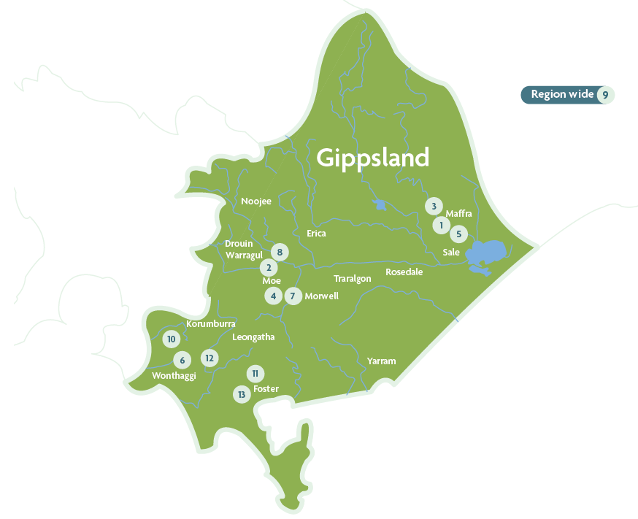

Figure 1: Locations of IWM opportunities across the Gippsland region. Locations are approximate.

## IWM opportunities

Thirteen opportunities have been identified in the region and these have been grouped into four themes that respond to the key priorities.

### Increasing community wellbeing through improved liveability

1. Water for the Gunaikurnai People at Knob Reserve
2. Greening Trafalgar Recreation Reserve
3. Maffra Stormwater Capture and Naturalisation – Phase 2
4. Fit-for-Purpose Water for Irrigating Recreation Reserves in Morwell
5. Flooding Creek Expansion – Room to Move
6. Wonthaggi Stormwater Harvesting
7. Kernot Lake and Surrounds Resilient Water Supply

### Achieving the best outcomes in a changing context

1. Stormwater Pollution Management at Willow Grove – Stage 2

### Strengthening Gippsland’s natural assets for future generations

1. Implementation, Review and Renewal of the West Gippsland Waterway Strategy
2. Bass Coast Biolinks

### Driving sustainable growth and economic opportunities for Gippsland

1. South Gippsland Shire Council IWM Plan
2. IWM to Secure the Leongatha Water Supply
3. Fish Creek Stormwater and Wastewater Solutions

Gippsland Integrated Water Management Forum

## Strategic Directions Statement 2022 summary

We work collaboratively with partners across the water cycle to find new ways to share resources and conserve water for multiple community and environmental benefits.

We work to meet the water needs of a changing region.

1. **Water for the Gunaikurnai People at Knob Reserve**

Providing drinking water supplies to an important Gunaikurnai cultural site and meeting place.

1. **Greening Trafalgar Recreation Reserve**

Establishing wetlands and stormwater harvesting to irrigate a growing regional multi-sport facility.

1. **Maffra Storm Water Capture and Naturalisation – Phase 2**

Developing the detailed plan to remove a concrete drain, restore overland flow, increase biodiversity and improve stormwater management

1. **Fit-for-Purpose Water for Irrigating Recreation Reserves in Morwell**

Exploring the potential of reuse water instead of potable water to irrigate local sporting grounds.

1. **Flooding Creek expansion – Room to Move**

Capturing stormwater and extending a linear park to support growing wildlife and resident populations.

1. **Wonthaggi Stormwater Harvesting – Stage 2**

Building a stormwater harvesting and storage system to collect water for irrigation and manage the risk of local flooding.

1. **Kernot Lake and Surrounds Resilient Water Supply**

Exploring more diverse water supply options and addressing water quality to secure the future of an important cultural, educational and recreational precinct.

1. **Stormwater Pollution Management at Willow Grove – Stage 2**

Protecting local waterways and Blue Rock Lake drinking water by extending an urban stormwater management project to the next adjacent subdivision.

1. **Implementation Review and Renewal of the West Gippsland Waterway Strategy**

Developing a strategy to ensure the future management of waterways supports dependent environmental, social, cultural, and economic values

1. **Bass Coast Biolinks**

Revegetating water courses to connect green spaces, extend wildlife corridors, support biodiversity, and mitigate flood-related risks

1. **South Gippsland Shire Council IWM Plan**

Developing an IWM plan to examine opportunities in a shire council area.

1. **IWM to Secure the Leongatha Water Supply**

Developing an adaptive strategy to explore the use of rainwater and stormwater to supplement local water supplies.

1. **Fish Creek Stormwater and Wastewater**

Investigating the potential for better stormwater and wastewater management in a small town.

Better together: integrating water management across Victoria

Traditional Owners have been living in balance with the natural environment in Victoria for tens of thousands of years, practising culture, caring for land and water, and maintaining sophisticated water management systems.

Victoria’s Gippsland region includes Country of the Gunaikurnai and the Bunurong people. Uncle Lloyd Hood from the Gunaikurnai Land and Waters Aboriginal Corporation (GLaWC) has said, “Water is very important – I suppose it’s important to everyone now today, but it’s always been at the very core of our existence.” In the words of Bunurong representatives, “We pay our deepest respects to our Ancestors and our Elders past and present who have nurtured and cared for Bunurong Country for tens of thousands of years. Today, we continue to preserve and protect the lands and waterways of our Ancestors, their sacred places, traditional ecological knowledge, cultural practices and stories.”

## Pressures emerge and evolve

European settlement and the gold rush of the 1800s saw thousands of people flock to Victoria to seek their fortunes. This created many towns, which have had large and long- lasting impacts on creeks and gullies. There were massacres of Indigenous people, and the surviving Traditional Owners were displaced from their Country.

Victoria’s regional towns and cities have thrived with the provision of urban drinking water and sanitation services. Irrigated agriculture and dryland farming have both played important roles in Victoria’s history and growth. Today, Victoria is the nation’s largest food and fibre exporter[1].

The complex challenges of water management continue throughout the state: we have lived through the Millennium Drought and experienced flooding, bushfires and extreme weather. We have seen the consequences of the overuse and overallocation of water in one area affecting the availability or quality of water in another, such as the multiple demands on the Thomson Reservoir. Significant investment and interventions have been required to start returning water to our rivers and floodplains, yet more remains to be done.

Water managers are now operating in an increasingly complex and uncertain environment. The drivers of change are both social and environmental, including climate change, population growth, shifting migration patterns associated with the coronavirus pandemic, economic challenges, and policy changes.

But our beautiful state remains a wonderful place to live, and we continue to see the population increase. Regional Victoria is expected to grow from 1.5 million people in 2015 to 2.2 million over the next 30 years to 2051[2].

The liveability of our regional towns and cities and the health of our people, environment and economy depend on the availability of water. Traditional Owners know that water is essential to life, and to Creation, and that waterways are living entities. The cultural, spiritual, physical and economic health of the Bunurong and Gunaikurnai peoples cannot be separated from the health of their respective Countries, including their water and waterways.

Therefore, we need an integrated and collaborative approach to adapt to change and maximise value across the whole water cycle.

## What is IWM? How can it help address challenges?

Integrated water management considers all parts of the water cycle as an integrated system to optimise the environmental, cultural, social and economic outcomes for our communities.

The current water supplies and liveability of towns and cities owe much to the collaborative work done to date by water corporations, local and state government, planning and development authorities, communities and, in recent decades, catchment management authorities. While we face the challenges of population growth, climate change and natural disasters, we can also build on the benefits of past experiences and established relationships. Together, we can make decisions today that we will celebrate in the future.

While everyone has a responsibility to conserve and protect water, there are several key groups charged with making decisions about water within each region. These groups include:

* Traditional Owner groups, who have a deep knowledge of and connection to the region’s waterways, other water resources and Country
* urban and rural water corporations, which manage the water storage, water supply, and wastewater services
* local governments, which manage surface water drainage, protect local waters from degradation and pollution, oversee onside domestic wastewater planning, regulate local
* catchment management authorities, which plan for flood management and work with landholders to consider the interactions of land, water and biodiversity.

The decisions these groups make individually, can have significant impacts on the quality and availability of the water for others in the catchment and further downstream. So, it makes sense they collaborate towards common goals to maximise water saving and reuse and share the benefits (Figure 2).

IWM is an approach that can be applied at multiple scales from water planning at the local park, right up to the whole of catchment. IWM can connect climate-change adaptation, planning and open space, water security and other strategies, so that collaborators can add value to each other’s projects.

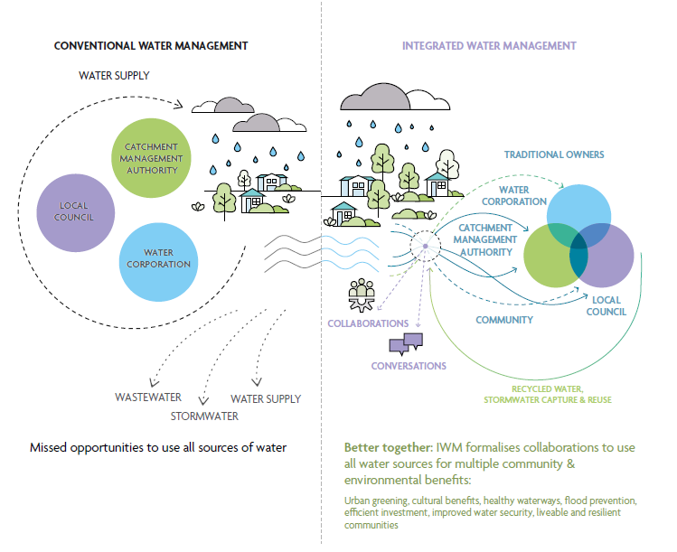

Figure 2: How does IWM work? Conventional water management saw a more siloed approach to water management, with a single supply source and two discharge systems to move stormwater and wastewater away as quickly as possible, resulting in missed opportunities to use all sources of water. The IWM approach brings water managers together to plan and deliver new opportunities to provide broader benefits to the community. Listening to and consulting with Victorian communities about how they want water managed is critical to informing IWM decision making. Communities are directly consulted on IWM plans and through existing catchment management authority, water corporation and local government strategies.

## How are we delivering IWM state-wide?

To facilitate IWM across Victoria, the Victorian Government’s Department of Environment, Land, Water and Planning (DELWP) supported the establishment of 10 IWM forums across regional Victoria (Figure 3). These forums bring together leaders of the local water sector to explore, prioritise and oversee the development of local IWM opportunities. Prioritised opportunities are managed and implemented by dedicated Working Groups and are captured within individual IWM plans. Where appropriate, the forums involve other organisations and groups that are not part of the water sector but have direct or indirect interests in water management and land use planning, such as community and Indigenous groups, planning authorities, Department of Transport, developers, educational institutions, or large landholders.

Being collaborative, IWM builds on existing partnerships and planning processes, and aims to break down silos between independently operating water decision-makers – encouraging forum members to consider the water cycle of their own service delivery, and the interdependencies or overlaps with other members (Figure 2). Forum members consider waters in rivers, streams and bays, wastewater, drinking water, stormwater and water treatment processes.

While collaboration can take more time and effort, working together achieves better outcomes for the environment, society, and the economy by finding mutually beneficial ways to share water, assets and costs.

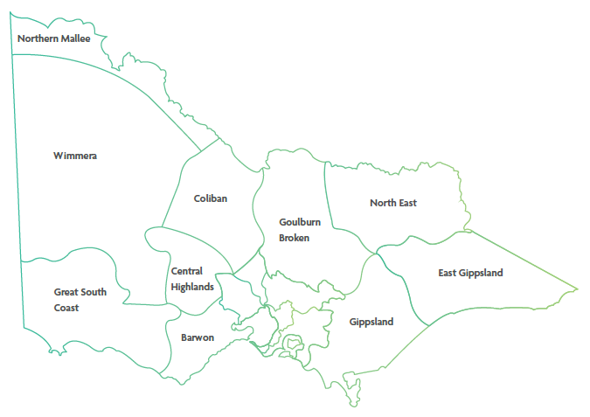

Figure 3: IWM forum regions of Victoria, which are based around water corporation boundaries

## Strategic outcomes

The Integrated Water Management Framework for Victoria (2017) proposed several strategic water-related outcomes that will deliver on the vision in the State water plan, Water for Victoria (2016), to ‘build resilient and liveable cities and towns’. These strategic outcomes provide a way to identify the multiple economic, social and environmental benefits that can come from a single initiative. The original framework included five such strategic outcomes that have since been expanded to seven. The identification of strategic outcomes will continue to evolve as the water management context changes and the sector innovates.

Proposed project opportunities are assessed and prioritised against how well and how many of these strategic outcomes they meet.

The strategic outcomes are:

* **safe, secure and affordable supplies in a changing future** – indicated by the amount of water conserved or alternative water volume supplied to meet an identified demand.
* **effective and affordable wastewater systems** – ensuring environmental and public health standards are met, and maximising resource recovery.
* **manage flood risks** – resilience to existing and future flood risk.
* **healthy and valued waterways and waterbodies** – indicated by the ecological health of riparian areas, hydrology and water quality.
* **healthy and valued landscapes** – maximising the connectivity, accessibility, greening and vegetation, cooling, aesthetic and/or recreational values of landscapes.
* **Traditional Owner and community values reflected in place-based planning** – ensuring that different communities are considered and included in planning and design, and provided with water-systems literacy to enable involvement.
* **jobs, economic opportunity and innovation** – recognising that water management is an integral part of economic growth.

To find out more about how Victoria is applying IWM through the Integrated Water Management Framework for Victoria (2017), visit: [www.water.vic.gov.au](http://www.water.vic.gov.au)

## Strategic Directions Statement – how IWM is happening in the region

This SDS articulates the collaborative intent and shared agreement of all stakeholders involved in the forum. It describes the water security challenges and opportunities in the region, sets the strategic direction for the next few years, and outlines the ‘best endeavours’ or ways in which IWM is and will be applied through opportunities that are proposed, in-progress or completed in the region.

This is the first update to the Gippsland SDS produced in 2019, and includes:

* an update on progress to date
* case studies illustrating IWM in the region
* details of planned and potential opportunities designed to meet the strategic outcomes and key challenges over the next three to five years.

This SDS has been developed to complement the other plans and strategies that apply to the region for water, climate change, Traditional Owners’ and Aboriginal Victorians’ rights, and catchment management.

The key related policies, strategies and plans for the Gippsland region are listed below, and displayed visually in Figure 4.

### Relevant plans and strategies in place in the region

**Water for Victoria**

State government strategic plan for management of our water resources, now and into the future.

**Integrated Water Management Framework for Victoria**

Whole-of-catchment water planning and management to maintain and enhance the liveability, prosperity and resiliency of Victoria’s cities and towns. Applied through five metropolitan and 10 regional IWM forums.

**2022 Gippsland IWM Forum SDS**

A revised statement of agreement between Forum members of urban and peri-urban IWM priorities and collaborative projects.

**Gippsland Water and South Gippsland Water Urban Water Strategies**

Detailed 50-year forecasts of water supply and sewer system demands for local communities, along with supply options to meet these demands.

**Caring for Country Plans**

Guiding and promoting awareness, investment and the rights of Aboriginal people and culture, working together now and for future benefits.

**Central and Gippsland Region Sustainable Water Strategy**

One of three regional Sustainable Water Strategies in Victoria. They are long-term plans and statutory processes for water resource planning to secure the water future of these regions.

**West Gippsland Regional Catchment Strategy**

Guides actions to improve and protect the catchment’s natural resources (water, land, biodiversity). Looking after these precious natural resources underpins the social, cultural and economic wellbeing of the diverse communities that make up the West Gippsland Catchment.

**Gippsland Regional Climate Change Adaptation Strategy**

Five-year practical strategy developed by the community to address and guide local action on the unique challenges and opportunities that climate change brings to the region.

**Local government plans and strategies**

Various strategies, plans, guidelines and other documents that have connections to the water cycle. Examples include open-space plans, local climate change adaptation strategies, and natural disaster management plans.

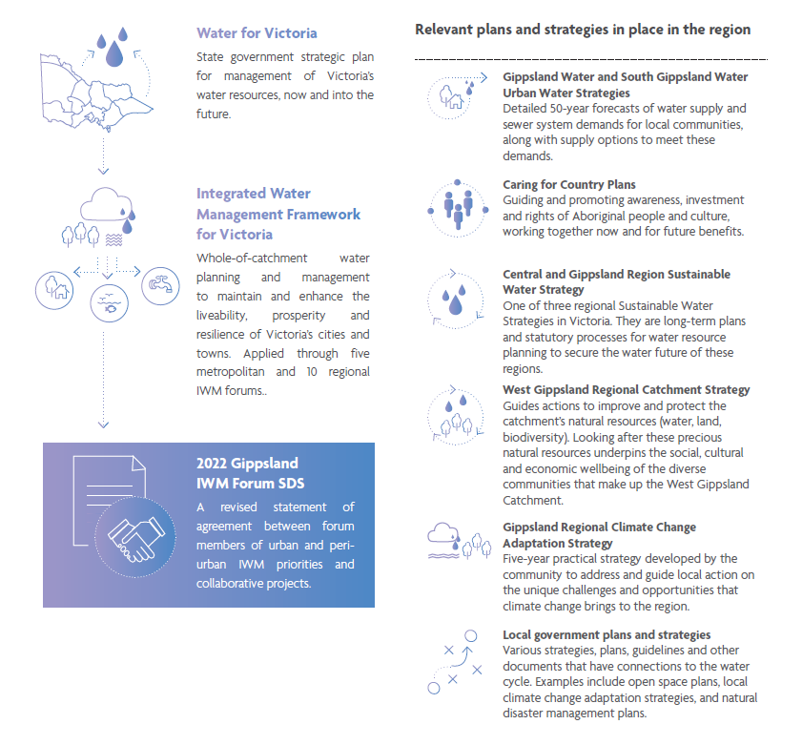

Figure 4: The SDS and related water policies, strategies and plans of the region

Water in the Gippsland region

The Gippsland IWM Forum region stretches from Wonthaggi in the west to Lake Wellington in the east. Its southern border is the Gippsland coastline, including Wilsons Promontory, extending north to the Great Dividing Range.

These lands include floodplains, coastlines, alpine areas, forests, more than 40,000 km of waterways that flow to the Victorian southern coast. The region has several internationally recognised environments, including the Gippsland Lakes and Corner Inlet Ramsar convention sites, Wilsons Promontory National Park and Tarra Bulga National Park.

The region is home to more than 215,000 people and encompasses the traditional lands and waters of Gunaikurnai and Bunurong people. Tourists and day-trippers come year- round to visit destinations like Wilsons Promontory and other nature parks, Ninety-Mile Beach, Mt Baw Baw’s snowfields, popular tourist towns like Foster and Inverloch, water sports and fishing hotspots, and many other attractions.

Waterbirds of state and national significance, including avocets, stilts, blue-winged parrots and the striated field wren, flock to the region’s wetlands. Tarra Bulga National Park is one of Victoria’s last remaining cool temperate rainforests. It is home to giant ferns, towering mountain ashes, platypus, wombats, and lyrebirds. Other local Gippsland wildlife includes wallabies, emus, dolphins, and other keystone and iconic species such as the eastern spider-orchid.

Dairy farming and forestry are major industries, together with a range of other agricultural activities including beef, lamb, wine, cheese, and vegetable production. As well as these important primary industries, the region hosts significant ‘value add’ industries of state and national importance. For example, paper and cardboards manufacturing, food processing facilities, and electricity generation – from both coal-derived and emerging renewable sources.

The health, prosperity and liveability of this thriving region are underpinned by water, across all parts of the water cycle, including:

* the provision of safe drinking water for residents and visitors
* water for industries that provide economic growth and employment
* the management of stormwater and wastewater in urban areas
* the physical, spiritual, economic, and cultural water needs of Traditional Owners
* the rivers, rainfall, and other environmental flows that support ecosystems, landscapes, and wildlife.

### Snapshot of key climate, waterway and population statistics for the Gippsland region.

**Population**

* Population in 2021 – 216,700
* Population in 2036 – 253,300
* Population increase – 17%

**Waterway condition**

* Excellent – 17%
* Good – 17%
* Moderate – 53%
* Poor – 7%
* Very Poor – 6%

**Climate**

* Change in rainfall – by 2040, increase by 4.5% in some areas, and decrease by 13.1% in some areas with more intense rainfall in some years
* Change in temperature – by 2040, an increase of 0.7 to 1.5 degrees Celsius

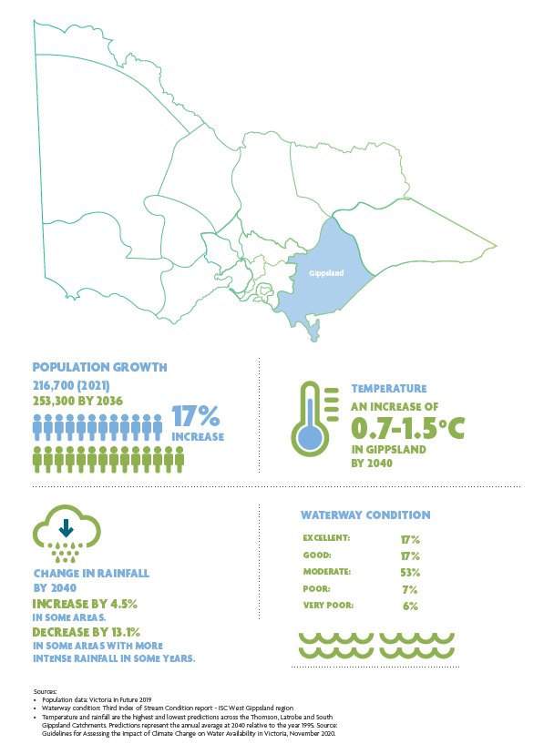

Figure 5: Key climate, waterway and population statistics for the Gippsland region

A changing region

The Gippsland IWM Forum’s desire is for Gippsland to be a liveable community with healthy waterways where people can live, work and play well.

The forum has been operating for three years, which has provided experience to draw on and projects to build upon. There have also been major disruptions, such as natural disasters and the coronavirus pandemic, which have highlighted the need for the forum to sharpen its focus, rescope projects, and prioritise activities.

Traditional Owners are increasingly being empowered by government to take a leading role in water policy, management, and planning. The Victoria State Government is increasing its obligation to recognise the rights of Traditional Owners to self- determination and their inherent obligations to speak for and look after the Country of their ancestors for current and future generations.

The SDS highlights the key challenges in the region and identifies collaborative IWM opportunities that can address climate change and other key drivers, to improve resilience and liveability in its cities and towns. The forum’s work over the next few years focuses on four key challenges or themes described below.

## Increasing community wellbeing through improved liveability

### We need water for community wellbeing and liveability as our population grows

Victoria in Future (2016) predicted an average regional population growth of one and a half per cent annually from 2018 to 2036. The first two years of this period saw growth exceed expectations, making water sensitive urban design in new residential areas and water services in small towns an urgent need. More recently, the global coronavirus pandemic saw a substantial increase in the number of people migrating from Melbourne to Victoria’s regional areas, changing traditional holiday destinations to have increased proportions of permanent residents. In addition, closed international borders have resulted in a domestic tourism boom, putting greater strain on water services.

Visitors and permanent residents alike need drinking water supplies and wastewater management. Communities are placing greater value on water-supported community assets, such as healthy parks, waterways, and landscapes – for recreation, local beauty and liveability.

Green spaces with shade and cooling vegetation are becoming vitally important as Gippsland experiences more days each year of extreme heat. This makes ‘green infrastructure’, such as parks, wetlands, and nature reserves, potentially a life-saving community asset.

The following projects fall under the 'increasing community wellbeing through improved liveability' theme:

* Water for the Gunaikurnai People at Knob Reserve
* Greening Trafalgar Recreation Reserve
* Maffra Stormwater Capture and Naturalisation – Phase 2
* Fit-for-Purpose Water for Irrigating Recreation Reserves in Morwell
* Wonthaggi Stormwater Harvesting
* Kernot Lake and Surrounds Resilient Water Supply
* Flooding Creek Expansion – Room to Move

## Achieving the best outcomes in a changing context

### We need to adapt to achieve the best outcomes for a growing population and changing economy under a climate change

Gippsland is already experiencing the consequences of climate change. The people in this region have seen a great deal – fires, floods, droughts, and extreme weather.

Climate change means it is likely the effects of heatwaves, fire, flood, and drought will worsen, and will be more frequent. This will impact the region's ecosystems and the community significantly. Future fires will require more water for firefighting. Fires and other natural disasters will demand greater capacity to manage water quality to deal with the consequential dirty water events. Changing weather patterns will also influence growing seasons for agriculture, along with the timing of periods of peak water demand.

These challenges, and approaches to addressing them, are or will be part of the West Gippsland Regional Catchment Strategy, the Central and Gippsland Region Sustainable Water Strategy, and the Gippsland Regional Climate Change Adaptation Strategy. IWM will assist in monitoring and adapting to climate change as a shared responsibility.

The project Stormwater Pollution Management at Willow Grove – Stage 2 falls under the 'achieving the best outcomes in a changing context' theme.

## Strengthening Gippsland’s natural assets for future generations

### Gippsland’s unique natural environment and waterways need to be protected for future generations

Natural assets such as waterways and coasts are part of the unique character of Gippsland. While some are in good condition, others have become degraded, and some creeks and rivers in urban areas have effectively become drains. More extreme weather events create greater challenges for maintaining good water quality in our rivers and creeks. While seasonal flooding is a natural and beneficial for some ecosystems, extreme flooding presents risks. There is an opportunity to manage the risks of flooding and drainage in an innovative way, and an opportunity repair degraded environments and heal Country.

The following projects fall under the 'strengthening Gippsland’s natural assets for future generations' theme:

* Implementation, Review and Renewal of the West Gippsland Waterway Strategy
* Bass Coast Biolinks

## Driving sustainable growth and economic opportunities for Gippsland

### Water is an enabler for economic growth and is central for the planning of Gippsland’s economic future

The economy in Gippsland is changing. Integrated water planning and management is needed to ensure Gippsland’s cities and towns can grow to accommodate more people and support the businesses and economic activity that provide jobs.

Economic growth needs water, but that comes at a cost to waterways and the environment. Power generation, mining, manufacturing, paper milling, dairy, agriculture, and food manufacturing are water-intensive sectors. Mine rehabilitation may also impact the water cycle.

There is an opportunity to make better use of water resources, considering both water quality and quantity, and directing water that is fit-for-purpose where it’s needed. This involves exploring opportunities to substitute potable water with captured stormwater or treated recycled water where drinking quality is not required. It also involves seeing discharges and wastewater as opportunities to increase water in the environment and improve liveability, rather than just problems to solve.

The following projects fall under the 'driving sustainable growth and economic opportunities for Gippsland' theme:

* South Gippsland Shire Council IWM Plan
* IWM to Secure the Leongatha Water Supply
* Fish Creek Stormwater and Wastewater Solutions

Progress to date

The first Gippsland IWM Forum SDS was published in April 2019. It articulated the regional context, the shared vision and the strategic water-related objectives for the region. It also listed IWM opportunities as ‘ready to advance’ projects, developed collaboratively by the forum partners. It can be viewed online at [www.water.vic.gov.au](http://www.water.vic.gov.au)

Many forum members have IWM at the forefront of their thinking and several are regularly implementing IWM as their principal approach to water management. The projects – past, current and future – listed in this document and endorsed by the forum members are those that will create shared benefits from a collaborative, multi-party approach.

Our first SDS identified 14 projects that reflected the Gippsland IWM Forum’s initial priorities and opportunities. Most of these projects are underway or completed. Progress on the 2019 SDS projects is summarised in Table 1. Six, including the Stormwater Management at Willow Grove project, have been completed. You can read more about this project on page 20. The Council IWM Plans flagship 2019 project has seen three councils develop their plans and, at the time of print, these are in the process of being endorsed through local government processes. South Gippsland Shire Council is drawing on their experience. The Water for Economic Growth in Central Gippsland project has been completed, and Gippsland Water is using its publication to educate and engage stakeholders to promote economic growth in the Latrobe Valley. Six more projects are well underway.

The Gippsland IWM Forum is flexible and responsive to the changing needs and priorities of local governments and other members. Some projects were delayed as forum members dealt with greater than expected population growth and the impacts of the coronavirus pandemic. Two projects have been rescoped or integrated into other projects and are included in this SDS.

Progress on the 2019 SDS projects is summarised in Table 1, with brief notes on their outcomes and how they inform the current and future opportunities detailed in this refreshed SDS.

Table 1: A summary of the status of the 2019 SDS IWM opportunities

|  |  |  |
| --- | --- | --- |
| **IWM opportunity** | **Status** | **Notes** |
| **Council IWM Plans** | In progress | Note: some are still in the process of being endorsed by councils  • Bass Coast – completed  • Wellington – completed  • Latrobe – completed  • Baw Baw – completed (funded through the Westernport IWM  Forum)  • South Gippsland – proposed.  See page 49. |
| **Repurposing Dams at Little Bass, Coalition Creek, Ness Gully and Bellview Creek** | Completed | Disused dams have had interim works completed to reduce safety risks and support community use, with good uptake from  fishing clubs. Three storages will be integrated into the water network. |
| **Kernot Lake Water Supply** | Completed | Feasibility report completed. A new project is proposed for the next stage. See page 40. |
| **Greening Sporting Reserves in Baw Baw Shire** | In progress | Western Park stormwater reuse irrigation construction partially completed; more reserves underway. The next stage is a feasibility study for Trafalgar Recreation Reserve. See page 34. |
| **Maffra Stormwater Harvesting (feasibility)** | In progress | Feasibility stage complete, design stage underway and moving to community consultation. See page 35. |
| **South Dudley Wetland** | In progress | Concept design & feasibility has been completed. Part of Bass Coast IWM Implementation Plan. |
| **Wonthaggi Stormwater Harvesting** | In progress | Feasibility completed. Designed and ready to go pending funding. See page 39. |
| **Water for Economic Growth in Central Gippsland** | Completed | This publication is being used by Latrobe City and Gippsland Water to promote economic growth in the Latrobe Valley, and for educating central authorities and agencies. |
| **Mt Baw Baw Water Storage for Snow Making** | Completed | Stage 1 completed. |
| **Stormwater Pollution Management at Willow Grove** | Completed | Stage 1 completed. Stage 2 proposed to extend planting and management to an adjacent area. See page 31. |
| **Bass Coast Biolinks** | Completed/ ongoing | An ongoing initiative, with the first section completed in October 2020. Already demonstrating good return on investment. Next stage projects proposed. See page 47. |
| **Waterway Health Program** | Ongoing | Follow-on project: Implementation, review and renewal of the West Gippsland Waterway Strategy. See page 45. |
| **Integrated Service Enhancement for Leongatha and Nearby Towns** | In progress | The 2022 Urban Water Strategy will be used to address long-term water supply opportunities. Other options being investigated, including the project: IWM to Secure the Leongatha Water Supply. See page 50. |
| **Recycled Water for Road Grading Investigation** | Superseded | To be incorporated into the South Gippsland Shire Council IWM Plan. |

Case study

## Western Park stormwater

### Making better use of different water resources in a growth area

The Western Park Ovals precinct in Warragul has switched to using stormwater for irrigation, saving 20 megalitres of drinking water every year – enough to provide about half a million four- minute showers!

Western Park Ovals is an important sporting events venue for the Baw Baw Shire. In 2017, a second oval was constructed to accommodate the sporting and recreational needs of a growing local community. The ovals were irrigated with 600 kilolitres of drinking water every week, and this was projected to increase to 900 kilolitres as the climate becomes drier and hotter.

Such increasing demand would put a strain on Warragul’s town water supply, drawn from the Tarago River. Finding ways to relieve this strain became critical to ensuring this important recreational space could be maintained without compromising other vital water needs.

Baw Baw Shire Council, West Gippsland Catchment Management Authority and Gippsland Water play different water-related roles at Western Park Ovals. The council oversees urban stormwater management and the management of public spaces, including sports fields. The catchment management authority manages floodplains and waterway health, while Gippsland Water is responsible for the supply of drinking water and treatment of wastewater in the town. Together, at a Gippsland IWM Forum planning workshop, they identified a potential solution to meet the growing water demands of Western Park Ovals more sustainably.

Adjacent to the ovals is a 2.5 hectare wetland that captures and treats stormwater runoff from upstream residential developments before discharging it into Hazel Creek.

Led by the Baw Baw Shire Council, the group developed and implemented a plan to pump a portion of this stormwater from the wetland toward irrigating the sporting oval. The project involved the installation of a pump station, an inline sediment filter, a UV filtration system, and an underground 600 kilolitre storage tank. This newly completed project was supported with funding from the council, the Victorian Government and Gippsland Water.

The collaborative and holistic approach that IWM encourages means this project will save potable water, decrease the pollution of Hazel Creek and maintain a valuable green space for community recreation that is climate resilient.

Case study

## Stormwater pollution management at Willow Grove

### Building new homes while protecting local waterways

Willow Grove is a small country town that is attracting new residents looking for a home near the popular Blue Rock Lake, surrounded by rolling green hills and Mount Baw Baw as a backdrop.

All new greenfield residential developments generate sealed surfaces that increase stormwater runoff, that is often polluted. Willow Grove and its new subdivisions sit within a drinking water catchment. Gippsland IWM Forum members recognised that urban stormwater from Willow Grove would run down a short, grazed, grassy gully into Blue Rock Lake, affecting its water quality.

Gippsland Water identified a project for the forum’s 2019 SDS to design and install cattle-excluding fences and vegetation to intercept and reduce stormwater pollutants from the township and surrounds, protecting Blue Rock Lake. Baw Baw Shire Council, West Gippsland Catchment Management Authority, Southern Rural Water, and Tanjil Landcare Group were the implementation partners for the project.

Stage 1 has been completed, conducting riparian planting along a gully and installing fencing to protect the area from grazing cattle. This work has reduced water pollution, helped to stabilise the land, and enhanced the beauty of the gully. It is believed these plantings have already helped reduce the damage done by a severe storm that left a trail of destruction across Victoria in mid-June 2021.

The project is a proven success. Stage 2, to extend the approach to an adjacent area that is also earmarked for development, has been proposed in this SDS and already has the support of the subdivision developer.

IWM opportunities

Opportunities that link to and address IWM challenges for the region were identified and developed by nominated practitioners of organisations participating in the forum.

A summary of the priority IWM opportunities are detailed in the following section. This list is dynamic and will continue to be updated to reflect the forum’s priorities and opportunities as they arise.

Partners are committing their ‘best endeavours’ to ensure priority projects and strategies are moved forward, in line with the shared vision and strategic outcomes of the forum.

Increasing community wellbeing through improved liveability

In Gippsland, green open spaces such as parks and sporting reserves can be at the heart of the community. Keeping these spaces irrigated with fit-for-purpose water will enhance the liveability of the region and have positive impacts on the wellbeing of residents.

## Water for the Gunaikurnai People at Knob Reserve

Knob Reserve was traditionally a common ground for the five clans of Gunaikurnai. Aboriginal people would travel for days to join great meetings where they would feast, share information, trade goods and practise corroboree and other cultural ceremonies. The reserve is owned by the Gunaikurnai people and jointly managed by the Gunaikurnai Land and Waters Aboriginal Corporation (GLaWAC) and the Victorian Government. This site continues to be a meeting place for the Gunaikurnai people, and many cultural events are held here.

There is currently no water supply to Knob Reserve. Through Gippsland Water’s partnership with GLaWAC, the provision of potable water to Knob Reserve is a priority and an opportunity to deliver meaningful outcomes to the Traditional Owner community.

This project will see the installation of a water main from the Stratford reticulation system to Knob Reserve, installation of drinking water fountains around the reserve (for which local Aboriginal artists will design artwork) and development and implementation of a program to promote Aboriginal health through targeted communications and engagement related to the benefits of drinking tap water rather than processed bottled water and, particularly, sugary drinks.

It will also provide sustainable water outcomes by reducing the cost of drinking water for the community and of the total water use of the community by avoiding the hidden water and energy consumption and plastic production required to produce bottled water.

**Table 2: A summary of key details for the Water for the Gunaikurnai People at Knob Reserve opportunity.**

|  |  |
| --- | --- |
| **Subject** | **Details** |
| **Status** | Identified |
| **Lead agency** | Gunaikurnai Land and Water Aboriginal Corporation |
| **Implementation partners** | Gippsland Water, DELWP, Wellington Shire Council |
| **Location** | Stratford |
| **Scale** | Park |

Table 3: A summary of the impact that the Water for the Gunaikurnai People at Knob Reserve opportunity has towards achieving the IWM outcomes.

|  |  |
| --- | --- |
| IWM outcome | Impact status |
| safe, secure and affordable supplies in a changing future | Medium impact |
| effective and affordable wastewater systems | Low impact |
| manage flood risks | Low impact |
| healthy and valued waterways and waterbodies | Medium impact |
| healthy and valued landscapes | Medium impact |
| Traditional Owner and community values reflected in place-based planning | High impact |
| community values reflected in place-based planning | High impact |
| jobs, economic opportunity and innovation | Medium impact |

## Greening Trafalgar Recreation Reserve

Trafalgar Recreation Reserve includes sporting facilities for football, netball, cricket, boxing, soccer, and other sports. The reserve’s new Turra Pavilion multi-sport facility will add more changing rooms for AFL, soccer, and cricket, as well as a new gymnasium, canteen, and other spaces. Additionally, there is a proposal to construct another oval.

At present, it costs the Baw Baw Shire Council about $30,000 per year to provide potable water to the reserve. The total irrigation requirement for the existing facilities is about 11 megalitres per year. With the new pavilion and future oval, potable water use will increase significantly.

This IWM opportunity proposes to transfer treated stormwater from a future wetland and retarding basin proposed for the south- west of Trafalgar, which will have a capacity of 19 megalitres. The water will be pumped at about 30 litres a second to an 800,000 litre storage tank at Trafalgar Recreation Reserve. The project proposes to harvest 9 megalitres of stormwater per year to be used to irrigate the recreation reserve, providing an 80% reliability of supply.

The project will benefit the Gippsland community by securing water supplies to help keep this premier regional sporting precinct healthy, functional and vibrant.

**Table 4: A summary of key details for the Greening Trafalgar Recreation Reserve opportunity.**

|  |  |
| --- | --- |
| **Subject** | **Details** |
| **Status** | Identified |
| **Lead agency** | Baw Baw Shire Council |
| **Implementation partners** | Gippsland Water, West Gippsland Catchment Authority |
| **Location** | Trafalgar |
| **Scale** | Precinct |

Table 5: A summary of the impact that the Greening Trafalgar Recreation Reserve opportunity has towards achieving the IWM outcomes.

|  |  |
| --- | --- |
| IWM outcome | Impact status |
| safe, secure and affordable supplies in a changing future | High impact |
| effective and affordable wastewater systems | Low impact |
| manage flood risks | High impact |
| healthy and valued waterways and waterbodies | Medium impact |
| healthy and valued landscapes | High impact |
| Traditional Owner and community values reflected in place-based planning | Low impact |
| community values reflected in place-based planning | Medium impact |
| jobs, economic opportunity and innovation | Low impact |

## Maffra Storm Water Capture and Naturalisation – Phase 2

In 2020, the Wellington Shire Council completed the Maffra Stormwater Strategy, which identified the key infrastructure requirements to capture and treat stormwater from the residential expansion in northern Maffra. This was a project proposed in the 2019 SDS.

The strategy identified the need to convert the Davis Street concrete drain into a natural watercourse, which would include passive recreational elements to enhance liveability and urban biodiversity. Phase 2 of the project involves surveying and detailed design of the proposed naturalisation of the Davis Street drain, which will bring the project to a shovel-ready stage.

**Table 6: A summary of key details for** **the Maffra Storm Water Capture and Naturalisation – Phase 2 opportunity.**

|  |  |
| --- | --- |
| **Subject** | **Details** |
| **Status** | Identified |
| **Lead agency** | Wellington Shire Council |
| **Implementation partners** | West Gippsland Catchment Authority |
| **Location** | Maffra |
| **Scale** | Precinct |

Table 7: A summary of the impact that the Maffra Storm Water Capture and Naturalisation – Phase 2 opportunity has towards achieving the IWM outcomes.

|  |  |
| --- | --- |
| IWM outcome | Impact status |
| safe, secure and affordable supplies in a changing future | Low impact |
| effective and affordable wastewater systems | Low impact |
| manage flood risks | Medium impact |
| healthy and valued waterways and waterbodies | Medium impact |
| healthy and valued landscapes | High impact |
| Traditional Owner and community values reflected in place-based planning | Low impact |
| community values reflected in place-based planning | Medium impact |
| jobs, economic opportunity and innovation | Medium impact |

## Fit-for-purpose Water for Irrigating Recreation Reserves in Morwell

In 2020, the Wellington Shire Council completed the Maffra Stormwater Strategy, which identified the key infrastructure requirements to capture and treat stormwater from the residential expansion in northern Maffra. This was a project proposed in the 2019 SDS.

The strategy identified the need to convert the Davis Street concrete drain into a natural watercourse, which would include passive recreational elements to enhance liveability and urban biodiversity. Phase 2 of the project involves surveying and detailed design of the proposed naturalisation of the Davis Street drain, which will bring the project to a shovel-ready stage.

**Table 8: A summary of key details for the** **Fit-for-purpose Water for Irrigating Recreation Reserves in Morwell opportunity.**

|  |  |
| --- | --- |
| **Subject** | **Details** |
| **Status** | Identified |
| **Lead agency** | Gippsland Water |
| **Implementation partners** | Latrobe City Council |
| **Location** | Morwell |
| **Scale** | Precinct |

Table 9: A summary of the impact that the Fit-for-purpose Water for Irrigating Recreation Reserves in Morwell opportunity has towards achieving the IWM outcomes.

|  |  |
| --- | --- |
| IWM outcome | Impact status |
| safe, secure and affordable supplies in a changing future | High impact |
| effective and affordable wastewater systems | Low impact |
| manage flood risks | Low impact |
| healthy and valued waterways and waterbodies | Low impact |
| healthy and valued landscapes | Medium impact |
| Traditional Owner and community values reflected in place-based planning | Low impact |
| community values reflected in place-based planning | Medium impact |
| jobs, economic opportunity and innovation | Low impact |

## Flooding Creek Expansion – Room to Move

In Sale, the original Flooding Creek Linear Park Plan is nearing completion. But, with the anticipated purchase of additional land, there are opportunities to extend and build on the linear park, achieving further benefits.

The North Sale Development Plan requires new end-point treatment infrastructure to facilitate residential growth in Sale. The proposed development and extension of the Flooding Creek Linear Park could incorporate a stormwater capture system to meet this need. This could enable the development of further residential allotments, while extending the linear park further north across the floodplain catchment.

Additionally, the project can contribute to the Love our Lakes, Room to Move concept of the East and West Gippsland Catchment Management Authorities. The Room to Move concept seeks ways to manage the lakes environment under climate change. Extending managed wetlands into the upper catchment can extend the habitat range for key wildlife under a variable climate.

Vulnerable or endangered fauna seen in the Flooding Creek area include the plumed egret, Australian bittern, hardhead duck, grey goshawk, black falcon, and the green and golden bell frog – all observed and recorded in the Victorian Biodiversity Atlas in 2020. Extending the range of suitable habitat for these species builds additional resilience into the natural system.

Expansion of the Flooding Creek Linear Park also increases the range of recreational activities and active transport opportunities, such as walking tracks and bike paths, from the new North Sale development area to the central business district of Sale.

**Table 10: A summary of key details for the** **Flooding Creek Expansion – Room to Move** **opportunity.**

|  |  |
| --- | --- |
| **Subject** | **Details** |
| **Status** | Identified |
| **Lead agency** | Wellington Shire Council |
| **Implementation partners** | West Gippsland Catchment Management Authority, DELWP, Gunaikurnai Land and Waters Aboriginal Corporation, Love Our Lakes Committee |
| **Location** | Sale |
| **Scale** | Catchment |

Table 11: A summary of the impact that Flooding Creek Expansion – Room to Move opportunity has towards achieving the IWM outcomes.

|  |  |
| --- | --- |
| IWM outcome | Impact status |
| safe, secure and affordable supplies in a changing future | Low impact |
| effective and affordable wastewater systems | Low impact |
| manage flood risks | High impact |
| healthy and valued waterways and waterbodies | High impact |
| healthy and valued landscapes | High impact |
| Traditional Owner and community values reflected in place-based planning | Medium impact |
| community values reflected in place-based planning | Medium impact |
| jobs, economic opportunity and innovation | Medium impact |

## Wonthaggi Stormwater Harvesting – Stage 2

A stormwater harvesting scheme is proposed for Wonthaggi, to provide two large ovals with irrigation water. The scope of the project involves the construction and installation of a 1 megalitre underground stormwater storage facility, the interception of feed-in pipes, mechanical water treatment devices, drains and the construction of two bunds (small dams). This initiative was commenced as part of the 2019 SDS development, and a feasibility study has been completed. The project is ready to progress to construction once funding is secured.

The system will be designed to allow stormwater to pass into the underground storage facility directly and from an above- ground bund. The bund can store four megalitres of water for several hours as an above ground pool and ground soak. When the underground storage and first bund are at capacity, overflow would be transferred to a second bund that, in turn, overflows via a pipeline into a natural wetland area.

The system is designed to collect water for irrigation while managing the risk of local flood events. The stored water will be used to irrigate ovals that currently require potable water.

**Table 12: A summary of key details for the** **Wonthaggi Stormwater Harvesting – Stage 2** **opportunity.**

|  |  |
| --- | --- |
| **Subject** | **Details** |
| **Status** | Committed |
| **Lead agency** | Bass Coast Shire Council |
| **Implementation partners** | South Gippsland Water, West Gippsland Catchment Management Authority, Bunurong Land Council Aboriginal Corporation |
| **Location** | Wonthaggi |
| **Scale** | Precinct |

Table 13: A summary of the impact that the Wonthaggi Stormwater Harvesting – Stage 2 opportunity has towards achieving the IWM outcomes.

|  |  |
| --- | --- |
| IWM outcome | Impact status |
| safe, secure and affordable supplies in a changing future | Medium impact |
| effective and affordable wastewater systems | Low impact |
| manage flood risks | High impact |
| healthy and valued waterways and waterbodies | High impact |
| healthy and valued landscapes | Medium impact |
| Traditional Owner and community values reflected in place-based planning | Medium impact |
| community values reflected in place-based planning | High impact |
| jobs, economic opportunity and innovation | Medium impact |

## Kernot Lake and Surrounds Resilient Water Supply

Kernot Lake is an important feature in the town of Morwell that includes the Gippsland Heritage Walk. If action is not taken, the lake may lose its current water supply to climate change and competing water demands. Surrounded by Immigration Park, Federation TAFE, sporting fields, and the newly established high- tech precinct, Kernot Lake is located adjacent to residential housing and is visible from Princes Drive, an area of high-density traffic. The lake’s water quality is also at risk of contamination from inflows from industrial precincts. Maintaining the current amenity of this asset is essential to the pride of the community of Morwell and the broader Latrobe Valley.

Recently completed water quality improvement projects have delivered a Gross Pollutant Trap as a primary treatment for stormwater discharges into Waterhole Creek from the adjacent 30 hectare residential housing catchment. This Gross Pollutant Trap also included provision for a future stormwater harvesting connection that is the focus of this project.

A feasibility study will determine the storage requirements and potential scale of more diverse water supply options that could provide the best balance of costs and benefits to maintain the water levels in Kernot Lake, as well as providing non-potable water for irrigation of nearby sporting reserves. This is a continuing project from the 2019 SDS.

**Table 14: A summary of key details for the** **Kernot Lake and Surrounds Resilient Water Supply** **opportunity.**

|  |  |
| --- | --- |
| **Subject** | **Details** |
| **Status** | Identified |
| **Lead agency** | Latrobe City Council |
| **Implementation partners** | Gippsland Water |
| **Location** | Morwell |
| **Scale** | Precinct |

Table 15: A summary of the impact that the Kernot Lake and Surrounds Resilient Water Supply opportunity has towards achieving the IWM outcomes.

|  |  |
| --- | --- |
| IWM outcome | Impact status |
| safe, secure and affordable supplies in a changing future | High impact |
| effective and affordable wastewater systems | Low impact |
| manage flood risks | Low impact |
| healthy and valued waterways and waterbodies | High impact |
| healthy and valued landscapes | High impact |
| Traditional Owner and community values reflected in place-based planning | Low impact |
| community values reflected in place-based planning | Medium impact |
| jobs, economic opportunity and innovation | Low impact |

Achieving the best outcomes in a changing context

With change comes the opportunity to do things better. There are many shifts currently taking place across Gippsland including changes to industry, populations and climate. The following projects will use IWM to create an opportunity for better outcomes in the face of these changes.

## Stormwater Pollution Management at Willow Grove – Stage 2

An application for a 30-lot subdivision has been approved for the Willow Grove township. This subdivision will be serviced by a reticulated water and sewer system. However, the development takes in an additional section of waterway, will incorporate significant areas of impermeable paved surfaces, and will generate domestic sources of water pollution that will drain towards Blue Rock Lake – an important water body used for recreation and to supply potable and industrial water.

This project proposes to expand Stage 1, which was part of the 2019 SDS and has been funded and successfully implemented. This expansion continues the establishment of native vegetation in a private farm gully that receives stormwater from the township and grazing land. The aim is to intercept pollutants and reduce the risks to water quality at Blue Rock Lake. A cattle crossing over the gully is also proposed.

The extension of the vegetation and fencing in the gully will reduce the stormwater quality risks of the existing and recently approved new development by:

* guiding cattle traffic to an engineered crossing over the gully
* continuing to slow the flow of additional stormwater
* providing greater stabilisation of the soil in an area proven to be subject to landslip
* intercepting greater volumes of nutrients and chemicals
* reducing the risk to water quality and public health.

**Table 16: A summary of key details for the** **Stormwater Pollution Management at Willow Grove – Stage 2** **opportunity.**

|  |  |
| --- | --- |
| **Subject** | **Details** |
| **Status** | Identified |
| **Lead agency** | Southern Rural Water |
| **Implementation partners** | Gippsland Water, West Gippsland Catchment Management Authority, Baw Baw Shire, Tanjil Valley Landcare Group |
| **Location** | Willow Grove |
| **Scale** | Precinct |

Table 17: A summary of the impact that the Stormwater Pollution Management at Willow Grove – Stage 2 opportunity has towards achieving the IWM outcomes.

|  |  |
| --- | --- |
| IWM outcome | Impact status |
| safe, secure and affordable supplies in a changing future | Medium impact |
| effective and affordable wastewater systems | Low impact |
| manage flood risks | Low impact |
| healthy and valued waterways and waterbodies | High impact |
| healthy and valued landscapes | High impact |
| Traditional Owner and community values reflected in place-based planning | Low impact |
| community values reflected in place-based planning | Medium impact |
| jobs, economic opportunity and innovation | Low impact |

Strengthening Gippsland’s natural assets for future generations

Natural assets such as waterways and coasts are part of the unique character of Gippsland and need to be protected for future generations. Through IWM, the following projects will strengthen natural assets and ensure they remain healthy and valued, while increasing the shared benefits enjoyed by community.

## Implementation, Review and Renewal of the West Gippsland Waterway Strategy

The West Gippsland Waterway Strategy aims to ensure that the future management of waterways – rivers, wetlands, and estuaries – provides appropriate environmental conditions to support dependent environmental, social, cultural, and economic values. The existing strategy term ends in 2022, so in preparation for its renewal, it is currently being reviewed.

The Gippsland IWM Forum partners, as a collaborative group with unique insights and knowledge, have been engaged to review the strategy. The experience and whole of water cycle perspective of this group, provide an excellent opportunity to identify, collaboratively build upon and implement catchment management projects from the current and renewed West Gippsland Waterway Strategy. Building on these projects, by considering the application of IWM outcome areas in a collaborative and holistic way, aims to grow the shared benefits delivered by the strategies.

Given the breadth of opportunities to build on in the strategy, specific projects will be identified and selected following input from forum partners. The priority areas and types of on-ground works already in the strategy, and for which the forum can expand to deliver more shared benefits to consider, include:

* Corner Inlet and catchments – waterway fencing, weed control and revegetation, saltmarsh protection, and fox and spartina grass control
* mid-Thomson River and Rainbow Creek – waterway fencing, weed control and revegetation, and the stabilisation of sites at high risk of initiating major movement of the river channel
* Powlett Catchment – restoration activities, including the estuary’s salt marsh and flood plain
* Great Dividing Range and Strzelecki Ranges – willow control in forested upland river reaches
* Anderson and Shallow Inlets – spartina grass control
* Latrobe, Thomson and Macalister Rivers and the Lower Latrobe Wetlands – delivery of water to the environment
* Port of Sale, Sale Common, Heart and Dowd Morass – on- ground works to provide and/or improve recreational values and opportunities
* region-wide – community projects (discretionary, based on interest and merit) and willow control at pest control sites.

Additional funding opportunities are underway and will be concluded in 2022, focused on the Gippsland Lakes and Hinterland, and flood recovery works in central and south Gippsland.

**Table 18: A summary of key details for the** **Implementation, Review and Renewal of the West Gippsland Waterway Strategy** **opportunity.**

|  |  |
| --- | --- |
| **Subject** | **Details** |
| **Status** | Committed |
| **Lead agency** | West Gippsland Catchment Management Authority |
| **Implementation partners** | All interest forum partners |
| **Location** | Gippsland |
| **Scale** | Forum area |

Table 19: A summary of the impact that the Implementation, Review and Renewal of the West Gippsland Waterway Strategy opportunity has towards achieving the IWM outcomes.

|  |  |
| --- | --- |
| IWM outcome | Impact status |
| safe, secure and affordable supplies in a changing future | Medium impact |
| effective and affordable wastewater systems | Low impact |
| manage flood risks | Low impact |
| healthy and valued waterways and waterbodies | High impact |
| healthy and valued landscapes | High impact |
| Traditional Owner and community values reflected in place-based planning | Medium impact |
| community values reflected in place-based planning | High impact |
| jobs, economic opportunity and innovation | Medium impact |

## Bass Coast Biolinks

This project seeks to increase the amount of native vegetation cover in Victoria's southeast region through a network of biolinks connecting open green spaces and wildlife corridors through the landscape. This will be done by creating and enhancing vegetated riparian zones to capture, filter and retain water, thereby providing habitat for birds, fish and animals, improving water quality, and mitigating flood-related issues.

The Bass Coast Biodiversity Biolinks Plan was completed in 2018, setting out a plan for riparian enhancement across the shire. Bass Coast Shire Council worked collaboratively with stakeholders, the community, and other regional parties to develop a shared vision and implementation plan. In the Bass Coast IWM Measures Report, the project was compared to 12 other IWM opportunities, with Bass Coast Biolinks providing the greatest improvement to water quality. The revegetation of waterways in the Gippsland IWM Forum region will lead to improved water quality in the potable water supply catchment of Lance Creek Reservoir and priority waterways i.e. Powlett River.

The Bass Coast Biodiversity Biolinks Plan has been put into action, working with surrounding regions to join biolink corridors. Together, the regions have developed a consistent approach to implementing biolinks, which is particularly important where they cross local government boundaries. The first stage was completed in October 2020 and is already demonstrating a good return on investment. This new stage of the project builds on the success of the first stage and doubles the scale of the initiative.

**Table 20: A summary of key details for the Bass Coast Biolinks opportunity.**

|  |  |
| --- | --- |
| **Subject** | **Details** |
| **Status** | Committed |
| **Lead agency** | Bass Coast Shire Council |
| **Implementation partners** | Bunurong Land Council Aboriginal Corporation, West Gippsland Catchment Management Authority, Landcare groups, community, stakeholders from other forums |
| **Location** | Bass Coast Shire |
| **Scale** | Inter-forum |

Table 21: A summary of the impact that the Bass Coast Biolinks opportunity has towards achieving the IWM outcomes.

|  |  |
| --- | --- |
| IWM outcome | Impact status |
| safe, secure and affordable supplies in a changing future | Low impact |
| effective and affordable wastewater systems | Low impact |
| manage flood risks | Low impact |
| healthy and valued waterways and waterbodies | High impact |
| healthy and valued landscapes | High impact |
| Traditional Owner and community values reflected in place-based planning | Medium impact |
| community values reflected in place-based planning | High impact |
| jobs, economic opportunity and innovation | Low impact |

Driving sustainable growth and economic opportunities for Gippsland

Water is a key enabler of economic opportunities. The following projects will use an integrated approach to drive opportunities through sustainable management of water.

## South Gippsland Shire Council IWM plan

An IWM plan will enable the South Gippsland Shire Council to consider the whole water cycle in a structured and consistent way.

The plan will examine opportunities such as recycled water for road grading, dual pipes in new residential developments, alternative water supply at council reserves and other IWM and water sensitive urban design projects.

It will highlight priority IWM projects and opportunities for implementation by the council and its partners into the future. South Gippsland Shire Council sees the benefit of undertaking a shire-wide IWM plan as it matches up with the vision and outcomes of the Westernport and Gippsland IWM Forums.

**Table 22: A summary of key details for the** **South Gippsland Shire Council opportunity.**

|  |  |
| --- | --- |
| **Subject** | **Details** |
| **Status** | Committed |
| **Lead agency** | West Gippsland Catchment Management Authority |
| **Implementation partners** | All interest forum partners |
| **Location** | Gippsland |
| **Scale** | Forum area |

Table 23: A summary of the impact that the South Gippsland Shire Council opportunity has towards achieving the IWM outcomes.

|  |  |
| --- | --- |
| IWM outcome | Impact status |
| safe, secure and affordable supplies in a changing future | Medium impact |
| effective and affordable wastewater systems | Medium impact |
| manage flood risks | Medium impact |
| healthy and valued waterways and waterbodies | Low impact |
| healthy and valued landscapes | Low impact |
| Traditional Owner and community values reflected in place-based planning | Medium impact |
| community values reflected in place-based planning | Medium impact |
| jobs, economic opportunity and innovation | Medium impact |

## IWM to Secure the Leongatha Water Supply

Leongatha has the least secure urban water supply in the South Gippsland region, with water restrictions forecast every five years at present, and with increasing frequency as climate change and population growth impact supply and demand. South Gippsland Water is developing an adaptive strategy to secure the Leongatha water supply. The use of rainwater and stormwater has been identified as an area that requires additional investigation.

This project is one of two focused on investigating the feasibility of large-scale rainwater and stormwater harvesting and use.

The feasibility study scope, tender process and consultant work will follow the completion of the South Gippsland Water Urban Water Strategy and a water security strategy for Leongatha.

**Table 24: A summary of key details for the IWM to Secure the Leongatha Water Supply opportunity.**

|  |  |
| --- | --- |
| **Subject** | **Details** |
| **Status** | Identified |
| **Lead agency** | South Gippsland Water |
| **Implementation partners** | South Gippsland Shire Council, West Gippsland Catchment Management Authority |
| **Location** | Leongatha |
| **Scale** | Town |

Table 25: A summary of the impact that the IWM to Secure the Leongatha Water Supply opportunity has towards achieving the IWM outcomes.

|  |  |
| --- | --- |
| IWM outcome | Impact status |
| safe, secure and affordable supplies in a changing future | High impact |
| effective and affordable wastewater systems | Low impact |
| manage flood risks | Medium impact |
| healthy and valued waterways and waterbodies | Medium impact |
| healthy and valued landscapes | Medium impact |
| Traditional Owner and community values reflected in place-based planning | Low impact |
| community values reflected in place-based planning | High impact |
| jobs, economic opportunity and innovation | Medium impact |

## Fish Creek Stormwater and Wastewater Solutions

Fish Creek is a picturesque township and popular tourism destination surrounded by idyllic lush countryside. But the small town of about 800 residents relies on septic tanks to deal with its wastewater. This has led to both health and environmental risks for the small town, with heavy rain causing overflows and wastewater to run down to the main street, as well as into the nearby creek from which the town draws its name. Despite its small population, Fish Creek is one of the last towns on the way to Victoria’s famous destination Wilsons Promontory and attracts a high influx of tourists, putting further stress on septic systems.

The town cannot afford a reticulated sewerage solution so is working with South Gippsland Water and RMIT University researchers to investigate the town’s health and the environment, looking at any potential innovative alternatives to improve the amenity of the town. Proposed solutions will lead to the next stage of project development and design.

**Table 26: A summary of key details for the** **Fish Creek Stormwater and Wastewater Solutions opportunity.**

|  |  |
| --- | --- |
| **Subject** | **Details** |
| **Status** | Committed |
| **Lead agency** | Fish Creek Community Development Group |
| **Implementation partners** | South Gippsland Shire Council, South Gippsland Water, RMIT University |
| **Location** | Fish Creek |
| **Scale** | Town |

Table 27: A summary of the impact that the Fish Creek Stormwater and Wastewater Solutions opportunity has towards achieving the IWM outcomes.

|  |  |
| --- | --- |
| IWM outcome | Impact status |
| safe, secure and affordable supplies in a changing future | Low impact |
| effective and affordable wastewater systems | Medium impact |
| manage flood risks | Low impact |
| healthy and valued waterways and waterbodies | High impact |
| healthy and valued landscapes | Medium impact |
| Traditional Owner and community values reflected in place-based planning | Low impact |
| community values reflected in place-based planning | Medium impact |
| jobs, economic opportunity and innovation | Medium impact |

1. Victoria Food and Fibre Export Performance Report 2019-20
2. Victoria in Future 2019